DANA AND ALDEN SHARE NEW SINGLE

“SUMMER NIGHTS”

NORTH AMERICAN TOUR BEGINS SEPTEMBER 10TH

PAPA’S BOAT OUT AUGUST 14TH VIA CONCORD JAZZ

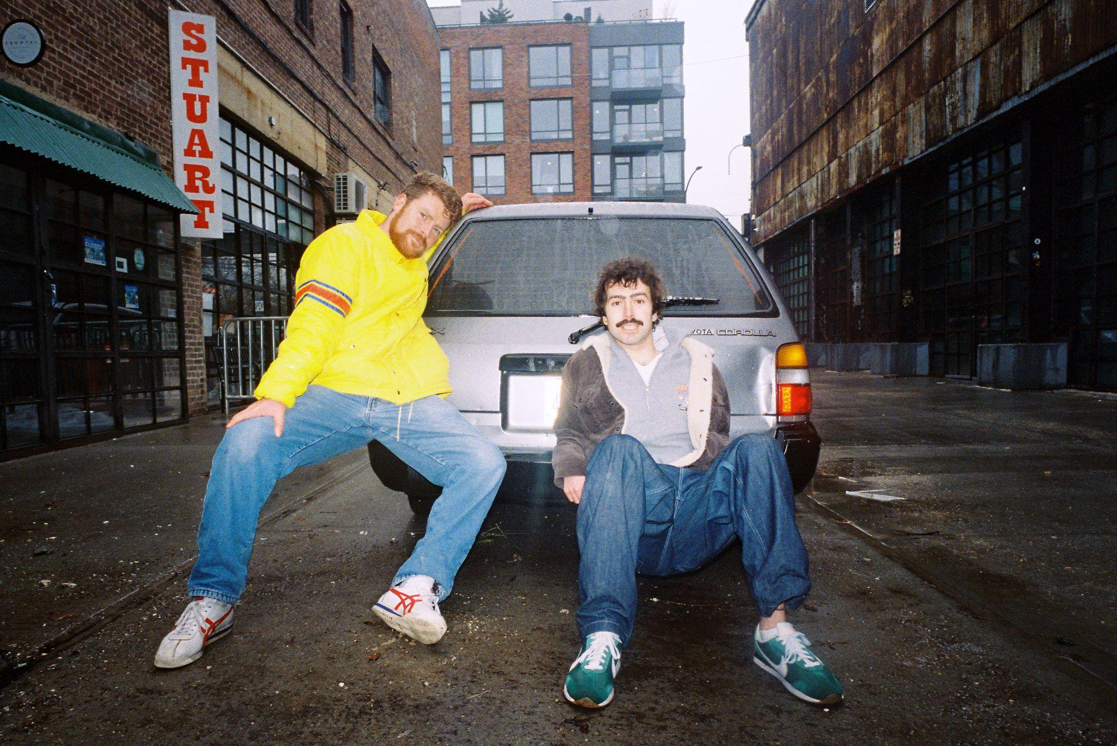
Dana and Alden by Rob Klassen (Download Hi-Res Assets HERE)

“Summer Nights”
LISTEN: https://i.concordjazz.com/dana-alden-summer

Papa’s Boat
PRE-SAVE/PRE-ORDER: https://ffm.to/dana-alden-papasboat

(July 17, 2026) - Ahead of the 3v3 soccer tournament the brothers are hosting tonight in NYC, Eugene, Oregon’s jazz duo Dana & Alden share their new single “Summer Nights”. Fittingly, their new single is an infectious, carefree jazz jam meant to soundtrack the warmth of Summer gatherings that you never want to end. The song is accompanied by a music video shot by Frontyard FM.

“Summer Nights” is the latest offering to score the globe-trotting sonic journey that Dana & Alden are taking listeners on with their forthcoming album Papa’s Boat, out August 14th via Concord Jazz. On the samba and bossa nova inspired previous single “El Gaucho”, the duo traveled to Rio de Janeiro to work with one of their heroes in Marcos Valle. Last week, Dana & Alden shared a short documentary, filmed and edited by Weston Borg, on their journey to Brazil, meeting Marcos and embracing the musical tapestry of Brazil with the help of renowned local musicians Zaza Desiderio and Mirella Costa, who also feature on the track.

Later this month, Dana & Alden will embark to Rhode Island to play Newport Jazz Festival, followed by another festival set at OFF in Poland, before they hit the road for their Papa’s Boat Tour this Fall. Beginning September 10th in Vancouver, this headlining run will see them play the biggest tour of their career to-date, spanning shows across North America through November.

Papa’s Boat is not only a personal ode to the brothers’ late maternal grandfather, it’s a continuation of his wanderlust spirit. Characterized by an adventurous and jubilant album that chronicles his travels both narratively and through sonic references, Dana and Alden aren’t just paying homage to Papa, they’re embodying his lust for life into an album that places community, tactile connection and passion for exploration above all else. Led by the jazz prowess of Dana’s saxophone and Alden’s drums, the album features a cadre of musician friends new and familiar, including the aforementioned Marcos Valle, Zaza Desiderio, Mirella Costa, as well as Melanie Charles, Mei Semones, and Cinya Khan.

The album was recorded across London, New York and Brazil, with the duo taking musical cues from each of the album’s spiritual homes. With the guidance of Yussef Dayes, Gilles Peterson and Marcos Valle on their recording trips, the duo infused the various soundscapes of their travels into an eclectic musical concoction that draws elements from indie rock, samba, bossa nova, jazz, rap, pop and more. The album was made with the duo’s backing band, all of whom were key collaborators and producers on Papa’s Boat: Andrew Mitchell on bass, Ebba Dankel on vocals and keys, Eli Torgersen on vocals and guitar, and Salim Charvet on sax and synths. The album was masterfully engineered by Malcolm Catto at his Quatermass Sound Lab studio in Dalston.

Bask in the warmth of “Summer Nights” above, and see below for Dana & Alden’s full run of upcoming tour dates + more information on Papa’s Boat.


Dana & Alden’s soccer tournament flier
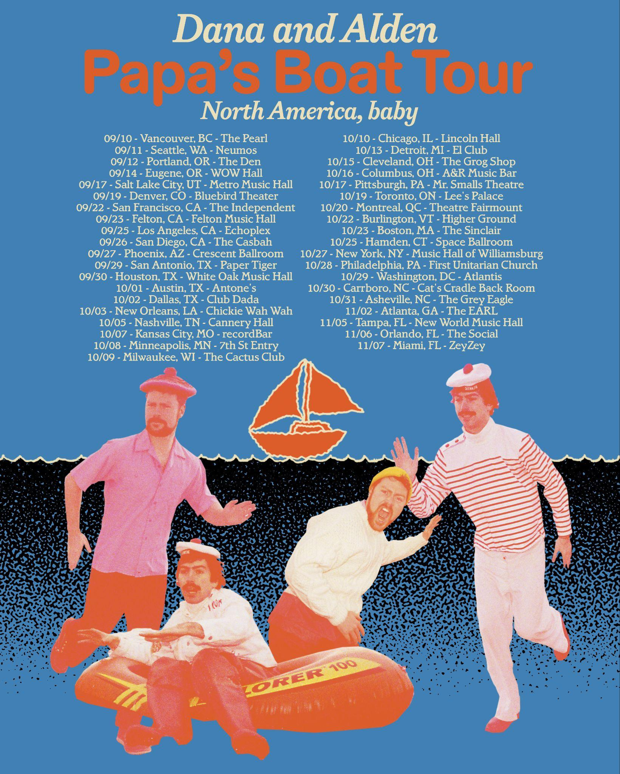
Upcoming Dana and Alden Live Dates:

7/31-8/2 - Newport, RI @ Newport Jazz Festival
8/7 - Katowice, Poland @ OFF Festival

9/10 - Vancouver, BC @ The Pearl
9/11 - Seattle, WA @ Neumos
9/12 - Portland, OR @ The Get Down
9/14 - Eugene, OR @ WOW Hall
9/17 - Salt Lake City, UT @ Metro Music Hall
9/19 - Denver, CO @ Bluebird Theater
9/22 - San Francisco, CA @ The Independent
9/23 - Felton, CA @ Felton Music Hall
9/25 - Los Angeles, CA @ Echoplex
9/26 - San Diego, CA @ The Casbah
9/27 - Phoenix, AZ @ Crescent Ballroom
9/29 - San Antonio, TX @ Paper Tiger
9/30 - Houston, TX @ White Oak Music Hall
10/1 - Austin, TX @ Antone’s
10/2 - Dallas, TX @ Club Dada
10/3 - New Orleans, LA @ Chickie Wah Wah
10/5 - Nashville, TN @ Cannery Hall (Row One Stage)
10/7 - Kansas City, MO @ recordBar
10/8 - Minneapolis, MN @ 7th St Entry
10/9 - Milwaukee, WI @ The Cactus Club
10/10 - Chicago, IL @ Lincoln Hall
10/13 - Detroit, MI @ El Club
10/15 - Cleveland, OH @ The Grog Shop
10/16 - Columbus, OH @ A&R Music Bar
10/17 - Pittsburgh, PA @ Mr. Smalls Theatre
10/19 - Toronto, ON @ Lee’s Palace
10/20 - Montreal, QC @ Theatre Fairmount
10/22 - Burlington, VT @ Higher Ground
10/23 - Boston, MA @ The Sinclair
10/25 - Hamden, CT @ Space Ballroom
10/27 - Brooklyn, NY @ Music Hall of Williamsburg
10/28 - Philadelphia, PA @ Ukie Club
10/29 - Washington, DC @ Atlantis
10/30 - Carrboro, NC @ Cat’s Cradle (Back Room)
10/31 - Asheville, NC @ The Grey Eagle
11/2 - Atlanta, GA @ The EARL
11/5 - Tampa, FL @ New World Music Hall
11/6 - Orlando, FL @ The Social
11/7 - Miami, FL @ ZeyZey (Zaku Stage)

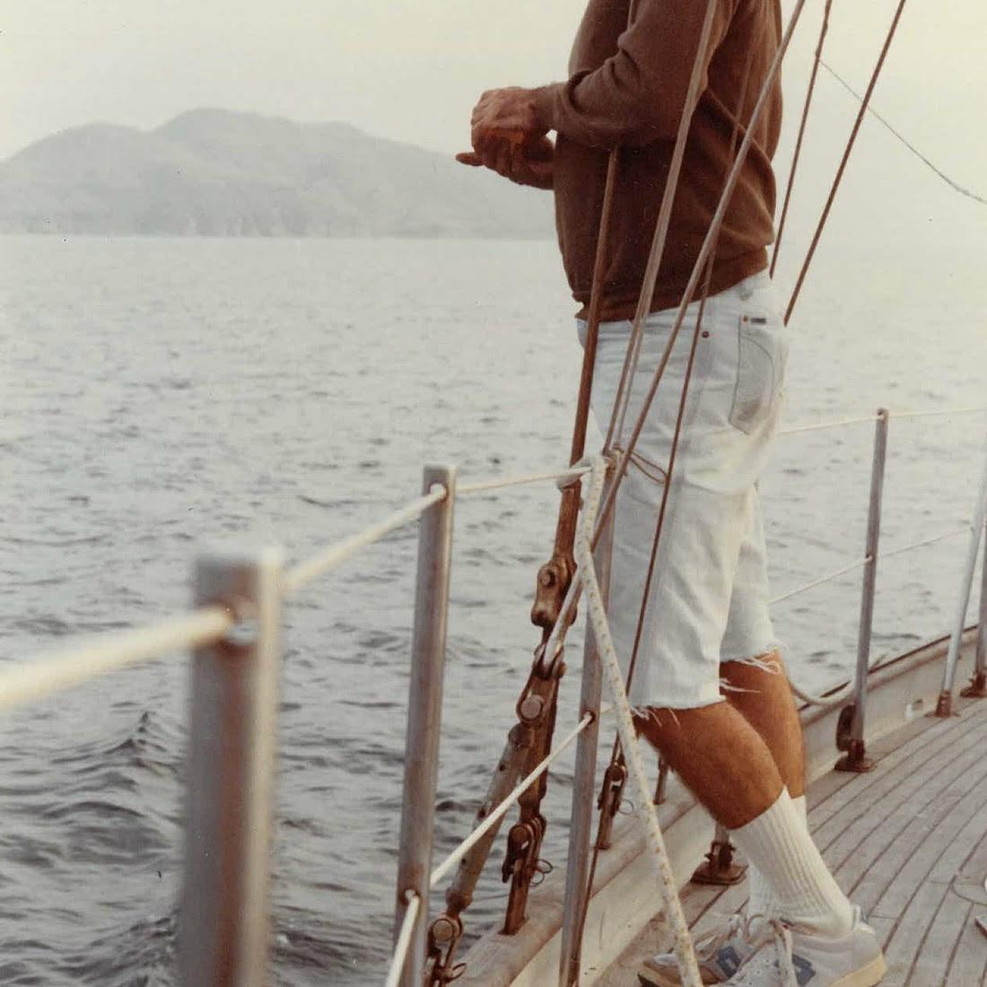
Dana and Alden
Papa’s Boat
August 14, 2026
Concord Jazz

1. Lighthouse (feat. EBBA)
2. Trick Dog (feat. Eli Torg)
3. Summer Nights
4. Napa 86
5. Friendship is a Boat (feat. Marcos Valle and Salim Charvet)
6. Milk and Honey (feat. Melanie Charles)
7. A Lullaby Flew Through My Window
8. Lee’s Greenhouse (feat. Mei Semones)
9. My Normal Life
10. North Star
11. Inthistogether (feat. Cinya Khan)
12. Good Kid
13. El Gaucho (feat. Marcos Valle, Mirella Costa and Zaza Desiderio)
14. Randy
15. A Broken Cup (feat. Melanie Charles)

(Download Hi-Res Assets HERE)

Connect with Dana and Alden:
Facebook | Instagram | TikTok | Website | YouTube |

For all Dana and Alden press inquiries, please contact Kevin at Orienteer
kevin@orienteer.us

