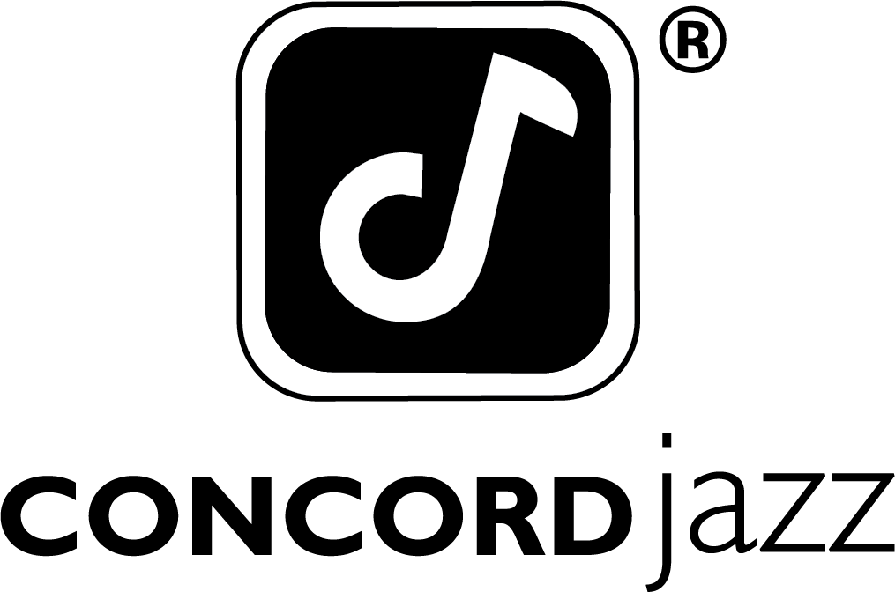

DANA AND ALDEN RELEASE NEW ALBUM

SHARE NEW MUSIC VIDEO FOR “NAPA 86”

NORTH AMERICAN TOUR BEGINS SEPTEMBER 10TH

PAPA’S BOAT OUT NOW VIA CONCORD JAZZ

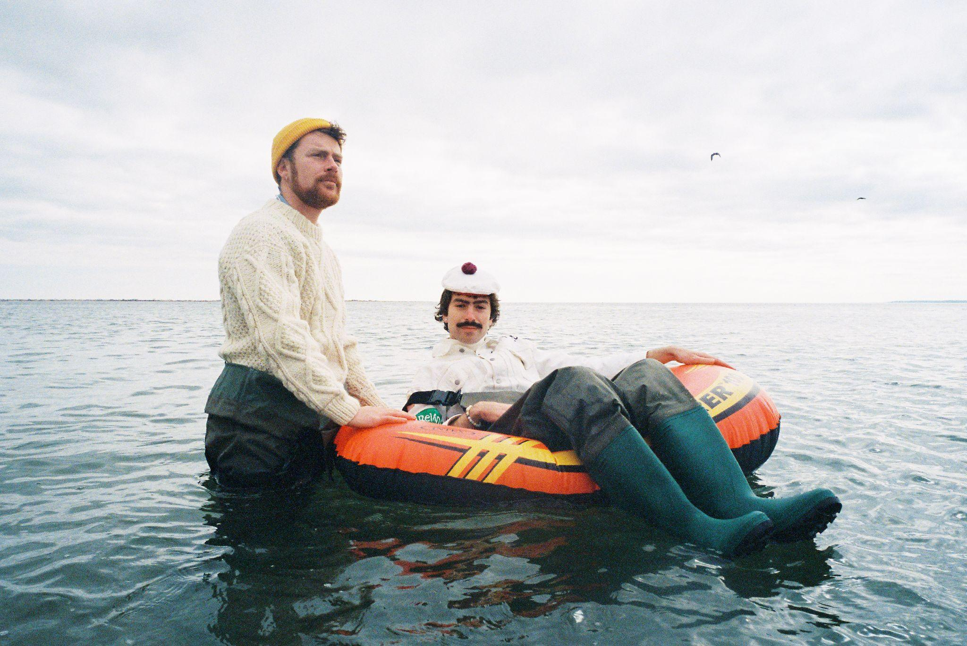
Dana & Alden by Rob Klassen (Download Hi-Res Assets HERE)

Papa’s Boat
https://ffm.to/dana-alden-papasboat

“Napa 86”
WATCH: https://i.concordjazz.com/dana-alden-napayt
(August 14, 2026) - Following the duo’s performance at Newport Jazz Festival earlier this month, Oregon’s favorite brothers Dana & Alden release their new album Papa’s Boat via Concord Jazz. The adventurous new album features a cadre of talented musician friends both new and familiar, including Rio De Janeiro legend Marcos Valle, Mei Semones, Melanie Charles, Zaza Desiderio, Mirella Costa and Cinya Khan. Coinciding with the album’s release, the duo are also sharing a new music video for “Napa 86”, directed by Weston Borg and shot in the Adventure Land theme park in Narrangansett, RI, a subtle nod to the adventurousness of Papa’s nautical travels.

Papa’s Boat is not only a personal ode to the brothers’ late maternal grandfather, it’s a continuation of his wanderlust spirit. Characterized by an adventurous and jubilant album that chronicles his travels both narratively and through sonic references, Dana and Alden aren’t just paying homage to Papa, they’re embodying his lust for life into an album that places community, tactile connection and passion for exploration above all else.

“Papa was a really special guy,” Dana says of the duo’s relationship with the titular Papa. “I think so much of what Alden and I are doing comes from just watching him live his own unique life. His emboldened, passionate personality gave us permission to be our own selves, to be unconventional and draw outside of the box.”

Next month, Dana & Alden will embark on the biggest headline run of their careers so far with their Papa’s Boat Tour. Beginning September 10th in Vancouver, this tour will see them play 39 shows across North America through November.

The album was recorded across London, New York and Brazil, with the duo taking musical cues from each of the album’s spiritual homes. With the guidance of Yussef Dayes, Gilles Peterson and Marcos Valle on their recording trips, the duo infused the various soundscapes of their travels into an eclectic musical concoction that draws elements from indie rock, samba, bossa nova, jazz, rap, pop and more. The album was made with the duo’s backing band, all of whom were key collaborators and producers on Papa’s Boat: Andrew Mitchell on bass, Ebba Dankel on vocals and keys, Eli Torgersen on vocals and guitar, and Salim Charvet on sax and synths. The album was masterfully engineered by Malcolm Catto at his Quatermass Sound Lab studio in Dalston.

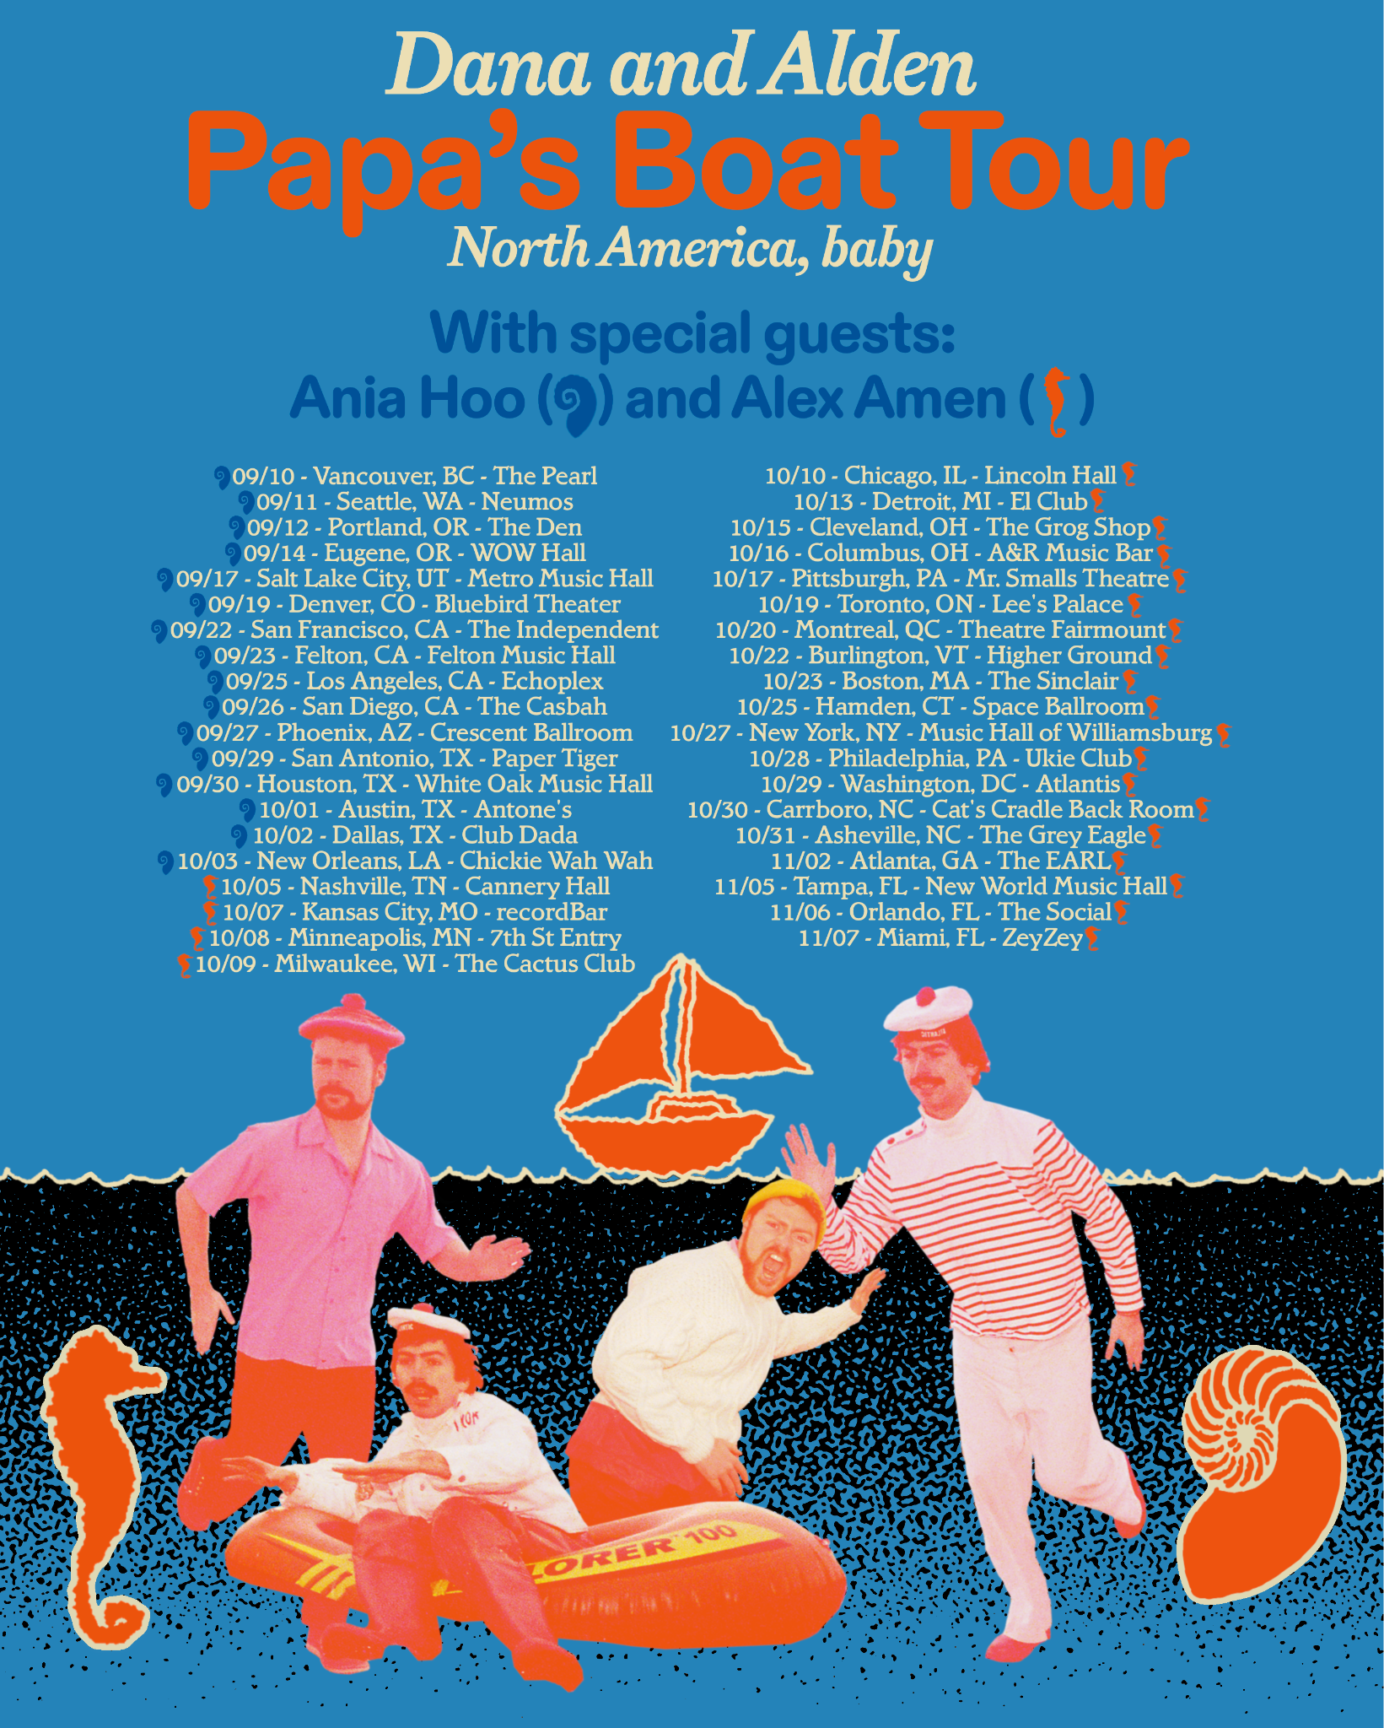
Upcoming Dana and Alden Live Dates:
*= support from Ania Hoo
^= support from Alex Amen

9/10 - Vancouver, BC @ The Pearl*
9/11 - Seattle, WA @ Neumos*
9/12 - Portland, OR @ The Get Down*
9/14 - Eugene, OR @ WOW Hall*
9/17 - Salt Lake City, UT @ Metro Music Hall*
9/19 - Denver, CO @ Bluebird Theater*
9/22 - San Francisco, CA @ The Independent*
9/23 - Felton, CA @ Felton Music Hall*
9/25 - Los Angeles, CA @ Echoplex*
9/26 - San Diego, CA @ The Casbah*
9/27 - Phoenix, AZ @ Crescent Ballroom*
9/29 - San Antonio, TX @ Paper Tiger*
9/30 - Houston, TX @ White Oak Music Hall*
10/1 - Austin, TX @ Antone’s*
10/2 - Dallas, TX @ Club Dada*
10/3 - New Orleans, LA @ Chickie Wah Wah*
10/5 - Nashville, TN @ Cannery Hall (Row One Stage)^
10/7 - Kansas City, MO @ recordBar^
10/8 - Minneapolis, MN @ 7th St Entry^
10/9 - Milwaukee, WI @ The Cactus Club^
10/10 - Chicago, IL @ Lincoln Hall^
10/13 - Detroit, MI @ El Club^
10/15 - Cleveland, OH @ The Grog Shop^
10/16 - Columbus, OH @ A&R Music Bar^
10/17 - Pittsburgh, PA @ Mr. Smalls Theatre^
10/19 - Toronto, ON @ Lee’s Palace^
10/20 - Montreal, QC @ Theatre Fairmount^
10/22 - Burlington, VT @ Higher Ground
10/23 - Boston, MA @ The Sinclair
10/25 - Hamden, CT @ Space Ballroom
10/27 - Brooklyn, NY @ Music Hall of Williamsburg
10/28 - Philadelphia, PA @ Ukie Club
10/29 - Washington, DC @ Atlantis
10/30 - Carrboro, NC @ Cat’s Cradle (Back Room)
10/31 - Asheville, NC @ The Grey Eagle
11/2 - Atlanta, GA @ The EARL
11/5 - Tampa, FL @ New World Music Hall
11/6 - Orlando, FL @ The Social
11/7 - Miami, FL @ ZeyZey (Zaku Stage)

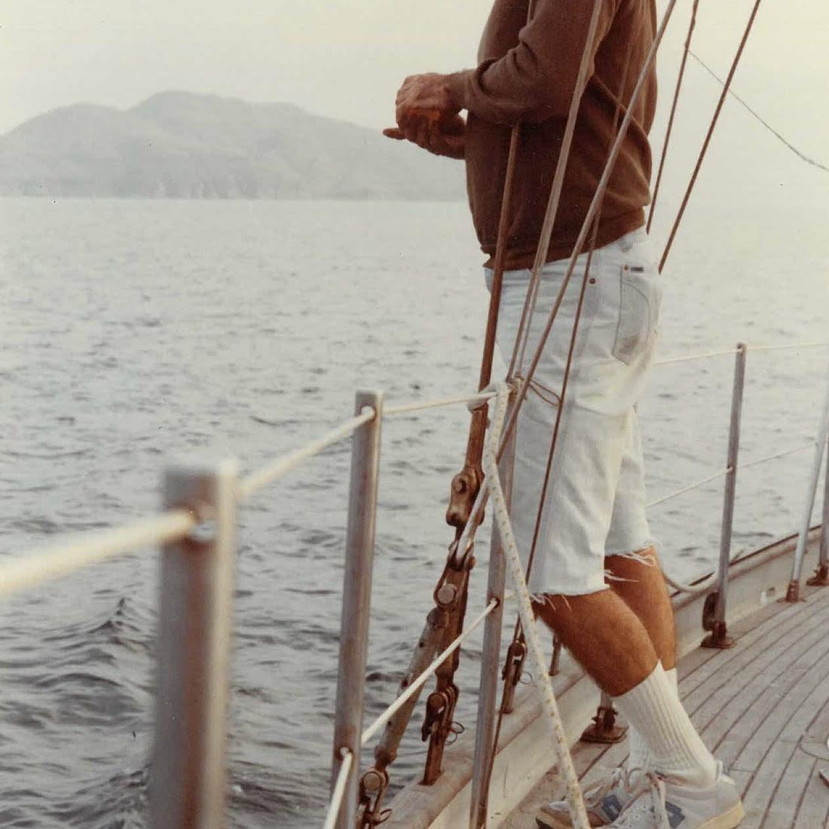
Dana and Alden
Papa’s Boat
August 14, 2026
Concord Jazz

1. Lighthouse (feat. EBBA)
2. Trick Dog (feat. Eli Torg)
3. Summer Nights
4. Napa 86
5. Friendship is a Boat (feat. Marcos Valle and Salim Charvet)
6. Milk and Honey (feat. Melanie Charles)
7. A Lullaby Flew Through My Window
8. Lee’s Greenhouse (feat. Mei Semones)
9. My Normal Life
10. North Star
11. Inthistogether (feat. Cinya Khan)
12. Good Kid
13. El Gaucho (feat. Marcos Valle, Mirella Costa and Zaza Desiderio)
14. Randy
15. A Broken Cup (feat. Melanie Charles)

(Download Hi-Res Assets HERE)

Connect with Dana and Alden:
Facebook | Instagram | TikTok | Website | YouTube |

For all Dana and Alden press inquiries, please contact Kevin at Orienteer
kevin@orienteer.us

