KODALINE
RELEASE FINAL STUDIO ALBUM
WE WERE ONLY YOUNG
OUT NOW VIA CONCORD
LISTEN / PURCHASE HERE

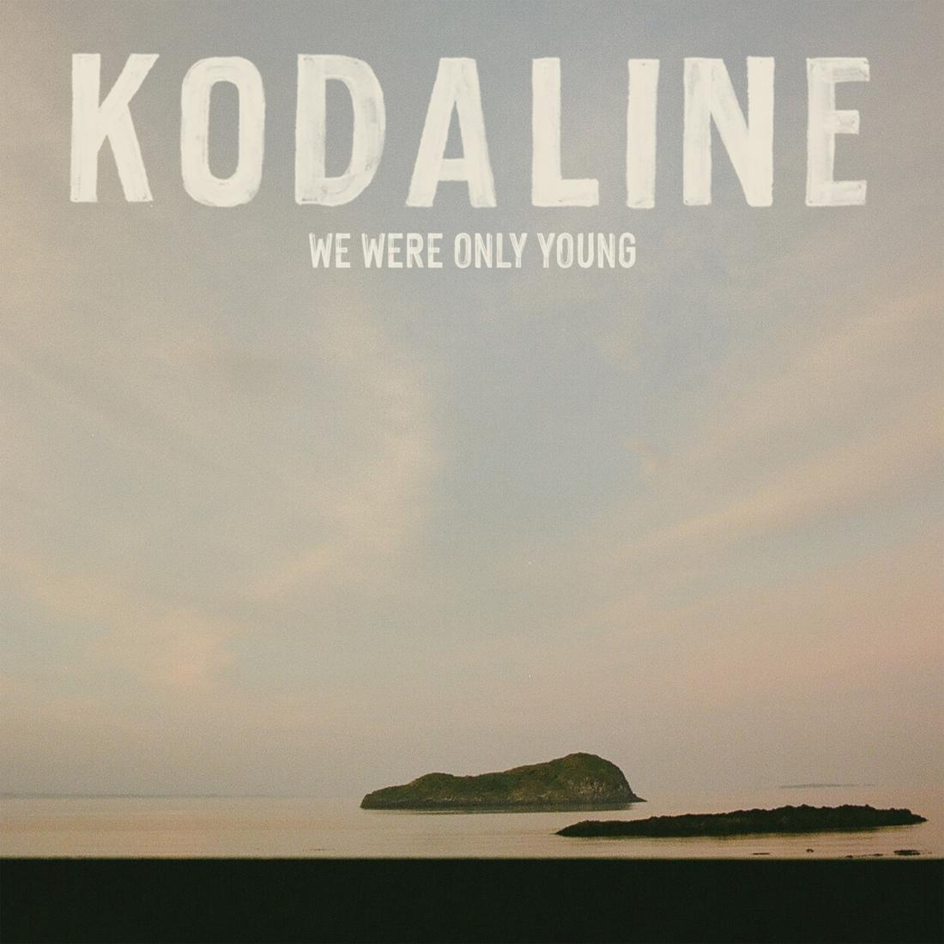
Download high res artwork here

FAREWELL WORLD TOUR
EUROPEAN LEG STARTS IN NOVEMBER
UK SHOWS IN DECEMBER SOLD OUT

October 2nd 2026 – Today, the beloved Irish band Kodaline have released their final studio album We Were Only Young via Concord. Listen/Purchase here

Saying goodbye is never easy, but Kodaline have written the perfect closing chapter to their story with We Were Only Young. A band born busking on the streets of Swords, Dublin to go on to triumph against the odds and deliver a chart-topping, multi-platinum and multi-billion streamed career to touch the hearts of fans across the globe.

Following an extraordinary career spanning more than a decade, Kodaline offer listeners this last statement, a contemplative and hugely moving work that explores pertinent themes of growth, connection, love and closure, as they look towards a bright and hopeful future.

“It’s a great feeling to be releasing new music, giving the fans something new before we go our separate ways,” says drummer Vinny May. “I think we owe it to them – some of them have been with us from the very start, supporting us through thick and thin, and we wouldn’t be who we are without them.”

“We’ve got fans who feel like family, who’ve grown up with us and played our music at their birthdays, weddings, funerals, the births of their children,” frontman Steve Garrigan adds. “It’s a strange feeling, reflecting on all of it now.”

We Were Only Young weaves a tapestry between beautiful ballads, from the soft and soaring acoustics of ‘All I Ever Need Is You’, to the piano and gospel-laced ‘Learn To Lose’. While the tender songs are joined by huge such pop anthems, such as the bright ‘It’s Not Over’, and the propulsive harmony driven ‘Get Me High’.

A jubilant folk bounce rings out through latest single ‘Vultures’, complimenting the haunting cavernous sounds that mark the beginning and end to the record, which launches with the bold and brooding ‘Who Will Save You Now’ and closes with the uplifting yet solemn ‘The One For Me’.

WE WERE ONLY YOUNG TRACK LISTING
- Who Will Save You Now
- We Were Only Young
- Back To Me
- Without You
- Get Me High
- All I Ever Need Is You
- Vultures
- Last Forever
- Learn To Lose
- Hindsight
- It’s Not Over
- The One For Me

Kodaline have been treating fans to songs from the new album live on their extensive Farewell World Tour this year. The shows are huge celebrations, and the band kicked things off with massive outdoor shows in Ireland, performing to 50,000 fans in June. This preceded a sold out run across Asia and Australia, while they will close the year with performances across Europe and the UK. Full dates are listed below and remaining tickets are available via kodaline.com

FAREWELL TOUR DATES 2026

EUROPE
Sun Nov 22 FR, Paris - L'Élysée Montmartre **SOLD OUT**
Tue Nov 24 NL, Utrecht – TivoliVredenburg **SOLD OUT**
Wed Nov 25 FR, Paris – Trianon **SOLD OUT**
Thu Nov 26 BE, Brussels - Ancienne Belgique **SOLD OUT**
Sat Nov 28 DE, Hamburg - Grosse Freiheit 36 **SOLD OUT**
Sun Nov 29 DE, Berlin - Huxleys
Mon Nov 30 DE, Frankfurt - Batschkapp
Wed Dec 02 CH, Zurich - X-Tra **SOLD OUT**
Thu Dec 03 IT, Milan – ALCATRAZ **SOLD OUT**
Sat Dec 05 CZ, Prague - Forum Karlin **SOLD OUT**
Sun Dec 06 AT, Vienna - Gasometer
Tue Dec 08 DE, Munich - Muffathalle **SOLD OUT**
Wed Dec 09 DE, Cologne - Carlswerk Victoria **SOLD OUT**
Thu Dec 10 NL, Utrecht - TivoliVredenburg **SOLD OUT**

UK
Sat Dec 12 UK, London – Roundhouse **SOLD OUT**
Mon Dec 14 UK, Glasgow – 02 Academy **SOLD OUT**
Tue Dec 15 UK, Manchester - Albert Hall **SOLD OUT**
Wed Dec 16 UK, London – Shepherd’s Bush Empire **SOLD OUT**

IRELAND
Fri Dec 18 IE, Dublin – 3Arena

For more information contact David Sullivan at Wilful & Sullivan Publicity
david@wilfulandsullivan.com

