KODALINE

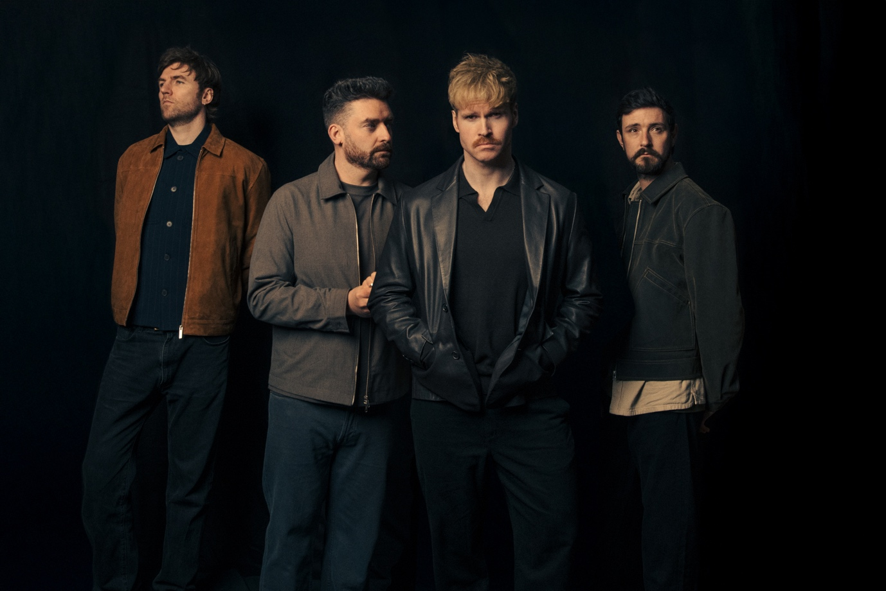
Photo Credit: Jennifer McCord – download here

‘BACK TO ME’
BRAND NEW SINGLE RELEASED
LISTEN HERE / WATCH THE VIDEO HERE

WE WERE ONLY YOUNG
FINAL STUDIO ALBUM
OUT OCTOBER 2ND VIA CONCORD
PRE-ORDER HERE

CURRENTLY TOURING WORLDWIDE WITH FAREWELL SHOWS

Beloved Irish band Kodaline have released their brand new single ‘Back To Me’, the latest song to be taken from their fifth and final album We Were Only Young out October 2nd via Concord.

The emotional new single ‘Back To Me’ has been written in support for those in their darkest hours. It opens with frontman Steve Garrigan’s pared-back vocals and tender piano notes that fall like autumn leaves: “I should have called, I should have asked, I should have said that I was there,” he sings. “I would have stayed, I would have made more time if I only knew.”

The lyrics are steeped in sorrow, and that sharp sting of fear at the possibility that it could be too late. But as the song builds, with swoons of strings and layered harmonies, Garrigan’s own voice grows stronger, urging: “You’ve got a whole lot of life left/ So don’t give up quite yet, come back to me.”

Regarding the single Steve says, “‘Back to Me’ is about being there for someone who’s given up on themselves. I’ve been there before, on both sides. I hope this song inspires people to keep going and reminds them that they’re never truly alone.”

The new album We Were Only Young is a contemplative and hugely moving body of work that explores pertinent themes of growth, connection, love and closure, as they look towards a bright and hopeful future.

We Were Only Young weaves a tapestry between beautiful ballads, from the soft and soaring acoustics of ‘All I Ever Need Is You’, to the piano and gospel-laced ‘Learn To Lose’. While the tender songs are joined by huge such pop anthems, such as the bright ‘It’s Not Over’, and the propulsive harmony driven ‘Get Me High’. A jubilant folk bounce rings out through ‘Vultures’, complimenting the haunting cavernous sounds that mark the beginning and end to the record, which launches with the bold and brooding ‘Who Will Save You Now’ and closes with the uplifting yet solemn ‘The One For Me’.

The latest single ‘Back To Me’ follows previously released singles further demonstrating the breadth and heartfelt songwriting of the record. These include ‘Without You’, written by Steve for his wife on their wedding day, while the title track is a bittersweet reflection on better times, understanding that they can’t be revisited. It is steeped with fond nostalgia, focused on laying demons to rest, while delivering an important and timely message of gratitude.

WE WERE ONLY YOUNG TRACK LISTING
- Who Will Save You Now
- We Were Only Young
- Back To Me
- Without You
- Get Me High
- All I Ever Need Is You
- Vultures
- Last Forever
- Learn To Lose
- Hindsight
- It’s Not Over
- The One For Me

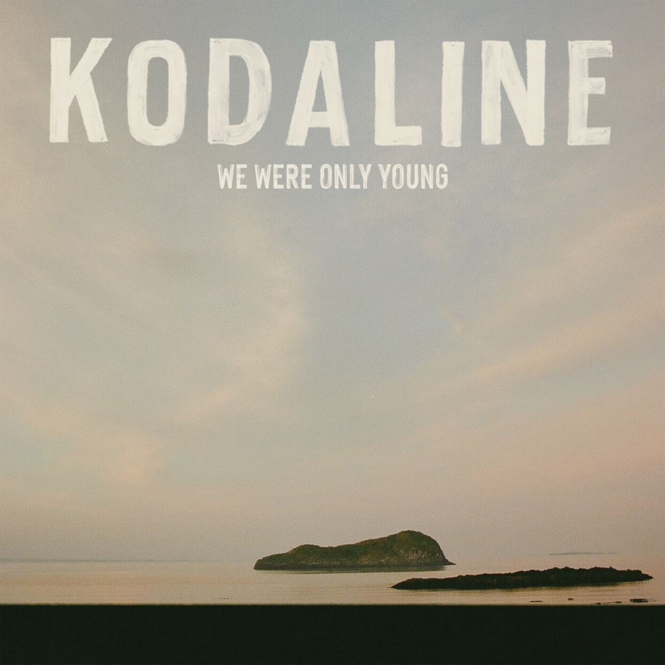
Download high res artwork here

Kodaline have been treating fans to songs from the new album live on their extensive Farewell World Tour this year. The shows are huge celebrations with sets spanning the breadth of their cherished chart-topping, multi-platinum and multi-billion streamed catalogue.

The band kicked things off with massive outdoor shows in Ireland, performing to 50,000 fans at major outdoor shows. Kodaline are currently touring throughout Asia, followed by Australia, Europe and the UK. The shows are widely sold out including the entirety of their UK leg in December. Full dates are listed below and remaining tickets are available via kodaline.com

FAREWELL TOUR DATES 2026

ASIA
Sat Aug 08 Singapore - The Star Theatre **SOLD OUT**
Mon Aug 10 Manila - MOA Arena
Wed Aug 12 Seoul - Olympic Hall
Fri Aug 14 Tokyo – Summer Sonic Festival
Sat Aug 15 Osaka – Summer Sonic Festival
Wed Aug 19 Hong Kong – TIDES **SOLD OUT**
Thu Aug 20 Hong Kong – TIDES
Sat Aug 22 Jakarta - LaLaLa Festival
Mon Aug 24 Tapei – TICC **SOLD OUT**
Wed Aug 26 Kuala Lumpur - Idea Live Arena
Fri Aug 28 Bangkok - UOB Live **SOLD OUT**
Sat Aug 29 Bangkok - UOB Live

AUSTRALIA
Tue Sep 01 AU, Perth - Riverside
Thu Sep 03 AU, Sydney - Enmore Theatre **SOLD OUT**
Sat Sep 05 AU, Melbourne - Forum Melbourne **SOLD OUT**
Sun Sep 06 AU, Brisbane - Fortitude Music Hall

EUROPE
Sun Nov 22 FR, Paris - L'Élysée Montmartre **SOLD OUT**
Tue Nov 24 NL, Utrecht – TivoliVredenburg **SOLD OUT**
Wed Nov 25 FR, Paris – Trianon **SOLD OUT**
Thu Nov 26 BE, Brussels - Ancienne Belgique **SOLD OUT**
Sat Nov 28 DE, Hamburg - Grosse Freiheit 36 **SOLD OUT**
Sun Nov 29 DE, Berlin - Huxleys
Mon Nov 30 DE, Frankfurt - Batschkapp
Wed Dec 02 CH, Zurich - X-Tra **SOLD OUT**
Thu Dec 03 IT, Milan – ALCATRAZ **SOLD OUT**
Sat Dec 05 CZ, Prague - Forum Karlin
Sun Dec 06 AT, Vienna - Gasometer
Tue Dec 08 DE, Munich - Muffathalle **SOLD OUT**
Wed Dec 09 DE, Cologne - Carlswerk Victoria **SOLD OUT**
Thu Dec 10 NL, Utrecht - TivoliVredenburg **SOLD OUT**

UK
Sat Dec 12 UK, London – Roundhouse **SOLD OUT**
Mon Dec 14 UK, Glasgow – 02 Academy **SOLD OUT**
Tue Dec 15 UK, Manchester - Albert Hall **SOLD OUT**
Wed Dec 16 UK, London – Shepherd’s Bush Empire **SOLD OUT**

IRELAND
Fri Dec 18 IE, Dublin – 3Arena – NEW DATE ADDED

For more information contact David Sullivan at Wilful & Sullivan Publicity
david@wilfulandsullivan.com

