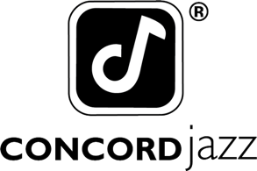

DANA AND ALDEN SHARE NEW SINGLE “EL GAUCHO”
FEATURING MARCOS VALLE, MIRELLA COSTA & ZAZA DESIDERIO

NORTH AMERICAN TOUR BEGINS SEPTEMBER 10TH

PAPA’S BOAT OUT AUGUST 14TH VIA CONCORD JAZZ

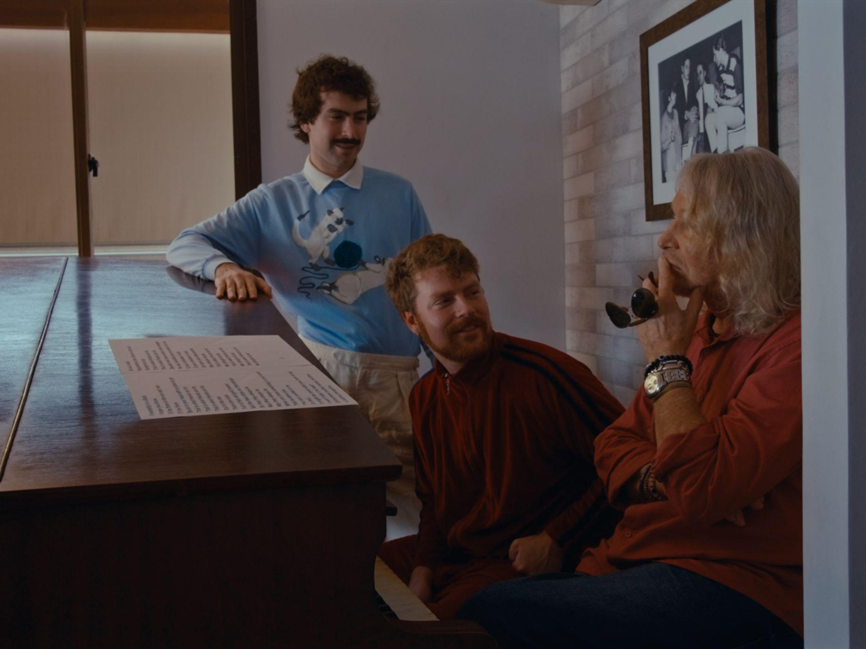
Dana and Alden and Marcos Valle by Weston Borg (Download Hi-Res Assets HERE)

“El Gaucho” featuring Marcos Valle, Mirella Costa & Zaza Desiderio
WATCH: https://i.concordjazz.com/dana-alden-elgauchoyt
LISTEN:

Papa’s Boat
PRE-SAVE/PRE-ORDER: https://ffm.to/dana-alden-papasboat

(June 12, 2026) - Just in time to soundtrack the opening games of the World Cup, Dana and Alden share their new single “El Gaucho” featuring Brazilian legend Marcos Valle, and renowned Brazilian musicians Mirella Costa and Zaza Desiderio. The brother jazz duo’s new single is an ode to Dana’s favorite soccer player of all time, the inimitable Ronaldinho of Brazil, and exudes the fleet-footed rhythms of the best soccer-inspired anthems led by the percussion prowess of Alden and Rio de Janeiro’s Zaza Desiderio. The song is accompanied by a Weston Borg filmed-and-directed music video shot in Rio de Janeiro that features Marcos Valle, Mirella Costa and Zaza Desiderio and pays homage to the city of Rio and the magic of Ronaldinho.

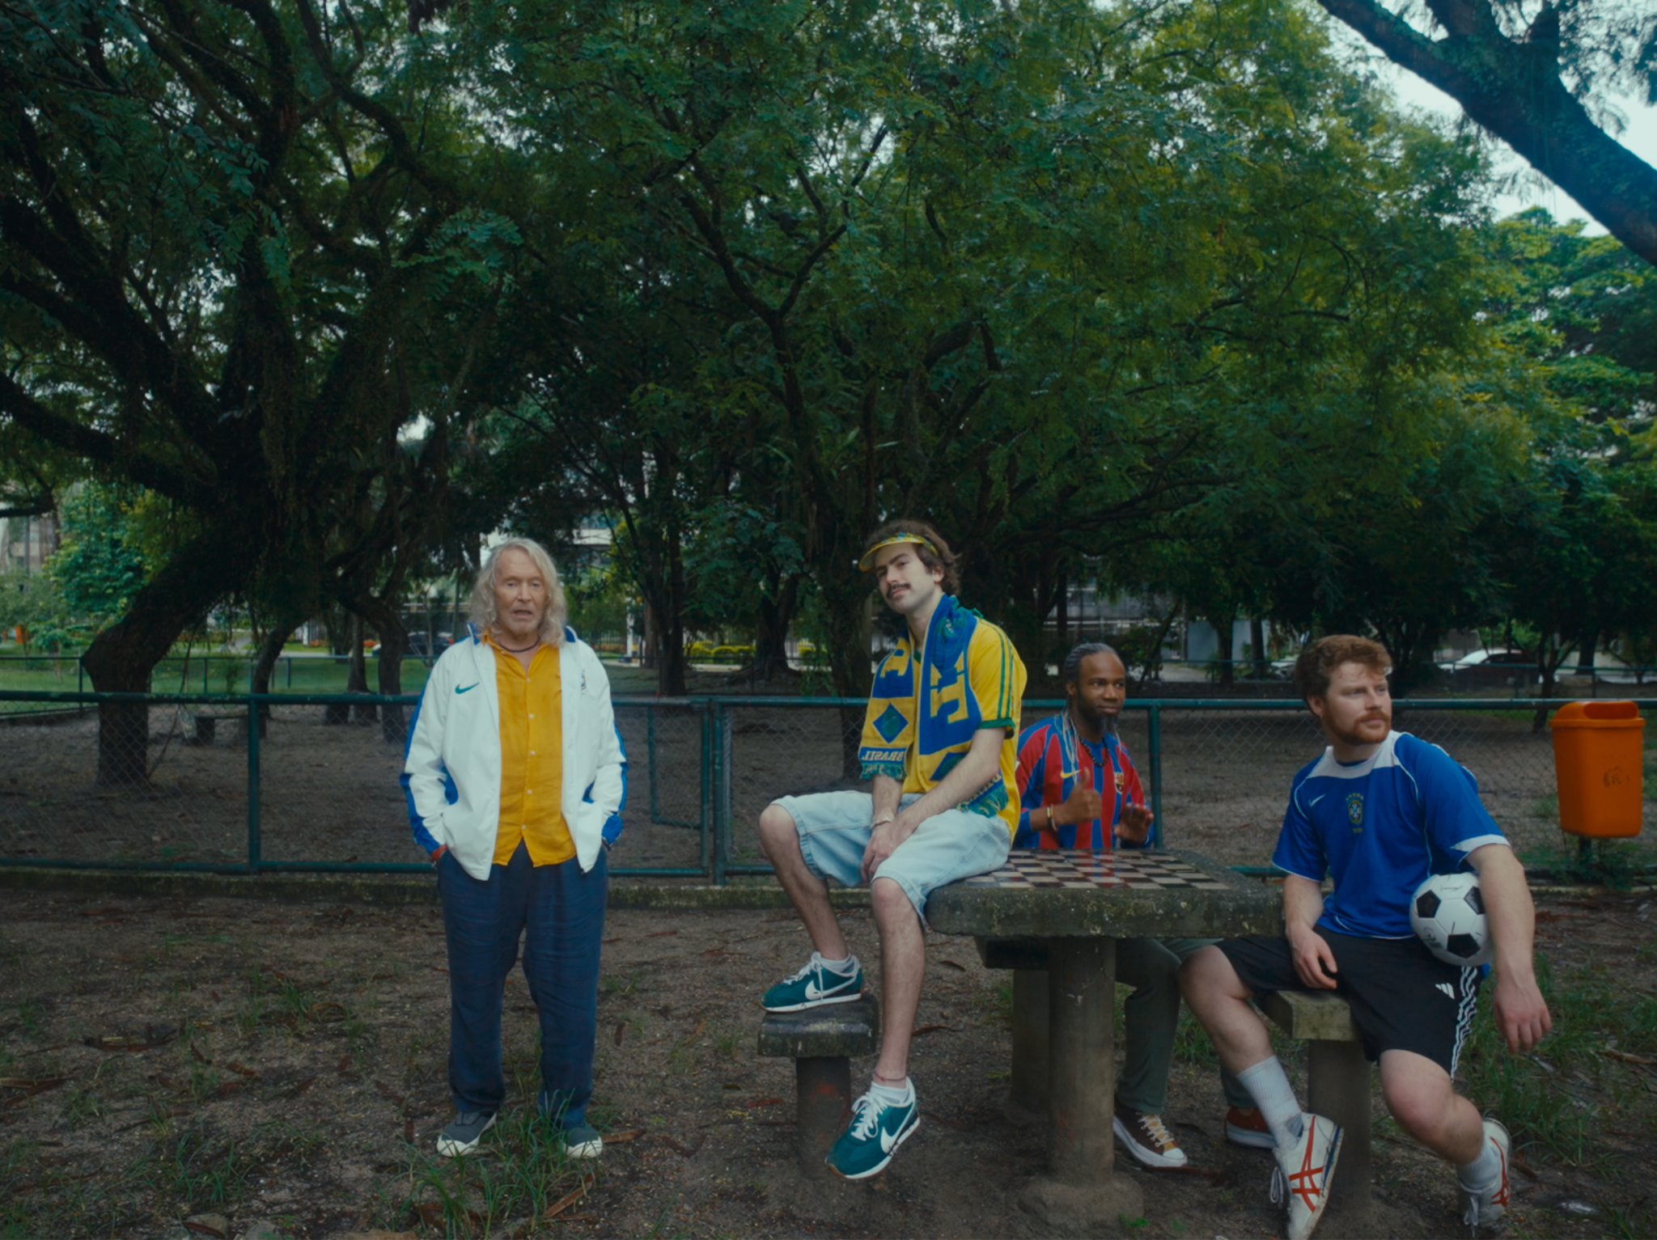
“El Gaucho” video still (Download Hi-Res Assets HERE)

“‘El Gaucho’ was birthed one day when we tracked a Brazilian tune on our tape machine and began to watch Ronaldinho highlights while listening back to it at the insistence of our flautist Salim,” Alden said of making the song. “The tune embodied his playing style immaculately, the way he weaved through players and danced with the ball on the field. We brought the song to the legendary Marcos Valle who wrote lyrics and sang on it—a dream come true. Our dear friends Mirella and Zaza added rich layers of harmonies and percussion and wrote the entire outro which became a stadium-like chant section.”

“El Gaucho” is the third advance stop on the journey that is the duo’s forthcoming album Papa’s Boat, which is set to arrive August 14th via Concord Jazz. Following “Good Kid” and “Lee’s Greenhouse” featuring Mei Semones, Dana & Alden’s new single finds the duo teaming up with one of their musical heroes in Marcos Valle, who they’ve been deeply inspired by since their preteens. Marcos is also featured on “Friendship Is A Boat”.

Last week, Dana & Alden announced their Fall headlining Papa’s Boat tour, which begins September 10th in Vancouver. The run will see them play the biggest headline tour of their career to-date, spanning shows across North America through November. Their tour is preceded by festival sets at Newport Jazz Fest and Poland’s OFF Festival this Summer.

Papa’s Boat is not only a personal ode to the brothers’ late maternal grandfather, it’s a continuation of his wanderlust spirit. Characterized by an adventurous and jubilant album that chronicles his travels both narratively and through sonic references, Dana and Alden aren’t just paying homage to Papa, they’re embodying his lust for life into an album that places community, tactile connection and passion for exploration above all else. Led by the jazz prowess of Dana’s saxophone and Alden’s drums, the album features a cadre of musician friends new and familiar, including the aforementioned Marcos Valle, Zaza Desiderio, Mirella Costa, as well as Melanie Charles, Mei Semones, and Cinya Khan.

Papa’s Boat was recorded across London, New York and Brazil, with the duo taking musical cues from each of the album’s spiritual homes. With the guidance of Yussef Dayes, Gilles Peterson and Marcos Valle on their recording trips, the duo infused the various soundscapes of their travels into an eclectic musical concoction that draws elements from indie rock, samba, bossa nova, jazz, rap, pop and more. The album was made with the duo’s backing band, all of whom were key collaborators and producers on Papa’s Boat: Andrew Mitchell on bass, Ebba Dankel on vocals and keys, Eli Torgersen on vocals and guitar, and Salim Charvet on sax and synths. The album was masterfully engineered by Malcolm Catto at his Quatermass Sound Lab studio in Dalston.

Lace up and hit the field with “El Gaucho” above, see below for Dana & Alden’s full run of upcoming tour dates and more information on Papa’s Boat.

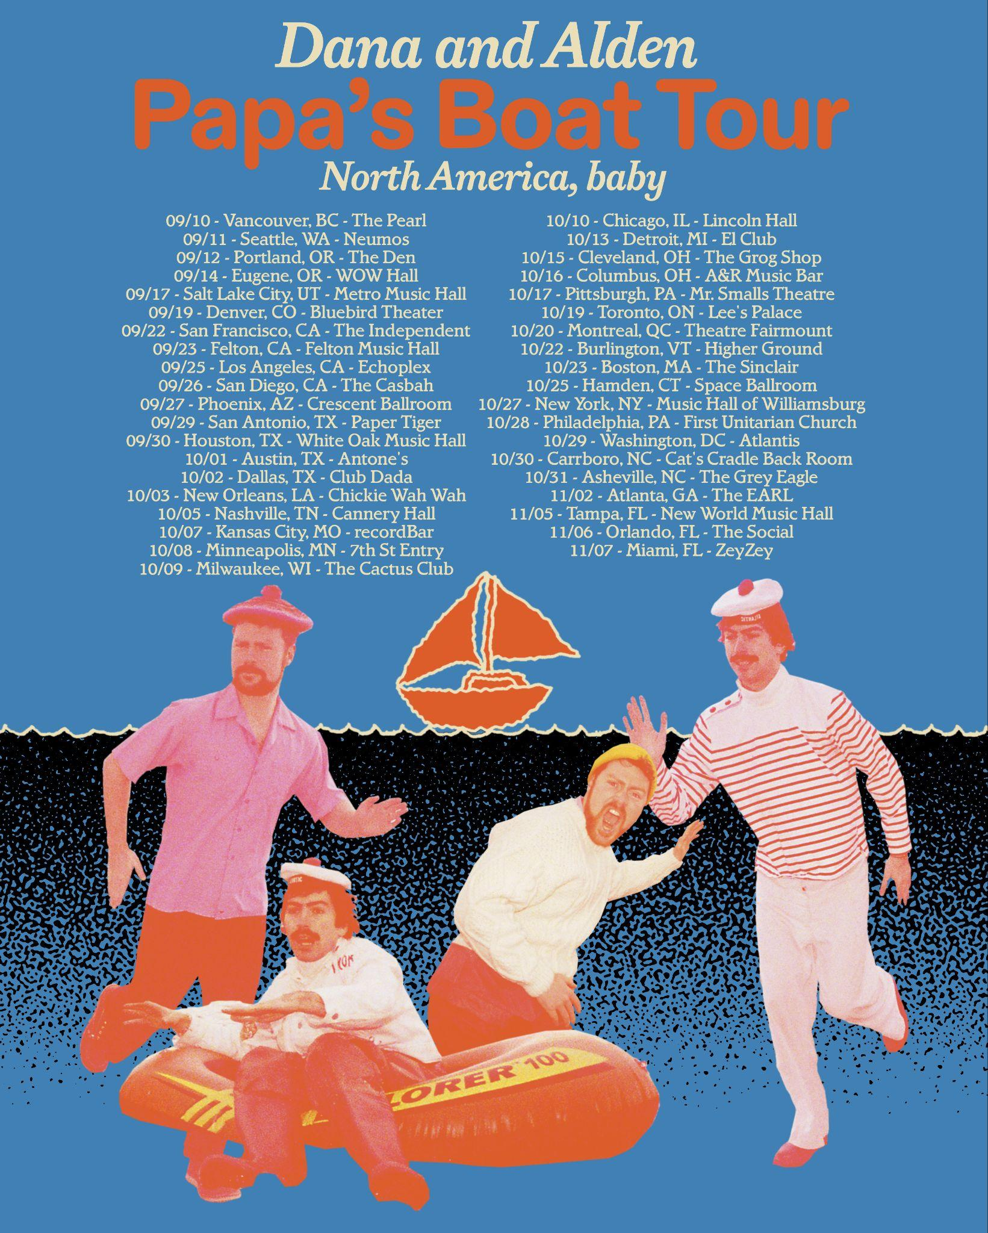

Upcoming Dana and Alden Live Dates:

7/31-8/2 - Newport, RI @ Newport Jazz Festival
8/7 - Katowice, Poland @ OFF Festival

9/10 - Vancouver, BC @ The Pearl
9/11 - Seattle, WA @ Neumos
9/12 - Portland, OR @ The Get Down
9/14 - Eugene, OR @ WOW Hall
9/17 - Salt Lake City, UT @ Metro Music Hall
9/19 - Denver, CO @ Bluebird Theater
9/22 - San Francisco, CA @ The Independent
9/23 - Felton, CA @ Felton Music Hall
9/25 - Los Angeles, CA @ Echoplex
9/26 - San Diego, CA @ The Casbah
9/27 - Phoenix, AZ @ Crescent Ballroom
9/29 - San Antonio, TX @ Paper Tiger
9/30 - Houston, TX @ White Oak Music Hall
10/1 - Austin, TX @ Antone’s
10/2 - Dallas, TX @ Club Dada
10/3 - New Orleans, LA @ Chickie Wah Wah
10/5 - Nashville, TN @ Cannery Hall (Row One Stage)
10/7 - Kansas City, MO @ recordBar
10/8 - Minneapolis, MN @ 7th St Entry
10/9 - Milwaukee, WI @ The Cactus Club
10/10 - Chicago, IL @ Lincoln Hall
10/13 - Detroit, MI @ El Club
10/15 - Cleveland, OH @ The Grog Shop
10/16 - Columbus, OH @ A&R Music Bar
10/17 - Pittsburgh, PA @ Mr. Smalls Theatre
10/19 - Toronto, ON @ Lee’s Palace
10/20 - Montreal, QC @ Theatre Fairmount
10/22 - Burlington, VT @ Higher Ground
10/23 - Boston, MA @ The Sinclair
10/25 - Hamden, CT @ Space Ballroom
10/27 - Brooklyn, NY @ Music Hall of Williamsburg
10/28 - Philadelphia, PA @ First Unitarian Church (Sanctuary)
10/29 - Washington, DC @ Atlantis
10/30 - Carrboro, NC @ Cat’s Cradle (Back Room)
10/31 - Asheville, NC @ The Grey Eagle
11/2 - Atlanta, GA @ The EARL
11/5 - Tampa, FL @ New World Music Hall
11/6 - Orlando, FL @ The Social
11/7 - Miami, FL @ ZeyZey (Zaku Stage)

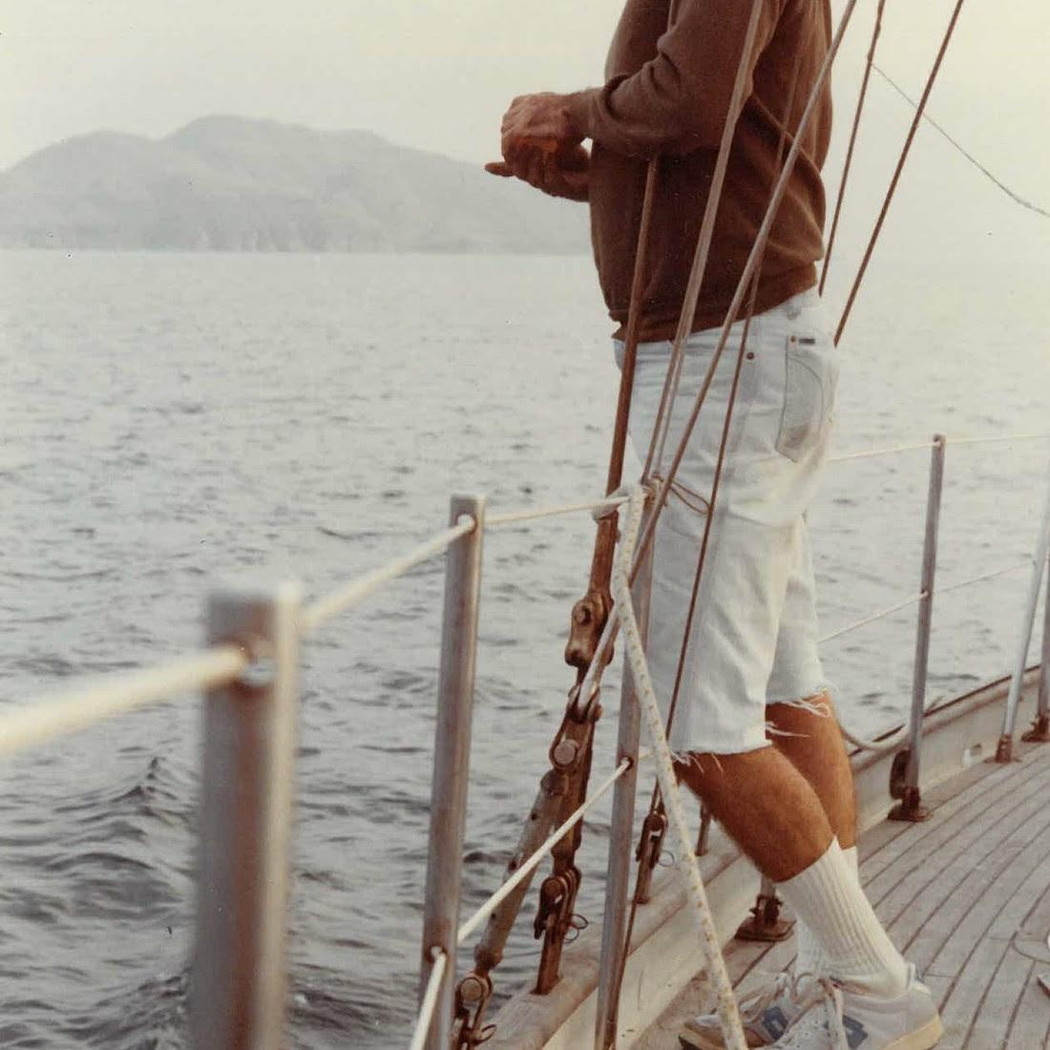
Dana and Alden
Papa’s Boat
August 14, 2026
Concord Jazz

1. Lighthouse (feat. EBBA)
2. Trick Dog (feat. Eli Torg)
3. Summer Nights
4. Napa 86
5. Friendship is a Boat (feat. Marcos Valle)
6. Milk and Honey (feat. Melanie Charles)
7. A Lullaby Flew Through My Window
8. Lee’s Greenhouse (feat. Mei Semones)
9. My Normal Life
10. North Star
11. Inthistogether (feat. Cinya Khan)
12. Good Kid
13. El Gaucho (feat. Marcos Valle, Mirella Costa and Zaza Desiderio)
14. Randy
15. A Broken Cup (feat. Melanie Charles)

(Download Hi-Res Assets HERE)

Connect with Dana and Alden:
Facebook | Instagram | TikTok | Website | YouTube |

For all Dana and Alden press inquiries, please contact Kevin at Orienteer
kevin@orienteer.us

