KODALINE

RELEASE BRAND NEW SINGLE
‘WE WERE ONLY YOUNG’
LISTEN HERE / WATCH THE VIDEO HERE

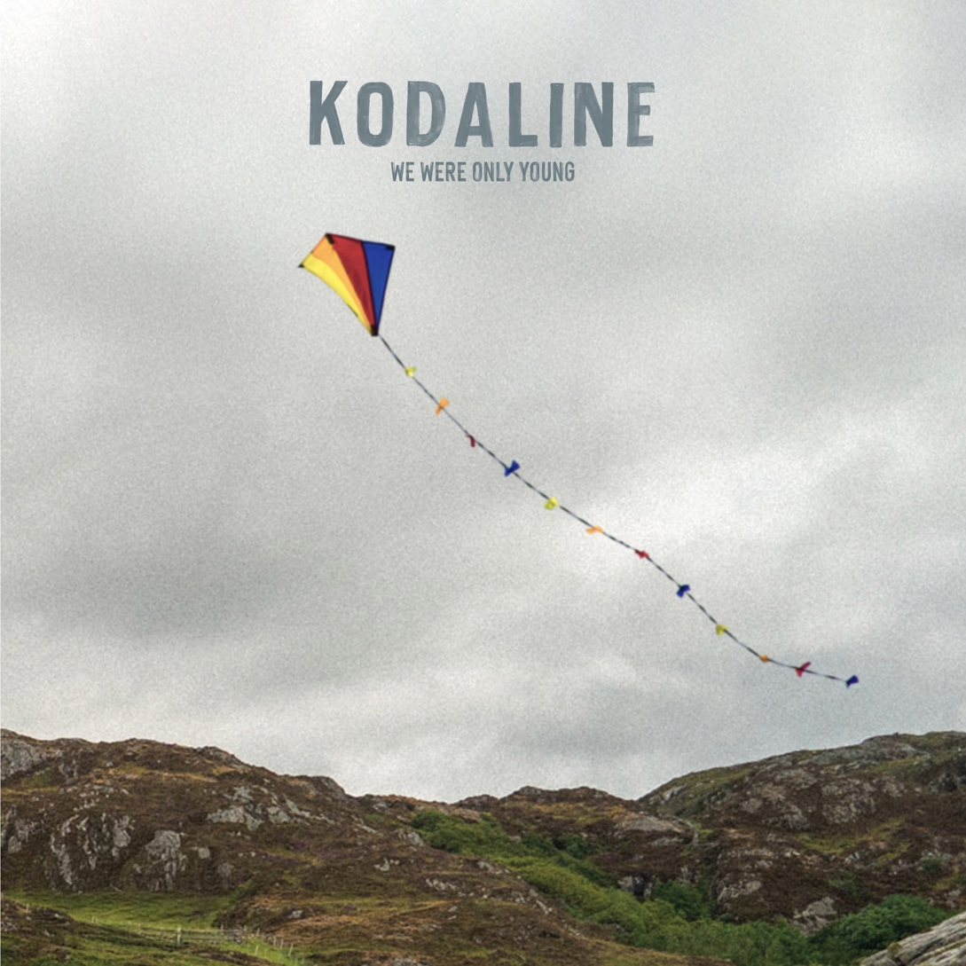
Download single artwork here

FIRST TRACK FROM FORTHCOMING FINAL STUDIO ALBUM
ALBUM PRE-ORDERS AVAILABLE HERE

FAREWELL WORLD TOUR STARTS JUNE 2026
SHOWS SELLING OUT QUICKLY
PROMPTING ADDITIONAL DATES
AND VENUE UPGRADES

April 15th 2026 - Kodaline have released their brand new single ‘We Were Only Young’, the first song to be taken from their fifth and final studio album due later this year via Fantasy Records. Album pre-orders start today here.

‘We Were Only Young’ is a stunning reflective piano ballad rich in soaring vocal harmonies, grand orchestration and soul-stirring emotion from the beloved Irish band.
The track sees frontman songwriter Steve Garrigan join forces with producer and co-writer Mads Christensen.

Regarding the single Steve says, “‘We Were Only Young’ is a bittersweet song about looking back on better times, knowing you can’t ever go back. Like most songs I write, it comes from something real, that feeling of being part of something special, and only fully understanding it with time. In some ways, it reflects the journey we’ve been on together.”

Steve Garrigan, Vinny May, Jason Boland, and Mark Prendergast launched Kodaline in Dublin in 2012, and after over a decade together, 2026 sees Kodaline drawing to a close their celebrated chart-topping career which has connected them with fans across the globe.

They skyrocketed to international fame with their 2013 debut album In A Perfect World, which topped the Irish charts going double platinum, also turning platinum in the UK at No.3, alongside several international radio hits. Kodaline continued to dominate domestic charts and prove global streaming and radio sensations across their following four albums. Now for Record Store Day 2026 (April 18th) In A Perfect World is revisited and expanded to a 2LP pressing, with many songs from the album pressed to vinyl for the first time.

The final chapter of Kodaline is both reflective and progressive, a celebration of their career alongside the birth of brand new music. This will be reflected in their extensive Farewell Tour for 2026, with shows set to mark the very best and fan favourites of Kodaline as well as songs from their final studio album.

The tour launches in June with Kodaline performing to 40,000 fans across their homeland, followed by tours across Asia, Australia, Europe and the UK. The shows have sold out quickly prompting additional dates to be added alongside further venue upgrades across Europe and the UK.

Full dates are listed below and tickets are available via kodaline.com

FAREWELL TOUR DATES 2026

IRELAND
Wed Jun 17 Belfast – Ulster Hall **SOLD OUT**
Fri Jun 19 Cork – Virgin Media Park
Sat Jun 20 Dublin – Malahide Castle

ASIA
Sat Aug 08 Singapore - The Star Theatre
Mon Aug 10 Manila - MOA Arena
Wed Aug 12 Seoul - Olympic Hall
Fri Aug 14 Tokyo – Summer Sonic Festival
Sat Aug 15 Osaka – Summer Sonic Festival
Wed Aug 19 Hong Kong – TIDES **SOLD OUT**
Thu Aug 20 Hong Kong – TIDES **NEW DATE ANNOUNCED**
Sat Aug 22 Jakarta - LaLaLa Festival
Mon Aug 24 Tapei – TICC **SOLD OUT**
Wed Aug 26 Kuala Lumpur - Idea Live Arena
Fri Aug 28 Bangkok - UOB Live **SOLD OUT**
Sat Aug 29 Bangkok - UOB Live **NEW DATE ANNOUNCED**

AUSTRALIA
Tue Sep 01 AU, Perth - Riverside
Thu Sep 03 AU, Sydney - Enmore Theatre
Sat Sep 05 AU, Melbourne - Forum Melbourne
Sun Sep 06 AU, Brisbane - Fortitude Music Hall

EUROPE
Sun Nov 22 FR, Paris - L'Élysée Montmartre **NEW DATE ANNOUNCED**
Tue Nov 24 NL, Utrecht – TivoliVredenburg **NEW DATE ANNOUNCED**
Wed Nov 25 FR, Paris – Trianon **SOLD OUT**
Thu Nov 26 BE, Brussels - Ancienne Belgique
Sat Nov 28 DE, Hamburg - Grosse Freiheit 36
Sun Nov 29 DE, Berlin - Huxleys
Mon Nov 30 DE, Frankfurt - Batschkapp
Wed Dec 02 CH, Zurich - X-Tra
Thu Dec 03 IT, Milan - ALCATRAZ
Sat Dec 05 CZ, Prague - Forum Karlin **VENUE UPGRADED**
Sun Dec 06 AT, Vienna - Gasometer
Tue Dec 08 DE, Munich - Muffathalle
Wed Dec 09 DE, Cologne - Carlswerk Victoria
Thu Dec 10 NL, Utrecht - TivoliVredenburg **SOLD OUT**

UK
Sat Dec 12 UK, London – Roundhouse **SOLD OUT**
Mon Dec 14 UK, Glasgow – 02 Academy **VENUE UPGRADED**
Tue Dec 15 UK, Manchester - Albert Hall **SOLD OUT**
Wed Dec 16 UK, London – Shepherd’s Bush Empire **NEW DATE ANNOUNCED**

FOLLOW KODALINE:
WEBSITE | INSTAGRAM | YOUTUBE | FACEBOOK | X

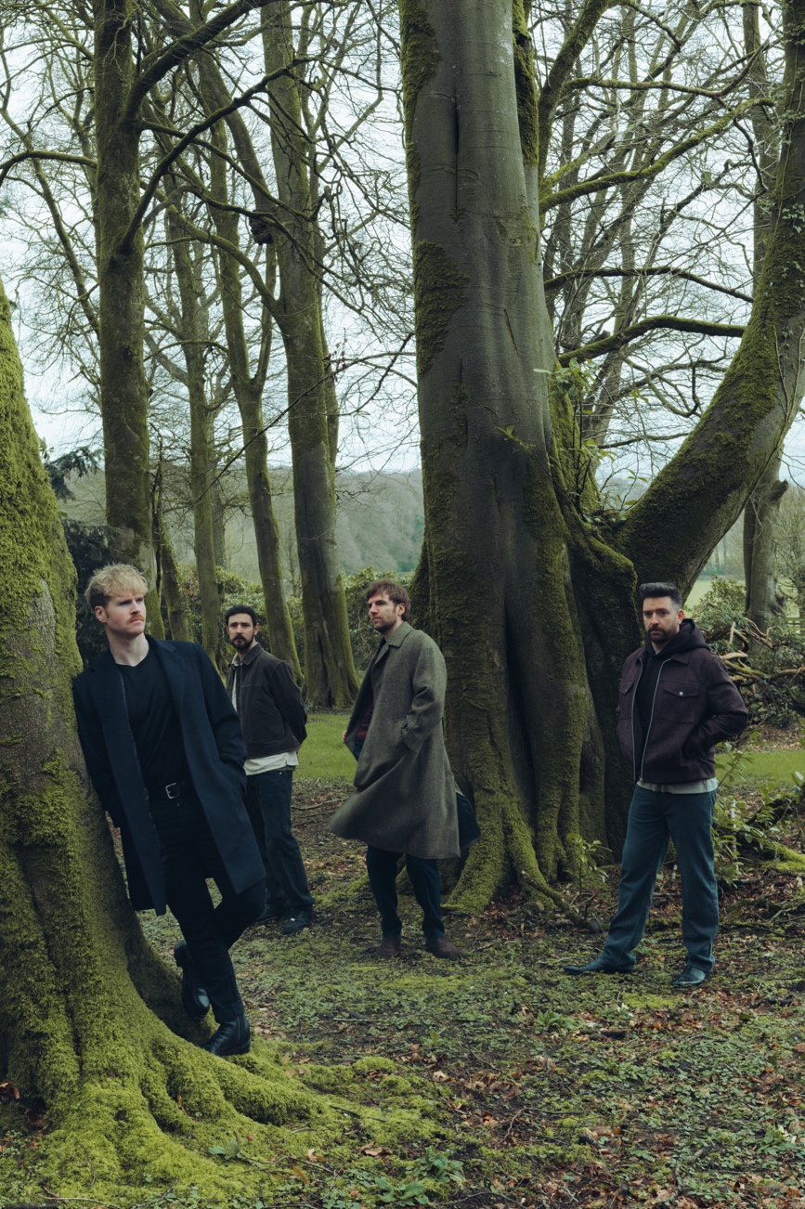
Photo Credit: Jennifer McCord – download here

For more information contact David Sullivan at Wilful & Sullivan Publicity
david@wilfulandsullivan.com

