KODALINE

ANNOUNCE FINAL STUDIO ALBUM
WE WERE ONLY YOUNG
OUT OCTOBER 2ND VIA CONCORD
PRE-ORDER HERE
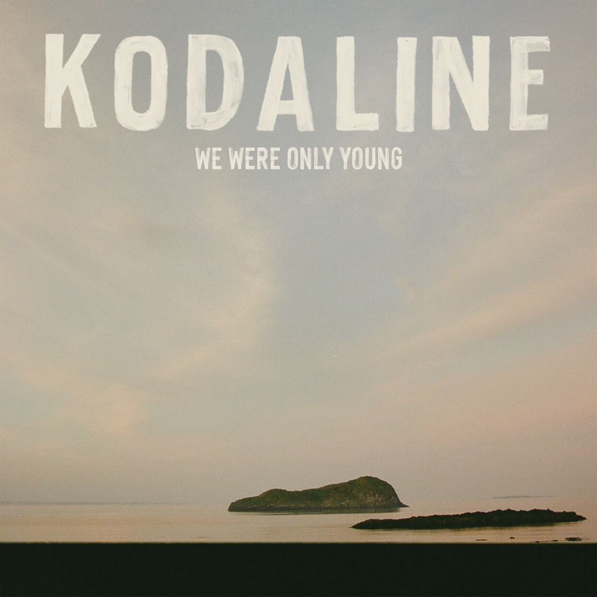

‘WITHOUT YOU’
BRAND NEW SINGLE RELEASED
LISTEN HERE / WATCH THE VIDEO HERE

FAREWELL WORLD TOUR STARTS NEXT WEEK

Beloved Irish band Kodaline have announced their fifth and final album We Were Only Young for release on October 2nd via Concord. The album is available to pre-order now here.

With the announcement Kodaline have released the brand new single ‘Without You’, a beautiful acoustic love song written by frontman Steve Garrigan for his wife on their wedding day. Listen here, watch the video here.

Regarding the single Steve says, “I’ve never been much of a talker, but I can write a song. I wanted to do something special for my wife on our wedding day, so I wrote her ‘Without You’. It became my speech, it was our first dance, and it felt too special not to share. It’s probably my favourite song on the album for obvious reasons.”

Kodaline are bowing out in tremendous fashion with their final album We Were Only Young, a grand emotive and heartfelt record of the greatest music they have made in years.

The reflective album captures the hard yet fulfilling journey through life, with a contemplative look on growth, the power of relationships, the development and strength of love, with an uplifting look to the future and becoming content with closure.

Fans were treated to the first taste of We Were Only Young with the release of the anthemic title track earlier this year. The song was quick to prove another Kodaline hit, receiving over six million streams to date with widespread airplay coming throughout the UK and Europe.

We Were Only Young weaves a tapestry between beautiful ballads, from the soft and soaring acoustics of ‘All I Ever Need Is You’, to the piano and gospel-laced ‘Learn To Lose’. While the tender songs are joined by huge such pop anthems, such as the bright ‘It’s Not Over’, and the propulsive harmony driven ‘Get Me High’. A jubilant folk bounce rings out through ‘Vultures’, complimenting the haunting cavernous sounds that mark the beginning and end to the record, which launches with the bold and brooding ‘Who Will Save You Now’ and closes with the uplifting yet solemn ‘The One For Me’.

Regarding the album Steve says, “I wrote this album over the last four years, and when I started it, I wasn’t even sure I wanted to write songs anymore. The record became a way of making sense of a really important period in my life, getting married, dealing with loss, uncertainty, and the end of the band. Some of the songs are deeply personal, while others found their meaning over time.

If anybody takes anything from it, I’d like to think it might help them through their own tough times, whether that’s love, loss, grief, uncertainty, or whatever life throws at them. Music has always had that power for me, and I hope these songs can do that for someone else too.

For something I never thought I’d do, or even get through, I’m very proud of it. And I’m very proud of everything we’ve achieved as a band over the years.”

WE WERE ONLY YOUNG TRACK LISTING
- Who Will Save You Now
- We Were Only Young
- Back To Me
- Without You
- Get Me High
- All I Ever Need Is You
- Vultures
- Last Forever
- Learn To Lose
- Hindsight
- It’s Not Over
- The One For Me

Kodaline will be treating fans to songs from the new album live on their extensive Farewell World Tour this year. The shows promise to be huge celebrations with sets spanning the breadth of their cherished chart-topping, multi-platinum and multi-billion streamed catalogue.

The band kick things off with massive outdoor shows in Ireland, performing to 50,000 fans next weekend. Before setting off across Asia, Australia, Europe and the UK. The shows are widely sold out including the entirety of their UK leg in December. Full dates are listed below and remaining tickets are available via kodaline.com

FAREWELL TOUR DATES 2026

IRELAND
Wed Jun 17 Belfast – Ulster Hall **SOLD OUT**
Fri Jun 19 Cork – Virgin Media Park **SOLD OUT**
Sat Jun 20 Dublin – Malahide Castle **SOLD OUT**

ASIA
Tue Aug 04 Beijing - Rana Minima Music Factory
Thu Aug 06 Shanghai - Vas Est
Sat Aug 08 Singapore - The Star Theatre
Mon Aug 10 Manila - MOA Arena
Wed Aug 12 Seoul - Olympic Hall
Fri Aug 14 Tokyo – Summer Sonic Festival
Sat Aug 15 Osaka – Summer Sonic Festival
Wed Aug 19 Hong Kong – TIDES **SOLD OUT**
Thu Aug 20 Hong Kong – TIDES
Sat Aug 22 Jakarta - LaLaLa Festival
Mon Aug 24 Tapei – TICC **SOLD OUT**
Wed Aug 26 Kuala Lumpur - Idea Live Arena
Fri Aug 28 Bangkok - UOB Live **SOLD OUT**
Sat Aug 29 Bangkok - UOB Live

AUSTRALIA
Tue Sep 01 AU, Perth - Riverside
Thu Sep 03 AU, Sydney - Enmore Theatre
Sat Sep 05 AU, Melbourne - Forum Melbourne **SOLD OUT**
Sun Sep 06 AU, Brisbane - Fortitude Music Hall

EUROPE
Sun Nov 22 FR, Paris - L'Élysée Montmartre
Tue Nov 24 NL, Utrecht – TivoliVredenburg
Wed Nov 25 FR, Paris – Trianon **SOLD OUT**
Thu Nov 26 BE, Brussels - Ancienne Belgique **SOLD OUT**
Sat Nov 28 DE, Hamburg - Grosse Freiheit 36 **SOLD OUT**
Sun Nov 29 DE, Berlin - Huxleys
Mon Nov 30 DE, Frankfurt - Batschkapp
Wed Dec 02 CH, Zurich - X-Tra **SOLD OUT**
Thu Dec 03 IT, Milan - ALCATRAZ
Sat Dec 05 CZ, Prague - Forum Karlin
Sun Dec 06 AT, Vienna - Gasometer
Tue Dec 08 DE, Munich - Muffathalle **SOLD OUT**
Wed Dec 09 DE, Cologne - Carlswerk Victoria
Thu Dec 10 NL, Utrecht - TivoliVredenburg **SOLD OUT**

UK
Sat Dec 12 UK, London – Roundhouse **SOLD OUT**
Mon Dec 14 UK, Glasgow – 02 Academy **SOLD OUT**
Tue Dec 15 UK, Manchester - Albert Hall **SOLD OUT**
Wed Dec 16 UK, London – Shepherd’s Bush Empire **SOLD OUT**

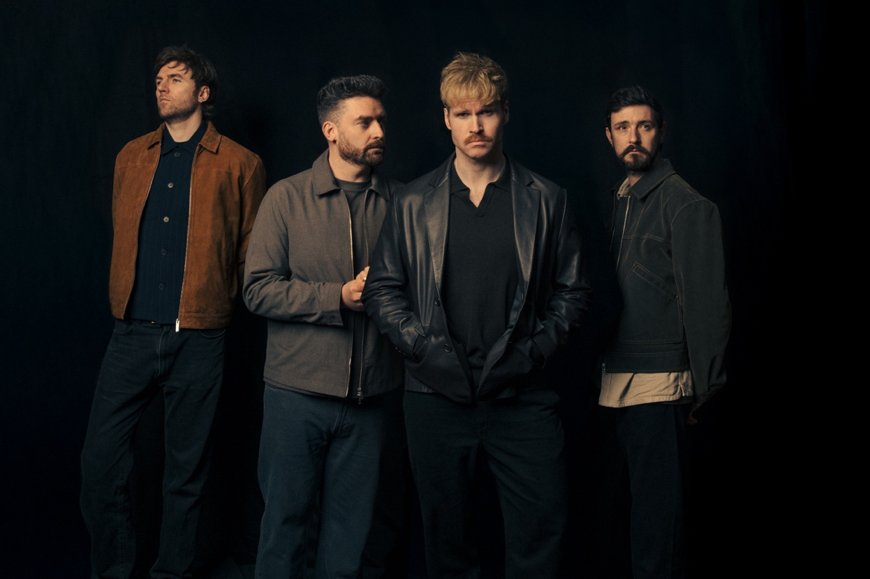

FOLLOW KODALINE
WEBSITE | INSTAGRAM | YOUTUBE | FACEBOOK | X

For more information contact David Sullivan at Wilful & Sullivan Publicity
david@wilfulandsullivan.com

