JOY OLADOKUN’S HIGHLY ANTICIPATED NEW ALBUM HOPE IS A HEAVY THING OUT NOW VIA CONCORD RECORDS
OFFICIAL MUSIC VIDEO FOR “EASY COMPANY” DEBUTS
EXTENSIVE “THE HEAVY THINGS TOUR” KICKS OFF NEXT MONTH; TICKETS ON-SALE NOW
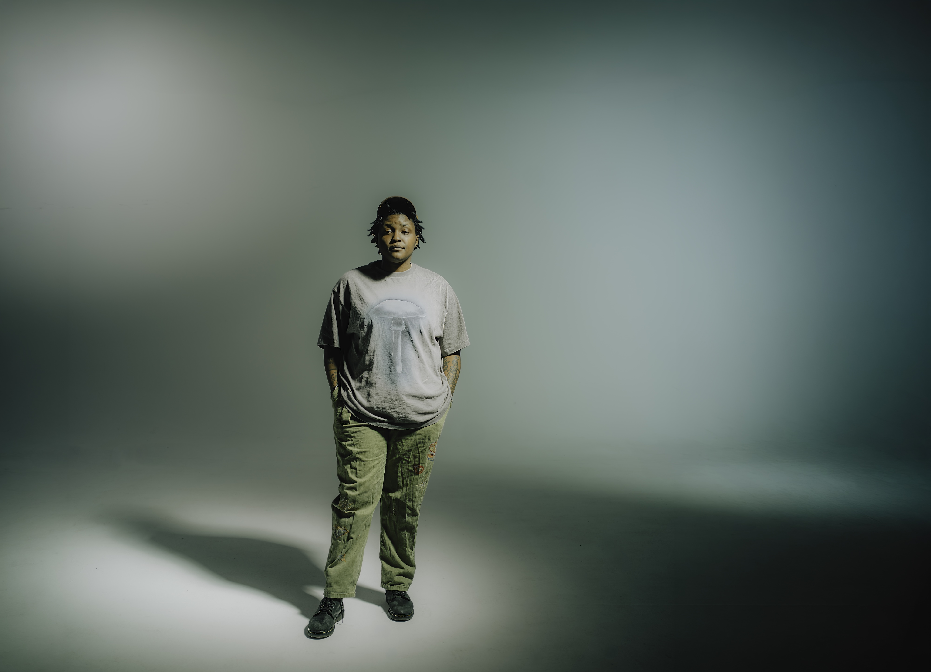
Press photo credit: Graham Tolbert
September 25, 2026—Acclaimed singer, songwriter, producer and performer Joy Oladokun shares their highly anticipated new album, Hope Is A Heavy Thing, today via Concord Records; stream/purchase HERE. The official music video for Oladokun’s new song, “Easy Company,” is also out now, directed by Rippy Austin. Watch/share HERE.
Produced by Oladokun with additional contributions from Nigerian producer Spellz, the new 12-track project marks a bold new chapter, expanding Oladokun’s sound while continuing to prove her ability to not only bend genres but also to bridge cultures. Across the album, Oladokun explores identity, connection and self-discovery with the emotional honesty that has become a hallmark of her songwriting.
Ahead of the release, Oladokun shared album tracks “Zombie,” “Sage” and “Kind,” the latter of which Stereogum praises, “‘Kind’ showcases Oladokun’s silky vocals. She even sounds comforting when her lyrics take a dark, vulnerable turn,” while Atwood Magazine declares, “We could all use a little more Joy in our lives. This song is a welcome, much-needed breath of humanity in the world.” Watch the music video for “Kind” HERE, directed by Grammy-nominated artist, producer and filmmaker Jesse Boykins III.
“‘To understand your future you have to confront your past.’ This is the driving theme behind Hope Is A Heavy Thing,” shares Oladokun. “It’s a collection of 12 songs that I wrote to help myself find my light again after burning out. Produced in Nashville, New York, and the back of a speeding tour bus, this album is sonically an homage to all of the music that inspires me. On this record you’ll find music that nods the brilliance of the Soulquarians, the rawness of Bob Dylan, the rhythms of afrobeats, and the sampling prowess of J Dilla. Not to mention a callback to the Ronettes and a few songs that find inspiration in rock and roll protest music of the 60’s and 70’s. You’ll also find me at the most authentic I’ve been able to be as an artist. It is a record I wrote for anyone who finds themselves wondering how to hope in these times. Sometimes it means looking back and digging through the muck to find what’s worth fighting for again.”
Next month, Oladokun will embark on their extensive “The Heavy Things Tour,” with upcoming stops at Austin’s Scoot Inn, Los Angeles’ The Bellwether, Brooklyn’s Warsaw Concerts, Denver’s Paramount Theatre, Chicago’s The Vic Theatre, Washington D.C.’s Howard Theatre and Nashville’s Ryman Auditorium, among many others. See below for complete tour itinerary.
Hope Is A Heavy Thing follows Oladokun’s critically acclaimed albums in defense of my own happiness (2021), Proof of Life (2023) and Observations From A Crowded Room (2024), which led NPR Music to call Oladokun “one of the great singer-songwriters pushing beyond roots or conventional singer-songwriter music today.” Additionally, The New York Times praised, “her songs are conversational and confessional, and her hooky but profound melodies turn her lyrics into mantras,” while Consequence declared, “One of the most refreshing voices coming out of Nashville…there’s a deeply honest quality to her music that makes her hard to shake.”
Oladokun is one of today’s most compelling genre-defying voices, using deeply vulnerable songwriting to seamlessly connect folk, soul, pop and rock with striking emotional clarity. A queer Black musician and daughter of Nigerian immigrants, Oladokun has become a vital cultural voice, writing songs that explore identity, faith, mental health, and social justice with honesty and restraint. She earned a nomination for Americana Artist of the Year and her protest anthem, “i see america,” was a finalist for the Recording Academy’s Special Merit Award for Best Song for Social Change. Oladokun has performed on The Late Show with Stephen Colbert, The Tonight Show Starring Jimmy Fallon, Jimmy Kimmel Live!, CBS Saturday Morning’s “Saturday Sessions,” TODAY, PBS’ Austin City Limits and NPR Music’s “Tiny Desk (Home) Concert” series. Widely respected by her peers, Oladokun has collaborated with artists such as Chris Stapleton, Brandi Carlile, Maxo Kream, Jack Antonoff, Jason Isbell and Noah Kahan and has joined Isbell, Kahan, John Mayer, Hozier, My Morning Jacket, Tyler Childers, Pink Sweat$, Leon Bridges and Manchester Orchestra on the road.
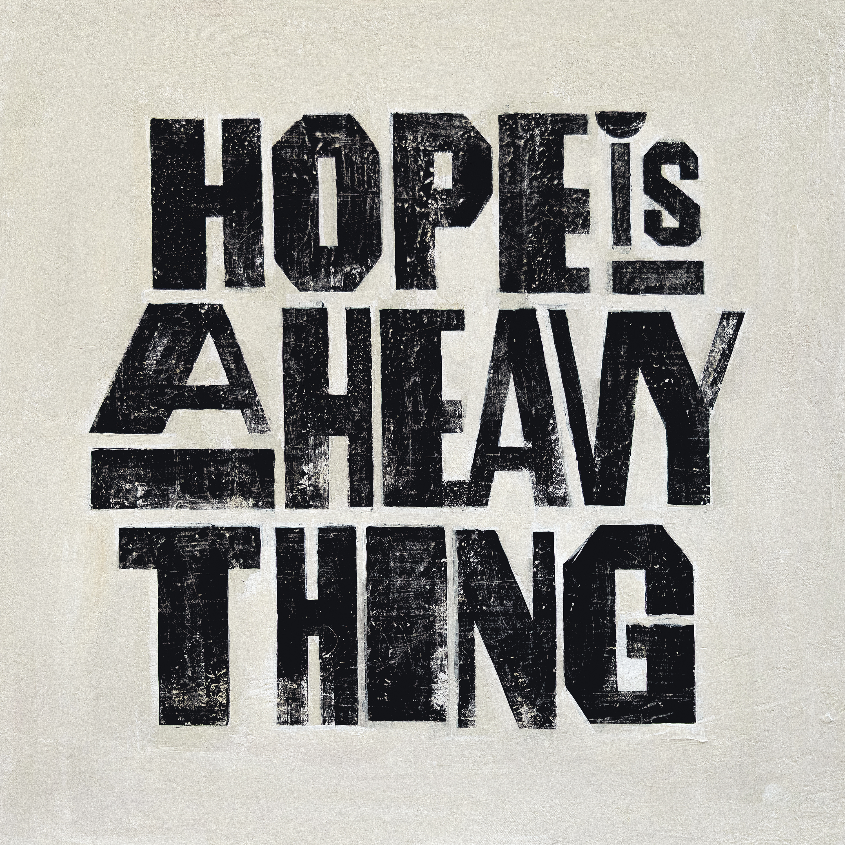
Album artwork
HOPE IS A HEAVY THING TRACK LIST
1. Raised By The Radio (A Reintroduction)
2. Dear Maria
3. Easy Company
4. Kind
5. TOGIAIM
6. Sage (feat. Adekunle Gold)
7. The End Of The World
8. Zombie
9. Toothache
10. Don’t Call Me Baby!
11. Die Young
12. Time Is A River
JOY OLADOKUN CONFIRMED TOUR DATES
October 5—Dallas, TX—State Fair of Texas 2026
October 16—Houston, TX—The Heights Theater
October 17—Austin, TX—Scoot Inn
October 20—Phoenix, AZ—Crescent Ballroom
October 21—San Diego, CA—The Observatory North Park
October 23—Los Angeles, CA—The Bellwether
October 25—San Francisco, CA—Castro Theatre
October 27—Portland, OR—Aladdin Theater
October 29—Vancouver, BC—Hollywood Theatre
October 30—Seattle, WA—Moore Theatre
November 2—Salt Lake City, UT—The Complex – The Grand
November 4—Denver, CO—Paramount Theatre
November 6—Lawrence, KS—The Granada Theater
November 7—St. Paul, MN—Palace Theatre
November 8—Chicago, IL—The Vic Theatre
November 11—Brooklyn, NY—Warsaw Concerts
November 12—Ardmore, PA—Ardmore Music Hall
November 13—Washington, D.C.—Howard Theatre
November 15—Saxapahaw, NC— Haw River Ballroom
November 17—Charlotte, NC—Neighborhood Theatre
November 18—Atlanta, GA—Variety Playhouse
November 19—Nashville, TN—Ryman Auditorium
April 25—Miramar Beach, FL—Moon Crush “Pink Moon” 2027
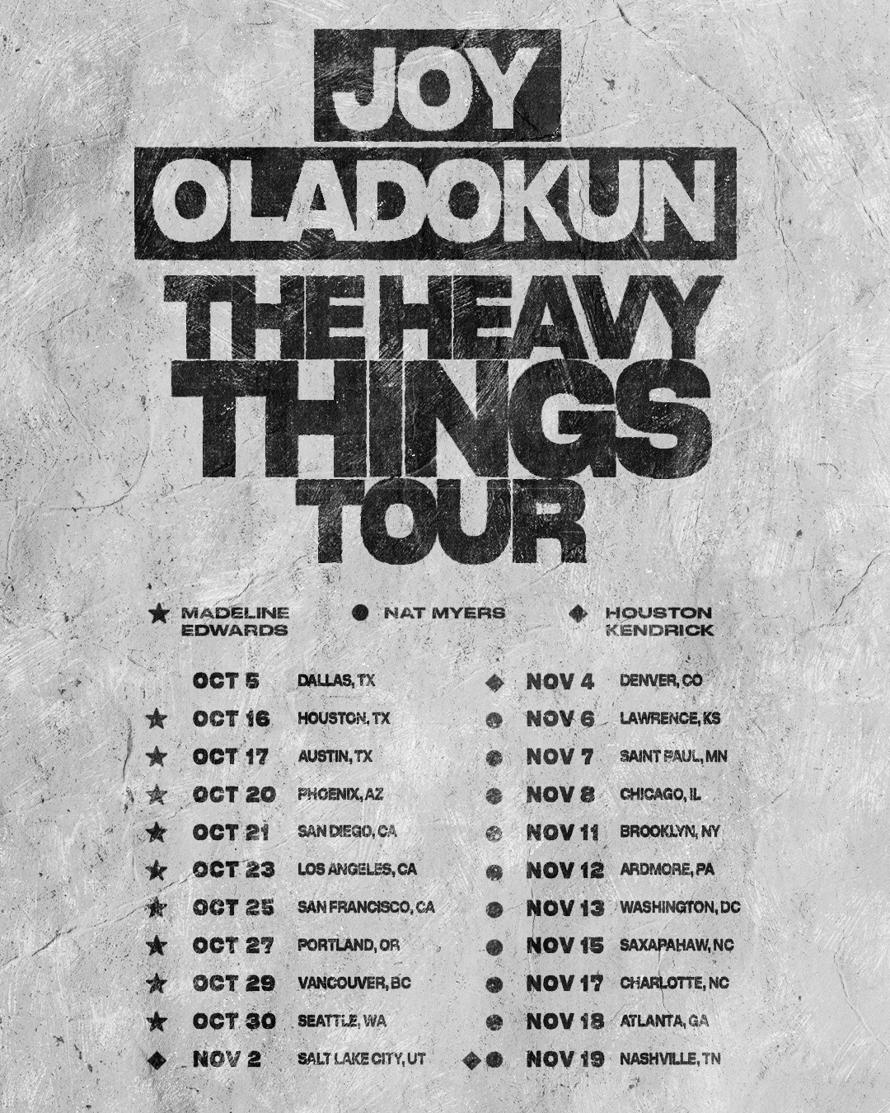
www.joyoladokun.com
For more information, please contact Asha Goodman, Catherine Snead,
Adrienne Harper or Carla Sacks at Sacks & Co., asha.goodman@sacksco.com, catherine.snead@sacksco.com, adrienne.harper@sacksco.com or carla@sacksco.com.

