JOY OLADOKUN RETURNS WITH NEW ALBUM HOPE IS A HEAVY THING ON SEPTEMBER 25, NEW SONG “KIND” OUT TODAY

Press photo credit: Graham Tolbert
July 24, 2026—Acclaimed singer, songwriter, producer and performer Joy Oladokun will release her anticipated new album, Hope Is A Heavy Thing, September 25 via Concord Records. Pre-order/pre-save HERE. Ahead of the release, Oladokun unveils a new song from the project, “Kind,” today—listen HERE.
Produced by Oladokun with additional contributions from Nigerian producer Spellz, the new 12-track project marks a bold new chapter, expanding Oladokun’s sound while continuing to prove her ability to not only bend genres but also to bridge cultures. Across the album, Oladokun explores identity, connection and self-discovery with the emotional honesty that has become a hallmark of her songwriting. In addition to “Kind” and the previously shared track “Zombie,” the album features a collaboration with Nigerian artist Adekunle Gold.
“‘To understand your future you have to confront your past.’ This is the driving theme behind Hope Is A Heavy Thing,” shares Oladokun. “It’s a collection of 12 songs that I wrote to help myself find my light again after burning out. Produced in Nashville, New York, and the back of a speeding tour bus, this album is sonically an homage to all of the music that inspires me. On this record you’ll find music that nods the brilliance of the Soulquarians, the rawness of Bob Dylan, the rhythms of afrobeats, and the sampling prowess of J Dilla. Not to mention a callback to the Ronettes and a few songs that find inspiration in rock and roll protest music of the 60’s and 70’s. You’ll also find me at the most authentic I’ve been able to be as an artist. It is a record I wrote for anyone who finds themselves wondering how to hope in these times. Sometimes it means looking back and digging through the muck to find what’s worth fighting for again.”
Hope Is A Heavy Thing follows Oladokun’s critically acclaimed albums in defense of my own happiness (2021), Proof of Life (2023) and Observations From A Crowded Room (2024), which led NPR Music to call Oladokun “one of the great singer-songwriters pushing beyond roots or conventional singer-songwriter music today.” Additionally, The New York Times praised, “her songs are conversational and confessional, and her hooky but profound melodies turn her lyrics into mantras,” while Consequence declared, “One of the most refreshing voices coming out of Nashville…there’s a deeply honest quality to her music that makes her hard to shake.”
Oladokun is one of today’s most compelling genre-defying voices, using deeply vulnerable songwriting to seamlessly connect folk, soul, pop and rock with striking emotional clarity. A queer Black musician and daughter of Nigerian immigrants, Oladokun has become a vital cultural voice, writing songs that explore identity, faith, mental health, and social justice with honesty and restraint. She earned a nomination for Americana Artist of the Year and her protest anthem, “i see america,” was a finalist for the Recording Academy’s Special Merit Award for Best Song for Social Change. Oladokun has performed on The Late Show with Stephen Colbert, The Tonight Show Starring Jimmy Fallon, Jimmy Kimmel Live!, CBS Saturday Morning’s “Saturday Sessions,” TODAY, PBS’ Austin City Limits and NPR Music’s “Tiny Desk (Home) Concert” series. Widely respected by her peers, Oladokun has collaborated with artists such as Chris Stapleton, Brandi Carlile, Maxo Kream, Jack Antonoff, Jason Isbell and Noah Kahan and has joined Isbell, Kahan, John Mayer, Hozier, My Morning Jacket, Tyler Childers, Pink Sweat$, Leon Bridges and Manchester Orchestra on the road.
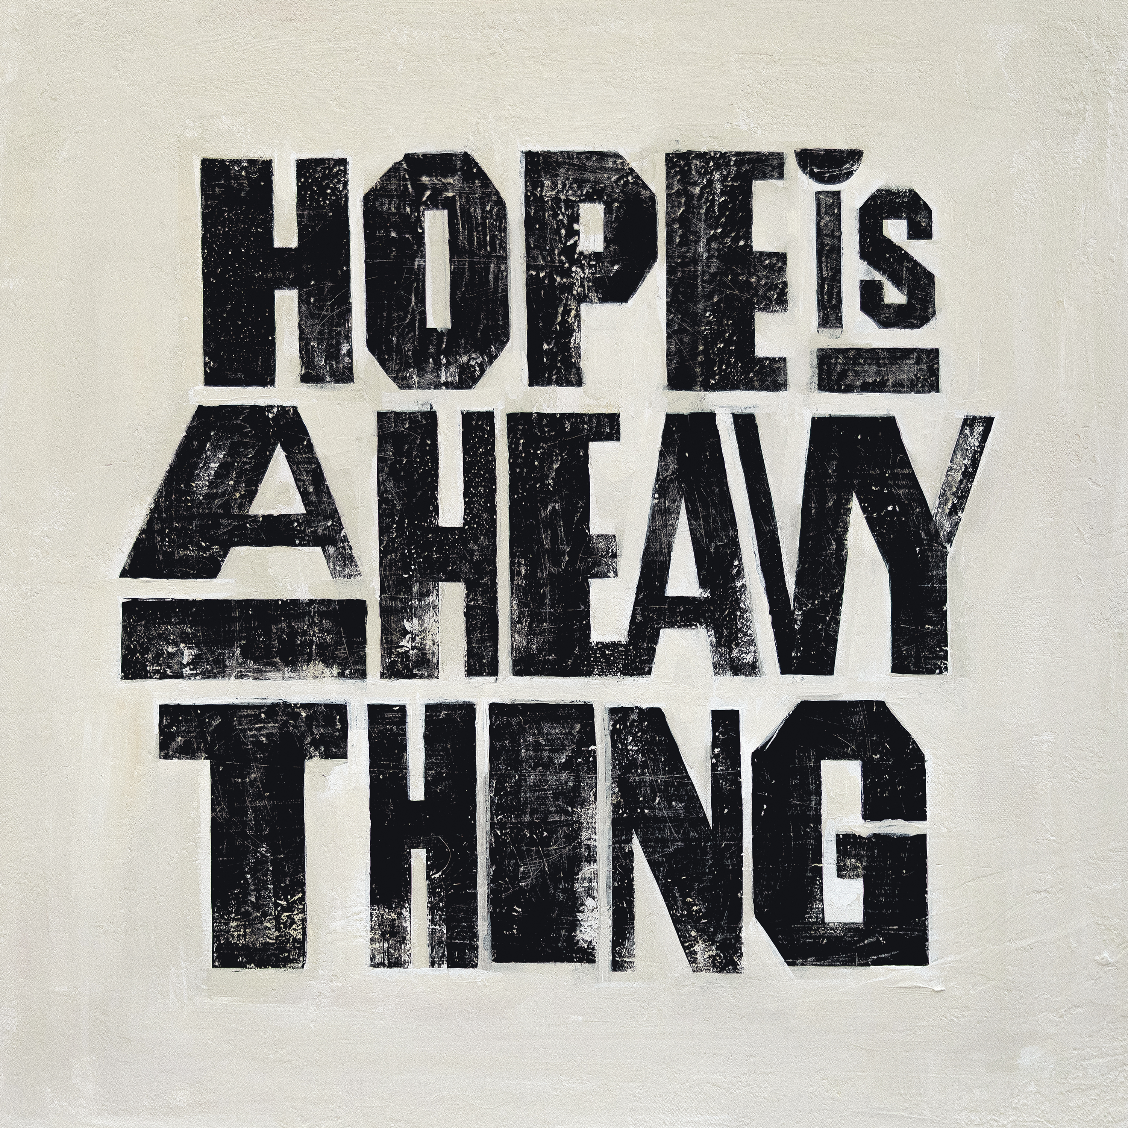
Album artwork
HOPE IS A HEAVY THING TRACK LIST
1. Raised By The Radio (A Reintroduction)
2. Dear Maria
3. Easy Company
4. Kind
5. TOGIAIM
6. Sage (feat. Adekunle Gold)
7. The End Of The World
8. Zombie
9. Toothache
10. Don’t Call Me Baby!
11. Die Young
12. Time Is A River
JOY OLADOKUN CONFIRMED TOUR DATES
August 15—Nashville, TN—Grand Ole Opry House
August 28—Portland, OR—Topaz Farm
October 5—Dallas, TX—State Fair of Texas 2026
April 23—Miramar Beach, FL—Seascape Resort
April 25—Miramar Beach, FL—Moon Crush
www.joyoladokun.com
For more information, please contact Asha Goodman, Catherine Snead,
Adrienne Harper or Carla Sacks at Sacks & Co., asha.goodman@sacksco.com, catherine.snead@sacksco.com, adrienne.harper@sacksco.com or carla@sacksco.com.

