DANA AND ALDEN SHARE NEW SINGLE “GOOD KID”

PAPA’S BOAT OUT AUGUST 14TH VIA CONCORD JAZZ

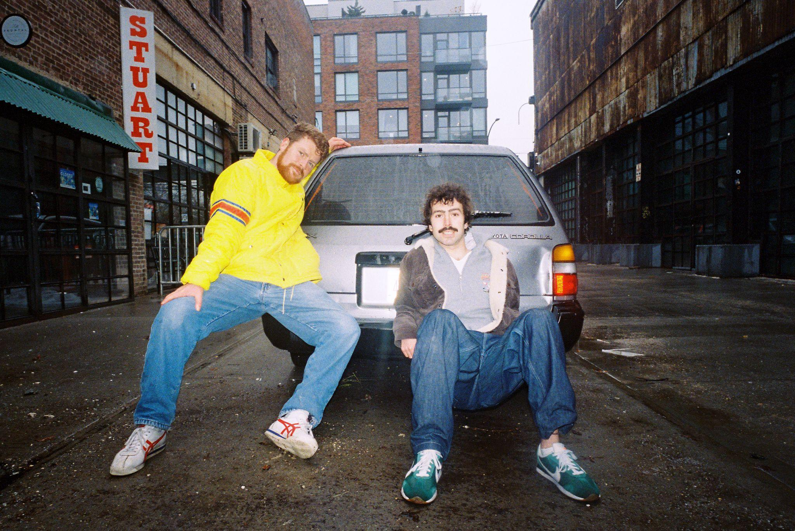
Dana and Alden by Robb Klassen (Download Hi-Res Assets HERE)

“Good Kid”
WATCH: https://i.concordjazz.com/dana-alden-ytgoodkid

LISTEN: https://ffm.to/dana-alden-papasboat

Papa’s Boat
PRE-SAVE/PRE-ORDER: https://ffm.to/dana-alden-papasboat

(May 15, 2026) - Oregon-born, Brooklyn-based brother duo Dana and Alden share their new single “Good Kid”. The second offering from their forthcoming new album Papa’s Boat, the new song introduces the first hint of Alden’s vocals on the album with a shimmering, subdued proclamation of budding young love. “Good Kid” adds another gust of wind in the sails of Papa’s Boat following the album’s lead single “Lee’s Greenhouse”, which featured friend and collaborator Mei Semones.

Dana and Alden’s new album is informed by lessons taken from the life of their beloved late maternal grandfather, Papa. An avid sailor and world traveler, the duo infuse his spirit and sounds from the various locales of his travels into Papa’s Boat. The result, is a personal ode to a dear member of their family, but also a universally resonant body of work that makes his spirit and zest for life everpresent.

Papa’s Boat was recorded across London, New York and Brazil, with the duo taking musical cues from each of the album’s spiritual homes. With the guidance of Yussef Dayes, Gilles Peterson and Marcos Valle on their recording trips, the duo infused the various soundscapes of their travels into an eclectic musical concoction that draws elements from indie rock, samba, bossa nova, jazz, rap, pop and more. The album was made with the duo’s backing band, all of whom were key collaborators and producers on Papa’s Boat: Andrew Mitchell on bass, Ebba Dankel on vocals and keys, Eli Torgersen on vocals and guitar, and Salim Charvet on sax and synths. The album was masterfully engineered by Malcolm Catto at his Quatermass Sound Lab studio in Dalston.

Speaking of what it meant to work with Marcos Valle, Dana says: “He has been one of our musical heroes since we were 12 years old. We worked on this apple orchard in Oregon for this farmer named Tom, who was obsessed with Brazilian music and Marcos Valle. He would just ride around on his tractor every day and come back and show us the new albums he had found. Both of the songs are really just a dream come true.”

That globe-trotting collection of influences gets woven into a tight-knight musical community on Papa’s Boat, with the duo prioritizing tactile connection and leaning on teachings of friends to further expand their musical knowledge. Led by the jazz prowess of Dana’s saxophone and Alden’s drums, the album features a cadre of musician friends new and familiar, including Brazilian legend Marcos Valle, Melanie Charles, Mei Semones, Zaza Desiderio, Cinya Khan, Mirella Costa and many more.

Listen to “Good Kid” above, see below for more information on Papa’s Boat and stay tuned for more from Dana and Alden coming soon.

Upcoming Dana and Alden Live Dates:

7/31-8/2 - Newport, RI @ Newport Jazz Festival
8/7 - Katowice, Poland @ OFF Festival

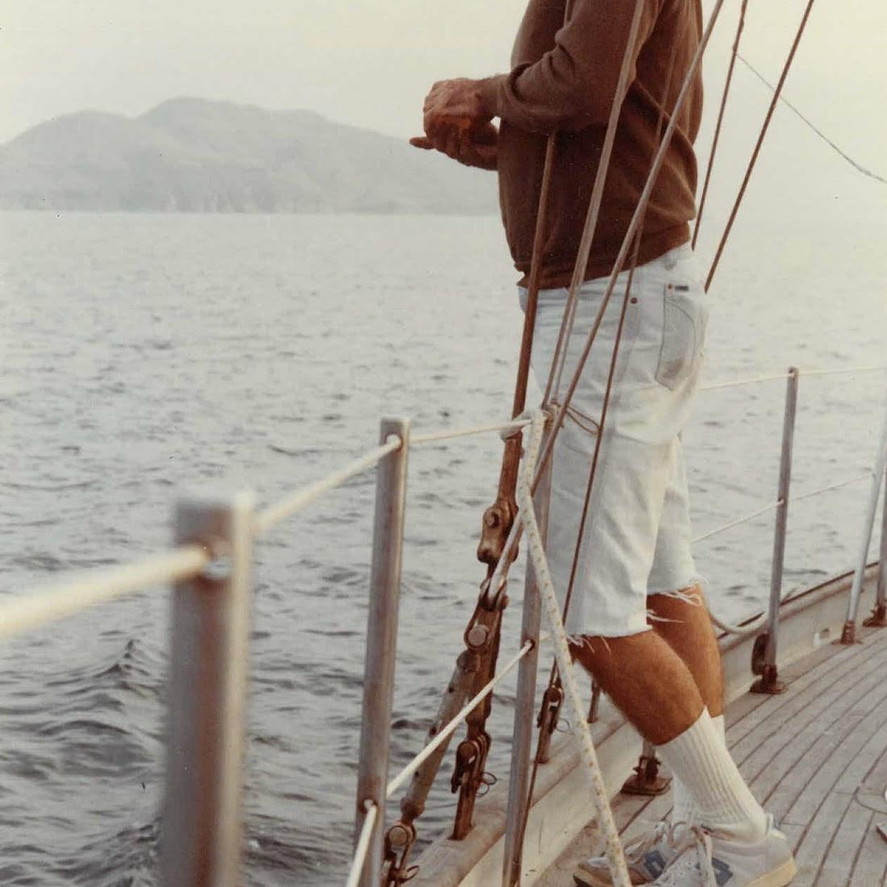
Dana and Alden
Papa’s Boat
August 14, 2026
Concord Jazz

1. Lighthouse (feat. EBBA)
2. Trick Dog (feat. Eli Torg)
3. Summer Nights
4. Napa 86
5. Friendship is a Boat (feat. Marcos Valle)
6. Milk and Honey (feat. Melanie Charles)
7. A Lullaby Flew Through My Window
8. Lee’s Greenhouse (feat. Mei Semones)
9. My Normal Life
10. North Star
11. Inthistogether (feat. Cinya Khan)
12. Good Kid
13. El Gaucho (feat. Marcos Valle, Mirella Costa and Zaza Desiderio)
14. Randy
15. A Broken Cup (feat. Melanie Charles)

(Download Hi-Res Assets HERE)

Connect with Dana and Alden:
Facebook | Instagram | TikTok | Website | YouTube |

For all Dana and Alden press inquiries, please contact Kevin at Orienteer
kevin@orienteer.us

