DANA AND ALDEN ANNOUNCE NEW ALBUM PAPA’S BOAT
OUT AUGUST 14TH VIA CONCORD JAZZ

SHARE LEAD SINGLE & MUSIC VIDEO “LEE’S GREENHOUSE”
FEATURING MEI SEMONES

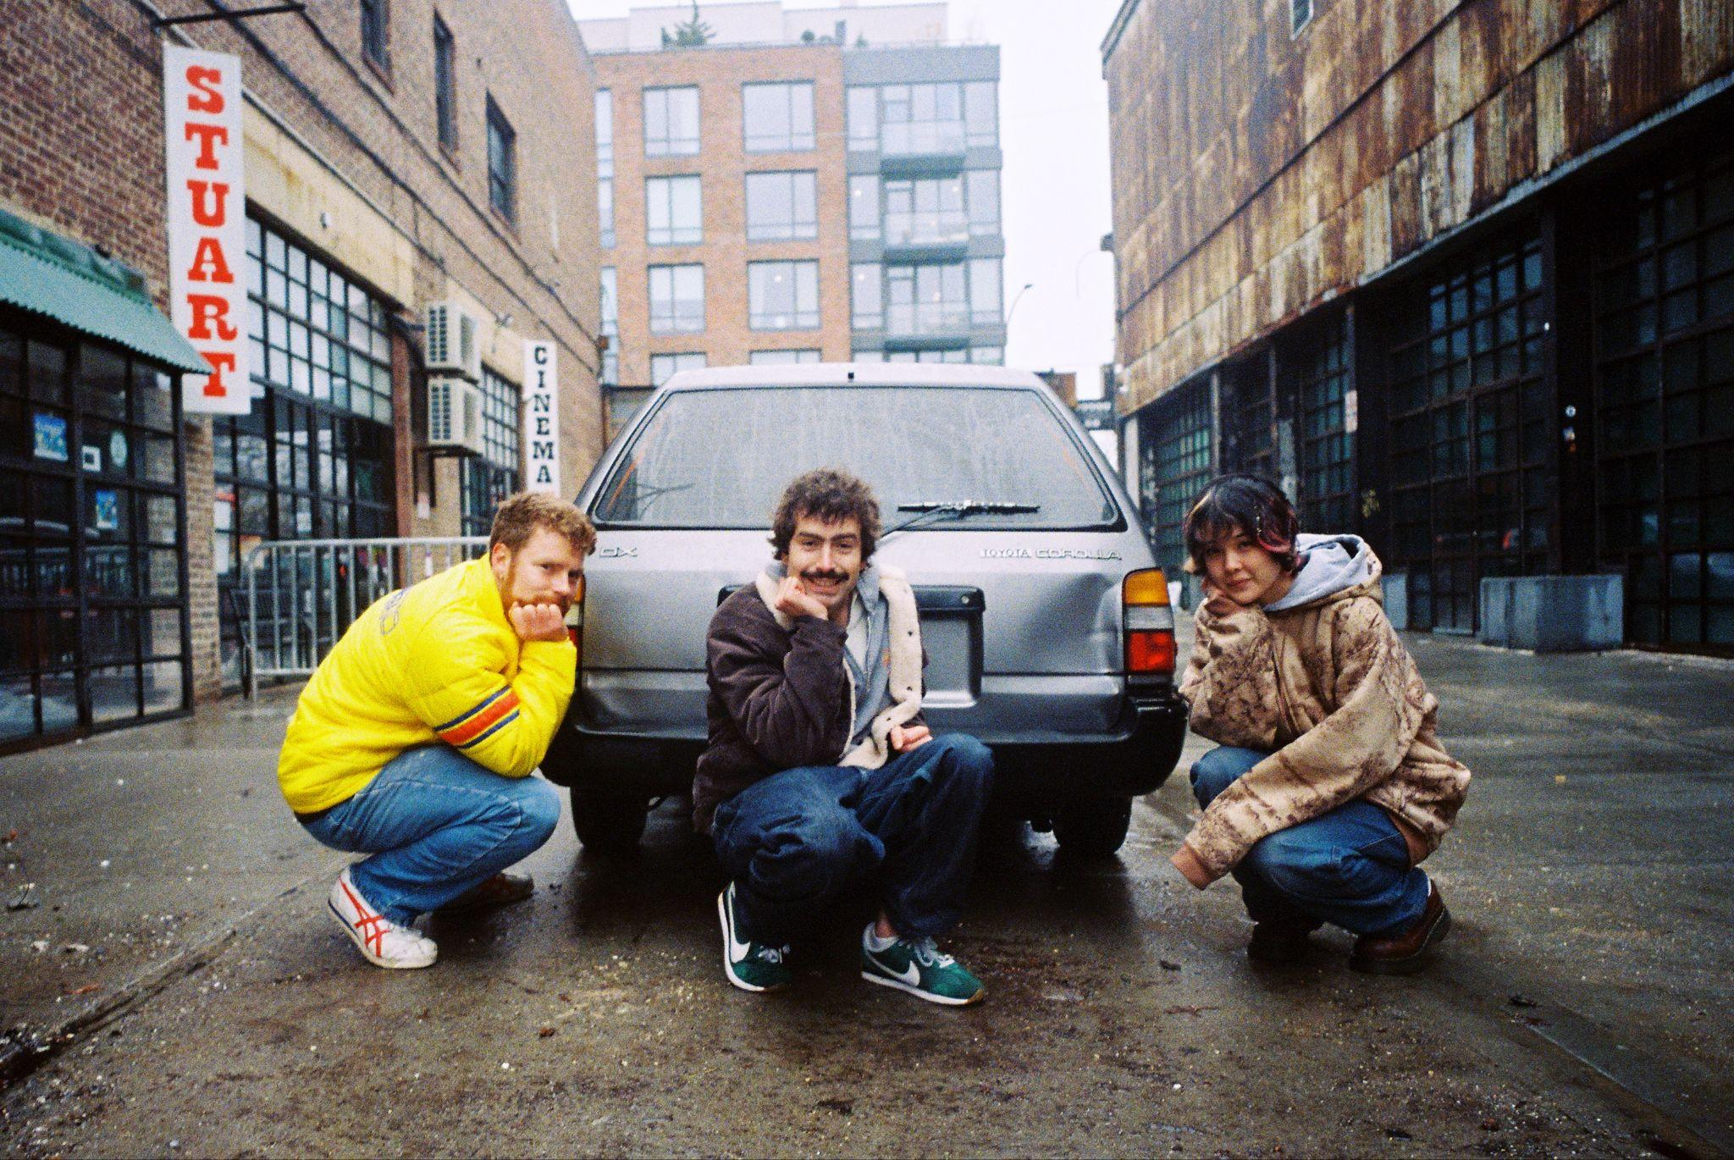
Dana & Alden and Mei Semones by Robb Klassen (Download Hi-Res Assets HERE)

“Lee’s Greenhouse” (feat. Mei Semones)
WATCH:
LISTEN: https://ffm.to/dana-alden-papasboat

Papa’s Boat
LISTEN: https://ffm.to/dana-alden-papasboat

(April 24, 2026) - Following its cheeky unveiling on social media last week, Oregon-born, Brooklyn-based brother duo Dana and Alden officially announce their new album Papa’s Boat, out August 14th via Concord Jazz, and share the project’s lead single. “Lee’s Greenhouse”, the first offering from the new album, features genre-bending savant Mei Semones and opens up this free-wheeling new musical chapter for Dana and Alden.

“Lee’s Greenhouse” is an agile jazz instrumental track dotted with flares of Brazilian samba rhythms and Semones’ soft vocals that serves as an introduction to the expansive global footprint of Papa’s Boat. In true Dana & Alden fashion, the song speaks to the wistful, spontaneous experiences the duo have had when approaching the world with an open heart. “Lee’s Greenhouse” is an ode to an eccentric, kombucha-fueled farmer named Lee that Dana met while working as an organic farm inspector in Oregon.

Named endearingly after their late maternal grandfather, Dana and Alden’s new album is imbued with their Papa’s wanderlust spirit as it musically traverses the places he traveled, memorializes moments from his life and channels his eclecticism. Papa’s Boat was recorded across London, New York and Brazil, with the duo taking musical cues from each of the album’s spiritual homes. With the guidance of Yussef Dayes, Gilles Peterson and Marcos Valle on their recording trips, the duo infused the various soundscapes of their travels into an eclectic musical concoction that draws elements from indie rock, samba, bossa nova, jazz, rap, pop and more. The album was made with the duo’s backing band, all of whom were key collaborators and producers on Papa’s Boat: Andrew Mitchell on bass, Ebba Dankel on vocals and keys, Eli Torgersen on vocals and guitar, and Salim Charvet on sax and synths. The album was masterfully engineered by Malcolm Catto at his Quatermass Sound Lab studio in Dalston.

That globe-trotting collection of influences gets woven into a tight-knight musical community on Papa’s Boat, with the duo prioritizing tactile connection and leaning on teachings of friends to further expand their musical knowledge. Led by the jazz prowess of Dana’s saxophone and Alden’s drums, the album features a cadre of musician friends new and familiar, including Brazilian legend Marcos Valle, Melanie Charles, Mei Semones, Zaza Desiderio, Cinya Khan, Mirella Costa and many more. Thematically, Papa’s Boat simultaneously commemorates the life of Dana and Alden’s ‘Papa’ as an influential figure and guiding light in the duo’s lives, while also capturing his lust for life in this record, channeling it into a universal experience to be shared.

“I think so much of what Alden and I are doing comes from just watching him live his own unique life.” Alden explains about his grandfather. “His emboldened, passionate personality gave us permission to be our own selves, to be unconventional and draw outside of the box.”

Dana and Alden McWayne, the brother duo, grew up enthralled with the music and endearing free spirited lifestyle that surrounded them in Eugene, Oregon. They first made music together as a duo with their 2021 debut EP Brothers, which led to the breakout success of viral track “Let’s Go to Trader Joe’s (featuring Cinya Khan)” on 2023’s Quiet Music for Young People. Last year, the band toured with Remi Wolf across the US, including a historic date at Colorado’s Red Rocks Amphitheatre, ahead of the release of their 2025 project Speedo. This summer, Dana and Alden will be playing Newport Jazz Festival in Rhode Island and OFF Festival in Poland, with more live dates to come later this year.

Listen to “Lee’s Greenhouse” featuring Mei Semones above, see below for more information on Papa’s Boat and stay tuned for more from Dana and Alden coming soon.

Upcoming Dana and Alden Live Dates:

7/31-8/2 - Newport, RI @ Newport Jazz Festival
8/7 - Katowice, Poland @ OFF Festival

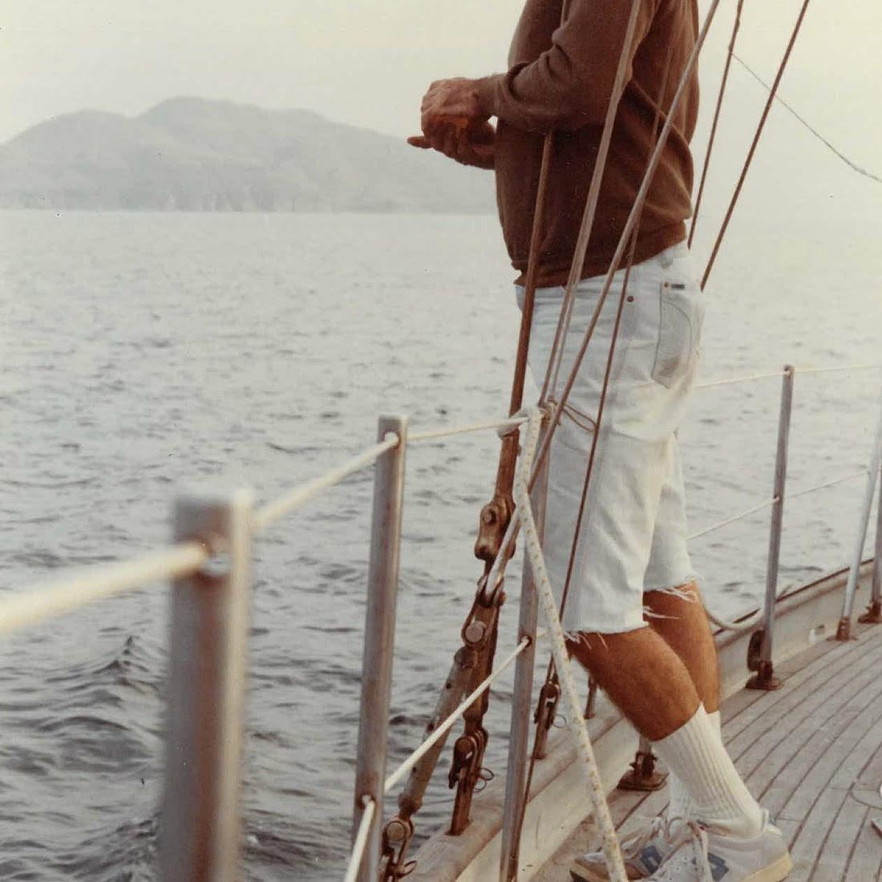
Dana and Alden
Papa’s Boat
August 14, 2026
Concord Jazz

1. Lighthouse (feat. EBBA)
2. Trick Dog (feat. Eli Torg)
3. Summer Nights
4. Napa 86
5. Friendship is a Boat (feat. Marcos Valle)
6. Milk and Honey (feat. Melanie Charles)
7. A Lullaby Flew Through My Window
8. Lee’s Greenhouse (feat. Mei Semones)
9. My Normal Life
10. North Star
11. Inthistogether (feat. Cinya Khan)
12. Good Kid
13. El Gaucho (feat. Marcos Valle, Mirella Costa and Zaza Desiderio)
14. Randy
15. A Broken Cup (feat. Melanie Charles)

(Download Hi-Res Assets HERE)

Connect with Dana and Alden:
Facebook | Instagram | TikTok | Website | YouTube |

For all Dana and Alden press inquiries, please contact Kevin at Orienteer
kevin@orienteer.us

