Watch GREEN SCREEN (1PM) HERE

May 29th, 2026
FOR IMMEDIATE RELEASE
judy@motormouthmedia.com
humbert@motormouthmedia.com

CAUTIOUS CLAY
ANNOUNCES NEW ALBUM
THE HOURS: HIGH NOON
OUT 7/31 VIA CONCORD
PRE-ORDER/PRE-SAVE HERE

SHARES LEAD SINGLE AND VIDEO
“GREEN SCREEN (1PM)”
WATCH HERE

Credit: Travys Owen, Hi-Res HERE

Musician Cautious Clay announces his new album, The Hours: High Noon, coming July 31st on Concord, marking the end to his Hours series that began in 2025. “Green Screen (1PM),” the lead single and opening song on the album, comes out today with an accompanying music video directed by Travys Owen.

The High Noon chapter captures a period of growth for Cautious Clay, both personally and artistically. One can hear both the maturity and sonic shift in “Green Screen (1PM).” Draped in a reggae beat and newfound wisdom, Cautious rolls with the punches and a pep in his step. Life is seen not as a great unknown but as a wealth of possibility, a canvas (or green screen) upon which a person may map out their own style, journey, and meaning. It’s the type of sage advice that comes with life lived, something that comes with time.

“The Hours: High Noon is a conclusion to the Hours album saga,” explains Cautious. “It feels like a middle ground between morning and night, sonically. I wanted to branch into reggae and some downtempo stuff with this album, which felt really refreshing for me to explore.”

The sunny disposition in “Green Screen (1PM)” warms the rest of The Hours: High Noon, a record rooted in emotional maturity, self-reflection, and sonic exploration. Cautious delves further into himself here, able to discuss frustrating situations (misaligned relationships) alongside unconventional ones (open relationships) with candor and candy-sweet hooks.

Expanding on the world introduced throughout the Hours series, the album finds Cautious embracing a warmer, more lived-in sound while continuing to refine his genre-blurring approach. His songwriting remains introspective and deeply human, balancing vulnerability with optimism as he moves towards a new creative chapter. The Hours may mark the end of one story, but it begins another for Cautious Clay.

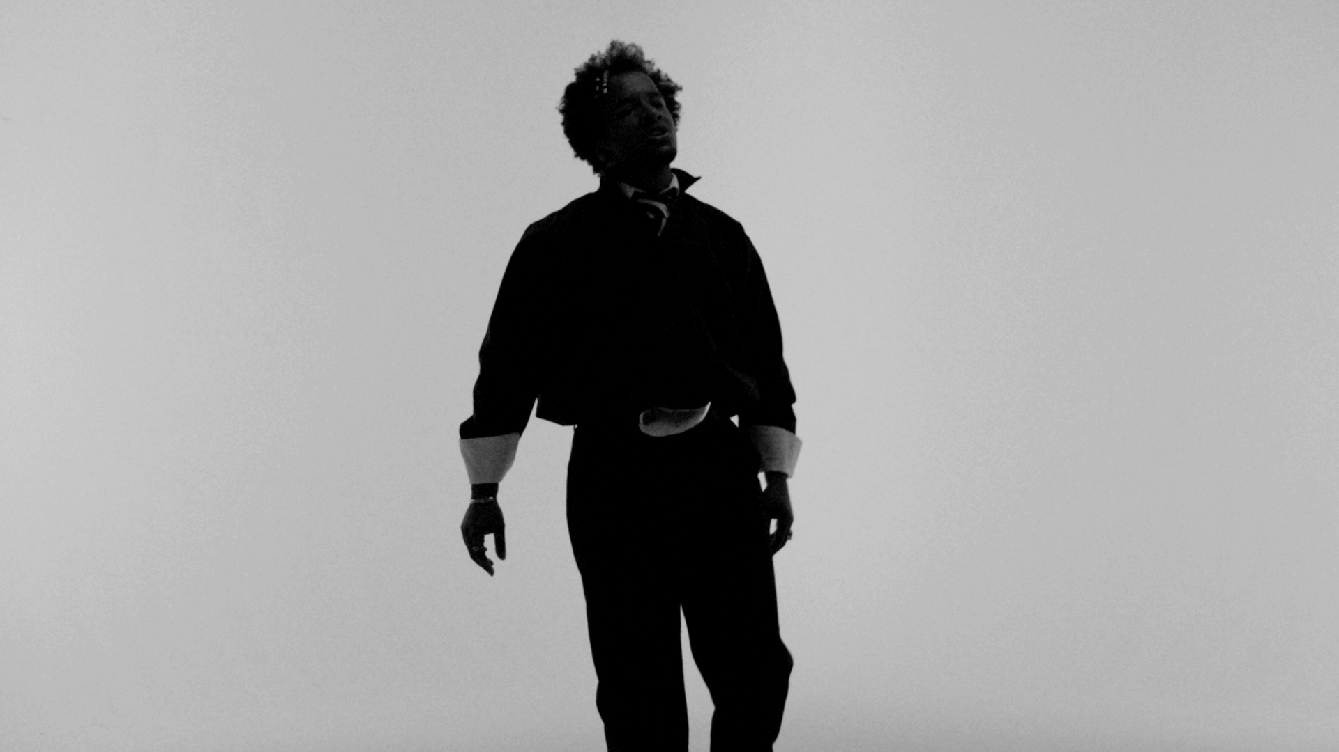

Last Spring, Cautious Clay kicked off this series with The Hours: Morning, a conceptual eight-track project equal parts mixtape and emotive timetable, exploring the feeling, color, and emotional landscape of each morning hour. Created after a move to Philly and an evolution of Cautious’ creative process, the project transcends genre and blends pop precision with elements of alternative R&B, jazz, and indie rock with open-ended reflection. It marks a fresh chapter for the genre-blending artist, following the success of his jazz-infused album KARPEH. From the calm of dawn to the energy of late morning, The Hours: Morning showcases Cautious’ versatility and evolving sound. Cautious followed up that album in Fall 2025 with The Hours: Night, which kicked up the tempo with its funk-infused sound including a collaboration with Q-Tip and Raphael Saadiq on “5th Floor (10pm)”. Less clear-eyed than Morning, Night tackles the unpredictability and uncertainty of the evening. Together, The Hours: Morning and The Hours: Night sketch two interconnected portraits of time: daylight measured against moonlight, order against freedom, routine against spontaneity. The true challenge for him came with High Noon, which refers to a time of day that Cautious finds “nebulous” in its atmosphere.

Beyond his own artistry, Cautious has established himself as a highly sought-after songwriter and producer, collaborating with Billie Eilish, John Mayer, John Legend, Khalid, Kavinsky, Melanie Martinez, Remi Wolf, and most recently, Tycho. Following the release of his acclaimed EPs Resonance and Table of Context, he delivered his full-length 2021 debut Deadpan Love, a nuanced exploration of the complexities of human connection that earned him praise from The New York Times, Rolling Stone, The Fader, PAPER, and more. With his 2023 album KARPEH, Cautious reached new artistic heights, delivering a more intentional and sonically rich project. This bold evolution offered an intimate portrayal of his journey, his past, and his family life, solidifying his place as a singular voice in modern music and one to watch.

Preorder/save The Hours: High Noon HERE
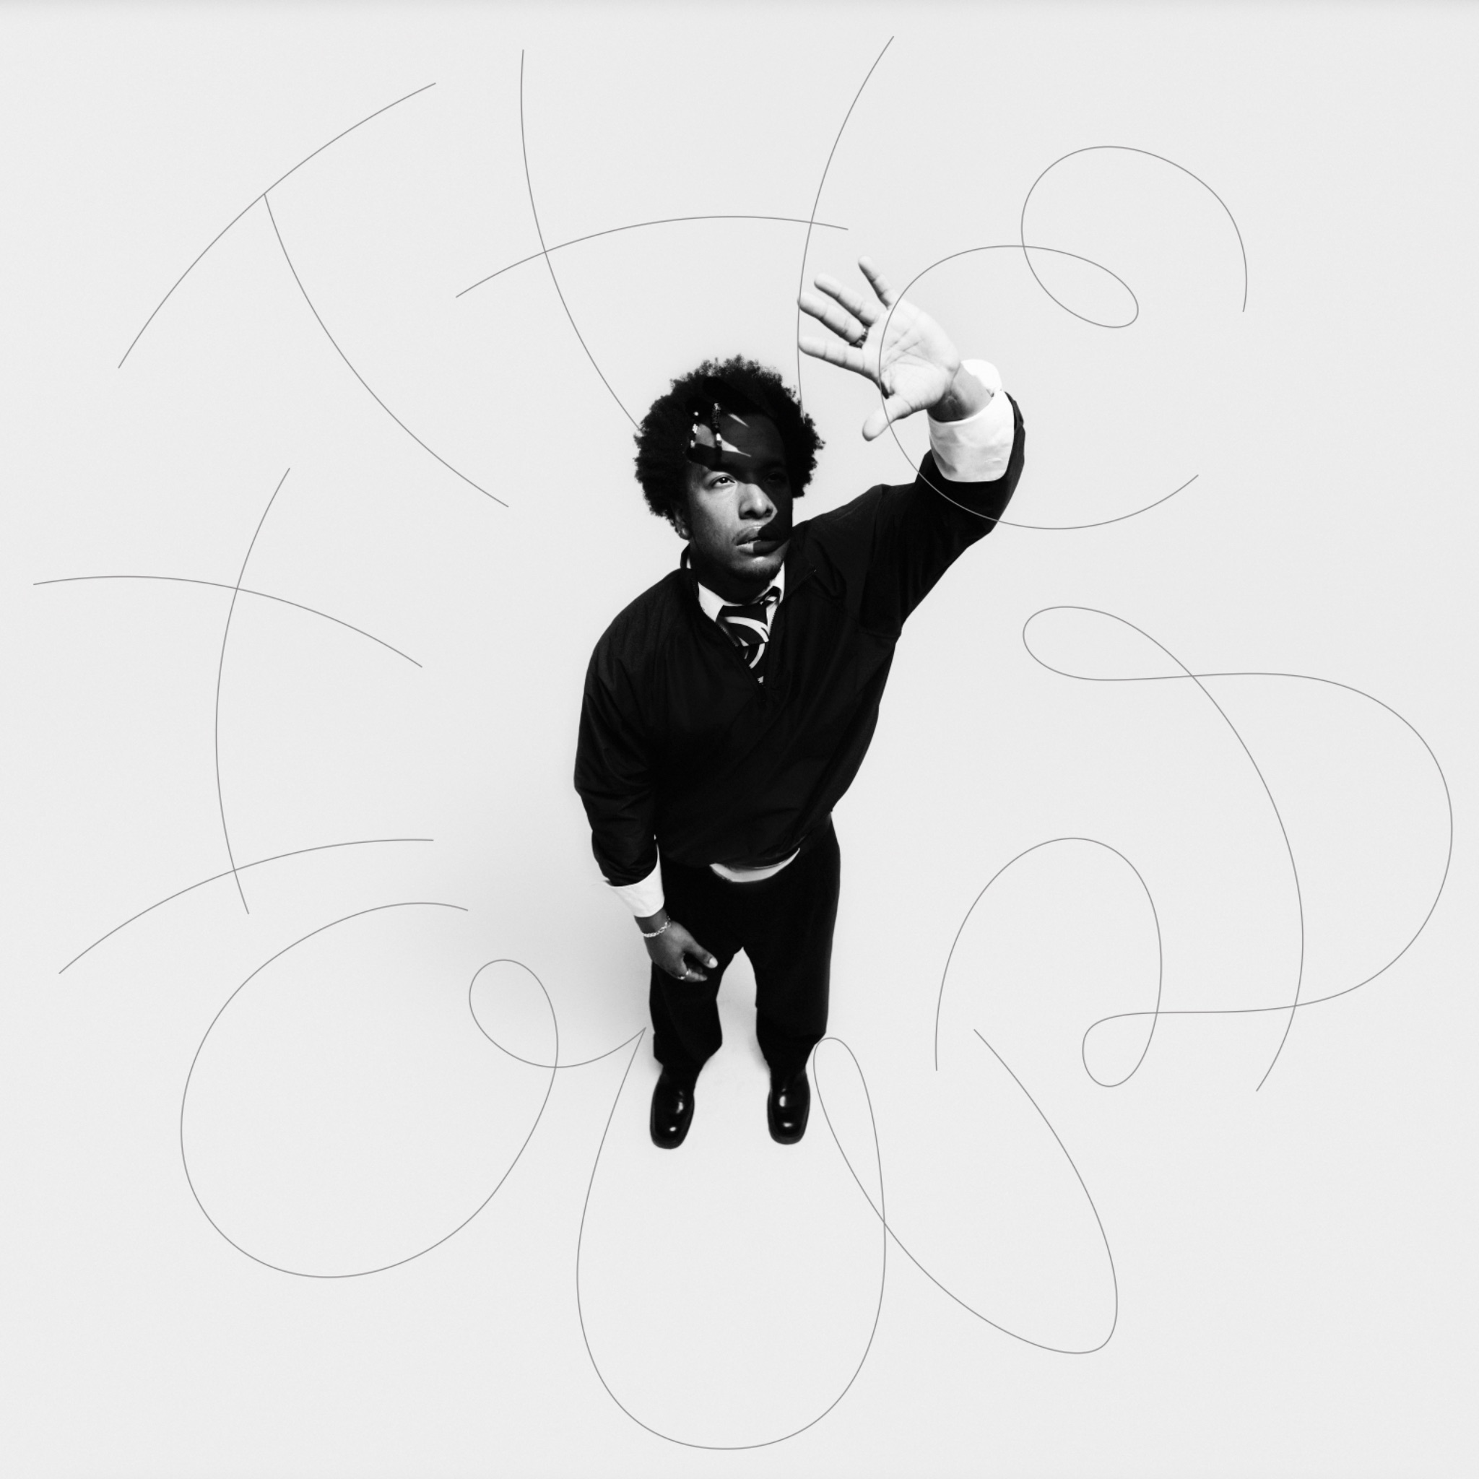
Hi-Res HERE

CAUTIOUS CLAY ONLINE
INSTAGRAM | TIKTOK | X | FACEBOOK | YOUTUBE | WEBSITE

