July 31, 2026
FOR IMMEDIATE RELEASE
judy@motormouthmedia.com
humbert@motormouthmedia.com
CAUTIOUS CLAY
RELEASES NEW ALBUM
THE HOURS: HIGH NOON
OUT NOW VIA CONCORD RECORDS

SHARES FOCUS TRACK AND VIDEO
“TRAIL MIX (3PM)”

+ JOINS JON BATISTE AS A SPECIAL GUEST PERFORMER IN NEW YORK ON AUGUST 15TH

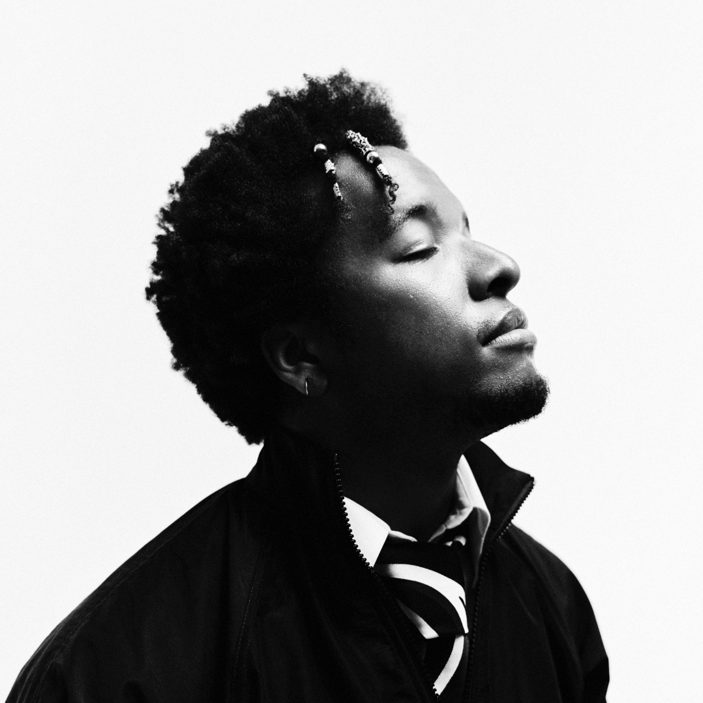
Credit: Travys Owen, Hi-Res HERE

Today, acclaimed musician, songwriter and producer Cautious Clay releases his new album, The Hours: High Noon, via Concord Records. The eight-track project is the final chapter in his Hours trilogy, completing the arc that began with The Hours: Morning and continued with The Hours: Night in 2025.
Alongside the album, Cautious shares focus track “Trail Mix (3pm),” a warm, playful exploration of being physically open to multiple people while remaining emotionally and spiritually aligned with one person. Embracing connection in all its forms, the song embodies the “spice of life” while recognizing the singular bond at its center.
The accompanying visual directed by frequent collaborator Haoyan Of America, extends the song’s reflection on the detours and uncertainty that come with sustaining a lasting relationship, unfolding through a surreal, warped and dreamlike lens. As every path leads back to the same place, it mirrors the track’s realization that sometimes you have to settle into what’s meant to be.
“This song is honestly about the feeling of being physically open with multiple people but emotionally and spiritually aligned with an individual person,” Cautious shares. “Truly embodying the spice of life.”
Where Morning found beauty in structure and clarity and Night ventured into darker, freer and more fluid territory, High Noon arrives at the center–warmer, more grounded and reflective. Across the album, Cautious captures the uncomfortable but illuminating space between certainty and the unknown, exploring growth, perspective, emotional maturity and the ongoing search for balance.
“‘The Hours: High Noon’ is a conclusion to the ‘Hours’ album saga,” explains Cautious. “Midday is a nebulous time, so making songs for that felt challenging, and it took me a bit more time to address sonically. These songs are generally more laid-back and downtempo, with some reggae influences.”
Blending the alternative R&B, jazz, indie and soul influences that have defined Cautious’ work with reggae-tinged rhythms and downtempo textures, High Noon represents both a natural conclusion and a subtle sonic shift. The album’s warm melodies and easy movement belie its emotional complexity as Cautious examines relationships, uncertainty and the lessons that only arrive through experience.
The album opens with lead single “Green Screen (1pm),” a breezy, reggae-inflected meditation on life’s possibilities and the freedom to shape one’s own path. Rather than treating the future as something to fear, Cautious approaches it as a blank canvas—a green screen onto which we can project our own journey, identity and meaning.
Recent single “Ivy (2pm)” enters more uneasy territory, using poison ivy as a metaphor for a relationship that feels misaligned and impossible to shake. Against the track’s midsummer warmth, Cautious confronts betrayal, establishes firm boundaries and finally chooses distance: “Grow on somebody else / it won’t be me.”
Throughout High Noon, Cautious approaches interpersonal friction with equal parts honesty and care. “Red Blossom (5pm)” wrestles with the complications of human connection, while “The Light (4pm)” captures moments of second-guessing and “Wave Chaser (6pm)” sits within the uncertainty of a new crush. Closing tracks “Mood Swing (7pm)” and “Shadow of a Doubt (8pm)” carry the story toward evening, bringing the trilogy full circle.
Cautious introduced the series with The Hours: Morning, a conceptual eight-track project that functioned as both mixtape and emotive timetable, exploring the feeling, color and emotional landscape of each morning hour. He followed with "The Hours: Night, a darker and more spontaneous collection shaped by ambient textures, neo-soul and experimental R&B and featuring “5th Floor (10pm),” a collaboration with Q-Tip and Raphael Saadiq. Together, the three projects trace the shifting moods of a day while reflecting a larger personal and creative evolution.
Next month, Cautious will join Jon Batiste for Songs for Hope and Change, a special benefit performance taking place August 15th at New York’s Forest Hills Stadium in support of Make-A-Wish America and the Louis Armstrong House Museum. The event will also feature Ingrid Silva, Matteo Bocelli and Nick Waterhouse, with Anthony Parnther conducting the ensemble.
Beyond his own artistry, Cautious Clay has established himself as a highly sought-after songwriter and producer, collaborating with Billie Eilish, John Mayer, John Legend, Khalid, Kavinsky, Melanie Martinez, Remi Wolf, Tycho, etc. Following the acclaimed EPs Resonance and Table of Context, he released his full-length debut, Deadpan Love, in 2021, earning praise from The New York Times, Rolling Stone, The FADER, PAPER and more. His jazz-infused 2023 album KARPEH offered an intimate portrait of his history, family and evolution, further establishing him as a singular voice in modern music.
With The Hours: High Noon, Cautious closes out the Hours trilogy while setting the stage for what’s next.

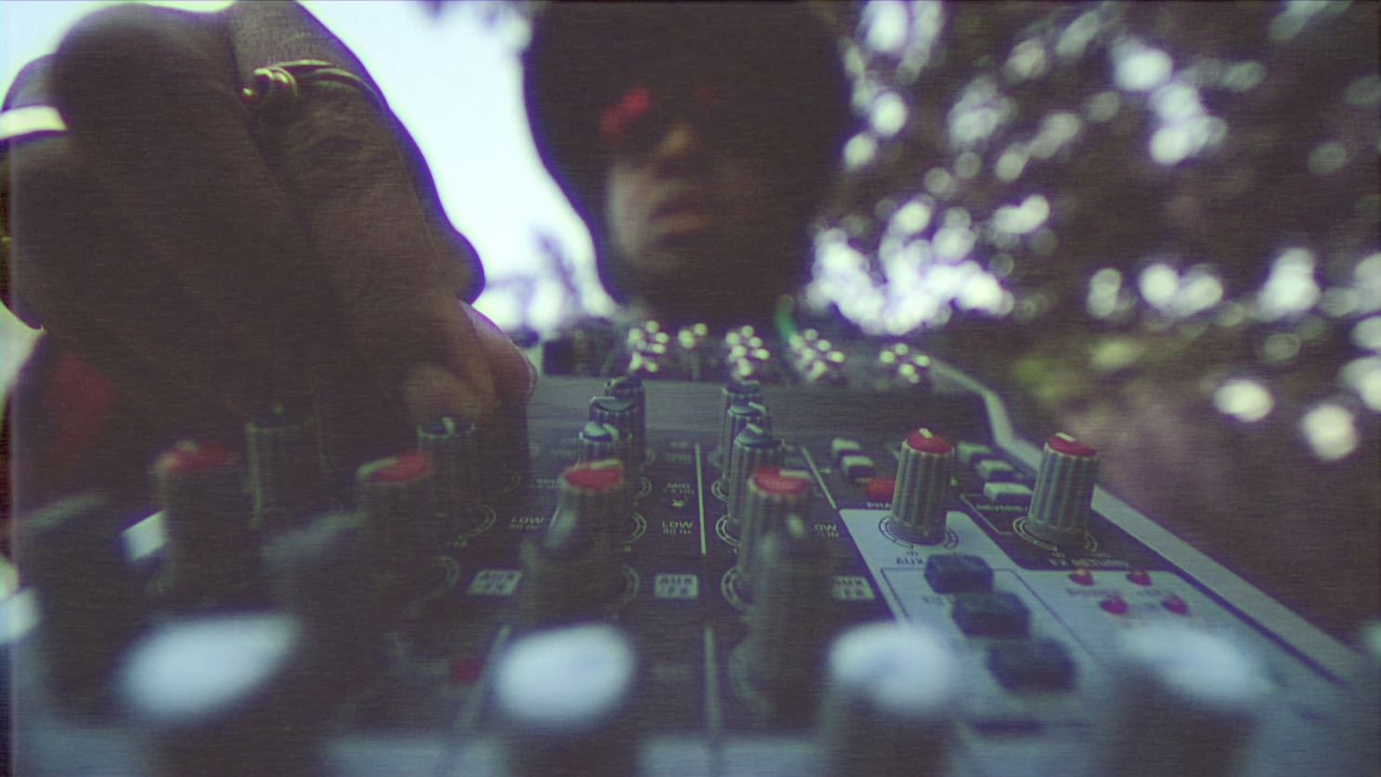
Hi-Res HERE

WATCH THE VIDEO FOR “TRAIL MIX (3PM)”
http://i.cautiousclay.com/trailmixomv

STREAM/PURCHASE THE HOURS: HIGH NOON
https://i.cautiousclay.com/cc-thehourshighnoon

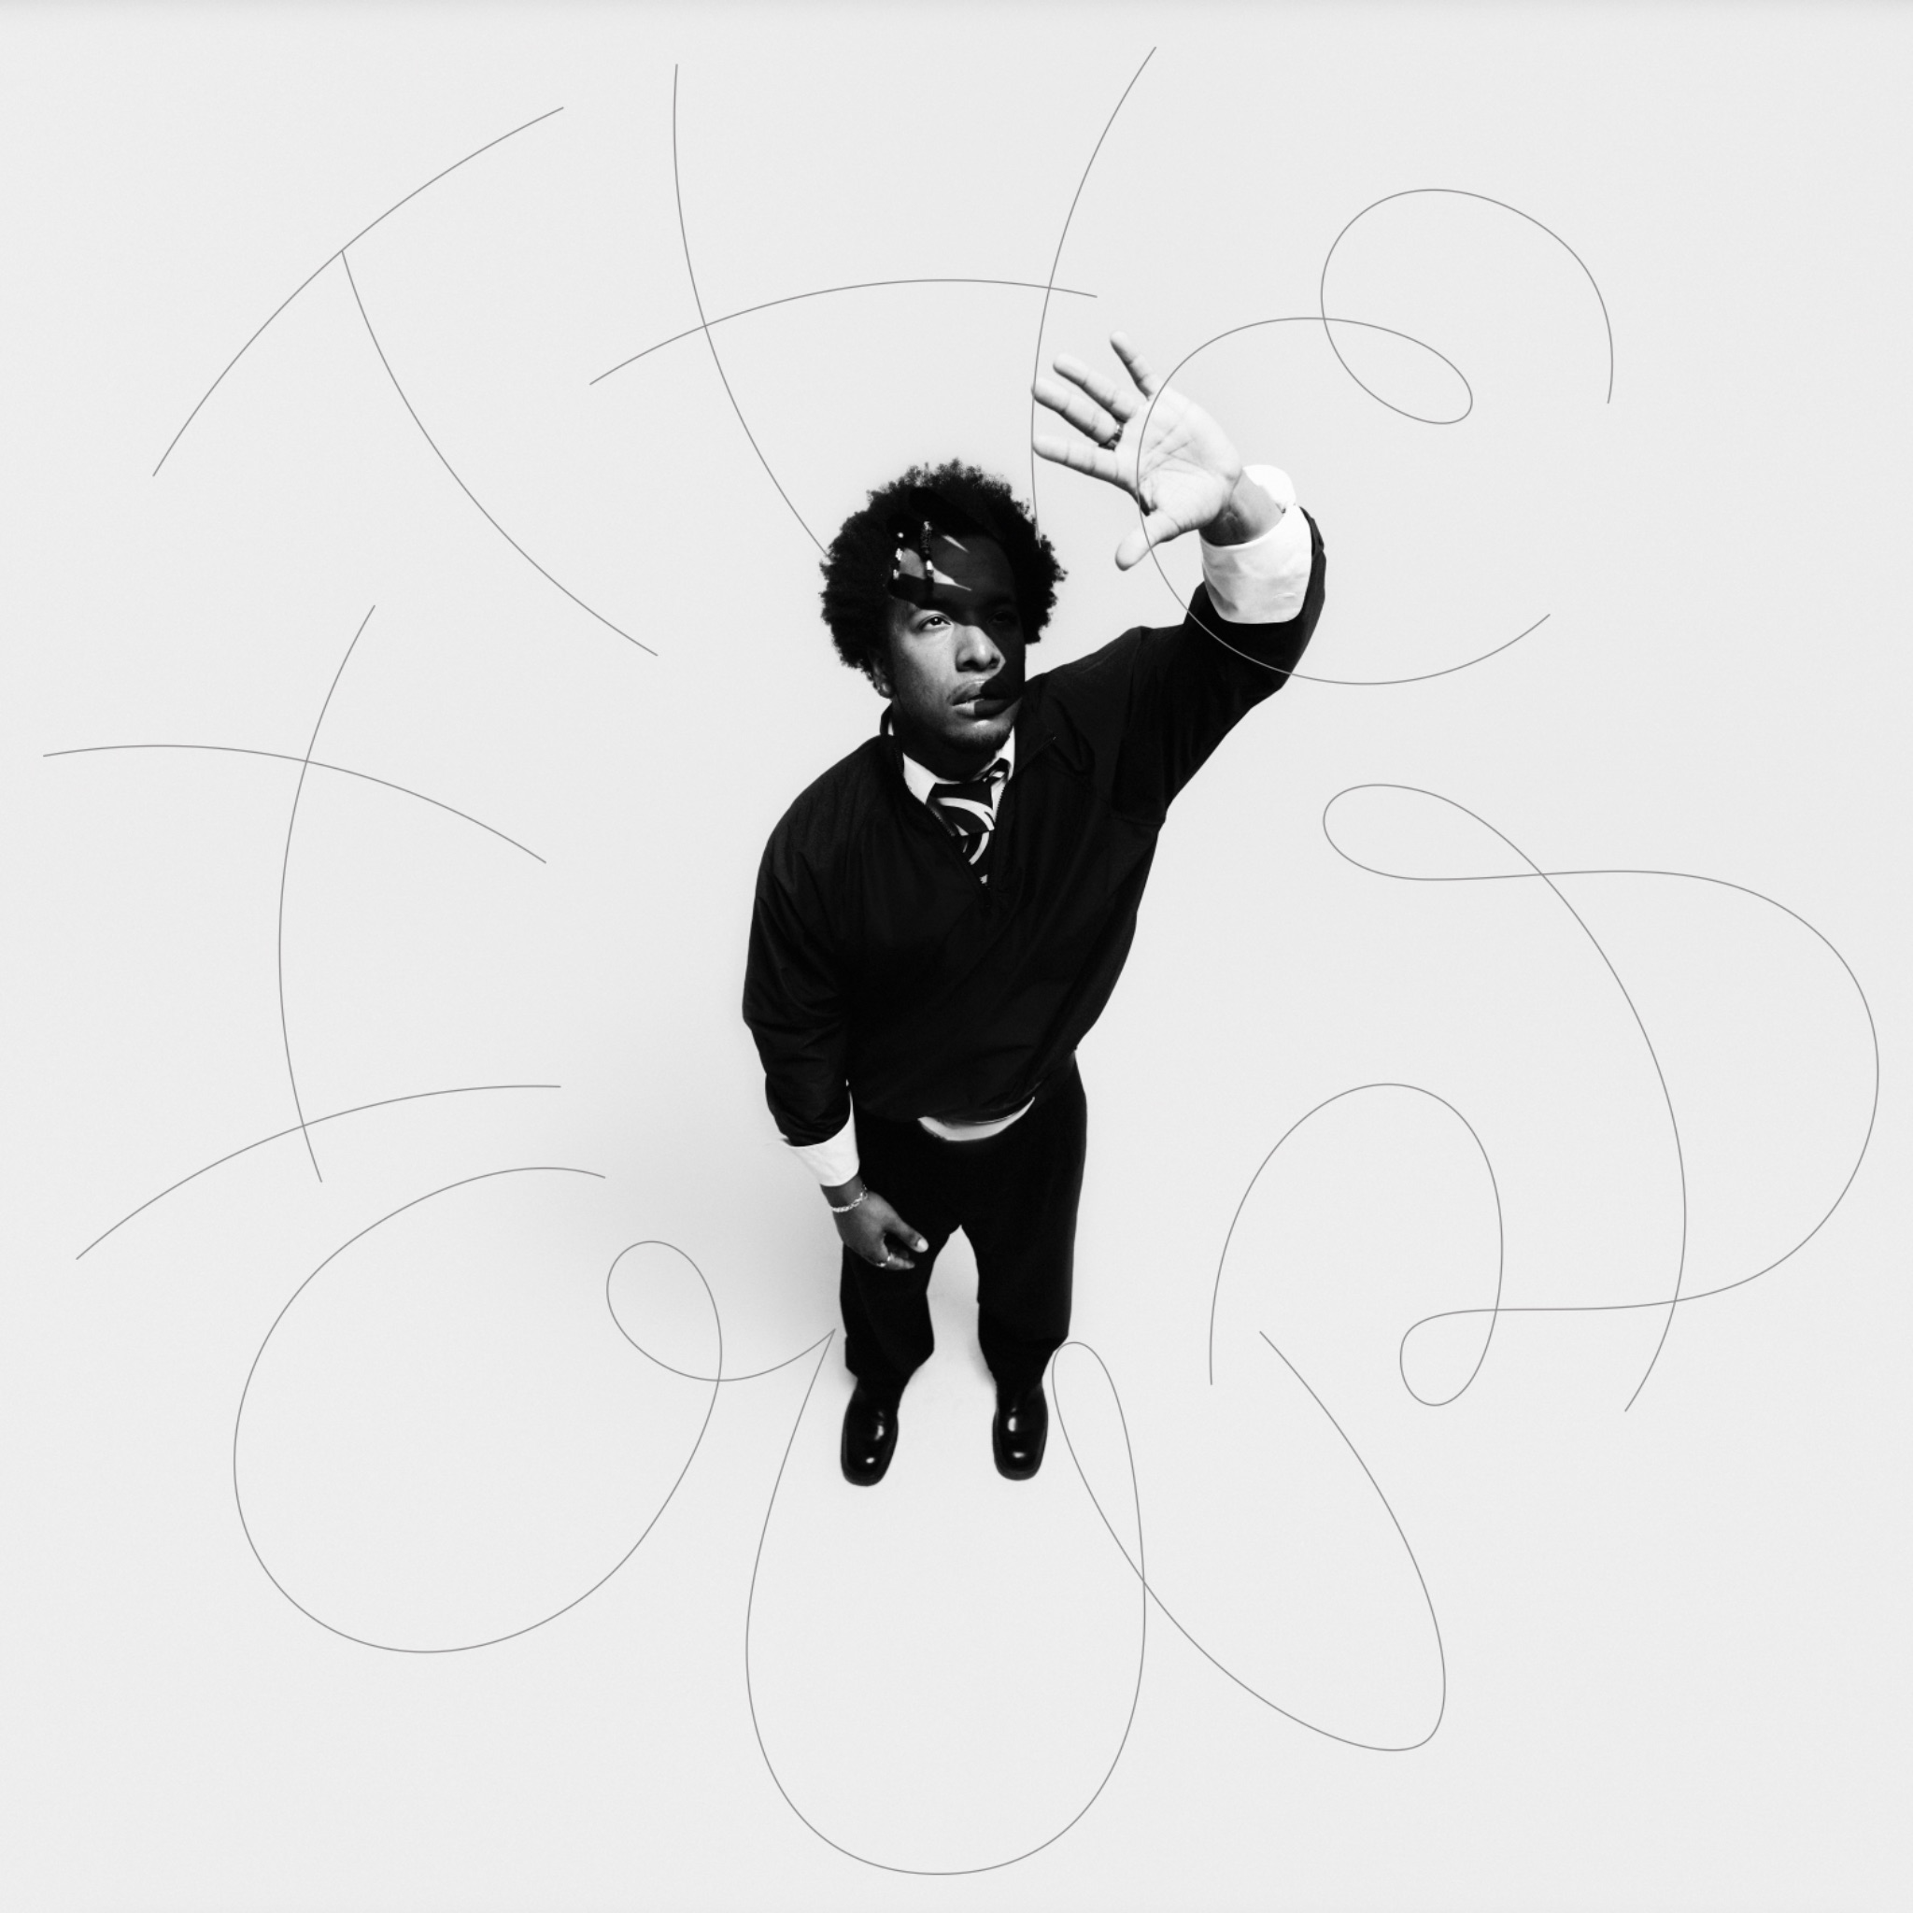
Hi-Res HERE

Cautious Clay The Hours: High Noon (Concord Records)
Tracklist

“Green Screen (1pm)”
“Ivy (2pm)”
“Trail Mix (3pm)”
“The Light (4pm)”
“Red Blossom (5pm)”
“Wave Chaser (6pm)”
“Mood Swing (7pm)”
“Shadow of a Doubt (8pm)”

STREAM/PURCHASE THE HOURS: NIGHT
https://ffm.to/cc-thehoursnight

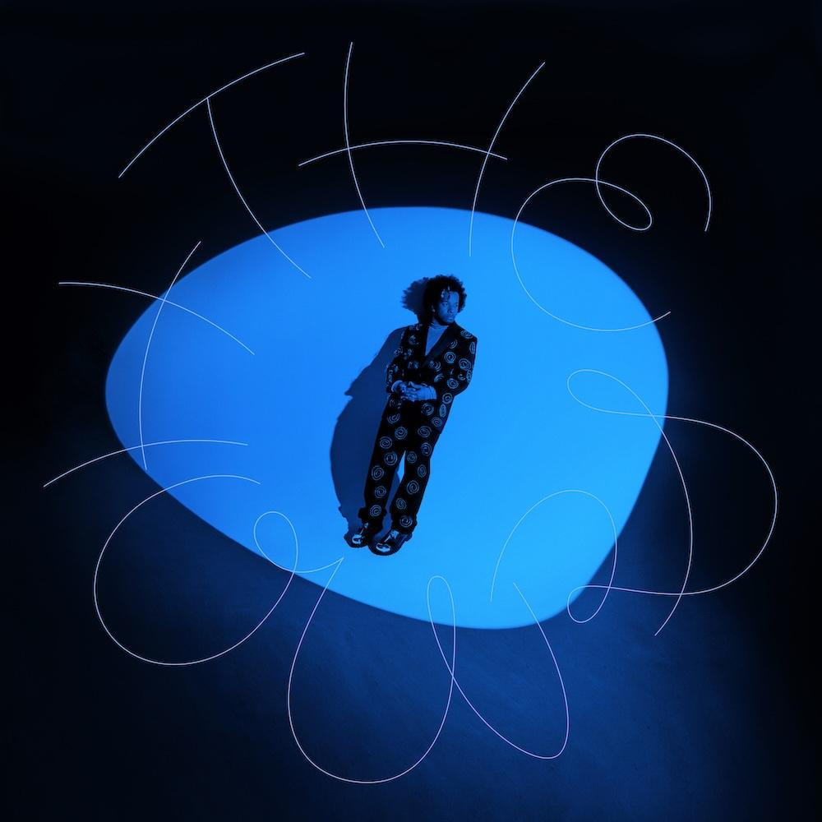
Hi-Res HERE

STREAM/PURCHASE THE HOURS: MORNING
https://found.ee/CC-TheHoursMorning
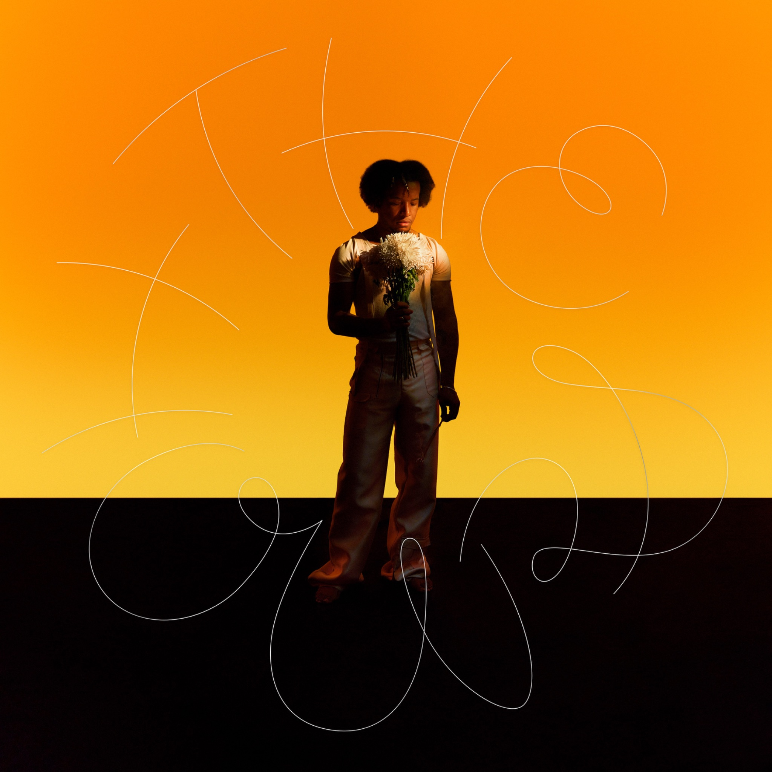
Hi-Res HERE

CAUTIOUS CLAY ONLINE
INSTAGRAM | TIKTOK | X | FACEBOOK | YOUTUBE | WEBSITE

