Devon Gilfillian’s Neo-Soul Wonder “Moonflower” Out Today, Headline Tour Announced

Watch the “Moonflower” video HERE

Headline tour includes shows in NYC, L.A., DC, Denver, Austin and more

New album Time Will Tell, out June 26th via Concord Records, was co-produced by Gilfillian and Jonathan Smalt, executive produced by Neal H Pogue (OutKast, Steve Lacy, Tyler, the Creator)
Pre-Orders/Pre-Saves Available Now

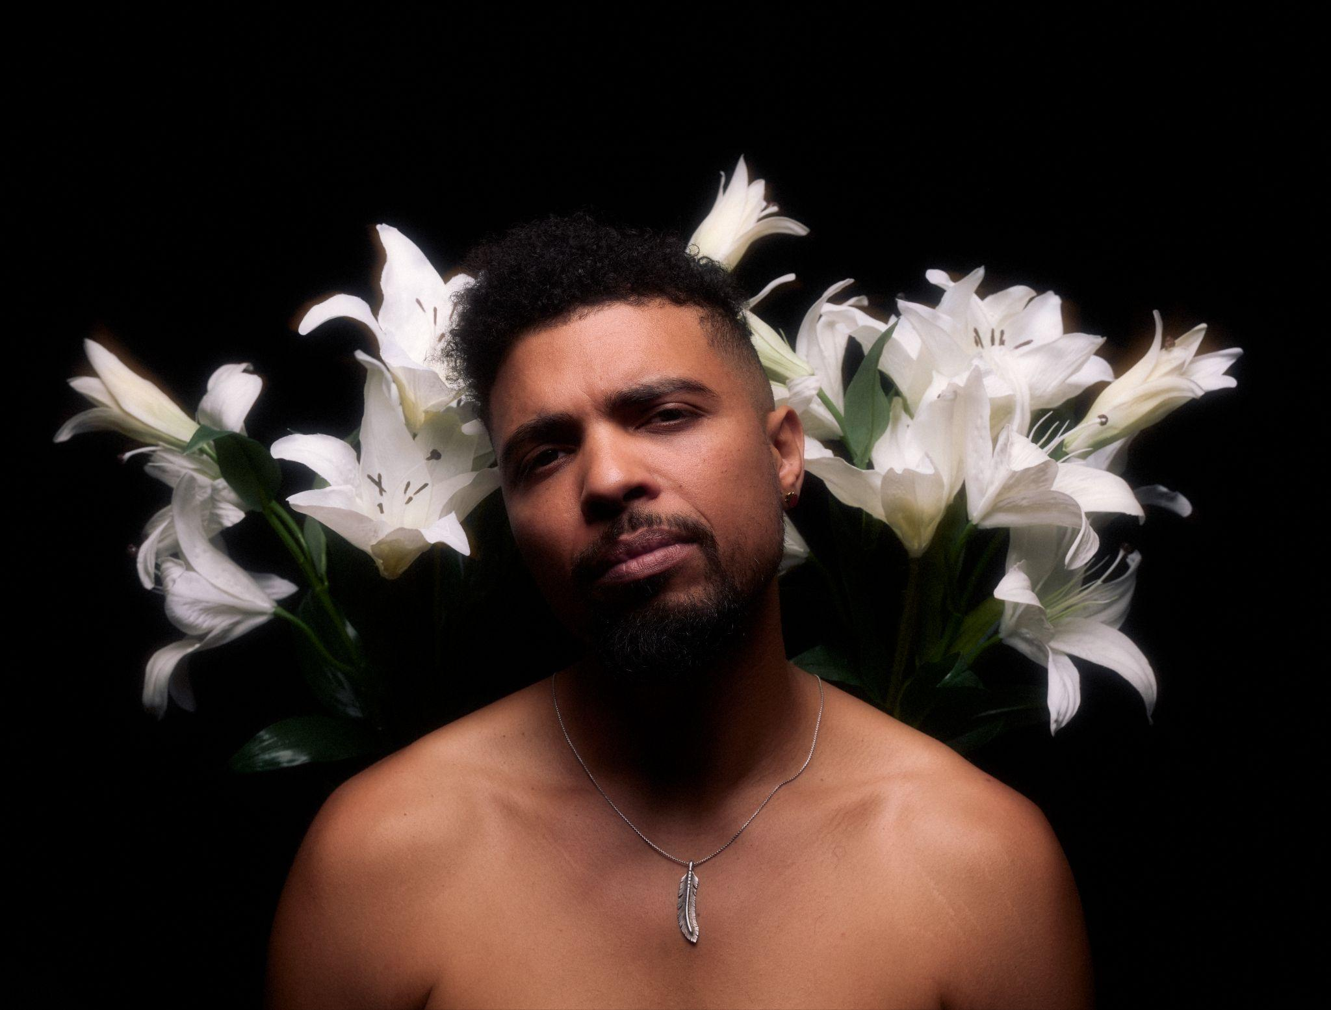
Download new press image HERE (photo credit Travys Owen)

May 15, 2026 - Devon Gilfillian yearns for a love he can’t have on the stunning neo-soul wonder “Moonflower,” the latest single from his upcoming album Time Will Tell (out June 26 via Concord Records). Lush strings wrap around Gilfillian’s exquisite vocals, heightening the song's tension. The masterful track is alternately filled with seduction and longing as Gilfillian sings “What am I to do/ I can’t stop loving you/ I want you Moonflower.”

“‘Moonflower’ is about the love I’m always chasing but can never reach because we have opposite natures - the moon and the sun,” explains Gilfillian. “The moonflower blossoms at night under the moon, but can it survive the day? This is my '90s baby, neo-soul and r&b side, lusting for what I can never really have. It’s a love song and a heartbreak song in one.”

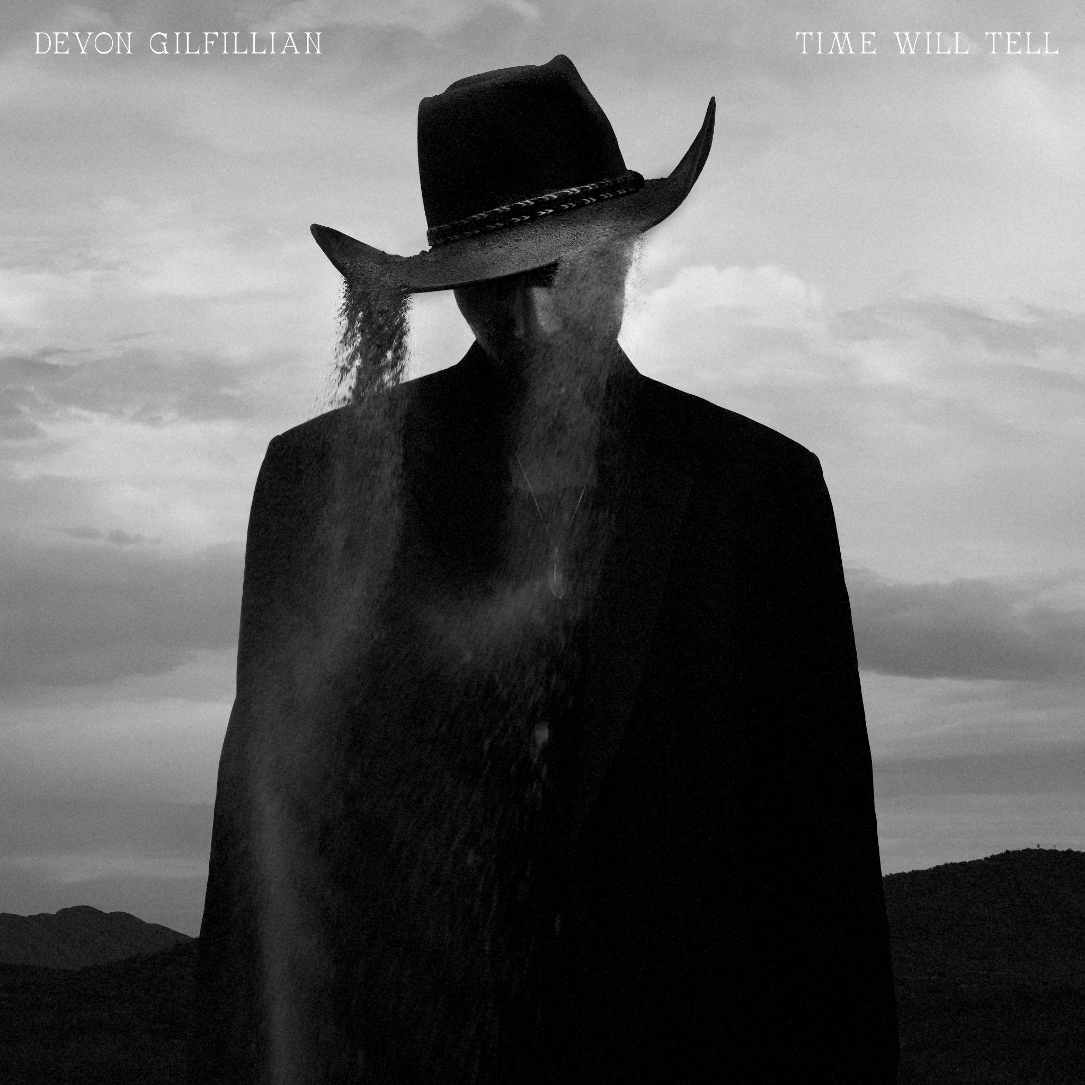
Download Time Will Tell album cover HERE

Time Will Tell is the album Gilfillian has been working towards his entire life. Born and raised in Philadelphia, one of America’s great soul music hubs, Gilfillian has since spent over a dozen years in Nashville. Recorded at the legendary RCA Studio A, Time Will Tell finds Gilfillian crafting a hybrid of the Philly soul he was raised on and the Nashville sounds he’s absorbed since moving there in 2013. The result is a magnetic take on country-soul, Gilfillian’s very own Nashville sound. But first, he had to wind his way through familial mortality, the heartache of a lost relationship, and ultimately take control of his musical destiny.

Gilfillian will tour extensively in support of Time Will Tell, and today he announces a headline run that includes shows in NYC, L.A., DC, Denver and Austin. Gilfillian plays Rolling Stone Stateside Fest on July 4th, the Minnesota Yacht Club festival on July 18th and XPONENTIAL Music Fest in Philadelphia on September 18th. Full tour details available at devongilfillian.com/tour.

Devon Gilfillian 2026 Tour Dates
Jun 6 - Healdsburg, CA - Bloodroot Ramble
Jun 7 - San Jose, CA - Levitt Pavillion
Jun 24 - Haddon Heights, NJ - Sundown Music Series
Jul 4 - Kingston, NY - Rolling Stone Stateside Fest
Jul 18 - St Paul, MN - Minnesota Yacht Club
Jul 19 - Swisher, IA - Cedar Ridge Distillery
Jul 21 - Appleton, WI - Appleton Beer Works
Jul 23 - Ann Arbor, MI - Sonic Lunch
Jul 24 - Chicago, IL - Wicker Park
Aug 5 - Portsmouth, NH - Prescott Park Arts Festival
Aug 7 - Westport, CT - Levitt Pavillion
Aug 8 - Stowe, VT - Strawberry Jam Music Festival
Aug 29 - Pittsburgh, PA - WYEP Neighborhood Concert Series
Sep 14 - Carrboro, NC - Cat's Cradle
Sep 15 - Washington, DC - Union Stage
Sep 17 - Brooklyn, NY - Sultan Room
Sep 18 - Camden, NJ - XPONENTIAL Music Fest
Sep 19 - Cambridge, MA - The Sinclair
Sep 20 - Bethlehem, PA - Musikfest Cafe
Sep 27 - St Louis, MO - Off Broadway
Sep 29 - Kansas City, MO - Recordbar
Oct 1 - Denver , CO - Bluebird Theater
Oct 2 - Fort Collins, CO - The Armory
Oct 3 - Salt Lake City, UT - The State Room
Oct 6 - Seattle, WA - The Crocodile
Oct 7 - Portland, OR - Mississippi Studios
Oct 10 - Los Angeles, CA - The Roxy
Oct 13 - Phoenix, AZ - Musical Instrument Museum
Oct 14 - Santa Fe, NM - Tumbleroot
Oct 16 - Austin, TX - Antone's
Oct 17 - Dallas, TX - The Kessler
Oct 19 - Foley, AL - OWA Theatre

###

Follow Devon Gilfillian:
Website l Instagram l TikTok l YouTube l Facebook l X

For more information on Devon Gilfillian, please contact Rob Krauser, rob@missingpiecegroup.com or 917.703.8361, and Joe Sivick, joe@missingpiecegroup.com
at Missing Piece Group.

