Devon Gilfillian Wants It “IRL”

Watch a live performance of “IRL” with Grace Bowers HERE

New album Time Will Tell, out June 26th via Concord Records, was co-produced by Gilfillian and Jonathan Smalt, executive produced by Neal H Pogue (OutKast, Steve Lacy, Tyler, the Creator)

Gilfillian kicks off tour with Cory Wong later this month

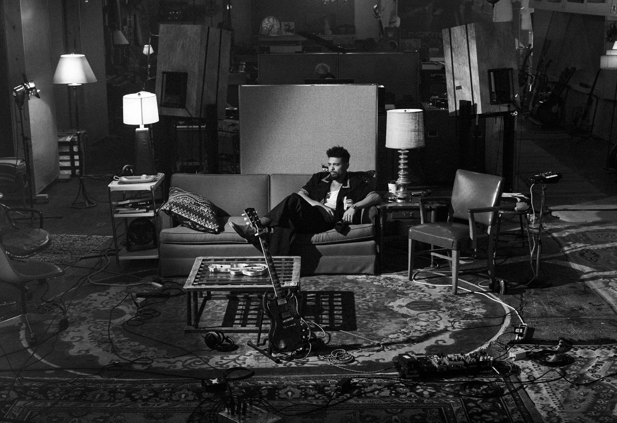
Download press photo HERE

April 3, 2026 - Devon Gilfillian is tired of the digital life on the greasy, strutting new single “IRL,” a standout from his upcoming album Time Will Tell (out June 26th via Concord Records). A boom-bap beat undergirds an organ’s psychedelic whirr before the whole thing snaps into a funk strut, all while Gilfillian gets stuck in the conflict between leaving and staying, between indulging what his body wants and his mind needs. The song is so unmitigated it feels like you’re listening to a real-time argument he’s having with himself about his future.

“I’m tired of watching life happen through a screen,” explains Dilfillian. “Give me the raw shit. Give me the friction. Give me the sweat.”

Time Will Tell is the album Gilfillian has been working towards his entire life. Born and raised in Philadelphia, one of America’s great soul music hubs, Gilfillian has since spent over a dozen years in Nashville. Recorded at the legendary RCA Studio A, Time Will Tell finds Gilfillian crafting a hybrid of the Philly soul he was raised on and the Nashville sounds he’s absorbed since moving there in 2013. The result is a magnetic take on country-soul, Gilfillian’s very own Nashville sound. But first, he had to wind his way through familial mortality, the heartache of a lost relationship, and ultimately take control of his musical destiny.

Gilfillian will tour heavily in the support of Time Will Tell. He hits the road in support of guitar ace Cory Wong in April, and will hit the Minnesota Yacht Club Festival in Saint Paul, MN in July. Headline tour dates are expected to be announced soon.

Devon Gilfillian - 2026 Tour Dates
Apr 15 - Kansas City, MO - The Truman*
Apr 17 - Denver, CO - The Mission Ballroom*
Apr 18 - Salt Lake City, UT - The Depot*
Apr 20 - Portland, OR - McMenamins Crystal Ballroom*
Apr 21 - Seattle, WA - Paramount Theatre*
Apr 23 - Sacramento, CA - Channel24*
Apr 24 - San Francisco, CA - The Warfield*
Apr 25 - Los Angeles, CA - The Wiltern*
Apr 26 - Del Mar, CA - The Sound at Del Mar*
Apr 27 - Las Vegas, NV - Brooklyn Bowl Las Vegas*
Apr 30 - Houston, TX - White Oak Music Hall*
May 1 - Dallas, TX - House of Blues Dallas*
Jul 18 - Saint Paul, MN - Minnesota Yacht Club Festival
Aug 8 - Stowe, VT - Strawberry Jam Music Festival
*supporting Cory Wong

Time Will Tell tracklist:
01) Time Will Tell
02) Moonflower
03) Hold On (Hourglass)
04) IRL
05) Black Dog Rabbit Hole
06) Glad To Be Here
07) Shines In You
08) Let’s Stop Fucking Around
09) Keep On Movin’
10) Some Days
11) You Can Hate Me Now (feat. Madeline Edwards)
12) Time (Reprise)

###

Follow Devon Gilfillian:
Website l Instagram l TikTok l YouTube l Facebook l X

For more information on Devon Gilfillian, please contact Rob Krauser, rob@missingpiecegroup.com or 917.703.8361, and Joe Sivick, joe@missingpiecegroup.com
at Missing Piece Group.

