Devon Gilfillian Forges His Own Nashville Soul Sound On Time Will Tell, Out June 26 Via Concord Records

Co-produced by Gilfillian and Jonathan Smalt, executive produced by Neal H Pogue (OutKast, Steve Lacy, Tyler, the Creator)

Official Video for “Hold On (Hourglass)” Out Now

Watch the Time Will Tell album trailer HERE

Pre-order/pre-save Time Will Tell HERE, Stream “Hold On (Hourglass)” HERE

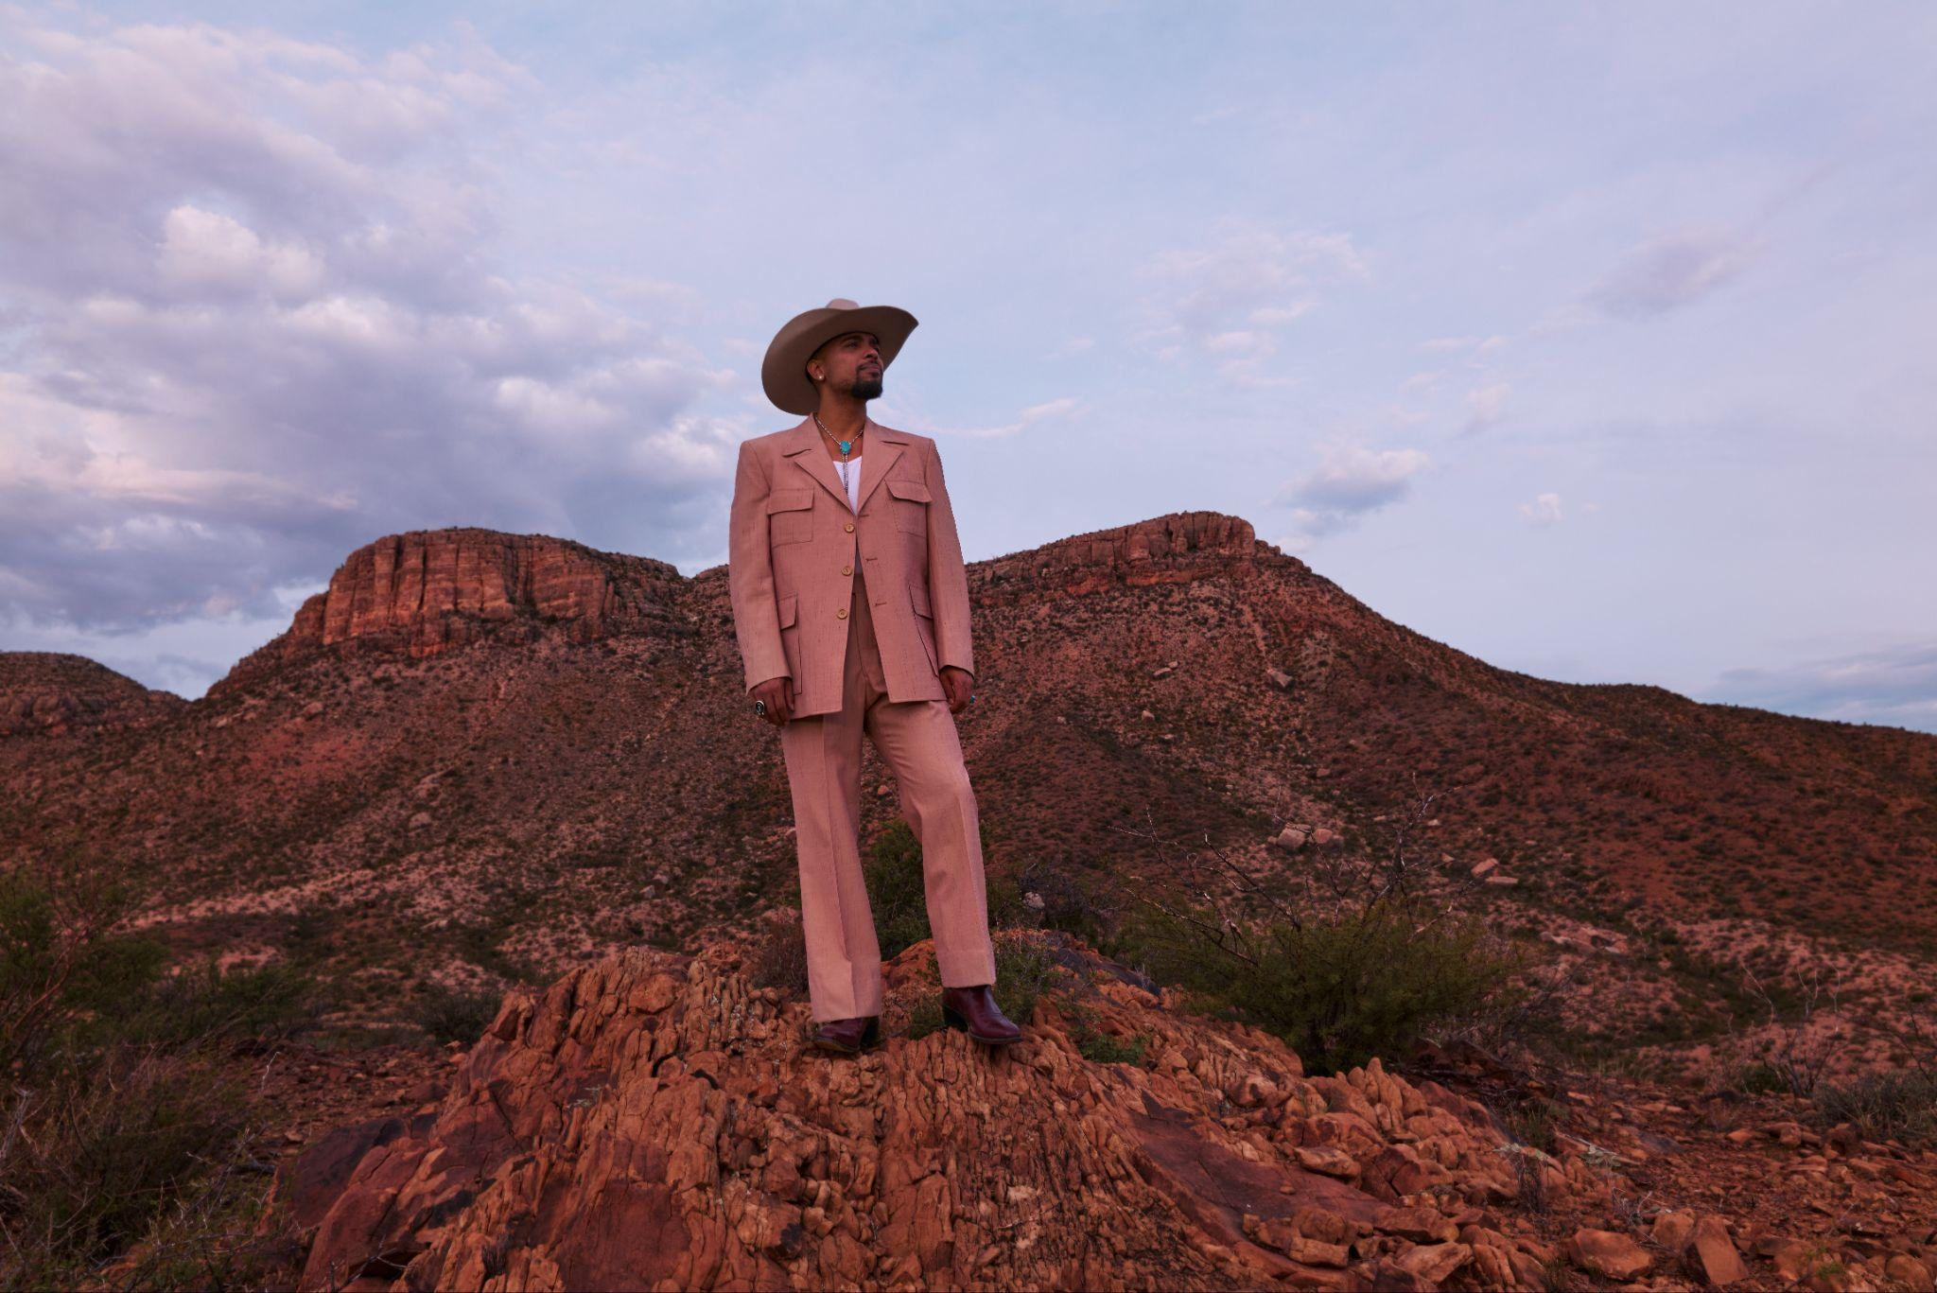Download new press photos HERE (photo credit Travys Owen)

February 27, 2026: Today, Nashville soul artist Devon Gilfillian announces Time Will Tell, out June 26 on Concord Records, the album he’s been working towards his entire life. Born and raised in Philadelphia, one of America’s great soul music hubs, Gilfillian has since spent over a dozen years in Music City. Recorded at the legendary RCA Studio A, Time Will Tell finds Gilfillian crafting a hybrid of the Philly soul he was raised on and the Nashville sounds he’s absorbed since moving there in 2013. The result is a magnetic take on country-soul, Gilfillian’s very own Nashville sound. But first, he had to wind his way through familial mortality, the heartache of a lost relationship, and ultimately take control of his musical destiny.

First came the shock of hearing his father Nelson, a man who hits the gym five times a week and generally watches what he eats, had suffered a heart attack. Nelson Gilfillian is fine now, but in a matter of weeks after the heart attack, his son wrote “Glad to Be Here,” a bittersweet and beautiful ode to existence – to slowing down long enough to remember what a gift it is to be alive at all. Like the sun slipping through closed curtains on a cold day, “Glad to Be Here” is the aching and grateful country-soul centerpiece of Time Will Tell, Gilfillian’s third album and honest account of the extreme highs and lows that come with living. The heartache came next. As he struggled to save a relationship into which he’d put so much time and love, he found himself writing about differences that he slowly recognized as irreconcilable. With its gospel surges, ringing bells, and jittery guitars, “Hold On (Hourglass)” races like a nervous heart, a sleepless and agitated Gilfillian wondering if his commitment to holding on is just a way of fooling himself.

“‘Hold On (Hourglass)’ is my psychedelic country western soul realization that I am holding on to a relationship that is no longer serving either parties, especially me,” explains Gilfillian. “Time is a healer and a revealer, and that is what this album is about.”

Gilfillian and his longtime drummer and friend Jonathan Smalt intuitively understood that the best way to capture the feelings in these songs was to cut them as quickly as possible. Gilfillian and Smalt have worked with several ace producers in the past, including Shawn Everett and Jeremy Lutito, but they felt like they finally knew enough to try it themselves. They asked Dave Cobb if they could borrow RCA Studio A, then recruited a few ace engineers and producers—Reid Leslie, Michael Harris, Ran Jackson—to help man the varispeed tape machines and make a few key calls. They built a band of session aces and strong sets of string and horn players, then tracked most of the vocals with single takes. Neal H Pogue, the producer legendary for his work with the likes of OutKast and Tyler, the Creator, was so passionate about Gilfillian’s demos that he enlisted as executive producer, eventually mixing the album himself. Everyone wanted the songs to feel like the epiphanies that had shaped them, for the recordings to reflect the realness of Gilfillian’s circumstances when he wrote them.

It absolutely worked. “Black Dog Rabbit Hole” is a riveting hard rock snapshot of mania, Gilfillian’s voice switching between falsetto frailty and a tormented bellow as he tries to find his way out of a spiral. Gilfillian has never made anything quite so raw, quite so cutting. On “IRL,” where a boom-bap beat undergirds an organ’s psychedelic whirr before the whole thing snaps into a funk strut, Gilfillian gets stuck in the conflict between leaving and staying, between indulging what his body wants and his mind needs. The song is so unmitigated it feels like you’re listening to a real-time argument he’s having with himself about his future. These aren’t breakup songs so much as exacting maps of Gilfillian’s relatable inner conflicts as he tries to find ways to be happy—ways of being, like his father, simply glad to be here at all.

Gilfillian will tour heavily in the support of Time Will Tell. He hits the road in support of guitar ace Cory Wong in April (and is Wong’s guest on the March 7th edition of CBS Saturday Morning “Saturday Sessions”), and will hit the Minnesota Yacht Club Festival in Saint Paul, MN in July alongside The Lumineers, The Strokes, Geese and many others. Headline tour dates are expected to be announced soon.

Gilfillian has performed on Jimmy Kimmel Live!, The Late Show with Stephen Colbert, The Kelly Clarkson Show, and CBS Saturday Morning. His debut album, Black Hole Rainbow, was produced by Shawn Everettt and nominated for a Grammy. His single, "All I Really Wanna Do," off his sophomore album, Love You Anyway, was a top 5 AAA radio hit.

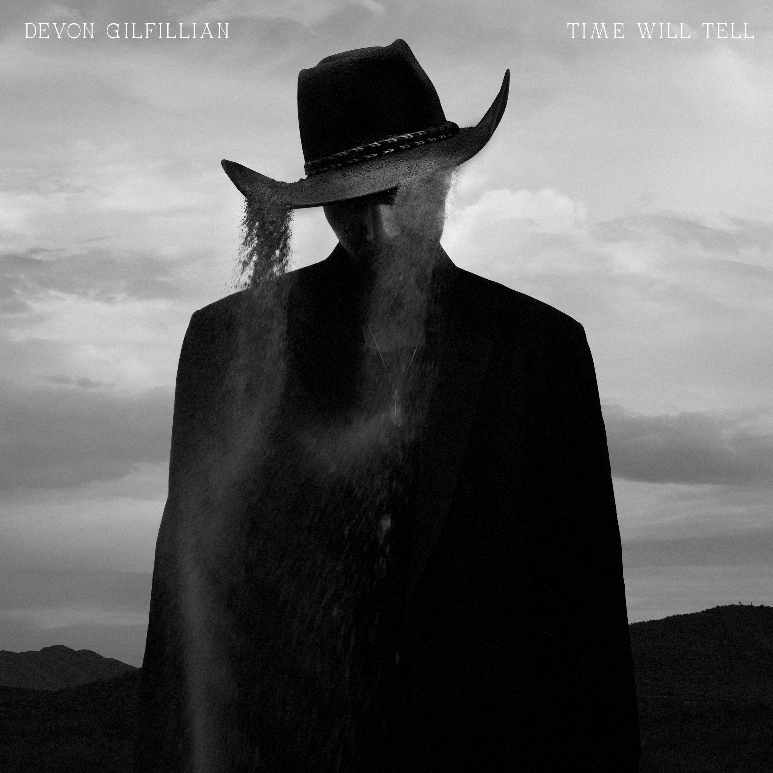
Download Time Will Tell album cover HERE

Time Will Tell tracklist:
01) Time Will Tell
02) Moonflower
03) Hold On (Hourglass)
04) IRL
05) Black Dog Rabbit Hole
06) Glad To Be Here
07) Shines In You
08) Let’s Stop Fucking Around
09) Keep On Movin’
10) Some Days
11) You Can Hate Me Now (feat. Madeline Edwards)
12) Time (Reprise)

Devon Gilfillian - 2026 Tour Dates
Apr 15 - Kansas City, MO - The Truman*
Apr 17 - Denver, CO - The Mission Ballroom*
Apr 18 - Salt Lake City, UT - The Depot*
Apr 20 - Portland, OR - McMenamins Crystal Ballroom*
Apr 21 - Seattle, WA - Paramount Theatre*
Apr 23 - Sacramento, CA - Channel24*
Apr 24 - San Francisco, CA - The Warfield*
Apr 25 - Los Angeles, CA - The Wiltern*
Apr 26 - Del Mar, CA - The Sound at Del Mar*
Apr 27 - Las Vegas, NV - Brooklyn Bowl Las Vegas*
Apr 30 - Houston, TX - White Oak Music Hall*
May 1 - Dallas, TX - House of Blues Dallas*
Jul 18 - Saint Paul, MN - Minnesota Yacht Club Festival
Aug 8 - Stowe, VT - Strawberry Jam Music Festival
*supporting Cory Wong

###

Follow Devon Gilfillian:
Website l Instagram l TikTok l YouTube l Facebook l X

For more information on Devon Gilfillian, please contact Rob Krauser, rob@missingpiecegroup.com or 917.703.8361, and Joe Sivick, joe@missingpiecegroup.com
at Missing Piece Group

