ALLISON RUSSELL TEASES NEW MUSIC
LISTEN TO THE SINGLE “NO SPRINGTIME” HERE
FEATURING JOY OLADOKUN & JULIE WILLIAMS

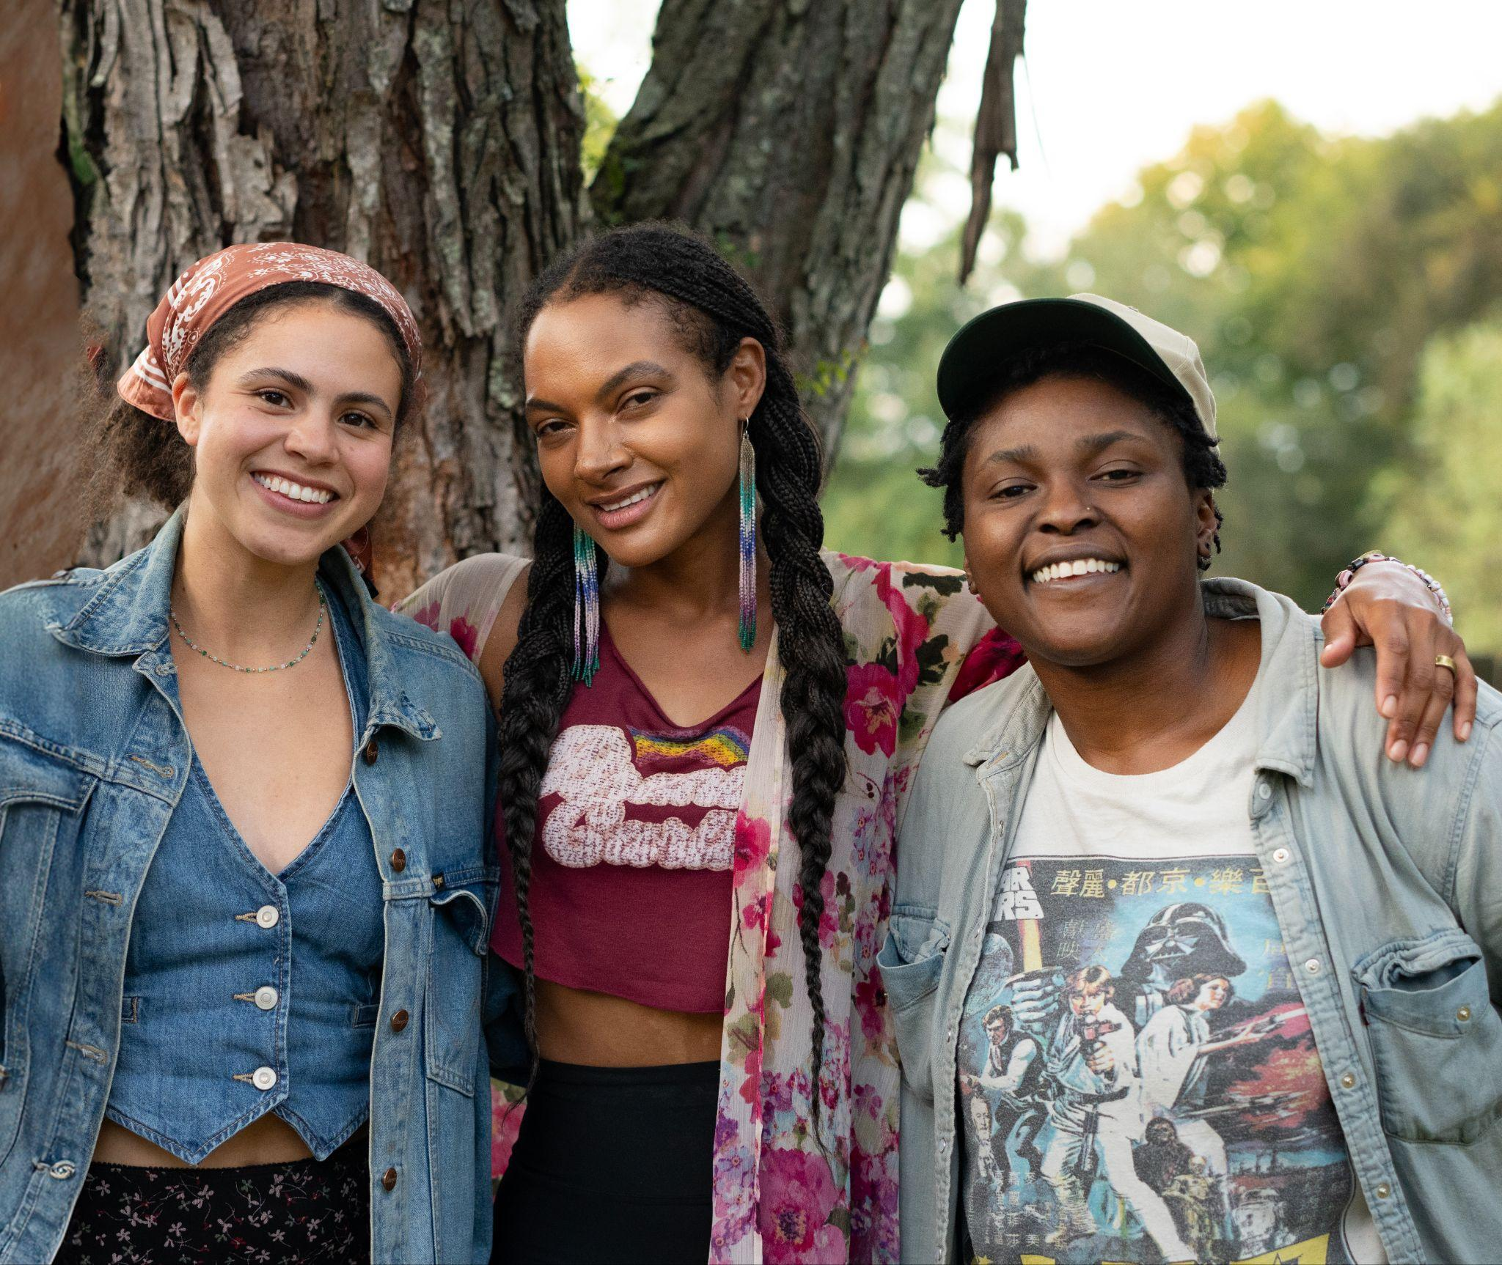
Julie Williams, Allison Russell & Joy Oladokun - Download Hi-Res HERE - Photo Credit: Athena Kulb

Today, Allison Russell has teased new music with the single release of “No Springtime” featuring Joy Oladokun and Julie Williams. The track was produced by Allison Russell & Dim Star and is out everywhere now. LISTEN HERE.

Allison Russell on “No Springtime”:
When I talk about reconnecting to something essential, I don’t mean grasping for the most available sunshine.
No Springtime is about embracing the dark side of the moon -
the blues, sadness, melancholy … Blues are activated sadness, never passive, and this is something Black Women deeply understand. It feels so good singing this with my sisters, Joy Oladokun and Julie Williams.
Live your blues, don’t wallow and loop. No light without shadows!

Last week, Russell took the stage at the JUNO Awards to pay tribute to fellow Canadian, Joni Mitchell. The performance was a duet between her and Sarah McLachan who she will tour with throughout the summer. Dates kick off on July 1st in Franklin, TN. A full list of tour dates is below.

Russell has also just completed her second run on Broadway as Persephone in the 8 x Tony Award winning musical Hadestown. She took over the role in November 2024 initially, after spending much of that year opening for Hozier on his Unreal Unearth Tour supporting his arena run on all US dates and throughout Europe. She made her Billboard Hot 100 debut thanks to their duet “Wildflower and Barley.”

The accolades for Russell from her previous two albums Outside Child and The Returner, have been immense. Last year she was nominated for the Polaris Prize and named Billboard Women In Music Canada’s “Breakthrough Artist of the Year.” She has had 8 GRAMMY nominations and one win, earned three 2022 Americana Award nominations and a win for Album of the Year with subsequent nominations in 2023 and 2024, two International Folk Music Award wins, a 2022 Juno nomination for ‘Songwriter of the Year,’ and her first-ever Juno Award win for Contemporary Roots Album of the Year. Russell won three Canadian Folk Music Awards, two UK Americana Music Awards, and more.

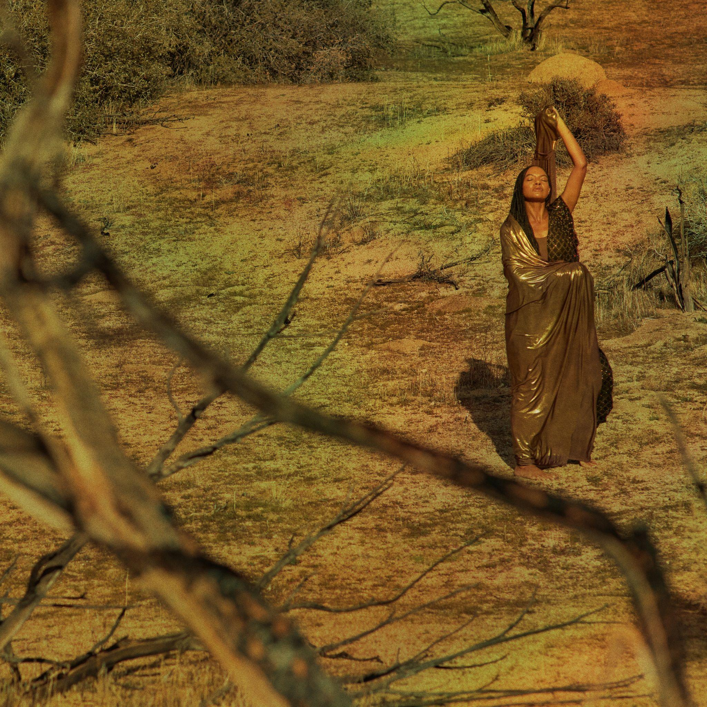
“No Springtime” Cover Art - Download Hi-Res HERE

Tour Dates
*All dates supporting Sarah McLachlan

Jul 1 – FirstBank Amphitheater – Franklin, TN
Jul 3 – Synovus Bank Amphitheater at Chastain Park – Atlanta, GA
Jul 7 – TD Pavilion at The Mann – Philadelphia, PA
Jul 8 – Hartford HealthCare Amphitheater – Bridgeport, CT
Jul 10 – Leader Bank Pavilion – Boston, MA
Jul 11 – Forest Hills Stadium – Forest Hills, NY
Jul 12 – BankNH Pavilion – Gilford, NH
Jul 14 – Artpark Mainstage Theater – Lewiston, NY
Jul 15 – Michigan Lottery Amphitheatre at Freedom Hill – Sterling Heights, MI
Jul 17 – Acrisure Amphitheater – Grand Rapids, MI
Jul 18 – Huntington Bank Pavilion at Northerly Island – Chicago, IL
Jul 19 – Everwise Amphitheater at White River State Park – Indianapolis, IN
Jul 21 – PNC Pavilion – Cincinnati, OH
Jul 23 – Saint Louis Music Park – Maryland Heights, MO
Jul 24 – Starlight Theatre – Kansas City, MO
Jul 26 – The Pavilion at Toyota Music Factory – Irving, TX
Jul 30 – Utah First Credit Union Amphitheatre – West Valley City, UT
Aug 1 – Toyota Pavilion at Concord – Concord, CA
Aug 2 – The Rady Shell at Jacobs Park – San Diego, CA
Aug 4 – Greek Theatre – Los Angeles, CA
Aug 5 – Greek Theatre – Los Angeles, CA
Aug 7 – Hayden Homes Amphitheater – Bend, OR
Aug 8 – Chateau Ste Michelle Winery – Woodinville, WA
Aug 9 – Chateau Ste Michelle Winery – Woodinville, WA

More About Allison Russell:
Montreal-born, Nashville-based Allison Russell is a Grammy, Juno, Americana, SOCAN, and Folk Award–winning artist and Polaris Prize–shortlisted singer-songwriter, producer, author, actor, and human rights advocate.
Her acclaimed solo debut Outside Child (2021) was followed by The Returner (2023), released via Concord/Fantasy. Prior to her solo work, she co-founded and toured internationally with Po’Girl, Birds of Chicago, and Our Native Daughters, and remains an active collaborator with OND and a member of Joni Mitchell’s Joni Jam.
In 2024, Russell joined Hozier’s Unreal Unearth tour across the U.S. and Europe, with their duet “Wildflower & Barley” earning her first Billboard Hot 100 entry. Her Rainbow Coalition ensemble and All Returners tour continued through 2025 across Australia and North America. She also co-wrote “Human Mind” with Hozier for Mavis Staples.
Russell has received eight Grammy nominations and one win, alongside multiple honors including Americana Award nominations and Album of the Year, a Juno Award for Contemporary Roots Album of the Year, International Folk Music Awards, Canadian Folk Music Awards, and UK Americana Awards. She was also named Billboard Women in Music Canada’s Breakthrough Artist of the Year and shortlisted for the Polaris Prize.
She made her Broadway debut as Persephone in Anaïs Mitchell’s Hadestown in November 2024 and has since completed a second run in the role. Offstage, Russell is a powerful advocate and organizer, curating the historic Once and Future Sounds set at Newport Folk Festival and co-founding Love Rising, which has raised over $550,000 in support of LGBTQIA+ communities.
Her forthcoming memoir will be published by Little, Brown, and her third album is slated for release in 2026.

ALLISON RUSSELL ONLINE:
Website | Twitter | Facebook | Instagram | YouTube
TikTok | Fantasy Records

For more information on Allison Russell contact:
Meg Helsel @ Grandstand Media Meghanh@grandstandhq.com

