ALLISON RUSSELL RELEASES
RAINBOWS EP
LISTEN HERE

ON TOUR WITH SARAH MCLACHLAN THIS SUMMER
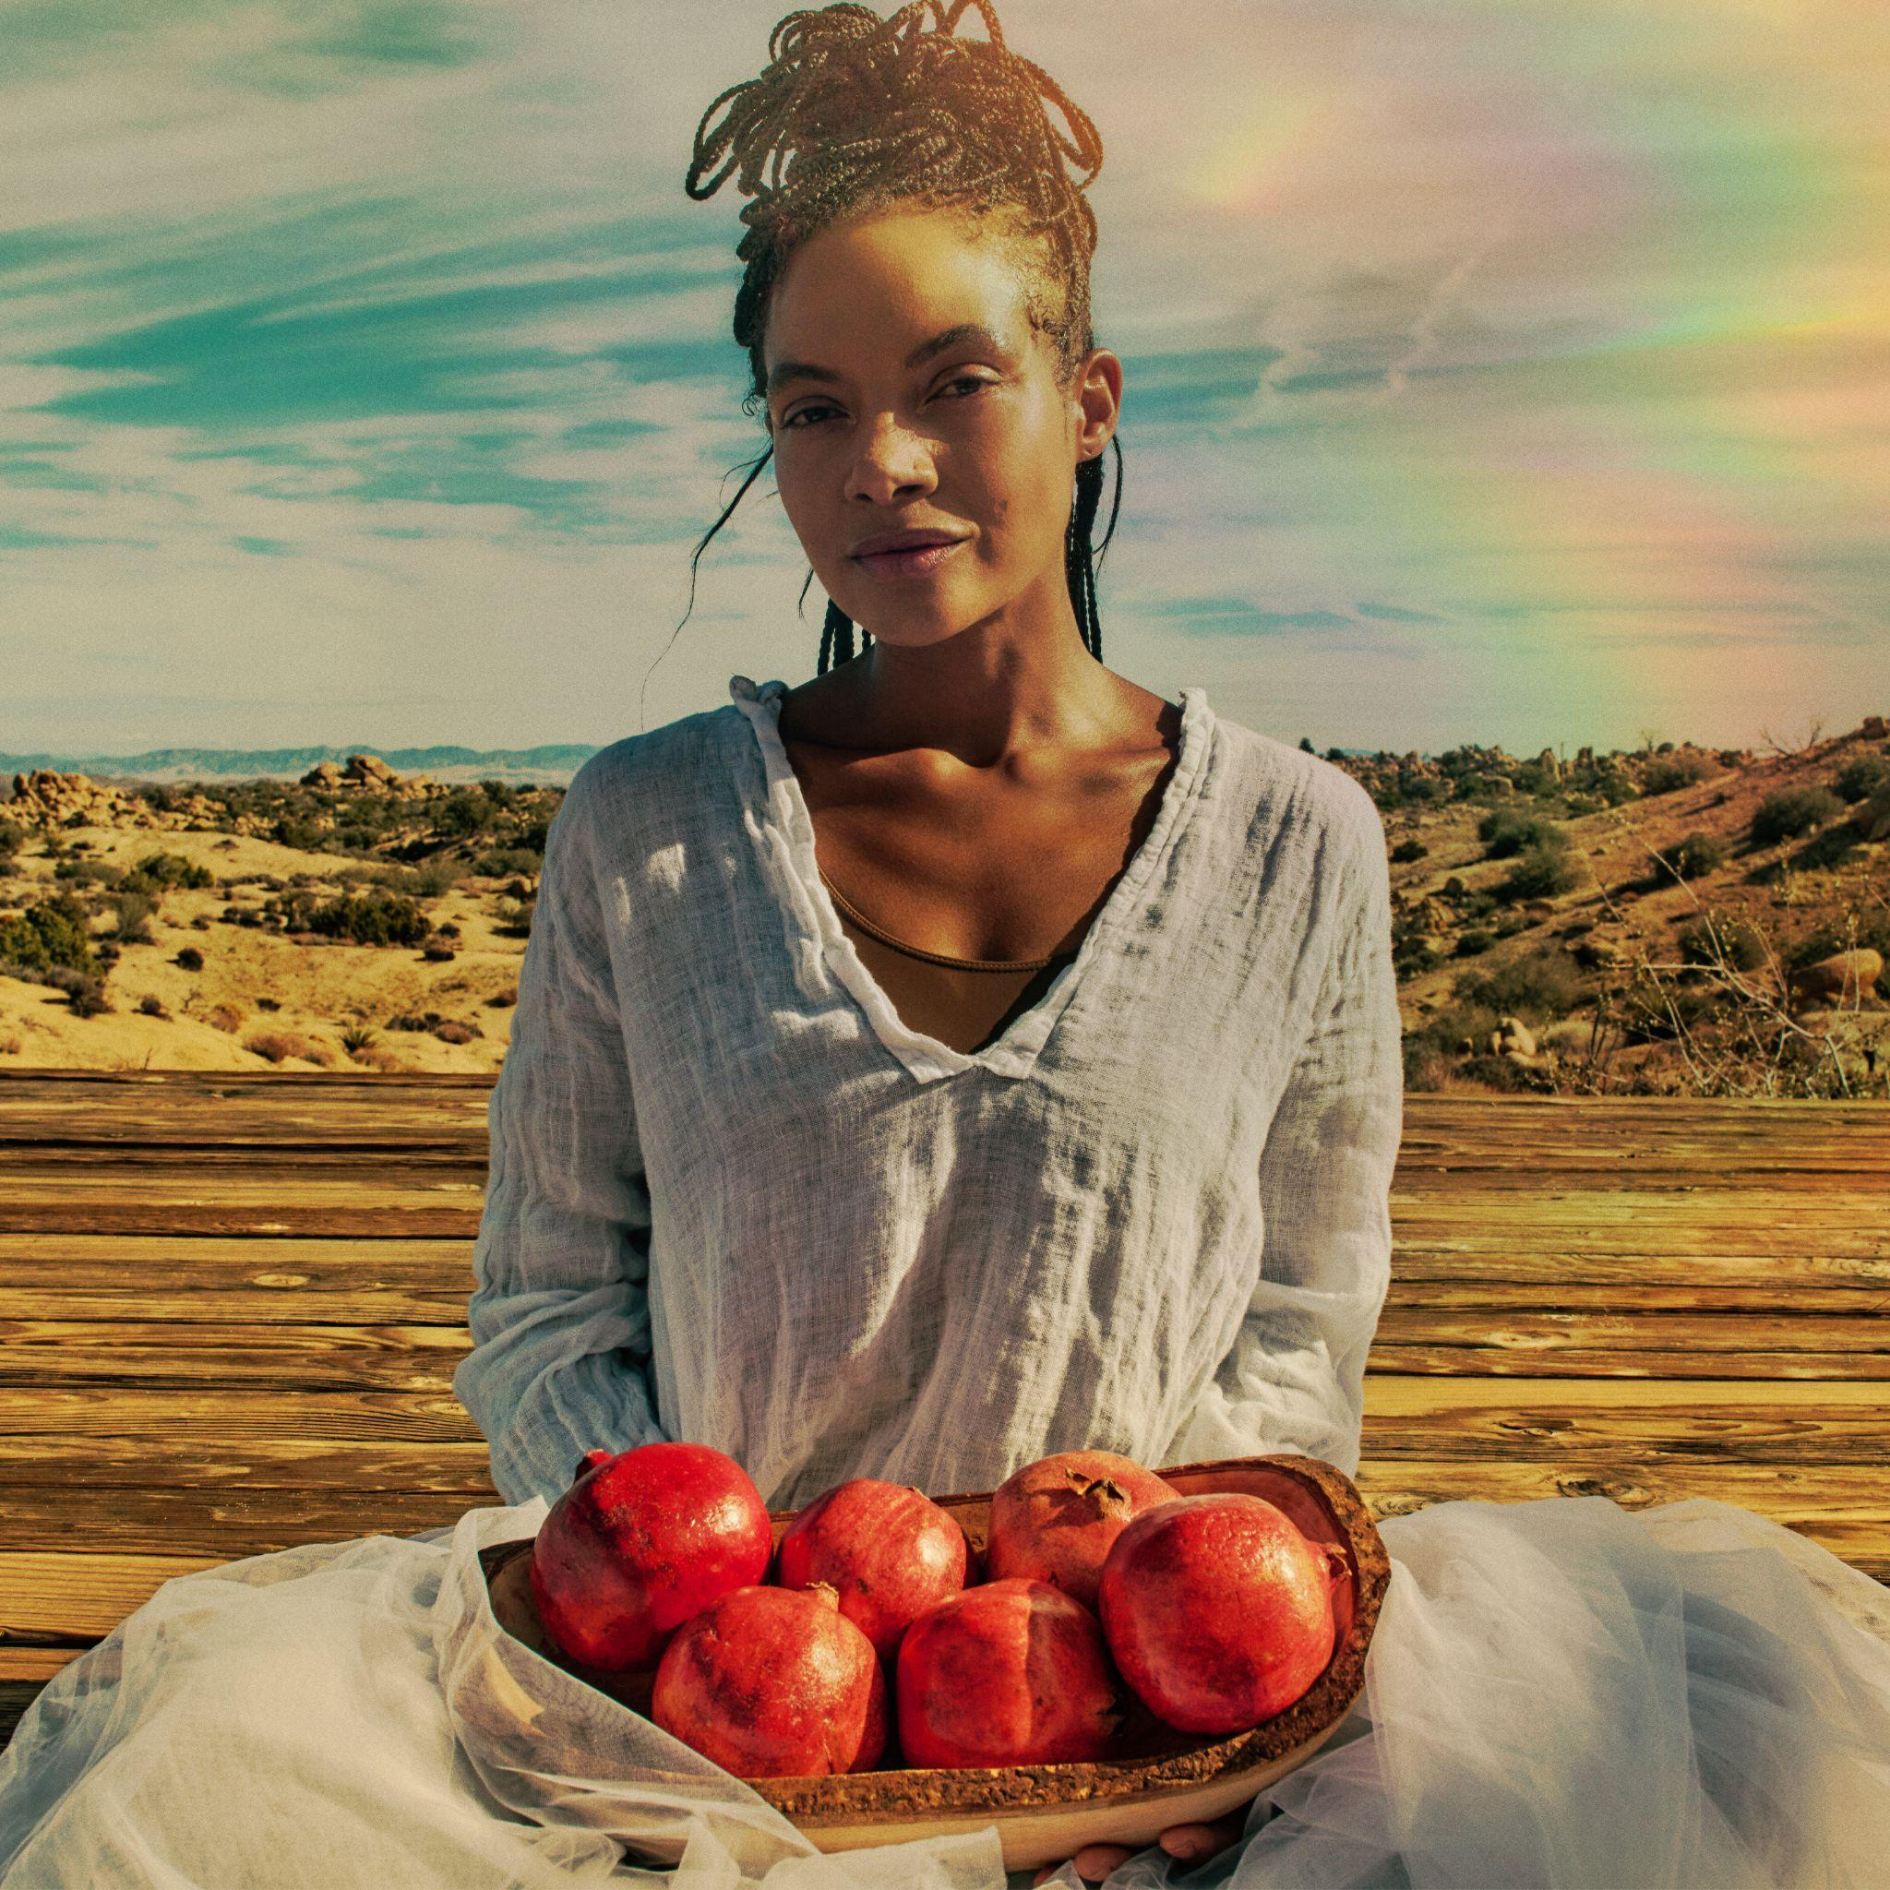
Photo Credit: Mason Poole | Download Hi-Res HERE

GRAMMY-winning singer-songwriter, poet, activist and multi-instrumentalist Allison Russell has released a new EP today titled, Rainbows. The 3-set includes her first new, original music in two years and is the title track. Listen to it HERE and watch the Mason Poole directed visualizer HERE. In addition to the original song, she has covered two Sarah McLachlan tracks including “Mary” and “Angel.” Russell will join the legendary artist on tour throughout the summer and the pair will perform together at the JUNO Awards later this month to honor Joni Mitchell. See all tour dates below and get your tickets HERE.

Allison Russell on “Rainbows”

“There is improbable magic all around us, and limitless magic in our own hearts and minds and imaginations. “Rainbows” is a song about reconnecting with our own essential magic —a magic maybe we thought we’d lost —so that we can pour it back into the World. It felt right to pair “Rainbows” with these two covers of Sarah McLachlan’s magical work. Sarah is a trailblazer for all women in music — her Lilith Fair taught an entire generation of girls & women that we were never in competition, always stronger in community.”

Russell has also just completed her second run on Broadway as Persephone in the 8 x Tony Award winning musical Hadestown. She took over the role in November 2024 initially, after spending much of that year opening for Hozier on his Unreal Unearth Tour supporting his arena run on all US dates and throughout Europe. She made her Billboard Hot 100 debut thanks to their duet “Wildflower & Barley.”

The accolades for Russell have been immense. Last year she was nominated for the Polaris Prize and named Billboard Women In Music Canada’s “Breakthrough Artist of the Year.” She has had 8 GRAMMY nominations and one win, earned three 2022 Americana Award nominations and a win for Album of the Year with subsequent nominations in 2023 and 2024, two International Folk Music Award wins, a 2022 Juno nomination for ‘Songwriter of the Year,’ and her first-ever Juno Award win for Contemporary Roots Album of the Year. Russell won three Canadian Folk Music Awards, two UK Americana Music Awards, and more. In addition, Russell has consistently used her platform to elevate, educate and inspire; curating the history making Once And Future Sounds: Roots and Revolution set for the Newport Folk Festival in 2021 and mobilizing the triumphant Love Rising All-Star benefit concert in support of LGBTQIA+ causes in Nashville - raising over $550,000 and calling national attention to Tennessee’s dangerous anti-trans and anti-drag laws. Russell has also announced a book deal for her debut novel, a memoir based on her life and the material that inspired Outside Child and The Returner.

Rainbows EP - Track Listing
- Rainbows
- Mary
- Angel

Tour Dates
*All dates supporting Sarah McLachlan

Jul 1 – FirstBank Amphitheater – Franklin, TN
Jul 3 – Synovus Bank Amphitheater at Chastain Park – Atlanta, GA
Jul 7 – TD Pavilion at The Mann – Philadelphia, PA
Jul 8 – Hartford HealthCare Amphitheater – Bridgeport, CT
Jul 10 – Leader Bank Pavilion – Boston, MA
Jul 11 – Forest Hills Stadium – Forest Hills, NY
Jul 12 – BankNH Pavilion – Gilford, NH
Jul 14 – Artpark Mainstage Theater – Lewiston, NY
Jul 15 – Michigan Lottery Amphitheatre at Freedom Hill – Sterling Heights, MI
Jul 17 – Acrisure Amphitheater – Grand Rapids, MI
Jul 18 – Huntington Bank Pavilion at Northerly Island – Chicago, IL
Jul 19 – Everwise Amphitheater at White River State Park – Indianapolis, IN
Jul 21 – PNC Pavilion – Cincinnati, OH
Jul 23 – Saint Louis Music Park – Maryland Heights, MO
Jul 24 – Starlight Theatre – Kansas City, MO
Jul 26 – The Pavilion at Toyota Music Factory – Irving, TX
Jul 30 – Utah First Credit Union Amphitheatre – West Valley City, UT
Aug 1 – Toyota Pavilion at Concord – Concord, CA
Aug 2 – The Rady Shell at Jacobs Park – San Diego, CA
Aug 4 – Greek Theatre – Los Angeles, CA
Aug 5 – Greek Theatre – Los Angeles, CA
Aug 7 – Hayden Homes Amphitheater – Bend, OR
Aug 8 – Chateau Ste Michelle Winery – Woodinville, WA
Aug 9 – Chateau Ste Michelle Winery – Woodinville, WA

ALLISON RUSSELL ONLINE:
Website | Twitter | Facebook | Instagram | YouTube
TikTok | Fantasy Records

For more information on Allison Russell contact:

Meg Helsel @ Grandstand Media Meghanh@grandstandhq.com

