ALLISON RUSSELL - ‘IN THE HOUR OF CHAOS’

NEW ALBUM OUT NOW VIA FANTASY RECORDS
Featuring Norah Jones, Brittney Spencer, Devon Gilfillian, Sara Watkins, Joy Oladokun, Kara Jackson, Kashus Culpepper, Denitia, Julie Williams, Ruby Amanfu, Kyshona, Ahya Simone, Chibueze Ihuoma, and more

WATCH NEW VIDEO FOR “SEARCHLIGHT (FT. KASHUS CULPEPPER)” HERE

ON TOUR NOW WITH SARAH MCLACHLAN

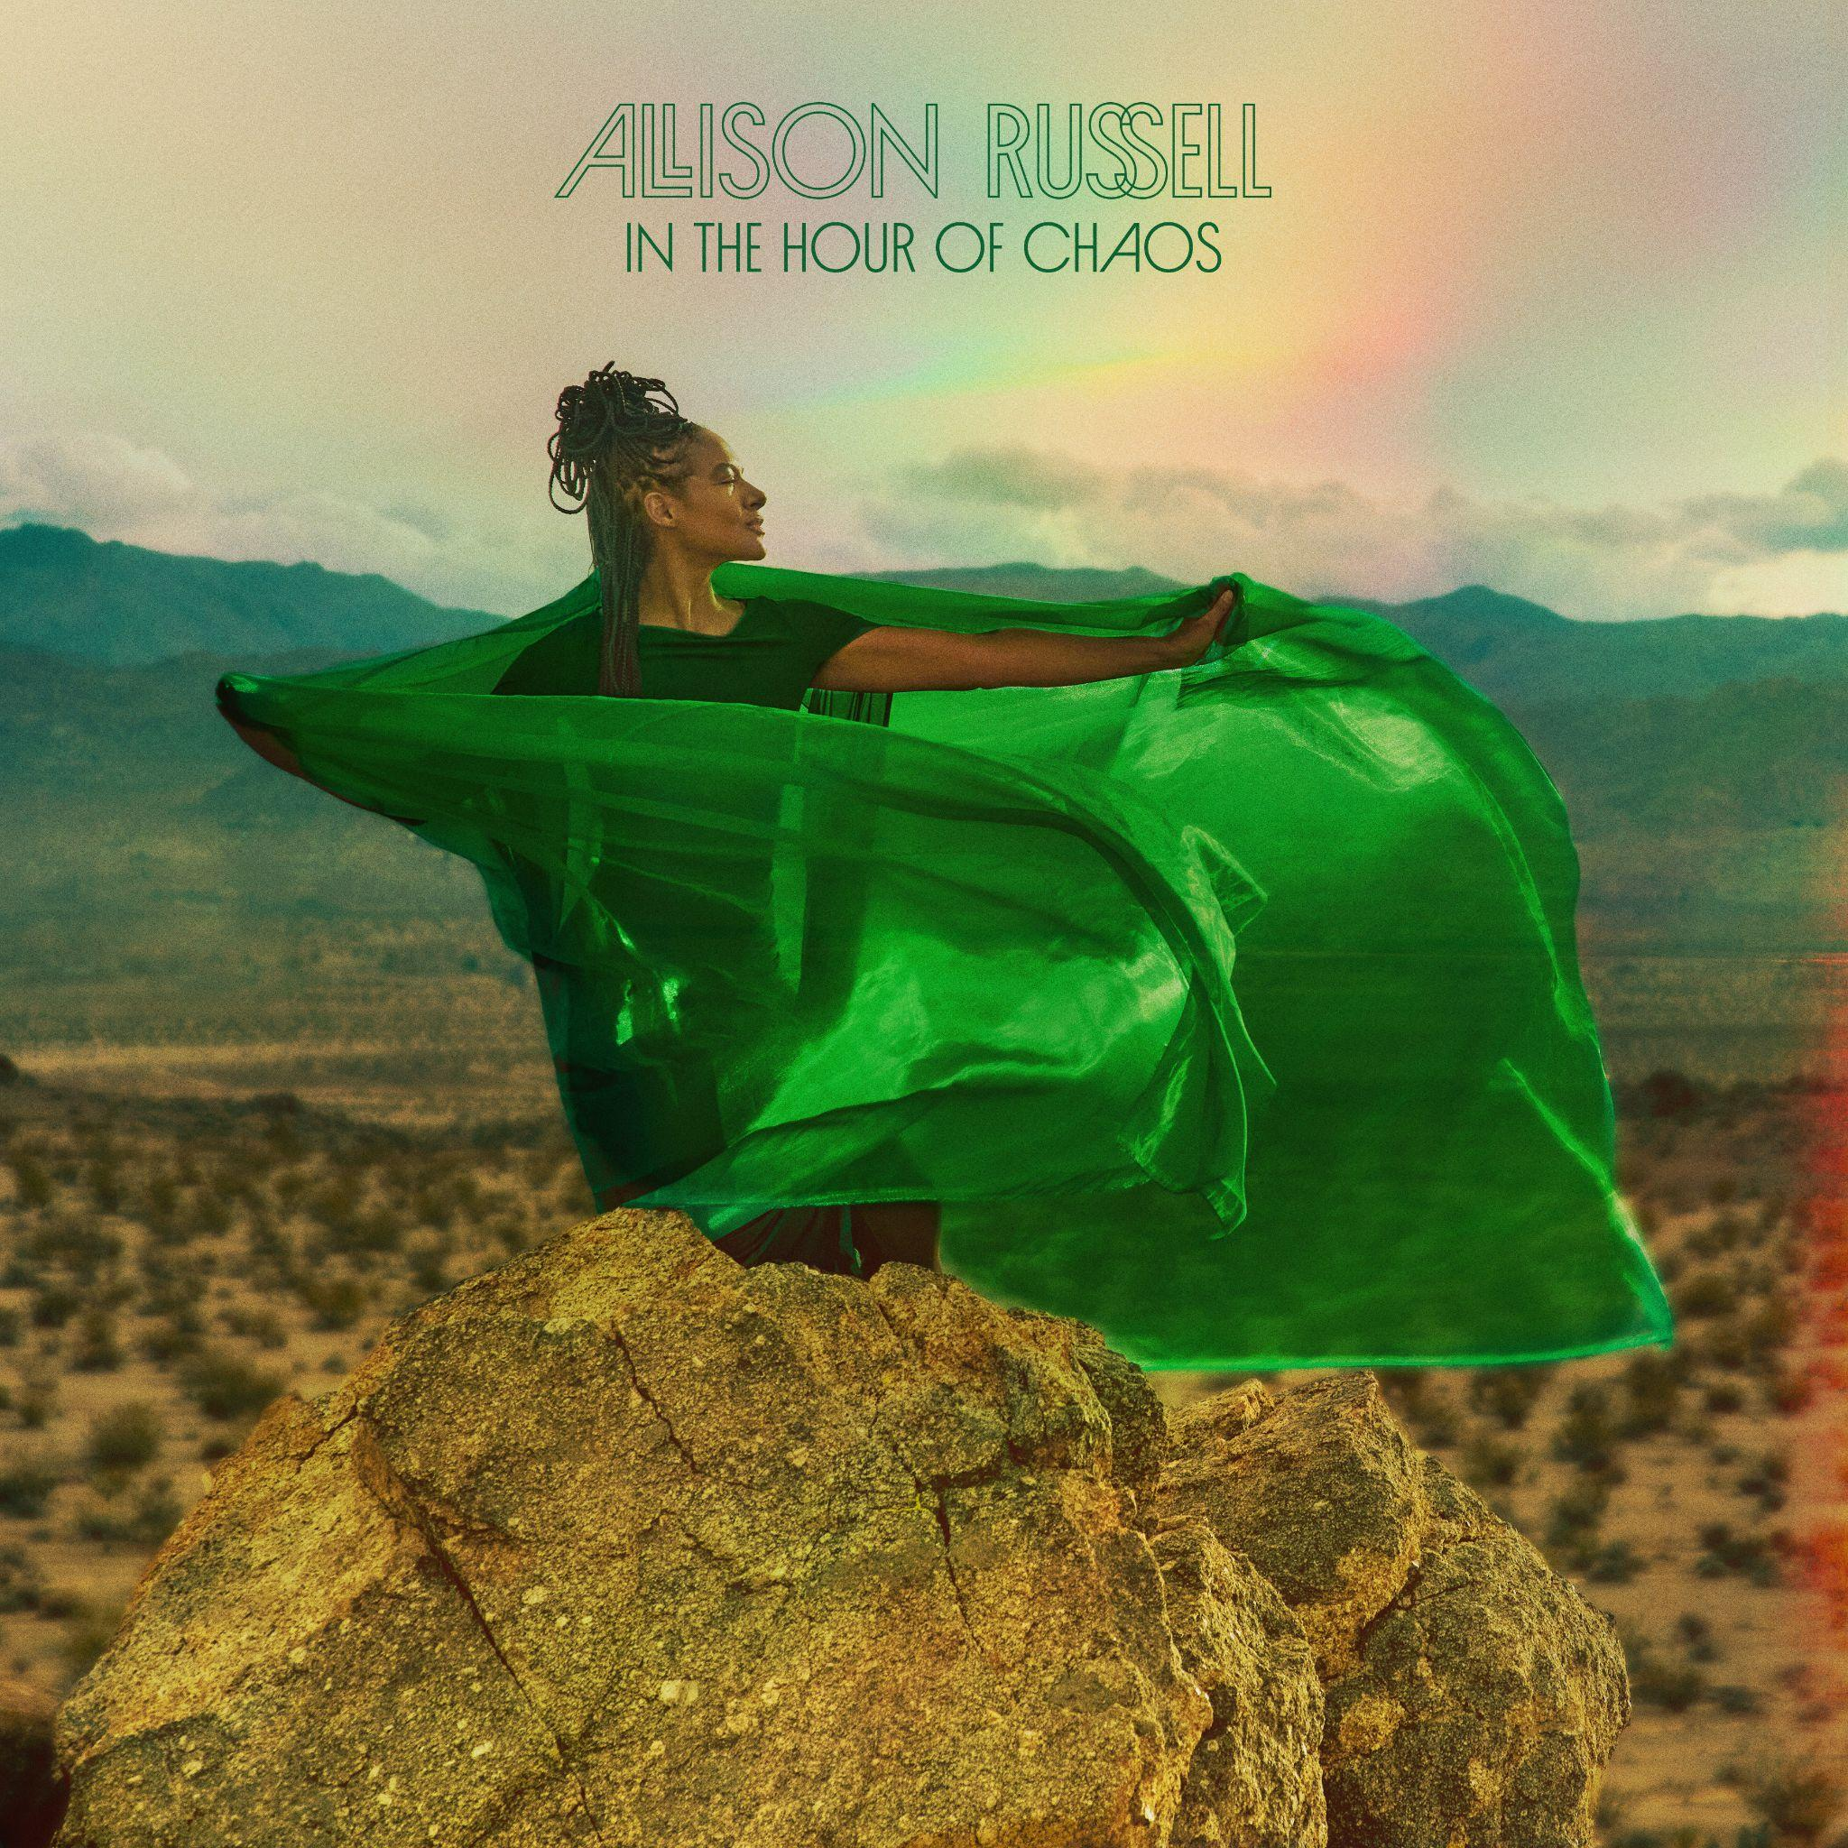
In The Hour Of Chaos album art - download hi-res here

“a duet of comfort, affirmation, praise and solace...The song recognizes opposition and the need to stay defensive, but it’s determinedly optimistic.” - The New York Times re: “Black Lavender”

"Allison Russell is one of those performers who smile as they hypnotize. She lulls you into a delighted state and then all of a sudden, you realize her talent has wrapped itself around you, and there is no escape" - American Songwriter

“In the Hour of Chaos testifies to the power of resilience and unity in the face of the political, social, economic, and personal chaos we face daily in these times...Russell creates an ebullient community of song." - No Depression

“Allison Russell leans into the healing power of music on ‘Cold April’... With voices lifted together, Russell channels resilience, community, and the strength to keep moving forward.” - KCRW re: “Cold April”

"arriving directly from the magical musical cosmos is a new track from the ethereal Allison Russell… a song about extending grace, comfort, and care – and the importance of community to lift each other up" - The Bluegrass Situation re: “Black Lavender”

“the gorgeous ballad “No Springtime,” a defiant resolution not to wallow in or to return to the resignation of past actions” - No Depression re: “No Springtime”

Today, Grammy-winning musician, poet and actor Allison Russell releases her third studio album In The Hour of Chaos via Fantasy Records. Produced by Russell and Dim Star, the album is a fervent plea for connection in this time of alienation, isolation and dread. It’s an album that is meant to make you feel GOOD and, in these times, feeling good is a radical act. She also shares the Athena Kulb-directed video for the album’s focus track, “Searchlight” featuring Kashus Culpepper, who adds grit and swagger to the track.

Listen to In The Hour of Chaos HERE and watch the video for “Searchlight (ft. Kashus Culpepper)” HERE.

The songs on Allison Russell’s In the Hour of Chaos are meant to reverse the tides that pull us farther and farther apart, even from ones we love the most. It’s only fitting that Russell leaned into her vibrant and ever expanding community of artists and friends to create a collaborative song suite that goes far beyond a succession of features.

These songs unfold like a series of one act plays with Allison, who joins with an artist(s) from her rainbow diaspora, many from her adopted home in Nashville. Tactile, vulnerable, raw, soothing, sensual, sad – each is a little capsule of humans being fully human and fully present. Allison Russell curates her collaborators with care including Norah Jones’ intimate ease on “Really Real” and Ruby Amanfu’s vulnerable grace on “Just Like Saturday” – all serve as portals into our flawed, fantastic, interconnected lives.

Early releases from the album include her Juneteenth single ft. Brittney Spencer, “Black Lavender” – a celebration of sisterhood; “No Springtime” featuring Joy Oladokun and Julie Williams; and “Cold April,” a track showing intergenerational depth by featuring her tourmate Kara Jackson — a recent collaborator of the Gorillaz and formerly the U.S. National Youth Poet Laureate, Denitia – a CMT Next Women of Country selection who was also featured in Dolly Parton’s Threads: My Songs in Symphony, and the Explore! Pop Choir featuring Russell’s daughter, Ida.

Elsewhere, Devon Gilfillian brings effortless warmth to “Love is a Golden Lion,” Chibueze Ihuoma adds an otherworldly tenderness to “Two Stars,” and Ahya Simone’s incomparable harp closes the circle with the haunting “Good Omens.” Across these songs, Russell holds the center effortlessly, while illuminating the voices of her chosen family. She turns these throughlines into golden thread, strengthening as she weaves, the only protection she knows against the chaos of this hour.

Community has deep importance to Allison, as evidenced in her recent conversation with community leader Rep. Justin Jones (TN-52) and moderated by singer-songwriter Ruby Amanfu at The National Museum of African American Music in Nashville where they discussed ways to remain strong and create joy during tumultuous times; in the midst of targeting, how to find strength in ourselves and for our neighbors. See select photos HERE.

Russell also took the stage at the JUNO Awards earlier this year to pay tribute to fellow Canadian, Joni Mitchell with a duet between her and Sarah McLachlan. Russell is currently on tour throughout North America with McLachlan – see a full list of her tour dates below.

Allison Russell just completed her second run on Broadway as Persephone in the 8x Tony Award winning musical Hadestown. She took over the role in November 2024 initially, after spending much of that year opening for Hozier on his Unreal Unearth Tour supporting his arena run on all US dates and throughout Europe. She made her Billboard Hot 100 debut thanks to their duet “Wildflower & Barley.”

The accolades for Russell have been immense. Last year she was shortlisted for the Polaris Prize and named Billboard Women In Music Canada’s “Breakthrough Artist of the Year.” She has had 8 GRAMMY nominations and one win, earned three 2022 Americana Award nominations and a win for Album of the Year with subsequent nominations in 2023 and 2024, two International Folk Music Award wins, a 2022 Juno nomination for ‘Songwriter of the Year,’ and her first-ever Juno Award win for Contemporary Roots Album of the Year. Russell won three Canadian Folk Music Awards, two UK Americana Music Awards, and more.

Album Tracklist
1. Rainbows
2. No Springtime ft Joy Oladokun & Julie Williams
3. Cold April ft Kara Jackson, Denitia & Explore! Pop Choir
4. Black Lavender ft Brittney Spencer
5. Really Real ft Norah Jones
6. Just Like Saturday ft Ruby Amanfu
7. Chaos Theory ft Kyshona & Sara Watkins
8. Love is a Golden Lion ft Devon Gilfillian
9. Searchlight ft Kashus Culpepper
10. Two Stars ft Chibueze Ihuoma
11. Good Omens ft Ahya Simone

Allison Russell Tour Dates
Jul 10 – Leader Bank Pavilion – Boston, MA*
Jul 12 – BankNH Pavilion – Gilford, NH*
Jul 14 – Artpark Mainstage Theater – Lewiston, NY*
Jul 15 – Michigan Lottery Amphitheatre at Freedom Hill – Sterling Heights, MI*
Jul 17 – Acrisure Amphitheater – Grand Rapids, MI*
Jul 18 – Huntington Bank Pavilion at Northerly Island – Chicago, IL*
Jul 19 – Everwise Amphitheater at White River State Park – Indianapolis, IN*
Jul 21 – PNC Pavilion – Cincinnati, OH*
Jul 23 – Saint Louis Music Park – Maryland Heights, MO*
Jul 24 – Starlight Theatre – Kansas City, MO*
Jul 26 – The Pavilion at Toyota Music Factory – Irving, TX*
Jul 30 – Utah First Credit Union Amphitheatre – West Valley City, UT*
Aug 01 – Toyota Pavilion at Concord – Concord, CA*
Aug 02 – The Rady Shell at Jacobs Park – San Diego, CA*
Aug 04 – Greek Theatre – Los Angeles, CA*
Aug 07 – Hayden Homes Amphitheater – Bend, OR*
Aug 08 – Chateau Ste Michelle Winery – Woodinville, WA*
Aug 09 – Chateau Ste Michelle Winery – Woodinville, WA*
Oct 15 – The Orange Peel – Asheville, NC
Oct 22 – Massey Hall – Toronto, ON
Oct 23 – Theatre Beanfield – Montreal, QC
Oct 24 – Imperial Bell – Quebec City, QC
Oct 25 – National Arts Centre - Southam Hall – Ottawa, ON
Oct 27 – Higher Ground The Ballroom – South Burlington, VT
Nov 01 – First Avenue – Minneapolis, MN
Nov 03 – Burton Cummings Theatre – Winnipeg, MB
Nov 05 – Winspear Centre – Edmonton, AB
Nov 06 – Grey Eagle Resort & Event Centre – Calgary, AB
Nov 09 – Chan Centre for the Performing Arts – Vancouver, BC
*supporting Sarah McLachlan

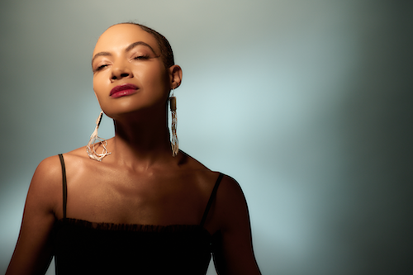
Press photo by Mason Poole | download here

More About Allison Russell
Montreal-born, Nashville-based Allison Russell is a GRAMMY, Juno, Americana, SOCAN, and Folk Award–winning artist and Polaris Prize–shortlisted singer-songwriter, producer, author, actor, and human rights advocate.

Her acclaimed solo debut Outside Child (2021) was followed by The Returner (2023), released via Concord/Fantasy. Prior to her solo work, she co-founded and toured internationally with Po’Girl, Birds of Chicago, and Our Native Daughters, and remains an active collaborator with OND and a member of Joni Mitchell’s Joni Jam.

In 2024, Russell joined Hozier’s Unreal Unearth tour across the U.S. and Europe, with their duet “Wildflower & Barley” earning her first Billboard Hot 100 entry. Her Rainbow Coalition ensemble and All Returners tour continued through 2025 across Australia and North America. She also co-wrote “Human Mind” with Hozier for Mavis Staples.

Russell has received eight Grammy nominations and one win, alongside multiple honors including Americana Award nominations and Album of the Year, a Juno Award for Contemporary Roots Album of the Year, International Folk Music Awards, Canadian Folk Music Awards, and UK Americana Awards. She was also named Billboard Women in Music Canada’s Breakthrough Artist of the Year and shortlisted for the Polaris Prize.

She made her Broadway debut as Persephone in Anaïs Mitchell’s Hadestown in November 2024 and has since completed a second run in the role. Offstage, Russell is a powerful advocate and organizer, curating the historic Once and Future Sounds set at Newport Folk Festival and co-founding Love Rising, which has raised over $550,000 in support of LGBTQIA+ communities.

Her forthcoming memoir will be published by LittleBrown, and her third album is slated for release in 2026.

ALLISON RUSSELL ONLINE:
Website | Twitter | Facebook | Instagram | YouTube
TikTok | Fantasy Records

For more information on Allison Russell, contact Grandstand Media:
Meghan Helsel, Meghanh@grandstandhq.com
Shazila Mohammed, shazm@grandstandhq.com
Grace Phalon (tour), grace@grandstandhq.com

