ALLISON RUSSELL ANNOUNCES THIRD STUDIO ALBUM
IN THE HOUR OF CHAOS
OUT JULY 10TH ON FANTASY RECORDS
Featuring Norah Jones, Brittney Spencer, Devon Gilfillian, Sara Watkins, Joy Oladokun, Kara Jackson, Kashus Culpepper, Denitia, Julie Williams, Ruby Amanfu, Kyshona, Ahya Simone, Chibueze Ihuoma, and more

LISTEN TO THE SINGLE “COLD APRIL” HERE
FEATURING KARA JACKSON, DENITIA & EXPLORE! POP CHOIR
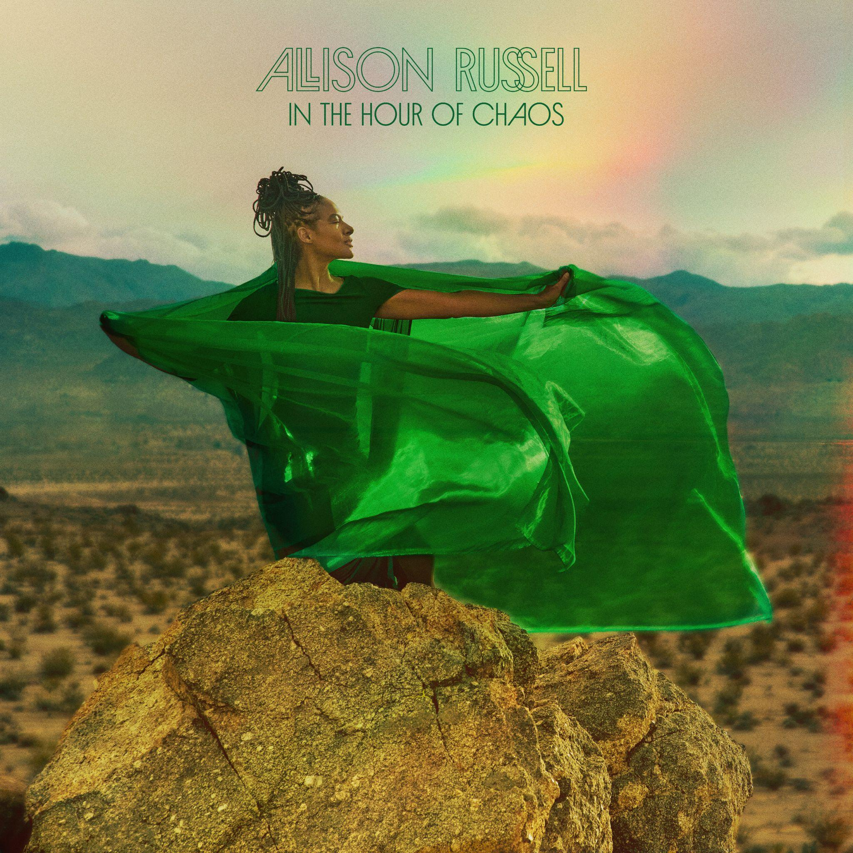
IN THE HOUR OF CHAOS ALBUM ART - DOWNLOAD HI-RES HERE

Today, Allison Russell has announced her third studio album, In The Hour of Chaos, produced by Russell and Dim Star and arriving on July 10th via Fantasy Records. To mark the occasion she has shared the single “Cold April” featuring her tourmate Kara Jackson, Denitia and the Explore! Pop Choir. LISTEN HERE.

Allison Russell on “Cold April”
Things are rough. Things have been rough before. Cold April is not laying out the grim facts of the moment. Cold April asks if we can let the music itself restore and recharge us. The act of singing with my sisters, Kara Jackson and Denitia, is a balm for my soul, and a wind at my back to keep on. And the Explore! Pop Choir… Let them tell it:
“Calling all birds from across the nation
yeah we got a brand new murmuration
we don’t have to fly in that
old formation, no”
Youth - and Love - will be served!

Allison Russell’s In the Hour of Chaos is a fervent plea for connection in this time of alienation, isolation and dread. These are songs meant to reverse the tides that pull us farther and farther apart, even from ones we love the most.This is a record meant to make you feel GOOD, and, in these times, feeling good is a radical act. It’s only fitting then, that Russell leaned into her vibrant and ever expanding community of artists and friends to create a collaborative song suite that goes far beyond a succession of features.

The songs unfold like a series of one act plays with Allison, who joins with an artist(s) from her rainbow diaspora, many from her adopted home in Nashville. Tactile, vulnerable, raw, soothing, sensual, sad – each is a little capsule of humans being fully human and fully present. From the quiet reckoning of “No Springtime” with Joy Oladokun and Julie Williams, to the joy- with-a-splash-of-sadness that is “Cold April,” where Kara Jackson, Denitia, and Russell’s daughter Ida’s Explore! Pop Choir add intergenerational depth, Allison Russell curates collaborators with care: Brittney Spencer’s earthy soul on “Black Lavender,” Norah Jones’ intimate ease on “Really Real,” Ruby Amanfu’s vulnerable grace on “Just Like Saturday,” – all serve as portals into our flawed, fantastic, interconnected lives.

Elsewhere, Devon Gilfillian brings effortless warmth to “Love is a Golden Lion,” Kashus Culpepper lends grit and swagger to “Searchlight,” Chibueze Ihuoma adds an otherworldly tenderness to “Two Stars,” and Ahya Simone’s incomparable harp closes the circle with the haunting “Good Omens.” Across these songs, Russell holds the center effortlessly, while illuminating the voices of her chosen family. She turns these throughlines into golden thread, strengthening as she weaves, the only protection she knows against the chaos of this hour.

Allison Russell - In The Hour Of Chaos
By Ocean Vuong

Music has healed human beings for as long as we have been singing. But what does it mean when an artist deliberately turns her instrument into medicinal enactment? What is discovered when joy, fulfillment, and wonder are the guiding lights of an album, when one does not repair by accident—but by deliberate artistry?

This is indeed rare, even daring, in a culture that sees artistic methods of healing and repair as merely “service” or “social work,” that believes “real” art, serious “grown-up” art, the art lauded by institutions and museums, shouldn’t concern itself with something so minor and domestic as “feeling better.” But this revisionist view of music goes against its historic reality: that music, made to heal, heals. This is true of our most ancient hymns and rhythms and chants. Why should this change now?

In this new album by Allison Russell, one of the greatest lyric storytellers of our time, redemption does not come from the voice alone—it comes through the act of controlling and re-casting our stories so that they might be embodied, shared, and celebrated by others. Not unlike the R&B, Blues, and Folk/Country traditions that she honors and expands, her songs are sonic accompaniment to life itself. This is music to live, fight, and fuck to. Songs you put on after work because you need to be beside somebody in an empty room. Songs to which you could drive to the edge of the county just to return to whatever keeps you faithful—or to floor it across state lines and start a Tracy-Chapman-fast-car new life and get “outta here.” But more importantly, these are songs you send to a friend and say, simply, call me after you hear this. An impulse that comes from the ancient desire to use music as a conductor of love between two people. Here’s what I wanted to say but couldn’t find the words for. And even if what we want to say are a litany of the most painful things, that the song makes it shareable, makes it known, like a cigarette passed from one to another in the dark, is a triumph.

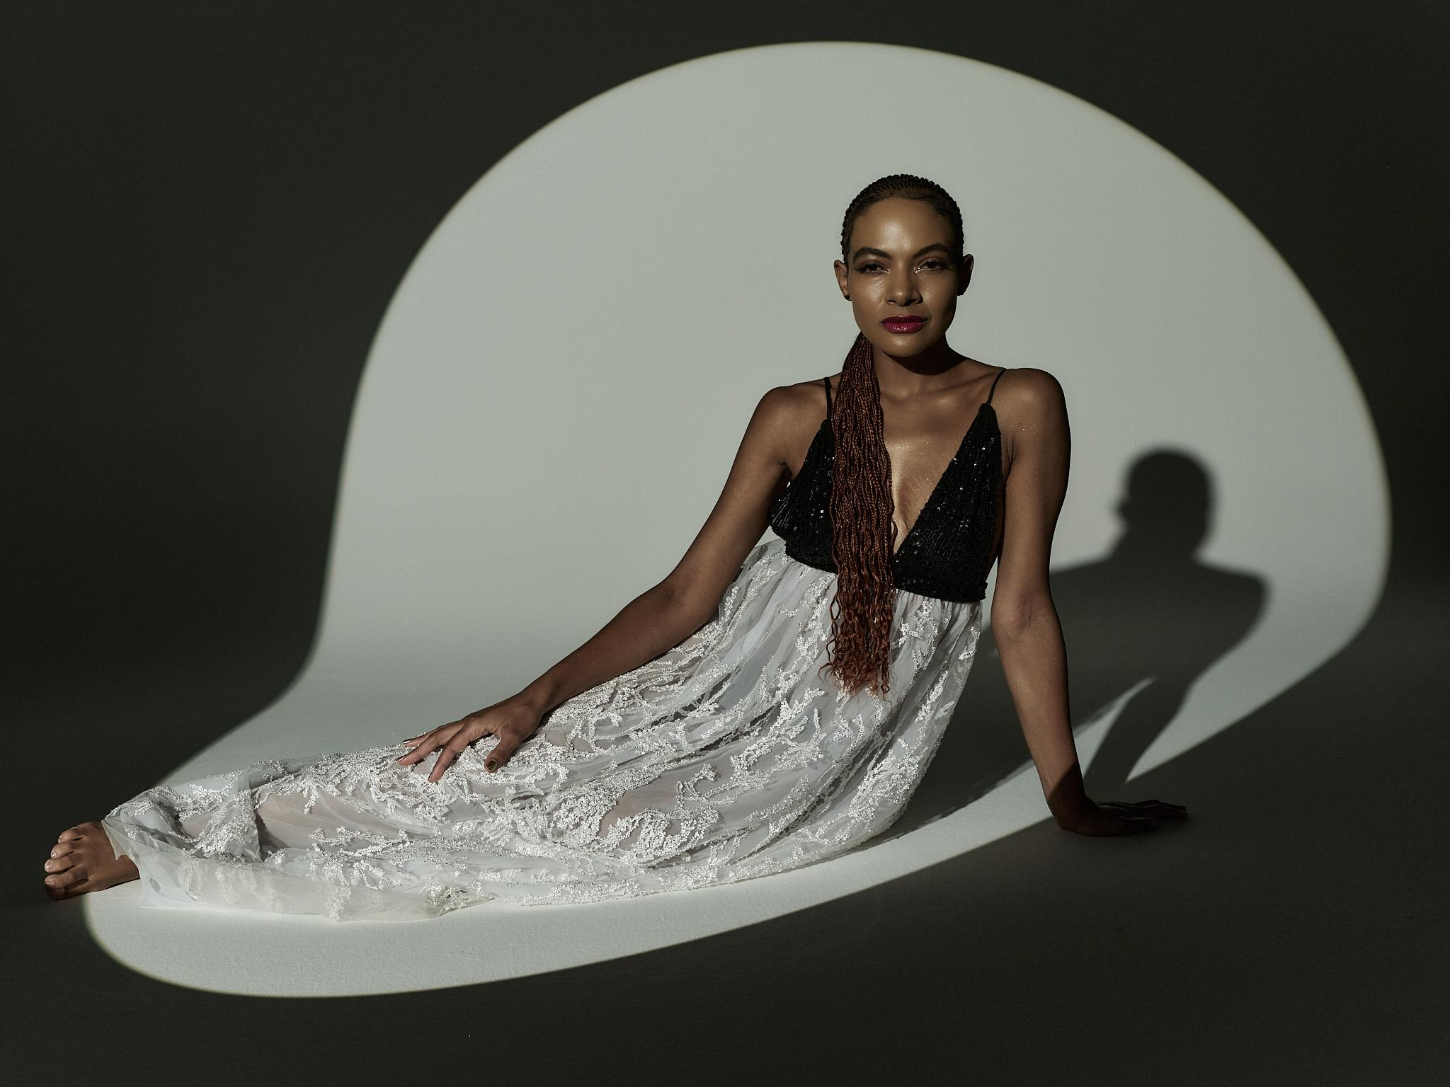
Photo Credit: Mason Poole - Download Hi-Res HERE

Allison Russell just completed her second run on Broadway as Persephone in the 8x Tony Award winning musical Hadestown. She took over the role in November 2024 initially, after spending much of that year opening for Hozier on his Unreal Unearth Tour supporting his arena run on all US dates and throughout Europe. She made her Billboard Hot 100 debut thanks to their duet “Wildflower & Barley.”

Russell recently took the stage at the JUNO Awards to pay tribute to fellow Canadian, Joni Mitchell. The performance was a duet between her and Sarah McLachan who she will tour with throughout the summer. Dates kick off on July 1st in Franklin, TN. A full list of tour dates is below.

The accolades for Russell have been immense. Last year she was nominated for the Polaris Prize and named Billboard Women In Music Canada’s “Breakthrough Artist of the Year.” She has had 8 GRAMMY nominations and one win, earned three 2022 Americana Award nominations and a win for Album of the Year with subsequent nominations in 2023 and 2024, two International Folk Music Award wins, a 2022 Juno nomination for ‘Songwriter of the Year,’ and her first-ever Juno Award win for Contemporary Roots Album of the Year. Russell won three Canadian Folk Music Awards, two UK Americana Music Awards, and more.

Album Tracklist
1. Rainbows
2. No Springtime ft Joy Oladokun & Julie Williams
3. Cold April ft Kara Jackson, Denitia & Explore! Pop Choir
4. Black Lavender ft Brittney Spencer
5. Really Real ft Norah Jones
6. Just Like Saturday ft Ruby Amanfu
7. Chaos Theory ft Kyshona & Sara Watkins
8. Love is a Golden Lion ft Devon Gilfillian
9. Searchlight ft Kashus Culpepper
10. Two Stars ft Chibueze Ihuoma
11. Good Omens ft Ahya Simone

Tour Dates
* supporting Sarah McLachlan

Jul 1 – FirstBank Amphitheater – Franklin, TN*
Jul 3 – Synovus Bank Amphitheater at Chastain Park – Atlanta, GA*
Jul 7 – TD Pavilion at The Mann – Philadelphia, PA*
Jul 8 – Hartford HealthCare Amphitheater – Bridgeport, CT*
Jul 10 – Leader Bank Pavilion – Boston, MA*
Jul 11 – Forest Hills Stadium – Forest Hills, NY*
Jul 12 – BankNH Pavilion – Gilford, NH*
Jul 14 – Artpark Mainstage Theater – Lewiston, NY*
Jul 15 – Michigan Lottery Amphitheatre at Freedom Hill – Sterling Heights, MI*
Jul 17 – Acrisure Amphitheater – Grand Rapids, MI*
Jul 18 – Huntington Bank Pavilion at Northerly Island – Chicago, IL*
Jul 19 – Everwise Amphitheater at White River State Park – Indianapolis, IN*
Jul 21 – PNC Pavilion – Cincinnati, OH*
Jul 23 – Saint Louis Music Park – Maryland Heights, MO*
Jul 24 – Starlight Theatre – Kansas City, MO*
Jul 26 – The Pavilion at Toyota Music Factory – Irving, TX*
Jul 30 – Utah First Credit Union Amphitheatre – West Valley City, UT*
Aug 1 – Toyota Pavilion at Concord – Concord, CA*
Aug 2 – The Rady Shell at Jacobs Park – San Diego, CA*
Aug 4 – Greek Theatre – Los Angeles, CA*
Aug 5 – Greek Theatre – Los Angeles, CA*
Aug 7 – Hayden Homes Amphitheater – Bend, OR*
Aug 8 – Chateau Ste Michelle Winery – Woodinville, WA*
Aug 9 – Chateau Ste Michelle Winery – Woodinville, WA*
Oct 15 – The Orange Peel – Asheville, NC
Oct 22 – Allied Music Centre - Massey Hall – Toronto, ON
Oct 23 – Theatre Beanfield – Montreal, QC
Oct 24 – Imperial Bell – Quebec City, QC
Oct 25 – National Arts Centre - Southam Hall – Ottawa, ON
Oct 27 – Higher Ground The Ballroom – South Burlington, VT
Nov 1 – First Avenue – Minneapolis, MN
Nov 3 – Burton Cummings Theatre – Winnipeg, MB
Nov 5 – Winspear Centre – Edmonton, AB
Nov 6 – Grey Eagle Resort & Casino Event Centre – Calgary, AB
Nov 9 – University of British Columbia Vancouver Chan Centre – Vancouver, BC

More About Allison Russell
Montreal-born, Nashville-based Allison Russell is a GRAMMY, Juno, Americana, SOCAN, and Folk Award–winning artist and Polaris Prize–shortlisted singer-songwriter, producer, author, actor, and human rights advocate.
Her acclaimed solo debut Outside Child (2021) was followed by The Returner (2023), released via Concord/Fantasy. Prior to her solo work, she co-founded and toured internationally with Po’Girl, Birds of Chicago, and Our Native Daughters, and remains an active collaborator with OND and a member of Joni Mitchell’s Joni Jam.
In 2024, Russell joined Hozier’s Unreal Unearth tour across the U.S. and Europe, with their duet “Wildflower & Barley” earning her first Billboard Hot 100 entry. Her Rainbow Coalition ensemble and All Returners tour continued through 2025 across Australia and North America. She also co-wrote “Human Mind” with Hozier for Mavis Staples.
Russell has received eight Grammy nominations and one win, alongside multiple honors including Americana Award nominations and Album of the Year, a Juno Award for Contemporary Roots Album of the Year, International Folk Music Awards, Canadian Folk Music Awards, and UK Americana Awards. She was also named Billboard Women in Music Canada’s Breakthrough Artist of the Year and shortlisted for the Polaris Prize.
She made her Broadway debut as Persephone in Anaïs Mitchell’s Hadestown in November 2024 and has since completed a second run in the role. Offstage, Russell is a powerful advocate and organizer, curating the historic Once and Future Sounds set at Newport Folk Festival and co-founding Love Rising, which has raised over $550,000 in support of LGBTQIA+ communities.
Her forthcoming memoir will be published by LittleBrown, and her third album is slated for release in 2026.
ALLISON RUSSELL ONLINE:
Website | Twitter | Facebook | Instagram | YouTube
TikTok | Fantasy Records

For more information on Allison Russell contact:

Meg Helsel at Grandstand Media Meghanh@grandstandhq.com

