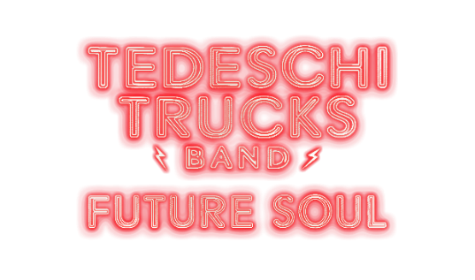

Tedeschi Trucks Band
Announces Sixth Studio Album
Future Soul
Out March 20th via Fantasy Records

First Single “I Got You” Out Now!
PRESS HERE To Listen
PRESS HERE To Pre-Order Album

Announces Future Soul 2026 Tour
Pre-Sale Tickets Available Starting Tuesday, January 27
General On Sale Begins Friday, January 30

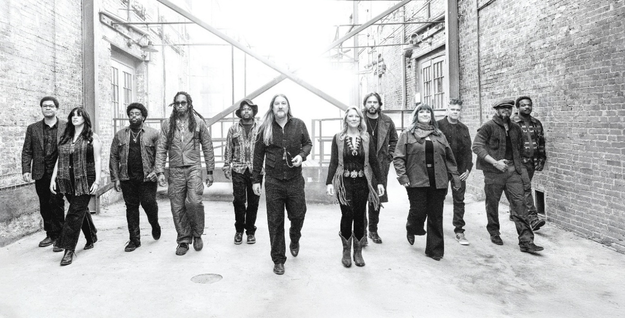
Photo Credit: Chapman Baehler

“A master class in bluesy roots-rock.” – Billboard

“An electrifying sound that mixes R&B, gospel and many shades of the blues.” – Rolling Stone

“Soul-stirring music.” – American Songwriter

“The Tedeschi Trucks Band [is] a rarity on the jam-band scene: an act that excels at singing and songwriting as much as at soloing.” – Paste Magazine

“Powerhouse vocals, searing solos and real musical synchronicity.” – Jazz Times

“A group that is, unquestionably, the most impressive rock outfit on the road today. No one comes close to touching their musicianship, energy, and outright capacity to create their own kind of magic night after night.” – Goldmine Magazine

‘The future certainly will have soul in it as long as the Tedeschi Trucks Band are still jamming out.”
– PopMatters

FOR IMMEDIATE RELEASE – January 23, 2026 – Tedeschi Trucks Band (TTB), the GRAMMY Award-winning band led by the dynamic wife and husband duo of Susan Tedeschi and Derek Trucks, has announced the details for their sixth studio album, Future Soul, and released the first single “I Got You.” The 11-track collection, the band’s most powerful album to date, will be released on Friday, March 20th via Fantasy Records in the middle of TTB’s 10-show headlining run at NYC’s Beacon Theatre. The infectious “I Got You,” written by guitarist/vocalist Mike Mattison, takes cues from the spirit of Derek and the Dominos and Delaney & Bonnie to create a driving, mid-tempo classic. PRESS HERE to listen and PRESS HERE to watch the official video. PRESS HERE to pre-save Future Soul on DSPs and to pre-order on CD and vinyl.
“‘I Got You’ is a breath of fresh air and pretty different for us,” shares Trucks. “It feels like the band, but it doesn’t feel like anything we’ve done before.”

Produced by Mike Elizondo (Twenty One Pilots, Eminem, Dr. Dre, Carrie Underwood) and co-produced by Trucks, Future Soul – recorded at their own Swamp Raga Recording (Jacksonville, FL) as well as Phantom Studios (Gallatin, TN) – marks the follow-up to TTB’s 2022 conceptual quadruple studio album, I Am The Moon, and their latest live release, Tedeschi Trucks Band and Leon Russell Present: Mad Dogs & Englishmen Revisited (LIVE AT LOCKN’) (2025). The heart, honesty, and full-band collaboration on Future Soul makes the forthcoming album the most unique collection to date from the revered 12-piece powerhouse ensemble. The majority of the songwriting was done by Trucks, Tedeschi, Mattison, Gabe Dixon, and Tyler Greenwell with the music sonically pulling from a variety of influences including funk, rock ‘n roll, blues, soul, punk, and much more. Track listing for Future Soul below.

To support the album’s release, Tedeschi Trucks Band has announced their Future Soul 2026 Tour, produced by Live Nation. Following the band’s residency at the Beacon Theatre in New York City from March 10-28, the 35-date headlining outing will kick off April 14th in Dallas for the spring leg, which also stops in Fort Worth, Houston, Raleigh and Atlanta, the latter as a co-headlining show with Jason Isbell and the 400 Unit. To launch the summer and fall portion of the tour, TTB – “one of the best bands on the road today” – returns to Red Rocks Amphitheatre for their annual double header on July 31st and August 1st. They’ll then bring their electrifying and acclaimed live show across the U.S. stopping in such cities as Seattle, Berkeley, Santa Barbara, San Diego, Los Angeles, Indianapolis, St. Louis, Cincinnati, Washington, DC, Bridgeport, St. Augustine, Tampa, and Milwaukee, among many others, before wrapping with a four-night stand in Chicago from October 23-27. Four dates in August will feature co-headlining shows with Alabama Shakes. Also joining will be very special guest Sheryl Crow for two shows in September, Lukas Nelson on select dates throughout the tour, and JJ Grey & Mofro and Molly Tuttle in various cities, respectively. TTB is also set to perform at numerous festivals this year including Bonnaroo, New Orleans Jazz & Heritage Festival, and Telluride Bluegrass Festival in addition to their own Sun, Sand & Soul experience in April. See below for all upcoming tour dates.

TTB Swamp Family Fan Club presales for the Future Soul 2026 Tour will be available starting Tuesday, January 27 at 10am local time. Citi is the official card of the tour. Citi cardmembers will have access to presale tickets beginning Tuesday, January 27 at noon local time through the Citi Entertainment program. For complete details visit www.citientertainment.com. Promoter and local presales will start Wednesday, January 28 at 10am local time with the public on-sale commencing Friday, January 30 at 10am local time. VIP options will also be available for a limited time. Note: ticket on-sales for the Los Angeles, Seattle, and Lenox shows will be at a later date. To sign up for the TTB Swamp Family presale, head over to https://www.tedeschitrucksband.com/swamp-family and visit www.tedeschitrucksband.com/tour for more information and to purchase tickets.

Future Soul has a lot to live up to…and it does. Tedeschi Trucks Band’s debut studio album, Revelator, won the 2012 Grammy Award for Best Blues Album, while 2018’s Live From the Fox Oakland was nominated for a Best Contemporary Blues Album Grammy. Since forming in 2010, TTB has been nominated for numerous Americana Music Honors & Awards and won Band of the Year in 2013, 2014, 2017 and 2023 at the Blues Music Awards. They’ve sold out Madison Square Garden and over 20 nights at Red Rocks Amphitheatre. In 2024, Derek Trucks and Susan Tedeschi (hailed as “two of the best roots rock musicians of their generation” by NPR) performed at the Kennedy Center Honors, honoring Bonnie Raitt, Grateful Dead, and more, and the full band played the 2025 Rock & Roll Hall of Fame induction ceremony honoring one of their biggest influences, Joe Cocker, with an all-star set featuring special guests Nathaniel Rateliff, Teddy Swims, Cyndi Lauper, Bryan Adams, Chris Robinson, and more.

Known for its world-class musicianship, Tedeschi Trucks Band is Susan Tedeschi (guitar, vocals), Derek Trucks (guitar), Mike Mattison (guitar, vocals), Gabe Dixon (keys, vocals), Brandon Boone (bass), Tyler “Falcon” Greenwell (drums, percussion), Isaac Eady (drums, percussion), Mark Rivers (vocals), Alecia Chakour (vocals), Kebbi Williams (saxophone), Emmanuel Echem (trumpet) and Elizabeth Lea (trombone).

Future Soul Track Listing
- Crazy Cryin’
- I Got You
- Who Am I
- Hero
- What In The World
- Future Soul
- Under The Knife
- Be Kind
- Devil Be Gone
- Shout Out
- Ride On

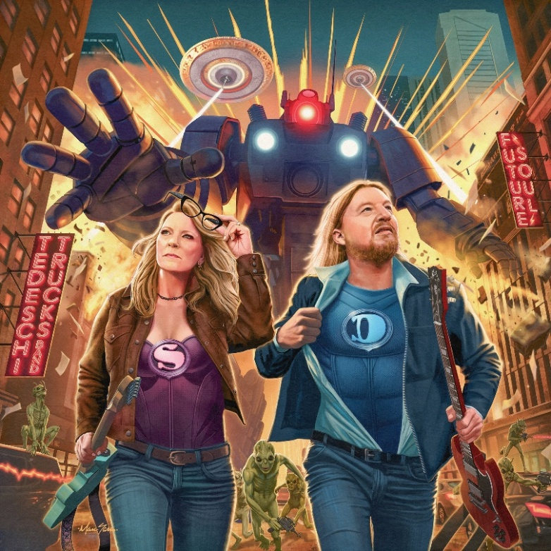
Future Soul cover art
Credit: Marc Sasso

TEDESCHI TRUCKS BAND TOUR DATES
New dates in bold

Beacon Theatre Residency:
Tuesday, March 10 – New York, NY @ The Beacon Theatre – SOLD OUT
Wednesday, March 11 – New York, NY @ The Beacon Theatre – SOLD OUT
Friday, March 13 – New York, NY @ The Beacon Theatre – SOLD OUT
Saturday, March 14 – New York, NY @ The Beacon Theatre – SOLD OUT
Wednesday, March 18 – New York, NY @ The Beacon Theatre
Friday, March 20 – New York, NY @ The Beacon Theatre – SOLD OUT
Saturday, March 21 – New York, NY @ The Beacon Theatre – SOLD OUT
Wednesday, March 25 – New York, NY @ The Beacon Theatre
Friday, March 27 – New York, NY @ The Beacon Theatre
Saturday, March 28 – New York, NY @ The Beacon Theatre – SOLD OUT

Future Soul 2026 Tour:
Tuesday, April 14 – Dallas, TX @ Music Hall at Fair Park ~
Wednesday, April 15 – Fort Worth, TX @ Will Rogers Auditorium ~
Friday, April 17 – Houston, TX @ The Cynthia Woods Mitchell Pavilion sponsored by Huntsman ^
Sunday, April 19 – Georgetown, TX @ Two Step Inn +
April 23-25 – Miramar Beach, FL @ Sun, Sand and Soul 2026 +
Tuesday, April 28 – Alpharetta, GA @ Ameris Bank Amphitheatre #
Wednesday, April 29 – Raleigh, NC @ Coastal Credit Union Music Park at Walnut Creek $
Sunday, May 3 – New Orleans, LA @ New Orleans Jazz & Heritage Festival +
Sunday, June 14 – Manchester, TN @ Bonnaroo Music & Arts Festival +
June 18-21 – Telluride, CO @ Telluride Bluegrass Festival +
Saturday, June 20 – Missoula, MT @ Zootown Music Festival +
July 22-26 – Floyd County, VA @ FloydFest +
Friday, July 31 – Morrison, CO @ Red Rocks Amphitheatre ^
Saturday, August 1 – Morrison, CO @ Red Rocks Amphitheatre ^
Tuesday, August 4 – Seattle, WA @ TBA ^
Wednesday, August 5 – Seattle, WA @ TBA ^
Friday, August 7 – Portland, OR @ Edgefield Concerts on the Lawn ^
Saturday, August 8 – Bend, OR @ Hayden Homes Amphitheater ^
Sunday, August 9 – Stateline, NV @ Lake Tahoe Amphitheatre at Caesars Republic ^
Wednesday, August 12 – Berkeley, CA @ Greek Theatre ^
Thursday, August 13 – Santa Barbara, CA @ Santa Barbara Bowl ^
Sunday, August 16 – San Diego, CA @ The Rady Shell at Jacobs Park ^
TBA – Los Angeles, CA @ TBA
Saturday, August 22 – Indianapolis, IN @ Ruoff Music Center %
Sunday, August 23 – St. Louis, MO @ Hollywood Casino Amphitheater %
Tuesday, August 25 – Grand Rapids, MI @ Acrisure Amphitheater %
Wednesday, August 26 – Cincinnati, OH @ Riverbend Music Center %
Friday, August 28 – Washington, DC @ Wolf Trap ^
Saturday, August 29 – Washington, DC @ Wolf Trap ^
Monday, August 31 – Bethel, NY @ Bethel Woods Center for the Arts ^
Wednesday, September 2 – Lenox, MA @ Tanglewood ^
Friday, September 4 – Bridgeport, CT @ Hartford Healthcare Amphitheater **
Saturday, September 5 – Bridgeport, CT @ Hartford Healthcare Amphitheater **
Sunday, September 6 – Gilford, NH @ BankNH Pavilion ^
Friday, October 9 – St. Augustine, FL @ The St. Augustine Amphitheatre =
Saturday, October 10 – St. Augustine, FL @ The St. Augustine Amphitheatre =
Tuesday, October 13 – Clearwater, FL @ The BayCare Sound =
Wednesday, October 21 – Milwaukee, WI @ Landmark Credit Union Live =
Friday, October 23 – Chicago, IL @ The Chicago Theatre =
Saturday, October 24 – Chicago, IL @ The Chicago Theatre =
Monday, October 26 – Chicago, IL @ The Chicago Theatre =
Tuesday, October 27 – Chicago, IL @ The Chicago Theatre =

% co-headlining with Alabama Shakes
# co-headlining with Jason Isbell and the 400 Unit
** with very special guest Sheryl Crow
^ Lukas Nelson supporting
$ JJ Grey & Mofro supporting
~ Molly Tuttle supporting
= An Evening With show
+ indicates festival appearance

FOLLOW TEDESCHI TRUCKS BAND:
www.tedeschitrucksband.com
Facebook | Instagram | TikTok | YouTube | Spotify

For more information on Tedeschi Trucks Band, please contact:
Press Here
Linda Carbone / linda@presshereproductions.com
Bari Lieberman / bari@pressherepublicity.com

