Cat Clyde Announces New Album Mud Blood Bone Due Out March 13 via Concord Records

Shares “Another Time” Single Today

To Embark On Extensive North American Headlining Tour This Spring

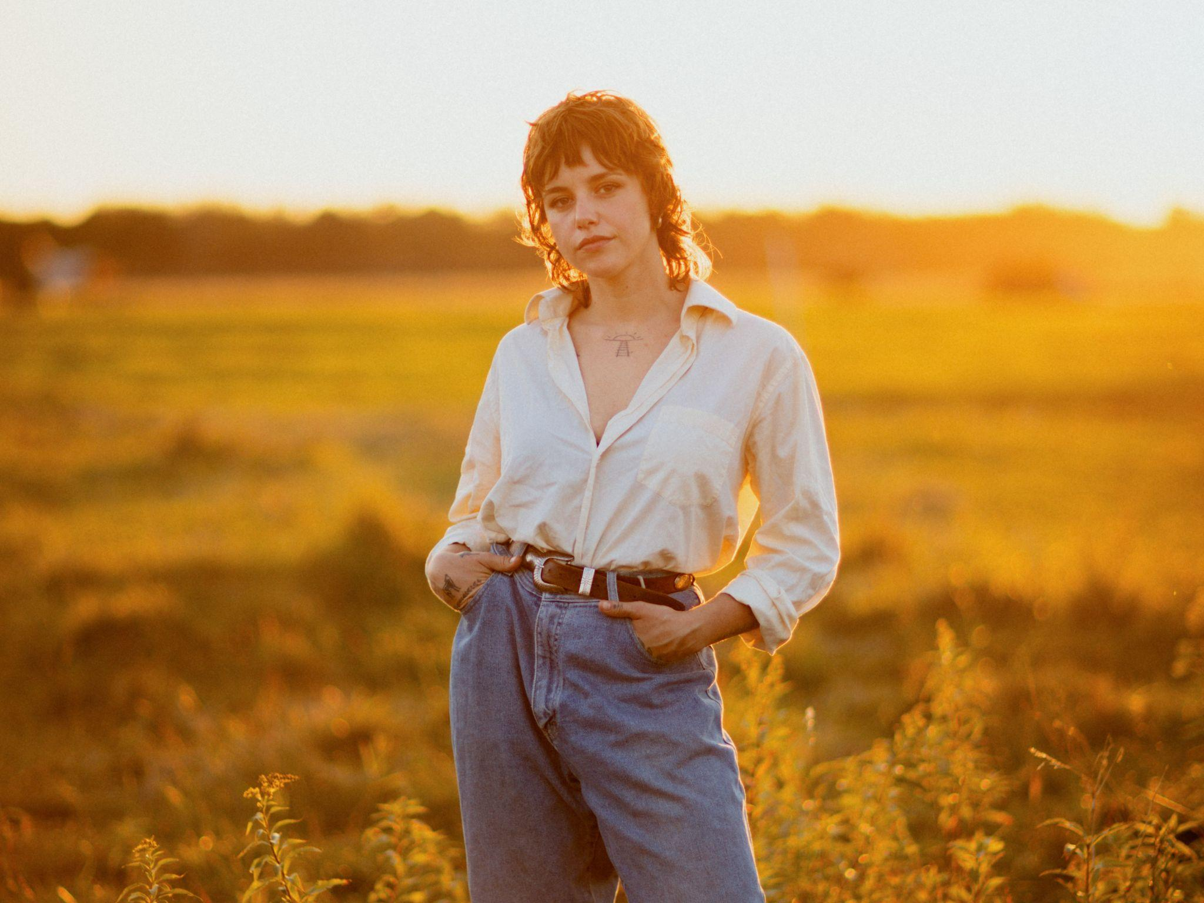

JANUARY 20, 2026 — Canadian indie-folk artist Cat Clyde has announced her new album, Mud Blood Bone, to be released on March 13 via Concord Records. Produced with Drew Vandenberg (Toro Y Moi, Faye Webster, S.G. Goodman) and including a co-write with Courtney Marie Andrews, Clyde’s fourth full-length and first release with Concord arrives in a sonic overlap: the rockabilly grit of contemporaries like Sierra Ferrell, The Deslondes, or Nick Shoulders, meets the vulnerable, folk rock volatility of Big Thief or Angel Olsen. It’s a trudge through the swamp and into vast, cleansing waters that finds Clyde at a critical point of personal evolution—equal parts despair, invocation, discovery, and celebration.

Today, Clyde is sharing the first preview of the new collection, “Another Time,” which is out now everywhere you stream music. It follows her recent "Cowboy Dreams" collaboration with Boy Golden, who will be supporting Clyde on tour in April and May.

Of the lead single, she offers, "While writing this song, I was pondering my experience of connection and intimacy, alongside the reality that life is constantly moving and changing. Thinking about the power to bottle up and lean into meaningful moments and memories. Considering how bittersweet it is for beautiful moments to be, knowing they all become a ripple in time. Wondering about different timelines - time is not linear. Having the power to shift myself and my reality into new timelines, and different selves. This song speaks to the grief and the joy of evolving constantly.”

Ahead of and throughout her writing sessions for Mud Blood Bone, Clyde looked to her indigenous Métis roots and invoked a deep reverence for nature in efforts to redefine her relationship with love in her life. Learning from the natural world, she took solace in its cyclicality. “Another Time” speaks to the endless change that makes life what it is: I walked a ragged mile / Found myself at your door / But that old road keeps calling me / To walk a thousand more. “Life is constantly moving forward,” she says. “I was writing about my past, but I was also writing to my future self.”

Clyde’s relationship with music began through a vent in the floor. “I’d lift the rug up to hear my grandfather playing his fiddle along to cassette tapes in the basement.” This was in North Ontario at summertime family gatherings, the best of which would culminate in impromptu family jam sessions. “I can’t really remember a time when I wasn’t singing.” After a fleeting, childhood stint with the piano, Clyde took on the guitar around age thirteen. “When I discovered Blues music, well, that changed my life.” The riffs of Lead Belly and Robert Johnson were too complicated for her small, preteen hands to master, but they inspired Clyde to write her own songs. She busked through adolescence, joined a punk band called Shit Bats in college, and recorded her first album in a friend’s basement before she graduated. Four full-lengths later, Clyde’s voice vibrates with that ferocious confidence of one who’s been doing this her whole life.

That sense of music as something lived, not learned, finds its clearest expression in how and where Clyde writes. The new songs exude nomadic independence: penned in her 1973 Boler trailer on a farm in Ontario, on a narrow boat in England, or in transit from one festival to another, letting lyrics stream freely from a jetlagged dream state. The result is uninhibited, raw, pure; it’s the sound of personal truth discovered in real time.

“Constantly being on the move, having to navigate new environments, it forces me to be present, and to confront my own feelings,” Clyde says. “You can’t hide behind comforts. You have to know exactly who you are, and what you want.”

Clyde will find herself on the move once again throughout much of 2026. In celebration of the album’s release, she will embark on an extensive North American tour this spring. Please see below for full tour details.

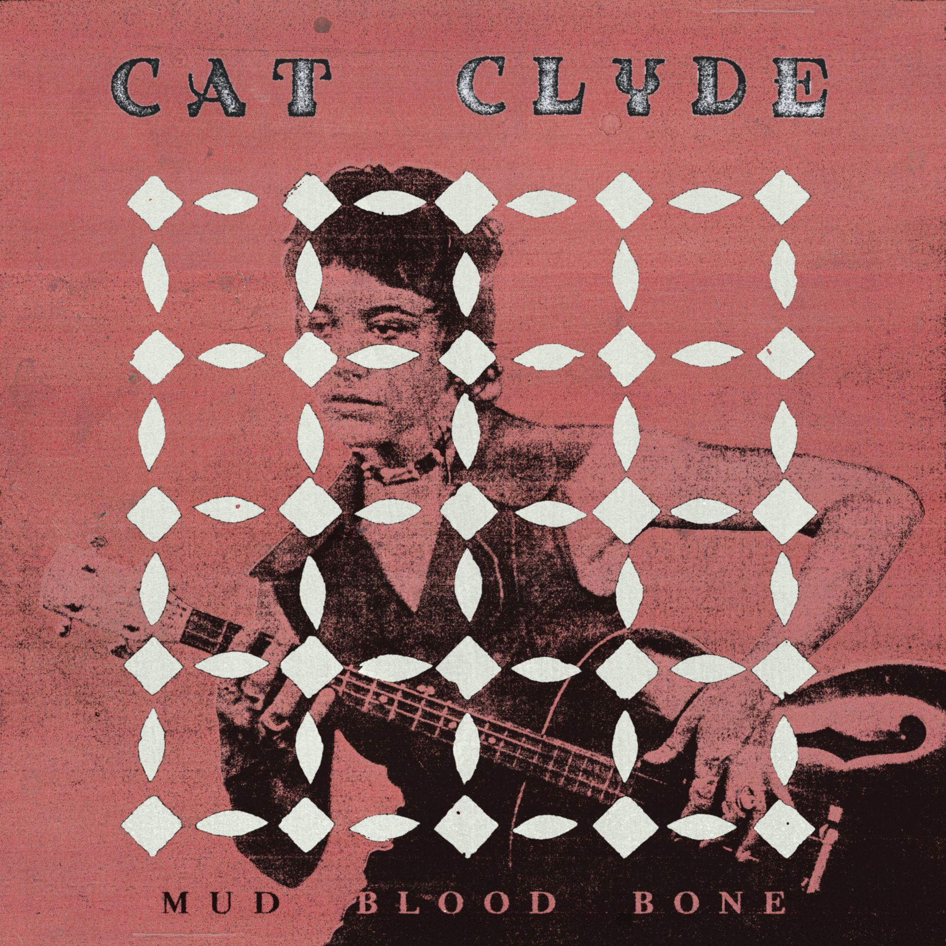

Mud Blood Bone Tracklist:
1. Where Is My Love
2. Man’s World
3. Wild One
4. Dark Back
5. Hold My Hand
6. I Am Now
7. My Love
8. Wanna Ride
9. Night Eyes
10. Press Down
11. Another Time

Cat Clyde On Tour:
March 17 — Mariposa, CA @ Grove House
March 19 — Pioneertown, CA @ Pappy & Harriet’s*
March 20 — Los Angeles, CA @ Lodge Room*
March 21 — Morro Bay, CA @ The Siren*
March 22 — San Francisco, CA @ The Chapel*
March 24 — Sisters, OR @ The Belfry
March 26 — Boise, ID @ Treefort Music Fest
March 27 — Salt Lake City, UT @ State Room
March 28 — Fort Collins, CO @ The Armory
March 29 — Boulder, CO @ eTown Music Hall
April 1 — Lawrence, KS @ Bottleneck^
April 2 — Columbia, MO @ Rose Music Hall^
April 3 — St. Louis, MO @ Old Rock House^
April 4 — Nashville, TN @ Row One^
April 6 — Louisville, KY @ The Monarch^
April 8 — Indianapolis, IN @ HiFi^
April 9 — Chicago, IL @ Schuba's^
April 10 — Davenport, IA @ Raccoon Motel^
April 11 — St Paul, MN @ Turf Club^
May 14 — Washington, DC @ Union Stage^
May 15 — Philadelphia, PA @ 118 N^
May 16 — Amagansett, NY @ The Stephen Talk House^
May 17 — Brooklyn, NY @ Baby’s All Right^
May 19 — Cambridge, MA @ Club Passim^
May 20 — Manchester, VT @ Billsville^
May 22 — Montreal, QC @ Bar Le Ritz
May 23 — Ottawa, ON @ Club Saw
May 24 — Kingston, ON @ Broom Factory
May 25 — St. Catharines, ON @ Warehouse
May 27 — Guelph, ON @ Sonic Hall
May 28 — Windsor, ON @ Meteor
May 29 — London, ON @ Rum Runners
May 30 — Toronto, ON @ Horseshoe Tavern
*co-bill with Goodnight, Texas
^ support from Boy Golden

For all press inquiries or to request more information, please contact:
Jake Lanier | jake@luckybirdmedia.com

