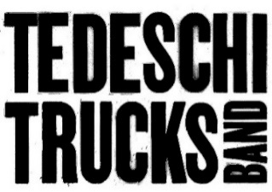

Tedeschi Trucks Band
Mad Dogs & Englishmen Revisited (LIVE AT LOCKN’)
With Leon Russell
Out Now via Fantasy Records
PRESS HERE To Listen

PRESS HERE To Watch Official Video For
“With A Little Help From My Friends”

‘Live In 25’ Headlining Tour
Continues Until October 25th

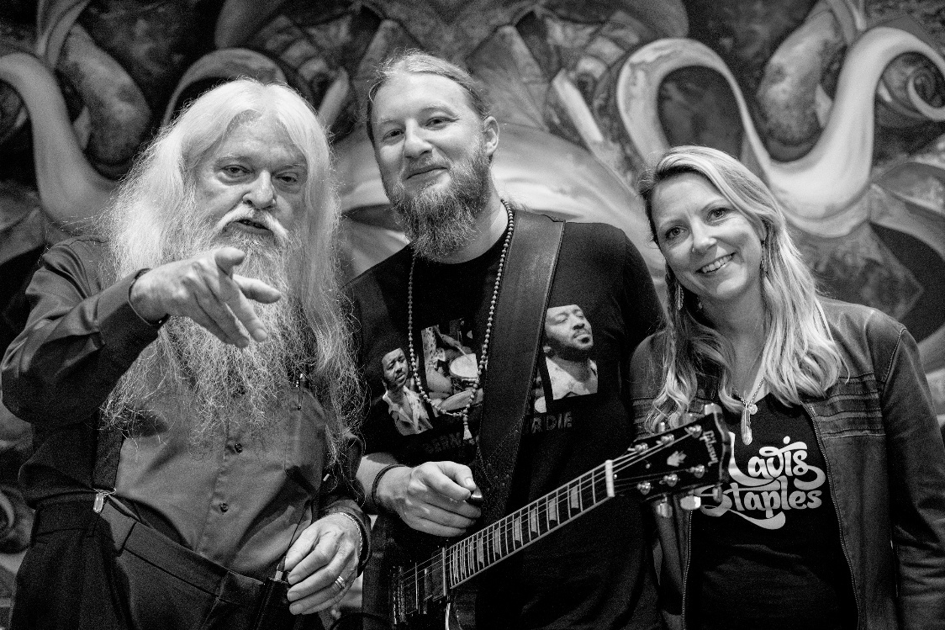
Photo Credit: Linda Wolf

“TTB’s interpretation, infused with their signature Southern-jam spirit, makes the material feel both reverent and freshly alive. It’s absolutely thrilling.” – Goldmine Magazine

“Pure blues greatness.” – Ultimate Guitar

“From start to finish, Mad Dogs & Englishmen Revisited (LIVE AT LOCKN’) embodies a vibe of friends gathered together to bring some of their favorite songs to life onstage—and with the expertise and passion involved, the result is worthy of putting on repeat.” – Blues Rock Review

“A riveting listen.” – The Arts Fuse

“The songwriting and musicianship [on Mad Dogs & Englishmen Revisited] remain unmatched.”
– Music Connection

“There was no better act to reproduce the Joe Cocker/Leon Russell led infamous Mad Dogs & Englishmen ensemble than the Tedeschi Trucks Band…TTB’s musical tribute captures and exudes the exhilaration and significance of an archetypal if brief moment in rock and roll history.” – Rock & Blues Muse

“A triumphant celebration of a rock ‘n’ roll milestone, delivered with passion, precision, and soul. It’s a must-listen for fans of TTB, Leon Russell and Joe Cocker, or really anyone who cherishes the raw, communal energy of live music.” – Americana Highways

FOR IMMEDIATE RELEASE – September 12, 2025 – Today, Tedeschi Trucks Band (TTB), the GRAMMY Award-winning band led by the dynamic duo of Susan Tedeschi and Derek Trucks, has released their new album, Mad Dogs & Englishmen Revisited (LIVE AT LOCKN’), with Leon Russell via Fantasy Records. The long-awaited release of Tedeschi Trucks Band and Leon Russell Present: Mad Dogs & Englishmen Revisited (LIVE AT LOCKN’) marks the first time the iconic tribute performance has been available anywhere since the original concert 10 years ago. PRESS HERE to listen on global streaming platforms and to order on CD and vinyl. To celebrate today’s release, TTB has also released the official music video for “With A Little Help From My Friends” featuring Tedeschi on vocals along with special guests Chris Robinson, Dave Mason, and Doyle Bramhall II. PRESS HERE to watch.

“It was a dream experience getting to work with Leon and all of the other amazing artists,” shares Susan Tedeschi.

Mad Dogs & Englishmen Revisited (LIVE AT LOCKN’) is a vibrant tribute to one of the most iconic live rock collaborations in music history. Originally led by Joe Cocker and legendary keyboardist and bandleader Leon Russell in 1970, Mad Dogs & Englishmen was a raucous, soulful tour that brought together a massive ensemble of musicians. In September 2015, Tedeschi Trucks Band – helmed by guitar virtuoso Derek Trucks and powerhouse vocalist Susan Tedeschi – revived this landmark event, infusing it with their own blend of Southern soul, blues, and rock.

The historic, star-studded tribute concert took place at the Virginia-based LOCKN’ Festival 45 years after the original tour. That night, TTB’s 12-piece ensemble and Russell welcomed original Mad Dogs members, such as Rita Coolidge, Claudia Lennear, and Chris Stainton, along with a diverse group of special guests including Chris Robinson of The Black Crowes, Warren Haynes, Anders Osborne, and Dave Mason. The stage often swelled to over 20 musicians, echoing the original tour’s grand, communal spirit. The setlist included memorable performances of such hits as “The Letter” featuring Tedeschi on lead vocals (PRESS HERE to watch the official music video), “Feelin’ Alright” featuring Mason, who penned the hit, on lead vocals and Osborne on guitar (PRESS HERE to watch the official music video), and “She Came In Through the Bathroom Window” featuring Haynes on lead vocals and guitar and Osborne on guitar (PRESS HERE to watch the official music video) as well as “The Weight,” “Delta Lady,” “Space Captain,” “The Ballad of Mad Dogs and Englishmen” and many more. Full track listing for Tedeschi Trucks Band and Leon Russell Present: Mad Dogs & Englishmen Revisited (LIVE AT LOCKN’) below.

Tedeschi Trucks Band, known for their dynamic interplay and emotional depth, breathe fresh life into these classic songs. More than just nostalgia, TTB and Leon Russell’s Mad Dogs & Englishmen set at LOCKN’ shows how timeless this communal approach to music-making still is – vibrant, necessary, and alive. Mad Dogs & Englishmen Revisited (LIVE AT LOCKN’) serves as the audio companion to TTB’s documentary Learning to Live Together: The Return of Mad Dogs & Englishmen (2021). The film, a unique retelling of the “Mad Dogs and Englishmen” tour as seen through the lens of Tedeschi Trucks Band, blends archival footage with new interviews and performance and rehearsal footage from the LOCKN’ tribute set.

Tedeschi Trucks Band’s expansive North American Live in ’25 Tour, produced by Live Nation, continues tonight (September 12th) in Bridgeport, Connecticut. Following a performance at Ohana Fest later this month, TTB will re-join longtime friends Gov’t Mule on October 11th in Macon, Georgia for their final co-headlining show together, following a five-date run which wrapped earlier this week. TTB remains on the road until October 25th traveling along the Eastern Seaboard. See below for all upcoming tour dates. Visit https://www.tedeschitrucksband.com/tour for more details and to purchase tickets.

Tedeschi Trucks Band and Leon Russell Present: Mad Dogs & Englishmen Revisited (LIVE AT LOCKN’) Track Listing:
- The Letter – ft. Susan Tedeschi
- Darling Be Home Soon – ft. Susan Tedeschi & Doyle Bramhall II
- Dixie Lullaby – ft. Doyle Bramhall II
- Sticks and Stones – ft. Chris Robinson
- Girl From the North Country – ft. Claudia Lennear
- Let’s Go Get Stoned – ft. Susan Tedeschi
- Feelin’ Alright – ft. Dave Mason & Anders Osborne
- She Came in Through the Bathroom Window – ft. Warren Haynes & Anders Osborne
- Bird On The Wire – ft. Rita Coolidge & Doyle Bramhall II
- The Weight – ft. Rita Coolidge, Pamela Polland, Susan Tedeschi, Claudia Lennear & Doyle Bramhall II
- Delta Lady – ft. John Bell
- Space Captain – ft. Susan Tedeschi & Chris Robinson
- With A Little Help From My Friends – ft. Chris Robinson, Susan Tedeschi, Dave Mason & Doyle Bramhall II
- The Ballad of Mad Dogs and Englishmen

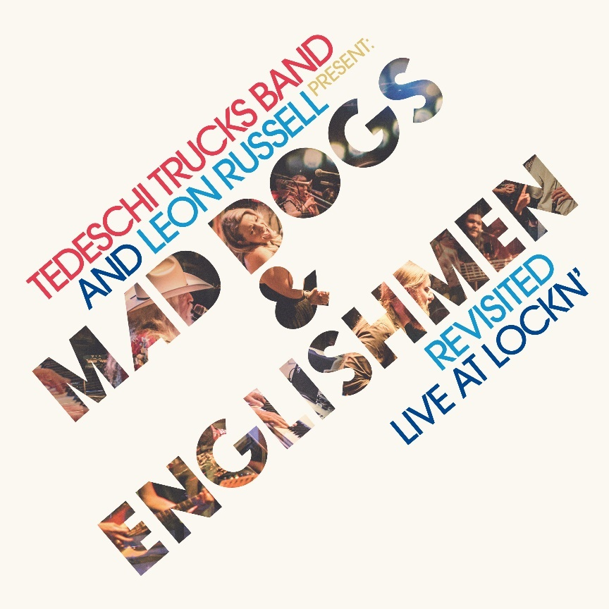
Tedeschi Trucks Band and Leon Russell Present: Mad Dogs & Englishmen Revisited (LIVE AT LOCKN’) cover art

TEDESCHI TRUCKS BAND 2025 TOUR DATES
Friday, September 12 – Bridgeport, CT @ Hartford Healthcare Amphitheatre #
Saturday, September 13 – Bridgeport, CT @ Hartford Healthcare Amphitheatre #
Saturday, September 27 – Dana Point, CA @ Ohana Fest
Saturday, October 11 – Macon, GA @ Atrium Health Amphitheater ^
Sunday, October 12 – Clearwater, FL @ The BayCare Sound =
Wednesday, October 15 – Franklin, TN @ FirstBank Amphitheater ~
Friday, October 17 – Raleigh, NC @ Red Hat Amphitheater ~
Saturday, October 18 – Charlotte, NC @ PNC Music Pavilion ~
Tuesday, October 21 – Richmond, VA @ Allianz Amphitheater at Riverfront ~
Wednesday, October 22 – Wilmington, NC @ Live Oak Bank Pavilion at Riverfront Park ~
Friday, October 24 – St. Augustine, FL @ The St. Augustine Amphitheatre **
Saturday, October 25 – St. Augustine, FL @ The St. Augustine Amphitheatre **

# with special guest Steve Winwood
^ co-headlining with Gov’t Mule
~ with special guest Little Feat
= with special guest Duane Betts & Palmetto Motel
** Evening with TTB

ABOUT TEDESCHI TRUCKS BAND
Tedeschi Trucks Band (TTB) is a GRAMMY Award-winning 12-piece rock and soul powerhouse that holds the well-deserved reputation as one of the best live acts touring today. Led by husband & wife, guitarist Derek Trucks and singer/guitarist Susan Tedeschi, “two of the best roots rock musicians of their generation” (NPR), TTB is known for its world-class musicianship and contemporary blend of a wide range of American musical influences that define their extensive catalog.

Since forming in 2010, TTB’s caravan has traveled countless miles to bring their music to audiences around the world. With a large catalog that spans rock, blues, jazz and even country, no setlist is ever the same, leaving their ever-growing fan base of all-ages returning again and again for electrifying performances. In the fall of 2023, Tedeschi Trucks Band played a pair of career-defining arena shows at TD Garden in Boston and a sold-out Madison Square Garden in New York City. Dubbed “The Garden Parties” the pair of gigs saw praise from Relix, who raved of the group's “seasoned grace and artistry.” The band's shows are an eagerly anticipated highlight of the live music calendar — “nothing short of exhilarating” (Salon) — from sold-out multi-night residencies across America to tours through Europe and Japan, to their flagship annual summer amphitheater tours. On top of an 82-show tour in 2024, Derek Trucks and Susan Tedeschi performed at the Kennedy Center Honors in December, honoring Bonnie Raitt, Grateful Dead, and more.

The band continues to tour behind their 2022 release, I Am The Moon, TTB's fifth and most ambitious studio project to date. Written while off the road during the pandemic, I Am The Moon captures a prolific and collaborative songwriting period for TTB that was inspired by an ancient poem of star-crossed lovers, “Layla and Majnun.” I Am The Moon includes four albums, I. Crescent, II. Ascension, III. The Fall, IV. Farewell and four companion films – delivering more than two hours of music that unfold across a robust tapestry of genre-defying explorations and propel the treasured American ensemble into new and thrilling creative territory. I Am The Moon joins an impressive studio discography that includes Signs (2019), High & Mighty EP (2019), Let Me Get By (2016), Made Up Mind (2013), and the Grammy-winning debut, Revelator (2011) in addition to their live releases, Layla Revisited (Live At LOCKN') featuring Trey Anastasio (2021), the GRAMMY-nominated film/audio, Live From The Fox Oakland (2017), and 2012’s Everybody’s Talkin’.

Tedeschi Trucks Band is Susan Tedeschi (guitar, vocals), Derek Trucks (guitar), Gabe Dixon (keyboards, vocals), Brandon Boone (bass), Tyler “Falcon” Greenwell (drums), Isaac Eady (drums), Mike Mattison (vocals), Mark Rivers (vocals), Alecia Chakour (vocals), Kebbi Williams (saxophone), Ephraim Owens (trumpet) and Elizabeth Lea (trombone).

FOLLOW TEDESCHI TRUCKS BAND:
www.tedeschitrucksband.com
Facebook | Instagram | TikTok | YouTube | Spotify

For more information on Tedeschi Trucks Band, please contact:
Press Here
Linda Carbone / linda@presshereproductions.com
Bari Lieberman / bari@pressherepublicity.com

