March 3, 2026
For Immediate Release

Introducing Deloyd Elze;
Stream the New Single, “Queen of Spades”

New EP, Nellene, Out This Friday via Concord Records

Performing At SXSW This Month,
Including Willie Nelson’s Luck Reunion


Photo Credit: Caity Krone

Deloyd Elze—the project of Georgia-born, California-based Jacob Henry Allen—releases “Queen of Spades,” the new single from his forthcoming EP, Nellene, out this Friday on Concord Records. Deloyd makes what he calls “digital twang,” music that sounds like it’s been captured on a digicam, rather than film, taking snapshots from the places he’s lived his life—glugging Hamms with the alligators on a Florida swamp pontoon, to working blue-collar jobs on boats and construction sites to scrape by in Los Angeles, to cracking a cold one with that old guy Willie living out back in his mom’s backyard in the doublewide, who’s siphoning power from the main house.

Following the release of his 2024 EP, A Horse Named Proletariat, Deloyd signed to Concord and released the fittingly titled single “Rite of Passage.” Wherever his music ends up taking him, Deloyd will always be anchored to where he came from—it’s in his very name. The name Deloyd Elze originally belonged to his great-grandfather: his legend is one of a Georgia-born dairy farmer-turned-alleged moonshiner who was run out of his hometown of Cairo by the cops and fled to Florida to start over, where he founded a successful family business in the infrastructure of seawall construction. Deloyd’s connection to home and family is felt deeply on Nellene, which is named after and dedicated to his grandmother, Margaret Nellene Williamson. Today’s single, “Queen of Spades,” was written in the wake of her passing.

Commenting on his grandmother, Deloyd says: “She had a laundry list of factoids that she collected over the years: she used to hustle people at pool at the local dive, drove a semi for a meat delivery company, worked in Vegas auditing black jack dealers, and she played a mean game of a card game called spades.” Of the song’s recording process he reflects: “When I got back to LA after the funeral I started writing what would become ‘Queen of Spades,’ but I didn’t think too much of it, I thought it was just gonna be ‘one for me’ type songs. I had a session on the books with a friend named Ryan Pollie. I had postponed this session so many times and decided that this time I wasn’t gonna reschedule, but I'll bring this ‘one for me’ song in so we have something to work on. All and all, I’d say roughly 6 hours went into a song that I never thought would be released to now being one of my most favorite songs that I've written and put out. All because of a card game called spades, and one of the world's best players.”

Stream Deloyd Elze’s “Queen of Spades”

With influences ranging from John Prine, MJ Lenderman, and Bon Iver to Dijon and Mk.gee, Deloyd’s music sounds natural when it’s all woven together. As a Berklee grad with a blue-collar background and multi-generational Southern roots, Deloyd Elze’s form of country music is inspired by the myriad of lives he’s intersected with, from the grit of job sites to the inspiration of music scenes to the undersung glory of the swamps of his youth. His songs struggle through the search of finding warmth and a home in this world, with grace for all of its strange turns and deeply twisted characters. Deloyd’s craving to push the sonic form and musical boundaries of country music is what he sees as an exploratory way of writing songs; the touchstone of his particularly Floridian lens on country music.

Deloyd Elze will play several showcases this month at SXSW in Austin, TX, including Willie Nelson’s Luck Reunion. A full list is below.

Pre-Order Nellene EP
Watch “George Jones” feat. Angela Autumn Video
Watch “Rite of Passage” Lyric Video

Nellene EP Tracklist:
1. Gatorade & Menthols
2. Rite of Passage
3. George Jones (feat. Angela Autumn)
4. Dog Will Hunt
5. Queen of Spades

Deloyd Elze SXSW Schedule:
Fri. March 13 - Austin, TX @ BMI x YETI Showcase
Fri. March 13 - Austin, TX @ UTOPIA Presents Showcase at Zilker Brewing
Mon. March 16 - Austin, TX @ Digital Twang Official SXSW Showcase
Tue. March 17 Austin, TX @ Make Out Music Showcase
Thu. March 19 - Austin, TX @ Willie Nelson’s Luck Reunion

Download Hi-Res Images and Cover Art Of Deloyd Elze

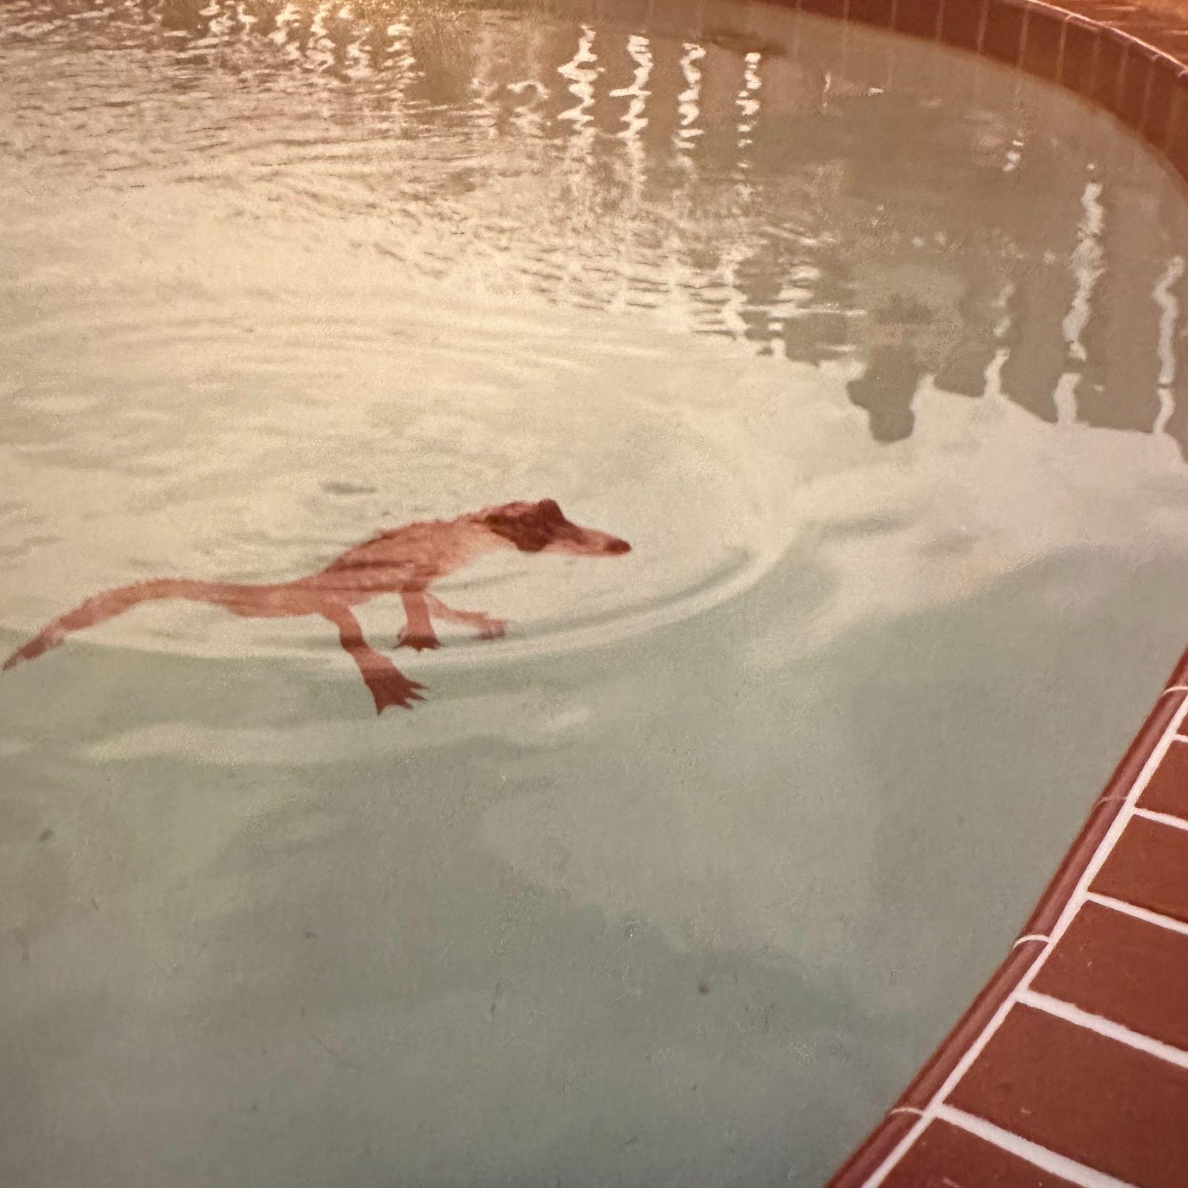
Nellene EP Artwork

Deloyd Elze Online:
Website | Instagram | TikTok

For more information, contact: Jacob Danema & Patrick Tilley | Pitch Perfect PR - jacob@pitchperfectpr.com, patrick@pitchperfectpr.com

###

