PREVIEW “ART MUSEUM (2am)”: https://youtu.be/8GcdKeWx7L8

EMBARGO 9 AM EST
September 12, 2025
FOR IMMEDIATE RELEASE
judy@motormouthmedia.com
humbert@motormouthmedia.com

CAUTIOUS CLAY
ANNOUNCES NEW ALBUM
THE HOURS: NIGHT
OUT OCTOBER 24TH VIA CONCORD RECORDS
PRE-SAVE/ORDER HERE

SHARES NEW SINGLE AND VIDEO
“ART MUSEUM (2AM)”
WATCH/LISTEN HERE

NORTH AMERICAN HEADLINE TOUR KICKS OFF THIS MONTH; TICKETS HERE

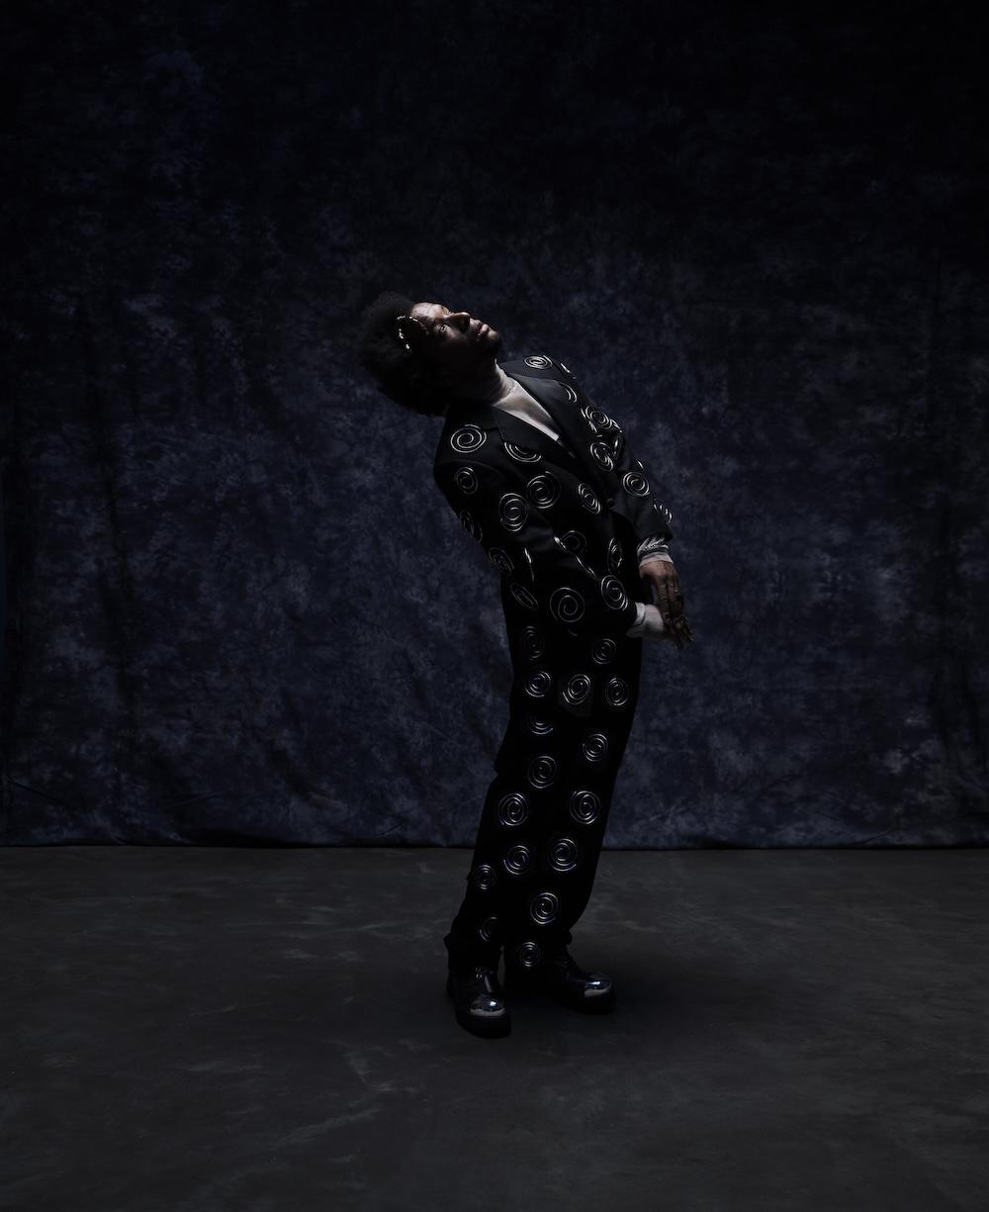
Photo Credit: Travys Owen

Following the spring release of his acclaimed album The Hours: Morning, Cautious Clay announces the next chapter of his conceptual series, The Hours: Night, due October 24th via Concord Records. Where Morning captures the clarity, warmth, and structure of daybreak, Night explores its inverse, a meditation on the untethered, unpredictable nature of nighttime.

The forthcoming album includes the previously released “Fade Blue (11pm)” and today’s coinciding single “Art Museum (2am)”, a song that reflects on a profound connection mirroring the timeless pull of great art, stretching beyond words, time, and self. Arriving alongside the track is a striking visual directed by Travys Owen, capturing Cautious in his element drenched in cool lighting, strumming guitar atop a subwoofer, channeling the intimate stillness of the late-night and the quiet vulnerability woven through “Art Museum (2am)”.

Cautious Clay shares, “‘Art Museum (2am)’ explores the idea of having a connection with someone that feels deeper than the physical or emotional—similar to how a painting or piece of art can transcend your own humanity and represent a moment in time.”

Together, The Hours: Morning and The Hours: Night sketch two interconnected portraits of time: daylight measured against moonlight, order against freedom, routine against spontaneity. Each installment expands the scope of Cautious Clay’s vision where Morning leans conversational and amber-hued, while Night taps into darker palettes and freer structures, embodying the openness, risk, and electricity of the late hours.

Reflecting on the new album, Cautious adds, ““The Hours: Night is the pure juxtaposition to the morning (clearly). I wanted the music to feel emblematic of how it feels to be out at night with a bunch of loose plans, but very few expectations. That feeling of being untethered. It was important for me to have fun with these records. I feel more in tune with the night. I consider myself a night person so this album was easier to make than the others. The night hours were, perhaps, more familiar.”

Later this month, Cautious Clay will bring both projects to life on The Hours Tour. The eight-date run, featuring support from Elujay, kicks off in Philadelphia on September 27th and continues across North America with stops in Boston, New York City, Washington D.C., Toronto and San Francisco, before wrapping up in Los Angeles. An additional date in D.C. has been added due to demand (full dates below). For more tickets and more information visit https://cautiousclay.com/#tour.

Beyond his own artistry, Cautious has established himself as a highly sought-after songwriter and producer, collaborating with Billie Eilish, John Mayer, John Legend, Khalid, Kavinsky, Melanie Martinez, Remi Wolf, BTS’s V and most recently, Tycho. Following his acclaimed EPs Resonance and Table of Context, he released his full-length 2021 debut Deadpan Love, a nuanced exploration of the complexities of human connection that earned him praise from The New York Times, Rolling Stone, The Fader, PAPER, and more. With his 2023 album KARPEH, Cautious reached new artistic heights, delivering a more intentional and sonically rich project that offered an intimate portrayal of his journey, his past, and his family life.

With The Hours: Night, Cautious Clay continues this ambitious new era, pushing his artistry into deeper emotional and conceptual territory while reaffirming his place as one of modern music’s most singular voices.

STREAM/WATCH “ART MUSEUM (2AM)”
https://ffm.to/cc-artmuseum
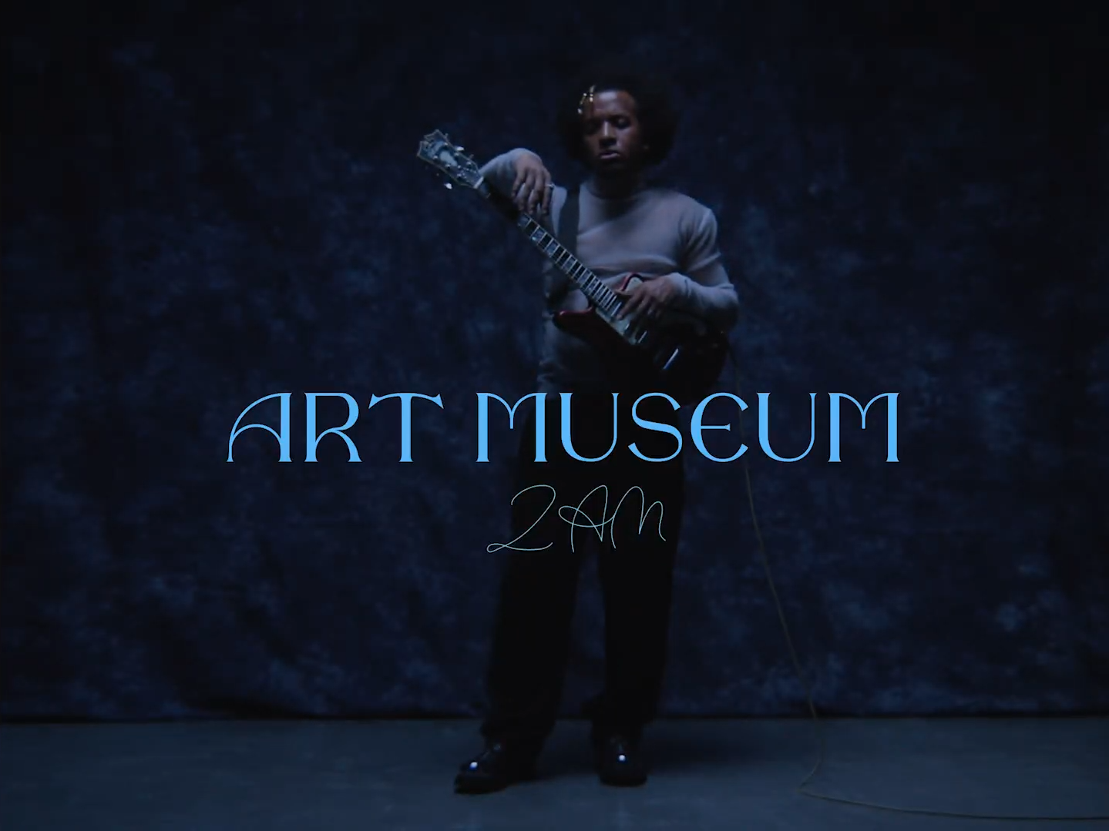

PRE-SAVE/ORDER THE HOURS: NIGHT
https://ffm.to/cc-thehoursnight
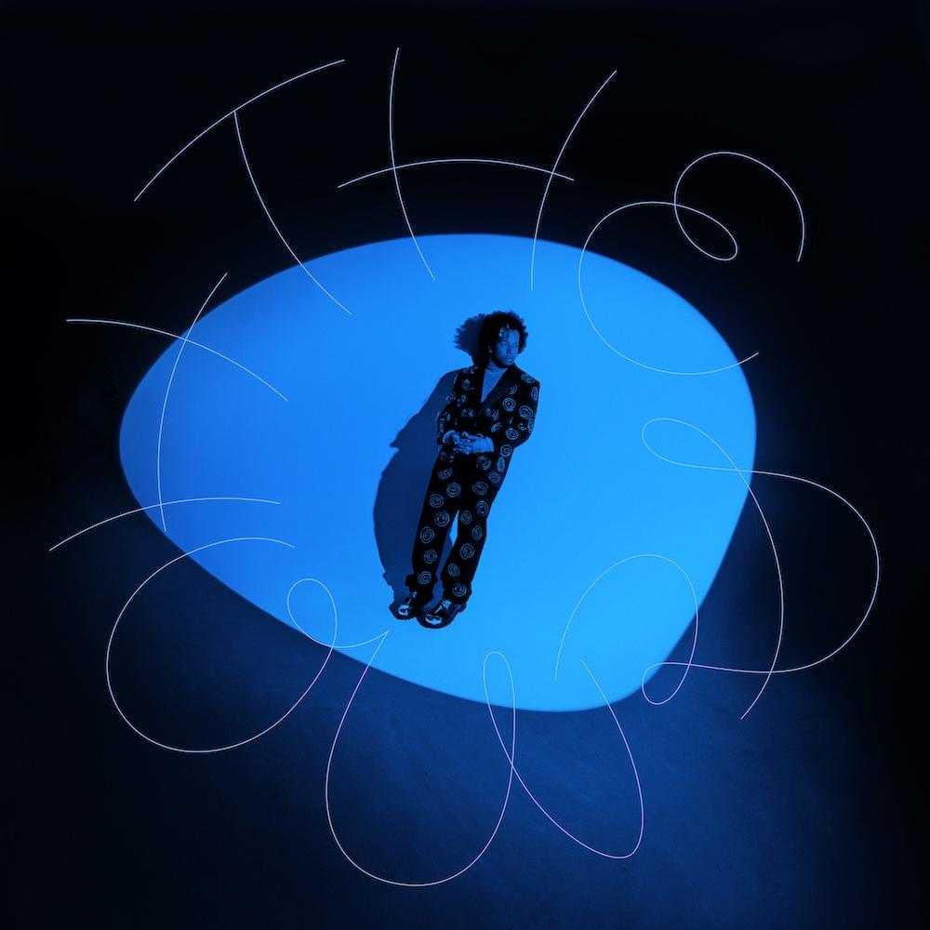

THE HOURS: NIGHT TRACKLIST
Shoulders (9pm)
5th Floor (10pm)
Fade Blue (11pm)
The Deep End (12am)
New Rochelle (1am)
Art Museum (2am)
Alchemy (3am)
Flip a Coin (4am)
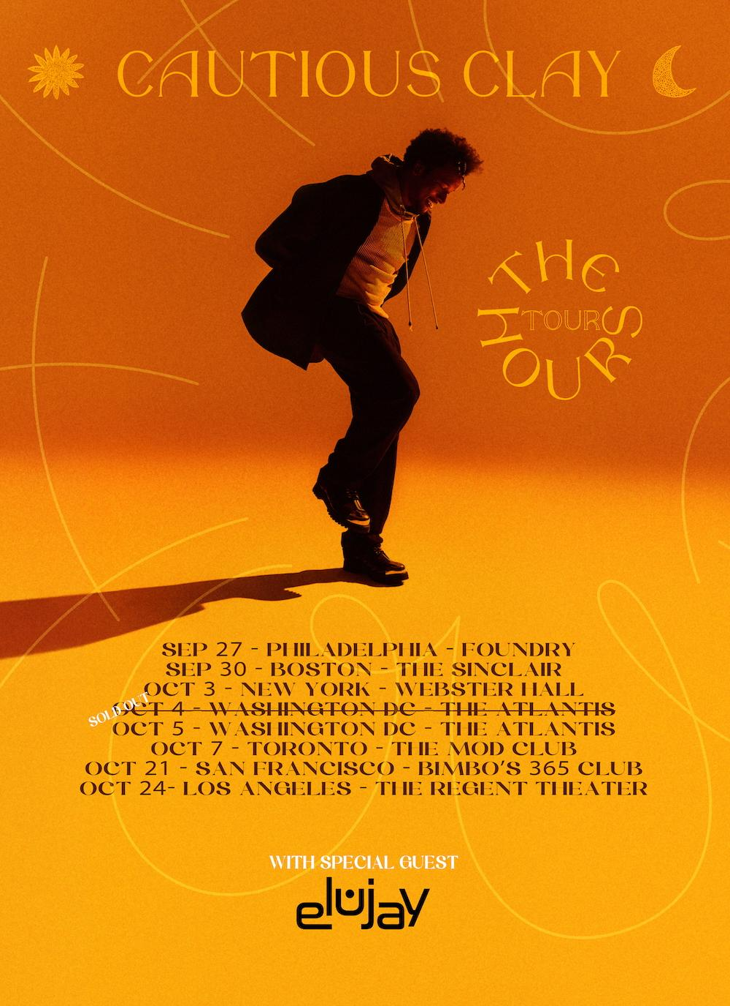
UPCOMING LIVE DATES
September 27 - Philadelphia, PA - Foundry
September 30 - Boston, MA - The Sinclair
October 3 - New York, NY - Webster Hall
October 4 - Washington, DC - The Atlantis SOLD OUT
October 5 - Washington, DC - The Atlantis
October 7 - Toronto, ON - The Mod Club
October 21 - San Francisco, CA - Bimbo's 365 Club
October 24 - Los Angeles, CA – The Regent Theater

CAUTIOUS CLAY ONLINE
INSTAGRAM | TIKTOK | X | FACEBOOK | YOUTUBE | WEBSITE

