RACHEL BOBBITT

RELEASES DEBUT ALBUM
SWIMMING TOWARDS THE SAND
VIA FANTASY RECORDS

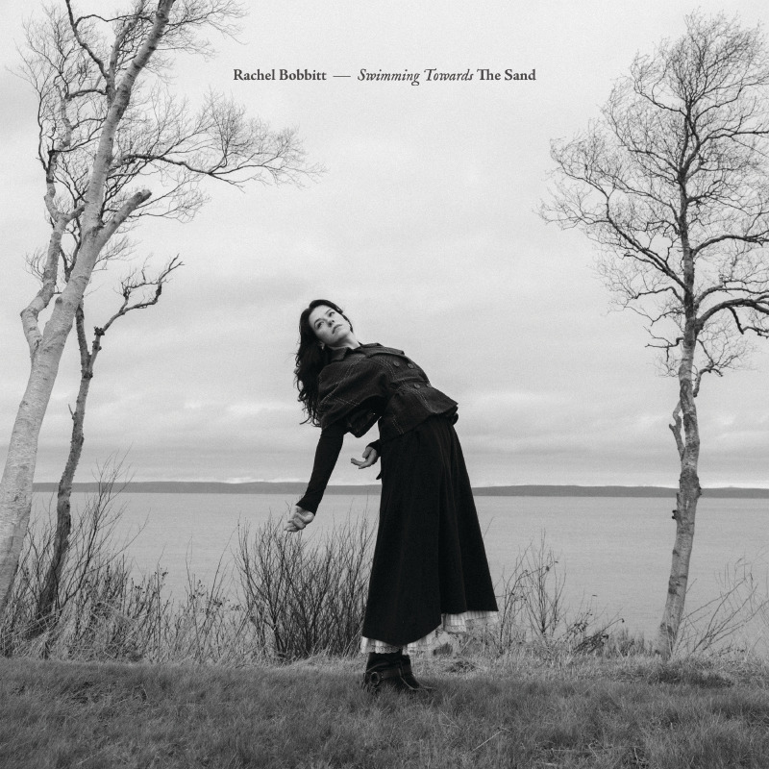
Album Art | download

“Striking…poignant” - NPR

“Rachel Bobbitt’s tender, shimmering voice has the capacity to carry a massive weight of emotion” - Consequence

“Evocative indie rock” - Brooklyn Vegan

“Over the past couple of years, Nova Scotia transplant Rachel Bobbitt has released stellar EPs back-to-back…In that time, I have tried — and struggled — to encapsulate how special her music is” - Exclaim!

“Dreamy, jangly indie-pop…formidable lushness” - Stereogum

“Stomach-jilting piece of bedroom alt-pop perfection.” -Paste

Rising Canadian artist Rachel Bobbitt releases her long-awaited debut full-length album, Swimming Towards the Sand today via Fantasy Records.

Swimming Towards the Sand was made in Los Angeles with producer Chris Coady (Beach House, Future Islands, DIIV), but it is rooted in Bobbitt’s childhood in Nova Scotia. Written between call centre shifts, hotel rooms, and fleeting homecomings, Swimming Towards the Sand is a reflection on loss, girlhood, coming of age, the thrill of new infatuation, and the confusion and discomfort that accompanies it, as showcased by the album’s singles “Hands Hands Hands,” “Hush,” “Furthest Limb,” “Deer on The Freeway,” “Sweetest Heart,”

Raised in the windswept Annapolis Valley of Nova Scotia, Bobbitt first found an audience through the lens of internet virality. Growing up in a musical household, where her mom’s side hosted kitchen fiddle parties, Bobbitt amassed a large Vine following, performing covers and originals to hundreds of thousands of followers, leading to Shorty Award nominations and being crowned by Buzzfeed as one of “13 Amazing Singers You Should Follow On Vine.” But instead of running with the fame, Bobbitt took a step back, overwhelmed by the onslaught of opinions—opinions on her career, appearance, voice, image—at an age when she was still figuring out what those things meant for herself.

A dozen years later, after studying Jazz and Vocal Pedagogy at the renowned Humber College, learning the rules of the road while touring with the likes of Men I Trust, Indigo de Souza, and Blonde Redhead, and navigating the music industry from her home base in Toronto, Bobbitt arrives at Swimming Towards the Sand with an unwavering sense of purpose. It’s an album that revisits her roots with the clarity of perspective, the wisdom of experience, and the lessons of resilience that can only come with time. It looks back with an eye both clear and nostalgic and reflects her memories via sharply contemporary music. On this album, Bobbitt wields her jazz-trained voice like a guitar or keyboard, layering harmonies in conversation with herself, for a poignant exploration of grief, girlhood, memory, and return.

LISTEN TO SWIMMING TOWARDS THE SAND

Tour Dates:
10/17 - Toronto, ON @ Monarch Tavern
Dec 3 - Pairs, ON - River’s Edge*
Dec 6 - Burnstown, ON - Neat Cafe*
Dec 7 - Stittsville, ON - Rainmaker*
Dec 9 - Vandorf, ON - Harmony Hall*
Dec 11 - Gravenhurst, ON - Gravenhurst Opera House*
Dec 12 - Galt, ON - Farm League Brewing*
Dec 13 - Ridgeway, ON - The Sanctuary *

* supporting Tim Baker

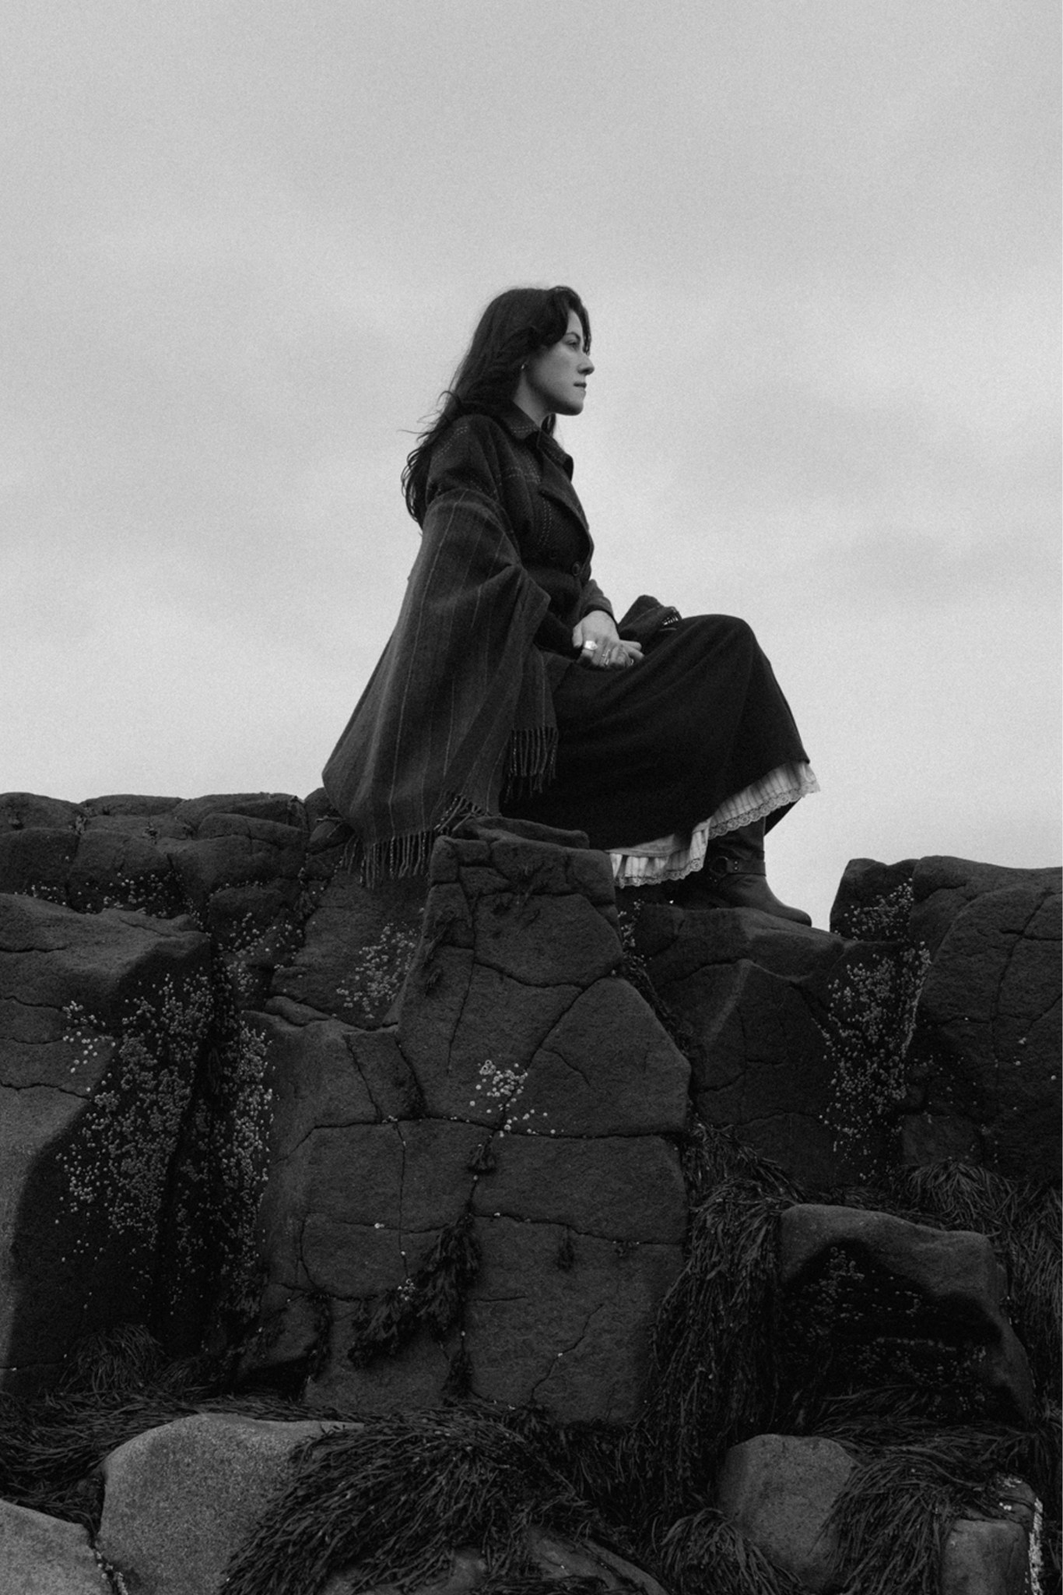
Credit: Ebru Yildiz | download

Swimming Towards The Sand Tracklisting
1. Don’t Cry
2. Hush
3.Light
4. Hands Hands Hands
5. Remember
6. I Want It All
7. Furthest Limb
8. Life By The Marsh
9. Ask Again
10. Deer on The Freeway
11. Sweetest Heart
12. Nothing

More on Rachel Bobbit & Swimming Towards The Sand:

“The ocean does not care about you at all,” declares Rachel Bobbitt. “That’s what makes something truly awesome—it could and will exist, with or without you.”

The ocean looms, uncaring yet vital, conceptually and actually on Bobbitt’s debut full-length LP, Swimming Towards the Sand. Raised in the windswept Annapolis Valley of Nova Scotia, Bobbitt recorded this album in Los Angeles at Chris Coady’s studio near Glendale’s Verdugo Mountainsm offering a symbolic contrast to the coastal terrain of her hometown. Alongside her musical and life partner, Justice Der, Bobbitt plays through a dozen tracks that are shaped by the East Coast—sinking into memory, floating through loss, and emerging from depths renewed.

A natural progression from Bobbitt’s collection of singles and EPs, including The Ceiling Could Collapse (2022) and The Half We Still Have (2023), Swimming Towards the Sand is her most cohesive and expansive work to date: a poignant exploration of grief, girlhood, memory, and return. It centres itself around memories and dreams, and how one can often feel interchangeable with the other. It is only through careful observation and steady rumination that we start to draw meaning and distinctions. The album is full is such reflections—and like the ocean, turns discarded bottles into frosted glass, these memories and dreams of loss, grief, and girlhood become something tangible and true.

Throughout Swimming Towards the Sand, Bobbitt returns again and again to the ocean—not just as a symbol, but as part of her internal landscape. “Having the water be so consistent and impartial to you, and terrifying and beautiful,” she says, adding, “it is such a strong presence for me.” The album is textured by the loss, yet it resists despair. It offers a return not just to home, but to self: a reclamation of the things that remain after the tide recedes. Bobbitt describes it as her most fully realized work, and it shows.

FOLLOW RACHEL BOBBITT
Website | Instagram | Twitter | Youtube

For more information on Rachel Bobbitt, please contact:
Grandstand Media
Eloy Lugo - eloyl@grandstandhq.com
Jaclyn Ulman - jaclynu@grandstandhq.com

