For immediate release


NOAH FLOERSCH
RELEASES ALTER-EGO ALBUM FRANCIS AQUARIUS TODAY VIA CONCORD RECORDS

FEATURES NEW TRACK “LOOK AT YOU”

INCLUDES PREVIOUSLY RELEASED “GROWING EVERYTHING OUT,” “SOMETHIN’ BOUT A BEER” & “SOMEBODY NOBODY GETS OVER”

UPCOMING ALBUM RELEASE SHOWS IN CHICAGO ON OCTOBER 10TH & NASHVILLE ON NOVEMBER 3RD

STREAM FRANCIS AQUARIUS ALBUM HERE & WATCH VISUALIZER FOR “LOOK AT YOU” HERE

“Brimming with honesty and a melody even when speaking, Noah very much carries himself as a musical being, a curious seeker collaging sounds with experiences in a profoundly relatable way.” – Ones To Watch
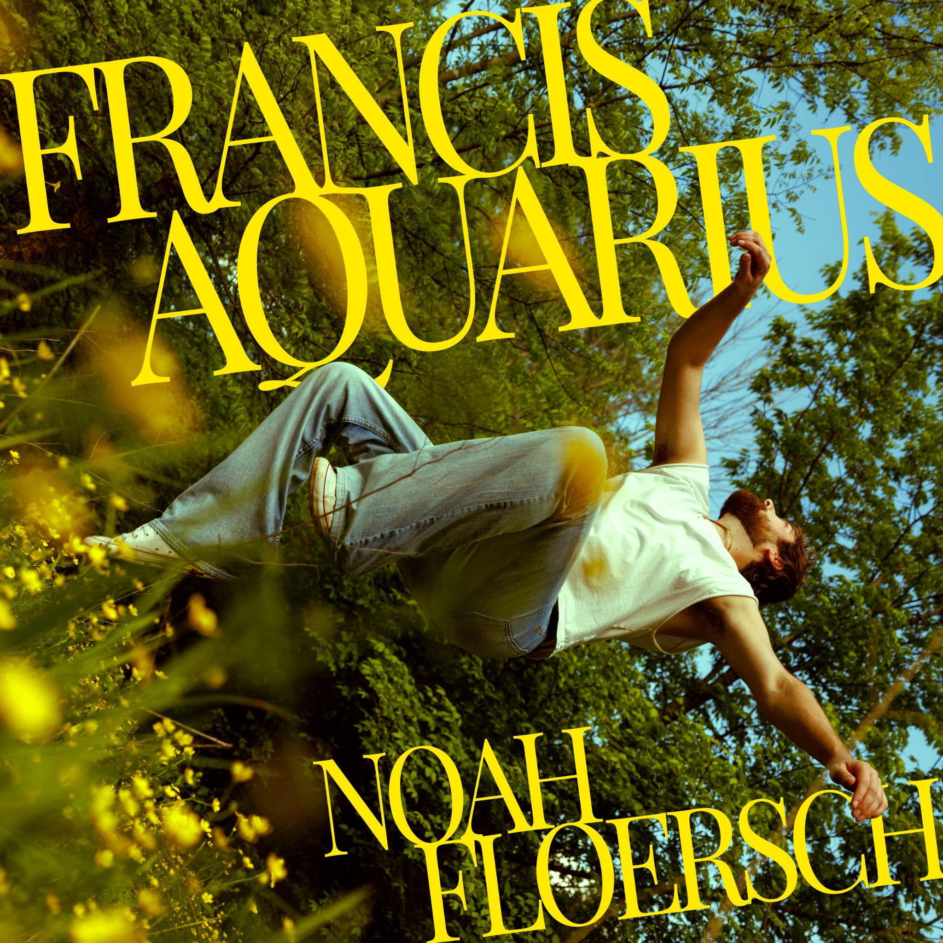
Assets: Tour admat, Artwork, Photos, Bio HERE

October 3, 2025 - Today, Omaha-born and Nashville-based indie pop lyrical songsmith Noah Floersch has released his long awaited Francis Aquarius via Concord Records featuring new track “Look At You.” The alter ego album has had the internet buzzing with its previously released tracks: “Somebody Nobody Gets Over,” “Somethin’ Bout A Beer” and “Growing Everything Out.”

Stream Francis Aquarius HERE & Watch The Visualizer for “Look At You” HERE

On the release of the new album and era of music: Noah said: “It’s a dream come true to have this album out in the world. Francis Aquarius is a bold swing, and I’m so proud with how it turned out. I can’t wait for people to hear it, and I’m so excited to play these tunes live.”
Francis Aquarius is more than just an album; it’s a character study, written from the perspective of the anti-hero and alter-ego character: Francis Aquarius. Named after Noah’s middle name and star sign, the album steps into the shoes of a messy, deeply flawed alter ego: Francis is a guy who’s spiraling through heartbreak, drinking too much, saying the wrong things, and learning the hard way that he might be the problem. With tongue-in-cheek humor and gut-punching emotional vulnerability, the album tackles the darker side of things as opposed to Noah’s self-titled debut album, Noah.

The new song “Look At You” continues the Francis Aquarius story arc as we see our anti-hero willing to try his hand at the game of love and failing miserably. He’s in over his head with a socialite who isn’t giving him the attention he thinks he deserves.”

But while Francis Aquarius might be an anti-hero, Noah Floersch is quite the opposite. With over 75 million global streams, Noah has built an audience one song and one heartbreak at a time. His breakout track “Ghost of Chicago” has racked up over 35 million Spotify streams, and his duet with Em Beihold, “The Bird Song,” has introduced his storytelling to a whole new audience, including earned co-signs from Gracie Abrams, SZA, and the Taco Bell Feed The Beat Class of 2025, along with praise from outlets like Ones To Watch.

Up next, Noah will be hitting the road and performing exclusive album release shows in Chicago’s Beat Kitchen on October 10th and Nashville’s own Basement East on November 3rd. See more information at www.noahfloersch.com/tour.


Assets: Tour admat, Artwork, Photos, Bio HERE
Press Photo Above HERE
Growing up in Omaha, Nebraska, Noah was one of six kids in a Catholic family (super Catholic — his great-aunt was a nun, and his older brother is now a monk). By middle school, he was hearing Jon Bellion, Vampire Weekend, and Mumford & Sons from his older brothers or in the carpool to soccer practice, and in high school choir, he gained a life-changing appreciation of the power of performance. He put out a slate of singles, EPs, and his first full-length, It’s Nice Out, while still in college in Lincoln, Nebraska; right after graduation, he moved to Nashville, and shortly thereafter, the single “Ghost of Chicago” from his second record Noah unexpectedly went viral, racking up millions of streams just about overnight.
Noah Floersch Album Release Shows:
October 10th Chicago, IL Beat Kitchen
November 3rd Nashville, TN Basement East
Noah Floersch
Noah Floersch (pronounced FleurISH) is an Omaha-born, Nashville-based indie pop singer-songwriter with over 75 million global streams and a fast-growing reputation as one of the most exciting new artists of 2025. His breakout single “Ghost of Chicago” went viral with 35M+ Spotify streams, propelling him from college gigs at the University of Nebraska-Lincoln to a support slot for Ricky Montgomery and more. Noah has since collaborated with Em Beihold (“The Bird Song”), earned co-signs from Gracie Abrams and SZA, and been named to Taco Bell’s 2025 Feed the Beat Class. This fall, Noah launches his biggest project yet: Francis Aquarius (out October 3 via Concord Records), a sharp and vulnerable anti-hero concept album led by singles “Somebody Nobody Gets Over,” “Growing Everything Out,” and “Somethin’ Bout A Beer.” With impeccable songwriting, magnetic live shows, and a 21-date headline run kicking off September 29, Noah Floersch is cementing himself as one to watch.

Follow Noah Floersch:
www.noahfloersch.com
Instagram // TikTok // YouTube

Media Contact:
Taylor Vaughn
Taylor@bigfeatpr.com

