For immediate release


NOAH FLOERSCH
RISING INDIE POP SINGER-SONGWRITER RELEASES ACHING NEW SINGLE “SOMEBODY NOBODY GETS OVER”

ANNOUNCES NEW ALTER-EGO ALBUM FRANCIS AQUARIUS
OUT OCTOBER 3RD VIA CONCORD RECORDS

ALBUM WRITTEN ABOUT AN ANTI-HERO WHO REPRESENTS THE BAD HABITS WITHIN OURSELVES AND FEATURES PREVIOUSLY RELEASED TRACKS “SOMETHIN’ BOUT A BEER” & “GROWING EVERYTHING OUT”

US HEADLINE TOUR KICKS ON SALE NOW

Pre-Order Francis Aquarius HERE
Listen to “Somebody Nobody Gets Over” HERE
Watch the official music video HERE

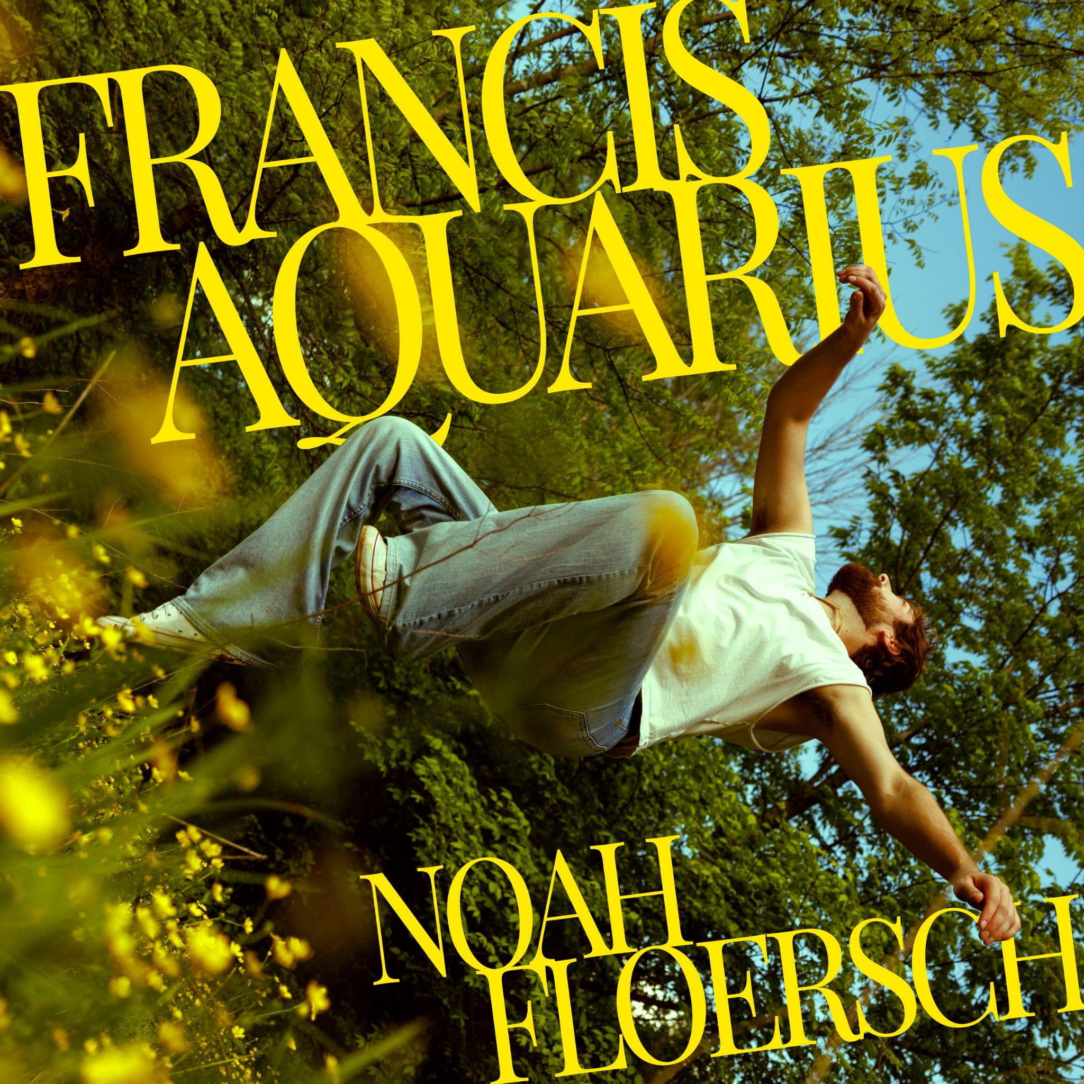
Assets: Tour admat, Artwork, Photos, Bio HERE

August 1, 2025 - Today, Omaha-born and Nashville-based indie pop lyrical songsmith Noah Floersch announced he will be releasing his brand new alter-ego album Francis Aquarius out October 3rd via Concord Records. In celebration of the announcement, Noah has released his most gut-wrenching track yet with “Somebody Nobody Gets Over.”

Pre-Order Francis Aquarius HERE
Stream “Somebody Nobody Gets Over” HERE & Watch the official music video HERE

The new song dives into the ache of unexpectedly running into an ex, watching them move on… and realizing you never really did. Co-written by Asia Whitacre, whose background vocals blend seamlessly with Noah’s, the track builds a vocally raw and emotionally charged performance that hits like a gut punch. The heart-on-sleeve chorus: “You’re somebody nobody gets over / Never gonna give myself the closure / Never gonna stop pulling you closer…” leaves listeners wanting to hit repeat the moment it ends. The music video, directed by Neta Ben Ezra and filmed in a Nashville greenhouse, captures the song’s emotional weight, showcasing Noah in his element: performing live.

Noah further elaborates: "‘Somebody Nobody Gets Over’ is an anthem for the heartbroken. Nothing hurts quite like watching the love of your life move on with someone new—especially as you try to remain friendly. It’s the kind of pain you get out by screaming along to a comfort song. Hopefully, Somebody Nobody Gets Over can be that song for some people."

The song will join previously released tracks “Somethin’ Bout A Beer” & “Growing Everything Out” on Noah’s new album: Francis Aquarius.

Francis Aquarius is more than just an album; it’s a character study, written from the perspective of the anti-hero and alter-ego character: Francis Aquarius. Named after Noah’s middle name and star sign, the album steps into the shoes of a messy, deeply flawed alter ego: Francis is a guy who’s spiraling through heartbreak, drinking too much, saying the wrong things, and learning the hard way that he might be the problem. With tongue-in-cheek humor and gut-punching emotional vulnerability, the album tackles the darker side of things as opposed to Noah’s self-titled debut album, Noah.

“The last album was like, ‘Here I am, check me out, and everything’s beautiful and great,’” Noah says. “This one is like, here’s this really fun facade, but don’t look too long or you might see the ugly in me. The music fucking rocks, and it’ll move your body, and it’s gonna be a blast to perform. But if you check out the lyrics a little bit, there’s some poignancy there that is very, very true for me.”

Earlier this year, Noah released the album’s first two tracks: “Growing Everything Out” and “Somethin’ Bout A Beer.” “Growing Everything Out” is an upbeat self-aware anthem that describes the feeling when you find yourself slightly partying too hard on tour every night and burning the candle at both ends. The song describes that moment when you look in the mirror and think, “wow, you look like a hot mess, but that’s okay right now- I’m growing everything out,” almost as if you’re giving yourself the permission to let go a little bit.

Stream “Growing Everything Out” HERE

“Somethin’ Bout A Beer” (or otherwise known as the unofficial Nashville bartenders’ anthem) is a prime example of Noah’s incredible style of lyricism and songwriting - upon first listen, you think the song is about one thing, but when you take a closer look, it’s got a deeper meaning. “Somethin’ Bout A Beer” follows that pattern as first listeners will hear a feel-good bar song about drinking away heartache…then upon the second listen, you will hear under the chorus the track is an homage to bartenders who help us nurse those wounds “Don’t forget to tip the ones who help you forget the ones you love.”

Stream “Somethin’ Bout A Beer” HERE & Watch the lyric video HERE

But while Francis Aquarius might be an anti-hero, Noah Floersch is quite the opposite. With over 75 million global streams, Noah has built an audience one song and one heartbreak at a time. His breakout track “Ghost of Chicago” has racked up over 35 million Spotify streams, and his duet with Em Beihold, “The Bird Song,” has introduced his storytelling to a whole new audience, including earned co-signs from Gracie Abrams, SZA, and the Taco Bell Feed The Beat Class of 2025, along with praise from outlets like Ones To Watch.

Noah recently announced he will be hitting the road this fall on his headline “Somethin’ Bout A Tour,” kicking off on September 29th in Orlando, Florida. The 21-date run will see Noah performing at some of the country’s hottest stages, including Music Hall of Williamsburg in Brooklyn, NY on October 6th, Los Angeles’s own Troubadour on October 24th, and returning to his now hometown of Nashville, TN to perform at Basement East on November 3rd. See more information at www.noahfloersch.com/tour.


Assets: Tour admat, Artwork, Photos, Bio HERE
Press Photo Above HERE
Growing up in Omaha, Nebraska, Noah was one of six kids in a Catholic family (super Catholic — his great-aunt was a nun, and his older brother is now a monk). By middle school, he was hearing Jon Bellion, Vampire Weekend, and Mumford & Sons from his older brothers or in the carpool to soccer practice, and in high school choir, he gained a life-changing appreciation of the power of performance. He put out a slate of singles, EPs, and his first full-length, It’s Nice Out, while still in college in Lincoln, Nebraska; right after graduation, he moved to Nashville, and shortly thereafter, the single “Ghost of Chicago” from his second record Noah unexpectedly went viral, racking up millions of streams just about overnight.
Noah Floersch “Somethin’ Bout A Tour” Dates:
September 29th Orlando, FL The Social
September 30th Atlanta, GA Aisle 5
October 2nd Washington, DC Union Stage
October 5th Philadelphia, PA First Unitarian Church
October 6th Brooklyn, NY Music Hall of Williamsburg
October 7th Boston, MA Brighton Music Hall
October 8th Toronto, ON Drake Hotel
October 10th Chicago, IL Beat Kitchen
October 12th Minneapolis, MN Fine Line
October 13th Omaha, NE Slowdown
October 15th Denver, CO Bluebird Theatre
October 17th Salt Lake City, UT The Grand at the Complex
October 19th Portland, OR Holocene
October 21st Seattle, WA Madame Lou's
October 23rd San Francisco, CA Rickshaw Stop (PopScene)
October 24th Los Angeles, CA Troubadour
October 26th Phoenix, AZ Valley Bar
October 29th Austin, TX The Parish
October 30th Dallas, TX Club Dada
October 31st Houston, TX Bronze Peacock
November 3rd Nashville, TN Basement East
Noah Floersch
Noah Floersch (pronounced FleurISH) is an Omaha-born, Nashville-based indie pop singer-songwriter with over 75 million global streams and a fast-growing reputation as one of the most exciting new artists of 2025. His breakout single “Ghost of Chicago” went viral with 35M+ Spotify streams, propelling him from college gigs at the University of Nebraska-Lincoln to a support slot for Ricky Montgomery and his own headline tour. Noah has since collaborated with Em Beihold (“The Bird Song”), earned co-signs from Gracie Abrams and SZA, and been named to Taco Bell’s 2025 Feed the Beat Class. This fall, Noah launches his biggest project yet: Francis Aquarius (out October 3 via Concord Records), a sharp and vulnerable anti-hero concept album led by singles “Somebody Nobody Gets Over,” “Growing Everything Out,” and “Somethin’ Bout A Beer.” With impeccable songwriting, magnetic live shows, and a 21-date headline run kicking off September 29, Noah Floersch is cementing himself as one to watch.

Follow Noah Floersch:
www.noahfloersch.com
Instagram // TikTok // YouTube

Media Contact:
Taylor Vaughn
Taylor@bigfeatpr.com

