SARAH McLACHLAN RELEASES EXTENDED VERSION OF BETTER BROKEN & NEW SINGLE
“THE KISS” VIA CONCORD RECORDS

BETTER BROKEN SUMMER TOUR KICKS OFF
JULY 1 WITH SHOWS AT CHASTAIN PARK, RED ROCKS AMPHITHEATRE, GREEK THEATRE
& MORE

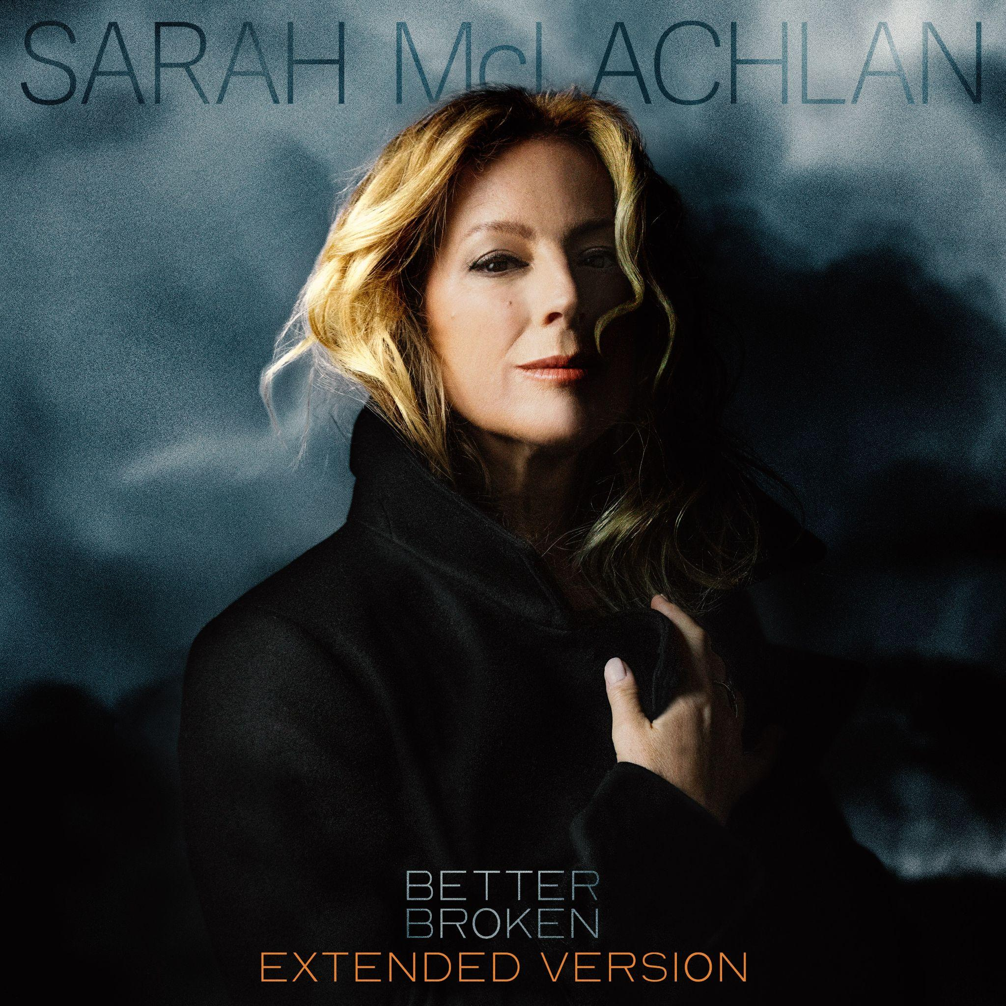
Album Artwork

STREAM “THE KISS” HERE | STREAM THE ALBUM HERE

FRIDAY, JUNE 26 – Today, 3X GRAMMY Award winner and “one of popular music’s most beautiful voices” (Variety) Sarah McLachlan released the extended version of her critically acclaimed album Better Broken via Concord Records. Also today, she released the new single “The Kiss.” Listen to “The Kiss” HERE and stream Better Broken Extended Version HERE.

“Tony Berg introduced me to Judee Sill the first week into working with him… he was playing different obscure musical choices as conversation starters and as soon as I heard ‘The Kiss,’ I was blown away,” McLachlan shares. “It drew me in and I knew I wanted to sing it. I did a deep dive and discovered she’d lived a tragic, short life. She died at 35 leaving behind a truly unique body of work.”

Better Broken, McLachlan’s first new album in almost a decade, was acclaimed by The New York Times, The Los Angeles Times, the Wall Street Journal, Grammy.com, and more. Earlier this year, McLachlan performed two songs from the record, as well as a few catalogue fan favorites, on NPR’s Tiny Desk. She also spoke about the album and the legacy of the iconic Lilith Fair, and more on the Golden Globe Award-winning podcast, Good Hang with Amy Poehler.

On July 1, she’ll kick off her Better Broken Summer Tour in Franklin, TN. The tour includes stops in Philadelphia, Boston, Chicago, San Diego, Los Angeles, and more, before concluding with two nights on August 8 and 9 in Woodinville, WA at Chateau Ste Michelle Winery. The tour will also feature performances at several iconic venues, including Chastain Park in Atlanta, GA, Red Rocks Amphitheatre in Morrison, CO and the Greek Theatre in Los Angeles, CA. Special guest Allison Russell will join on all dates. For more information and tickets, please visit http://sarahmclachlan.com.

Over her three-decade career, McLachlan has sold more than 40 million albums worldwide and earned three GRAMMY Awards and thirteen JUNO Awards. Beyond her music, her cultural impact includes founding Lilith Fair, the groundbreaking all-female festival that helped reshape the live music landscape. That legacy was recently revisited in Lilith Fair: Building A Mystery – The Untold Story, which premiered at the 2025 Toronto International Film Festival to critical acclaim before debuting on Hulu. The film is executive produced by Dan Levy and directed by Ally Pankiw and was noted as one of the top documentary films to watch in 2025 by the Los Angeles Times.

McLachlan’s influence also extends deeply into philanthropy. She is the founder of the Sarah McLachlan School of Music, a not-for-profit providing free music education and mentorship to underserved children and youth facing barriers to access. Established in Vancouver in 2002, the school now serves more than 2,000 students annually across three Canadian cities, with McLachlan personally covering administrative costs to ensure all fundraising directly supports its students. $1 from every ticket sold on the tour will be donated to the School.

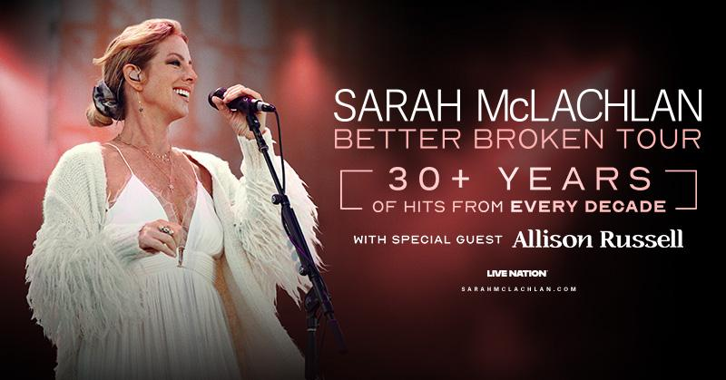

Better Broken Tour Summer 2026 Dates
Wed Jul 1 - Franklin, TN - FirstBank Amphitheater
Fri Jul 3 – Atlanta, GA – Synovus Bank Amphitheater at Chastain Park
Sun Jul 5 – Vienna, VA – Wolf Trap Filene Center*
Tue Jul 7 – Philadelphia, PA – TD Pavilion at Highmark Mann
Wed Jul 8 – Bridgeport, CT – Hartford HealthCare Amphitheater
Fri Jul 10 – Boston, MA – Leader Bank Pavilion
Sun Jul 12 – Gilford, NH – BankNH Pavilion
Tue Jul 14 – Lewiston, NY – Artpark Outdoor Amphitheater
Wed Jul 15 – Sterling Heights, MI – Michigan Lottery Amphitheatre at Freedom Hill
Fri Jul 17 – Grand Rapids, MI – Acrisure Amphitheater
Sat Jul 18 - Chicago, IL - Huntington Bank Pavilion at Northerly Island
Sun Jul 19 – Indianapolis, IN – Everwise Amphitheater at White River State Park
Tue Jul 21 – Cincinnati, OH – PNC Pavilion
Thu Jul 23 – Maryland Heights, MO – Saint Louis Music Park
Fri Jul 24 – Kansas City, MO – Starlight Theatre
Sun Jul 26 – Irving, TX – The Pavilion at Toyota Music Factory
Tue Jul 28 – Morrison, CO – Red Rocks Amphitheatre
Thu Jul 30 – West Valley City, UT – Utah First Credit Union Amphitheatre
Sat Aug 1 – Concord, CA – Toyota Pavilion at Concord
Sun Aug 2 – San Diego, CA – Rady Shell at Jacobs Park
Tue Aug 4 – Los Angeles, CA – Greek Theatre
Fri Aug 7 – Bend, OR – Hayden Homes Amphitheater
Sat Aug 8 – Woodinville, WA – Chateau Ste Michelle Winery
Sun Aug 9 – Woodinville, WA – Chateau Ste Michelle Winery
*Non-Live Nation Date

