SARAH McLACHLAN RELEASES NEW SINGLE “GRAVITY”

FIRST ALBUM IN OVER A DECADE BETTER BROKEN DUE OUT SEPTEMBER 19 VIA CONCORD

LILITH FAIR: BUILDING A MYSTERY DOCUMENTARY SET TO MAKE WORLD PREMIERE AT TIFF

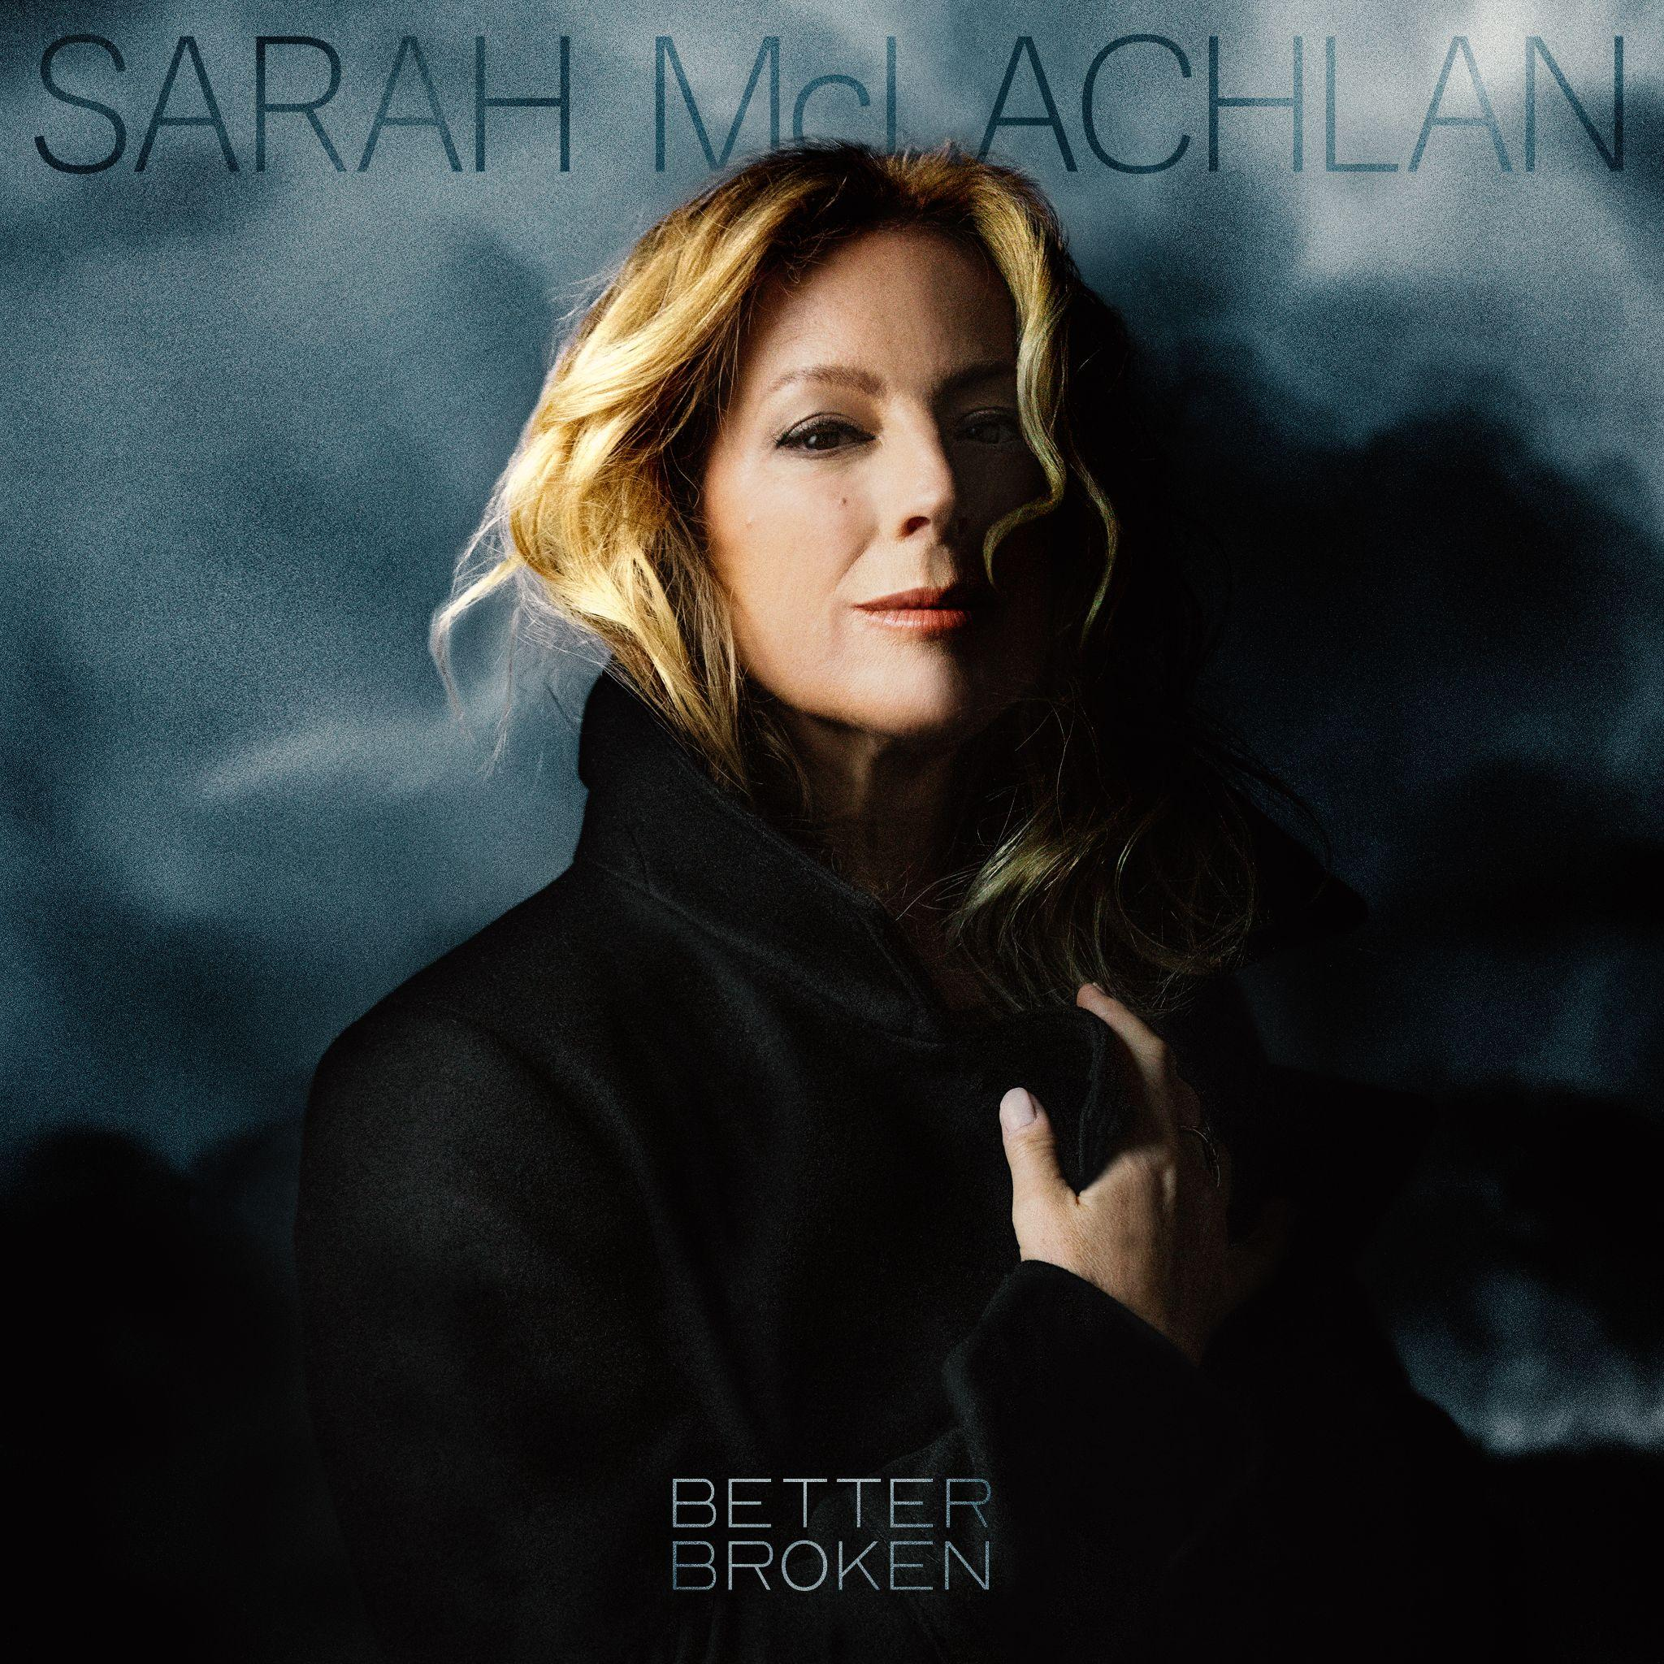
Photo Credit: Kharen Hill
Hi-res download

PRE-ORDER BETTER BROKEN & STREAM “GRAVITY” HERE

WATCH THE “GRAVITY” MUSIC VIDEO HERE

FRIDAY, AUGUST 8 (LOS ANGELES, CA) - Today, 3X GRAMMY Award winner and global phenomenon Sarah McLachlan released “Gravity,” the second single from her highly anticipated album Better Broken, due out September 19 via Concord Records. The first song recorded for Better Broken, “Gravity” delves deeper into McLachlan’s emotional life and explores the complexities of her relationship with her older daughter. With its graceful string arrangement (courtesy of Patrick Warren), the tender piano ballad channels both quiet heartache and tremendous compassion in its words of loving benediction. Pre-order the album and stream “Gravity” HERE. Watch the “Gravity” music video HERE.

“For a long time my daughter and I had a very combative and fraught relationship, and what I came to realize is that so much of what I perceived as obstinance or rage was actually masking a ton of anxiety on her part,” says McLachlan. “We went to counseling together, and I learned that she felt so alone and unvalidated by me—which was devastating to hear, but it led us both to change the way we communicate with each other. I wrote ‘Gravity’ as a way of saying to her, ‘I’ve always loved you and want the best for you, and you’re perfect the way you are.’”

McLachlan’s tenth studio album and debut release for Concord Records, Better Broken takes its title from its opening track – a soul-searching reflection on the fortitude that comes from weathering life’s constant storms – and furthers her legacy with a selection of songs that speak an uncompromising but radically illuminating truth about the state of the human condition.

Mainly recorded at the legendary Sound City Studios in Los Angeles, Better Broken instills a potent new energy into her lush and moody form of pop-rock, with contributions from esteemed musicians like Wendy Melvoin (a former guitarist for Prince and the Revolution), drummer Matt Chamberlain (Bob Dylan, David Bowie), multi-instrumentalist Benny Bock (Lucy Dacus, beabadoobee), and pedal-steel guitarist Greg Leisz (Kacey Musgraves, Florence + the Machine). In a monumental leap for McLachlan, Better Broken finds her widening her creative circle and working with producers Tony Berg (Phoebe Bridgers, boygenius) and Will Maclellan (Lucy Dacus, Phoebe Bridgers).

The tracklisting’s myriad high points include “One In a Long Line,” an irrepressible anthem railing against the rapid erosion of women’s rights in recent years, “Long Road Home,” a rapturous love song, the pedal-steel-laced reverie “Reminds Me,” a lovestruck duet with MUNA’s Katie Gavin, and the previously released title track. All throughout Better Broken, McLachlan and her fellow musicians bring an ineffable beauty to her expression of longing and grief and fierce determination.

Over the course of her three-decades-long career, McLachlan has won 3 GRAMMY Awards,
12 JUNO Awards, and sold over 40 million albums worldwide. McLachlan also founded the groundbreaking all-female music festival Lilith Fair, featuring an A-list lineup for female alternative musicians of the moment, including Sheryl Crow, Jewel, The Indigo Girls, Lisa Loeb, Fiona Apple, Erykah Badu, Tracy Chapman, Natalie Merchant and more. Lilith Fair: Building A Mystery, a new documentary directed by Ally Pankiw and produced by Dan Levy’s Not A Real Production Company is set to make its world premiere at the 2025 Toronto International Film Festival in September. The documentary will premiere in the US on Hulu on September 21.

McLachlan is also a philanthropist and the founder of Sarah McLachlan School of Music (SoM), a not-for-profit that offers music instruction and mentorship at no cost to children and youth facing barriers to access. SoM was founded in Vancouver in 2002 and it currently serves over 1,200 students a year with locations in Vancouver, New Westminster and Edmonton. McLachlan personally covers the administrative costs so that every dollar raised goes directly to support the students.

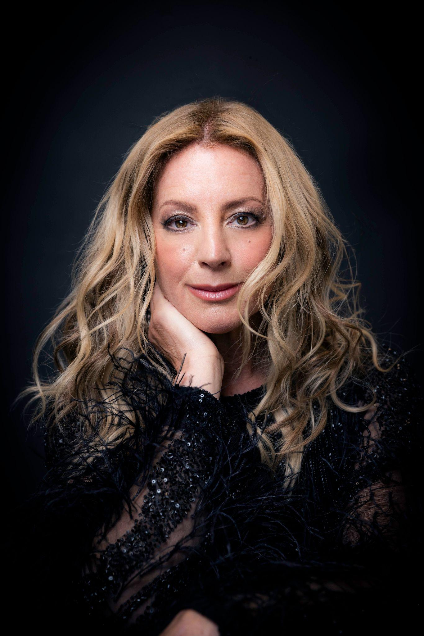
Photo Credit: Kharen Hill
Hi-res download

Better Broken Tracklisting
- Better Broken
- Gravity
- The Last to Go
- Only Way Out Is Through
- Reminds Me (feat. Katie Gavin)
- One In a Long Line
- Only Human
- Long Road Home
- Rise
- Wilderness
- If This Is the End…

Connect with Sarah McLachlan:
Website | Facebook | Instagram | TikTok | School of Music

