

JOHN FOGERTY ANNOUNCES LEGACY: THE CREEDENCE CLEARWATER REVIVAL YEARS

A Celebration, Reclamation, and New Chapter: As Fogerty Marks His 80th Birthday, He Fully Owns His Songs for the First Time, Recording Them Anew with Backing from Sons Shane and Tyler Fogerty

Three Singles Available Now - “Up Around The Bend,” “Have You Ever Seen The Rain,” and “Porterville”

LISTEN HERE

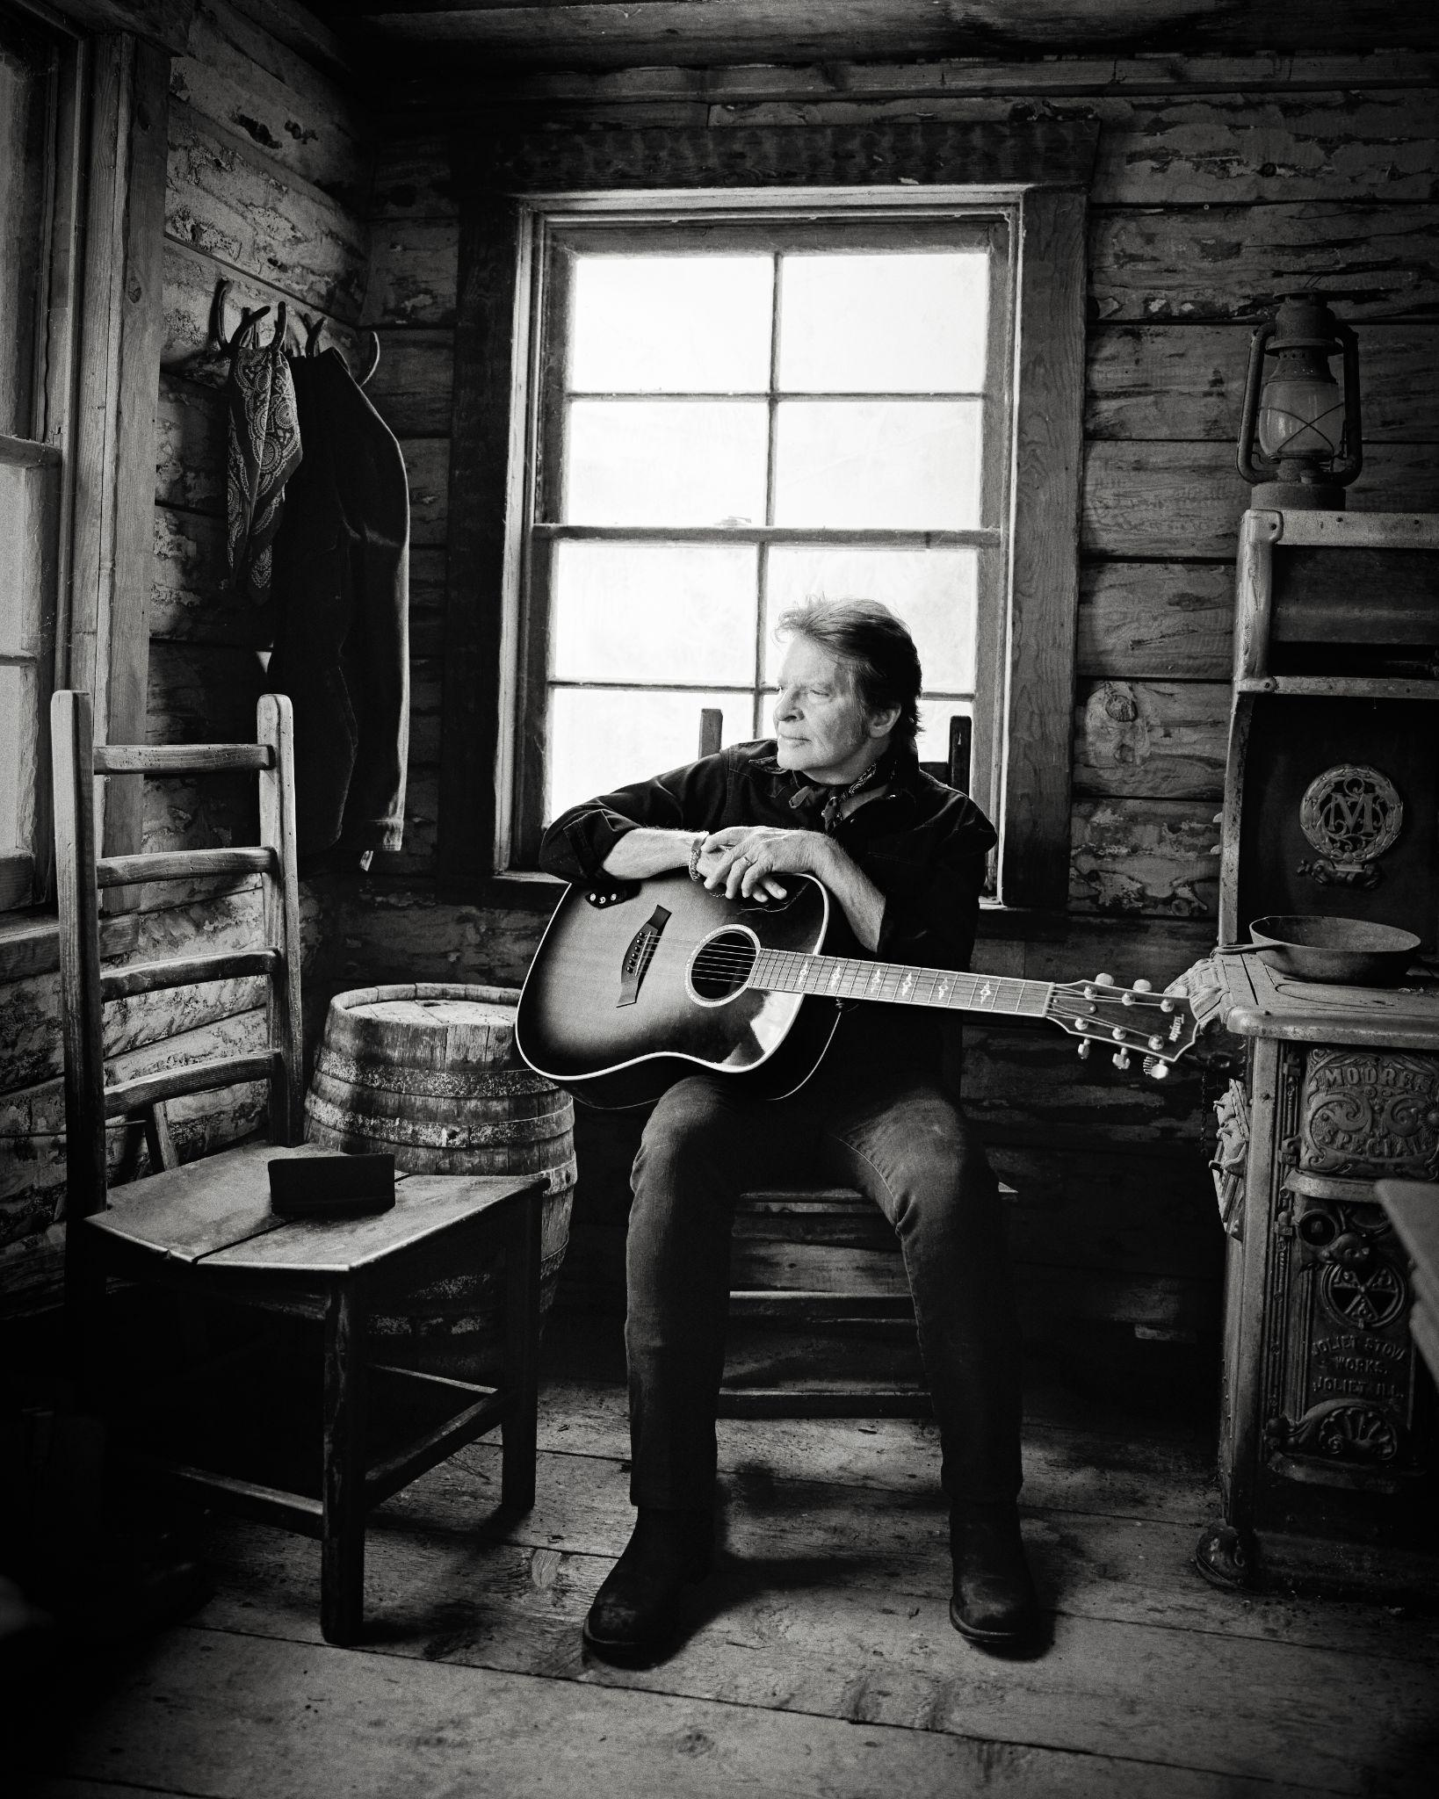
Photo credit: David McClister
Download press photos here

New York NY — Legendary musician and Rock & Roll Hall of Famer John Fogerty has announced the release of a powerful new album, Legacy: the Creedence Clearwater Revival years, arriving August 22, 2025 via Concord. The 20-track collection features newly recorded versions of Fogerty’s most beloved songs—from “Proud Mary” and “Bad Moon Rising” to “Fortunate Son” and “Have You Ever Seen the Rain”—marking both a celebration of an iconic catalog and a personal reclamation of artistic ownership. Fogerty announced the album from the stage during his sold-out 80th birthday bash last night at NYC’s Beacon Theatre (photos here). He returns to the Beacon stage tonight for another thrilling performance.

For the first time in his career, Fogerty fully owns the rights to his groundbreaking Creedence Clearwater Revival catalog—a milestone decades in the making. With Legacy, he offers fresh takes on the music that continues to define American rock, recorded with renewed energy and a deep sense of purpose as he celebrates his 80th birthday.

“For most of my life I did not own the songs I had written,” says Fogerty. “Getting them back changes everything. Legacy is my way of celebrating that—of playing these songs on my terms, with the people I love.”

Produced by Fogerty and his son Shane Fogerty, with executive production by his wife Julie Fogerty, Legacy is a family affair through and through. Julie Fogerty says, “I knew first hand how much it meant for John to get his publishing back. It has been so joyful and beautiful since this happened for him. This is a celebration of his life's work. It is the biggest party for the good guy/artist winning.”

Both Shane and his brother Tyler Fogerty perform throughout the album, recorded with Matt Chamberlain, Bob Malone, Bob Glaub and Rob Stone. It was mixed by legendary engineer Bob Clearmountain. The result is a vibrant, electrifying collection that captures the raw spirit of Fogerty’s original songs while infusing them with vital new life.

Today, new recordings of “Up Around The Bend” “Have You Ever Seen The Rain,” and “Porterville” are available to stream on DSPs. Listen here.

The album’s release comes during a banner year for Fogerty, who continues to experience a remarkable career resurgence. From a recent induction at the American Music Honors, introduced by Bruce Springsteen, to headlining sets at JazzFest (hailed as a “home run” in a Times Picayune front-page rave review), Glastonbury, The Hollywood Bowl, and more, Fogerty is as fierce and joyful as ever. His recent “Celebration Tour” sold out venues across the country, and his iconic Chronicle anthology has spent over 14 consecutive years on the Billboard 200.

In another major cultural moment, Fogerty has teamed up with Eric Church and NASCAR on Prime to create the league’s brand-new anthem—a reimagined version of his classic “Up Around The Bend,” available exclusively on Amazon Music.

Still, for Fogerty, the thrill remains rooted in the music itself. As Legacy makes clear, the fire still burns. The album is a testament to an artist who’s not only reclaimed his songs, but continues to shape the sound of American rock & roll—even as he turns 80.

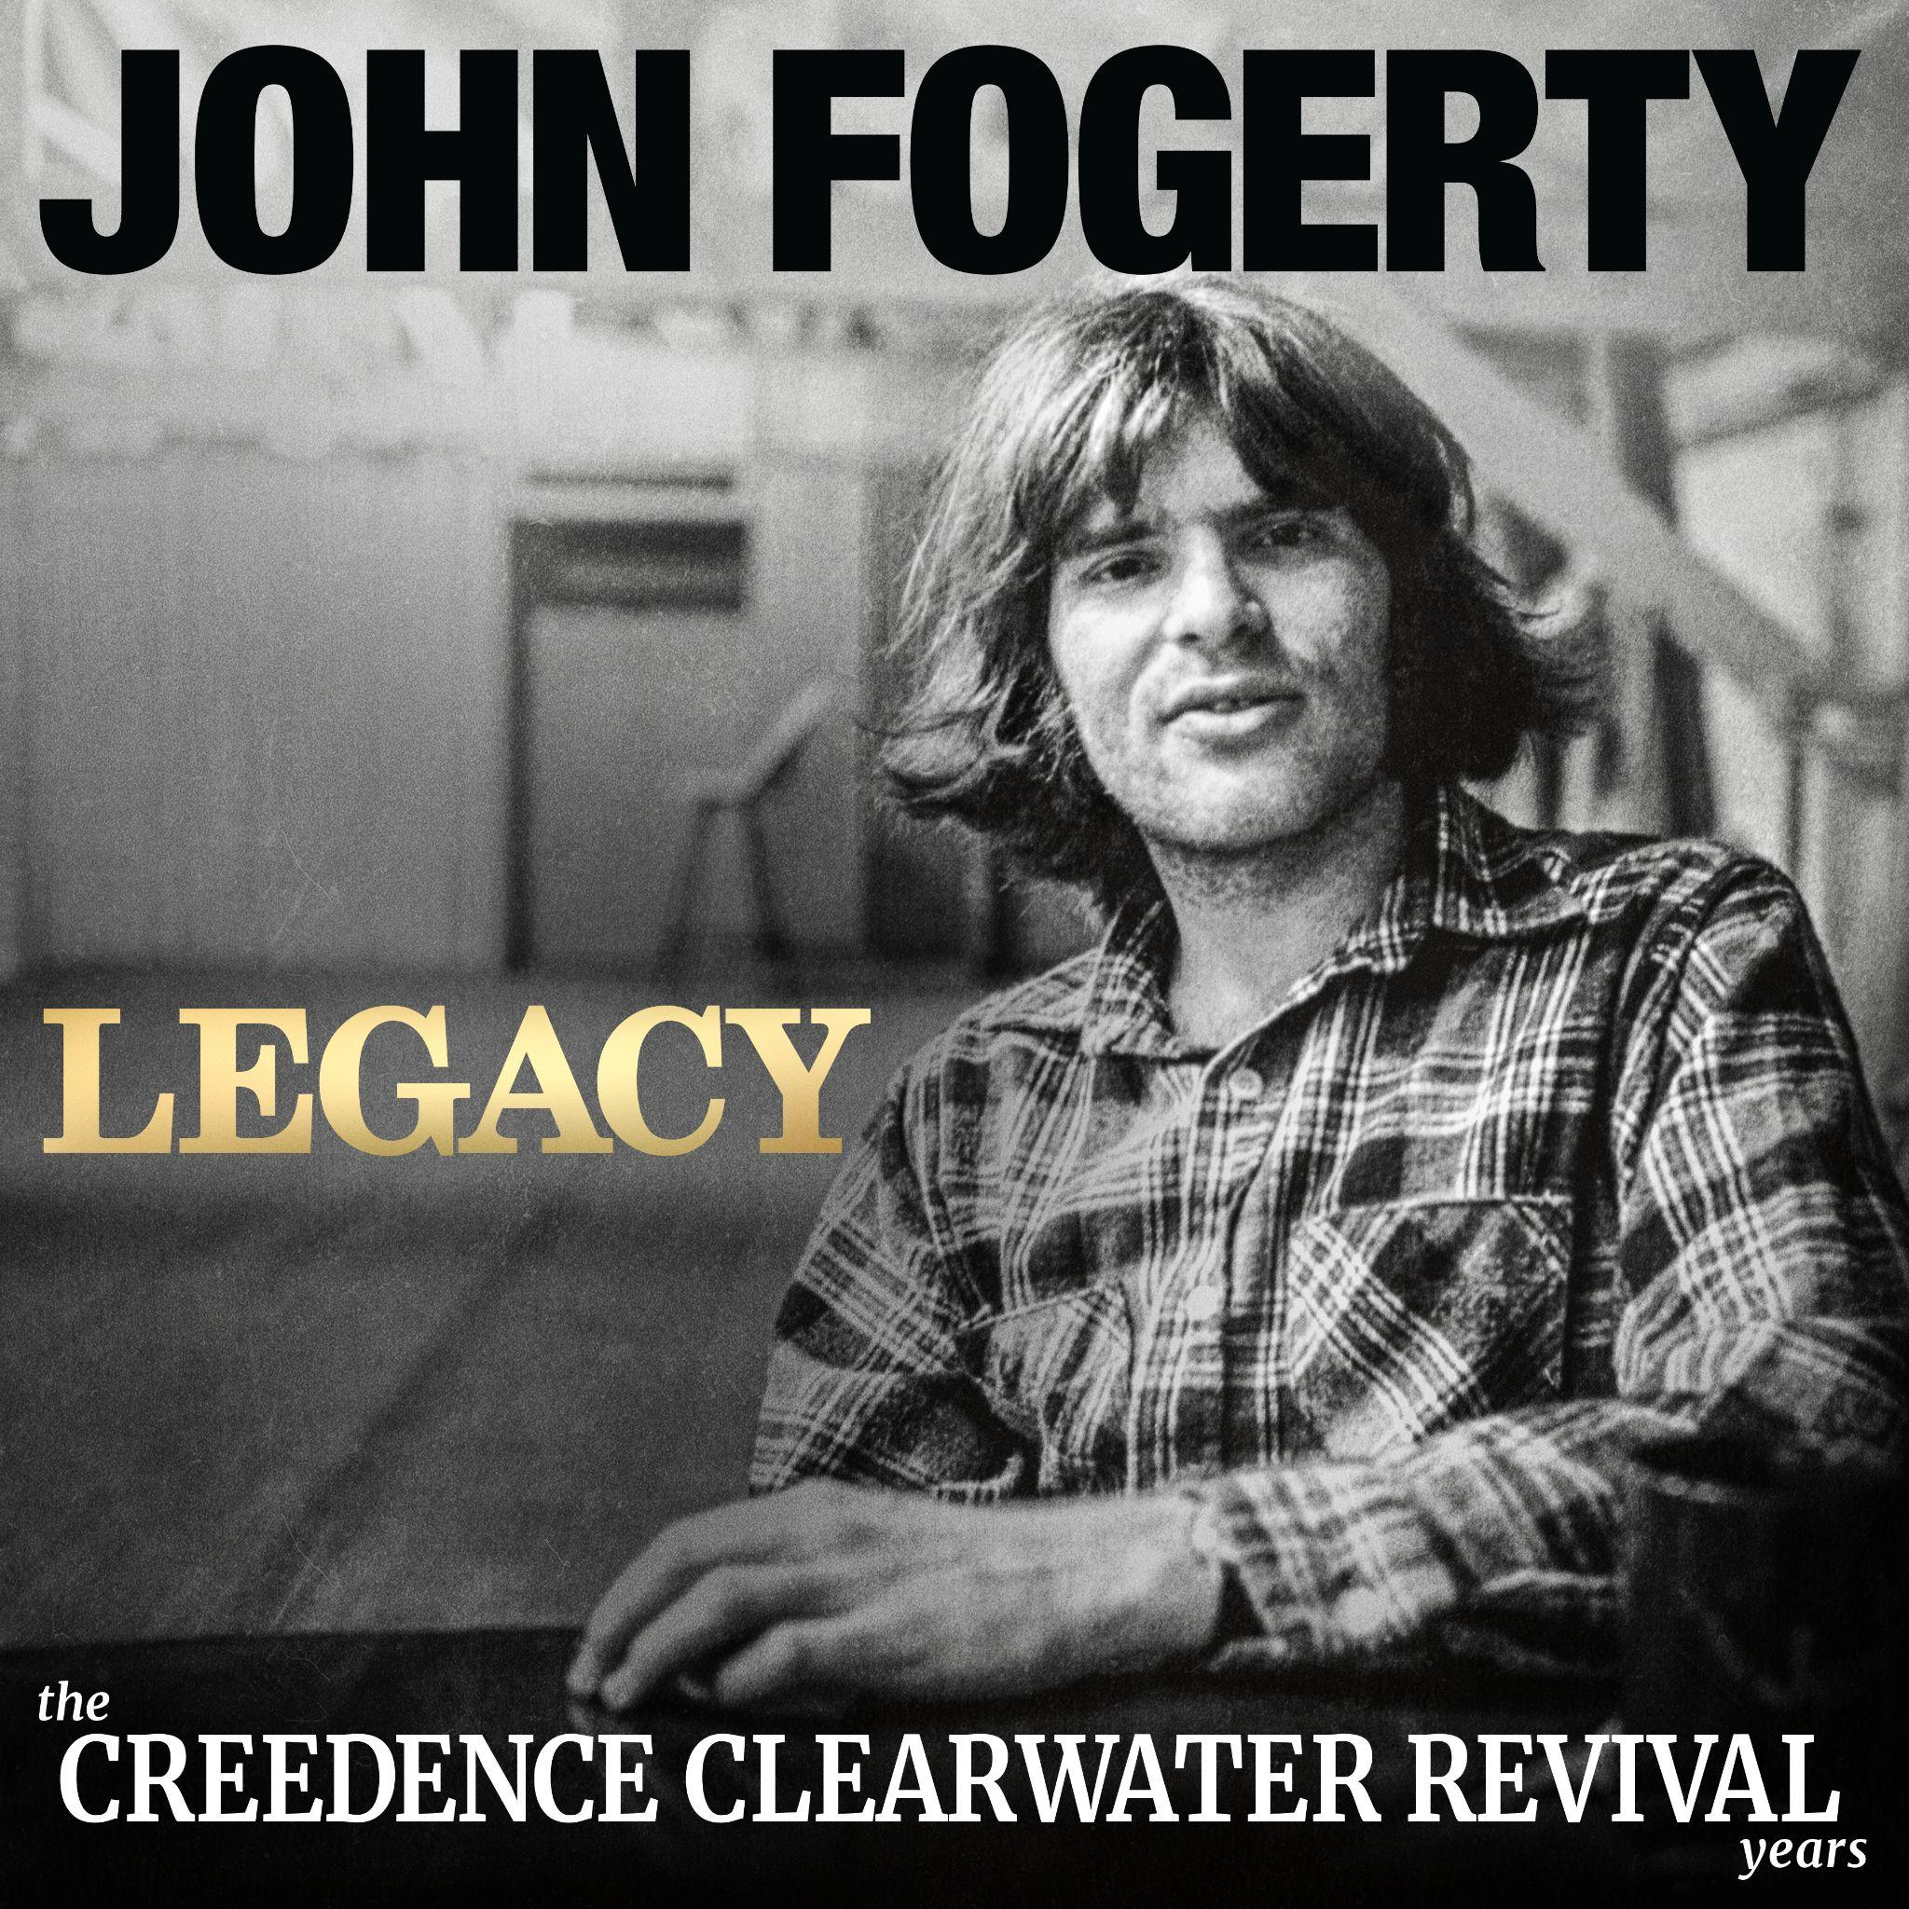

About John Fogerty
As the leader of Creedence Clearwater Revival, Fogerty helped shape the sound of American music, blending blues, country, pop, rockabilly, R&B, and swamp boogie into a genre-defying style that continues to resonate with fans around the world. One of the greatest songwriters of all time, he has received multiple awards and honors for his undeniable impact on the culture including induction in the Songwriters Hall of Fame, the BMI Icon Award, a star on the Hollywood Walk of Fame, and a special honor for his song “Centerfield” making him the only musician ever honored by the Baseball Hall of Fame.

John Fogerty’s songwriting canon spans nearly six decades and includes foundational classics such as “Proud Mary,” “Fortunate Son,” “Born on the Bayou,” “Bad Moon Rising,” and “Have You Ever Seen the Rain.” Both “Fortunate Son” and “Bad Moon Rising” have both surpassed 1 Billion streams, while “Have You Ever Seen The Rain” continues to go viral on TikTok and has garnered over 2 Billion streams. Fogerty has sold over 100 million records worldwide, and CCR’s album Chronicle: The 20 Greatest Hits recently logged 735 weeks - or 14 years - on the Billboard 200, only the fifth album ever to reach that chart milestone.

His 1997 Blue Moon Swamp won the Grammy for Best Rock Album, and his solo work has been nominated for a total of 8 Grammys over the years. So Fogerty’s status as a legend has long been secure. What’s more remarkable, though, is how popular and influential his music remains after more than 50 years. Recently, Rolling Stone ran a story with the headline “The Biggest Band in America in 2024 is…Creedence Clearwater Revival.”
Legacy: the Creedence Clearwater Revival years Tracklist
01. Up Around The Bend
﻿﻿﻿02. Who’ll Stop The Rain
03. Proud Mary
04. Have You Ever Seen The Rain
﻿﻿﻿05. Lookin’ Out My Back Door
06. Born On The Bayou
07. ﻿﻿﻿Run Through The Jungle
08. Someday Never Comes
﻿﻿﻿09. Porterville
10. Hey Tonight
11. Lodi
﻿﻿﻿﻿12. Wrote A Song For Everyone
﻿﻿﻿﻿13. Bootleg
﻿﻿﻿﻿14. Don’t Look Now
﻿﻿﻿15. Long As I Can See The Light
16. Down On The Corner
﻿﻿﻿﻿17. Bad Moon Rising
﻿﻿﻿﻿18. Travelin’ Band
﻿﻿﻿﻿19. Green River
﻿﻿﻿﻿20. Fortunate Son

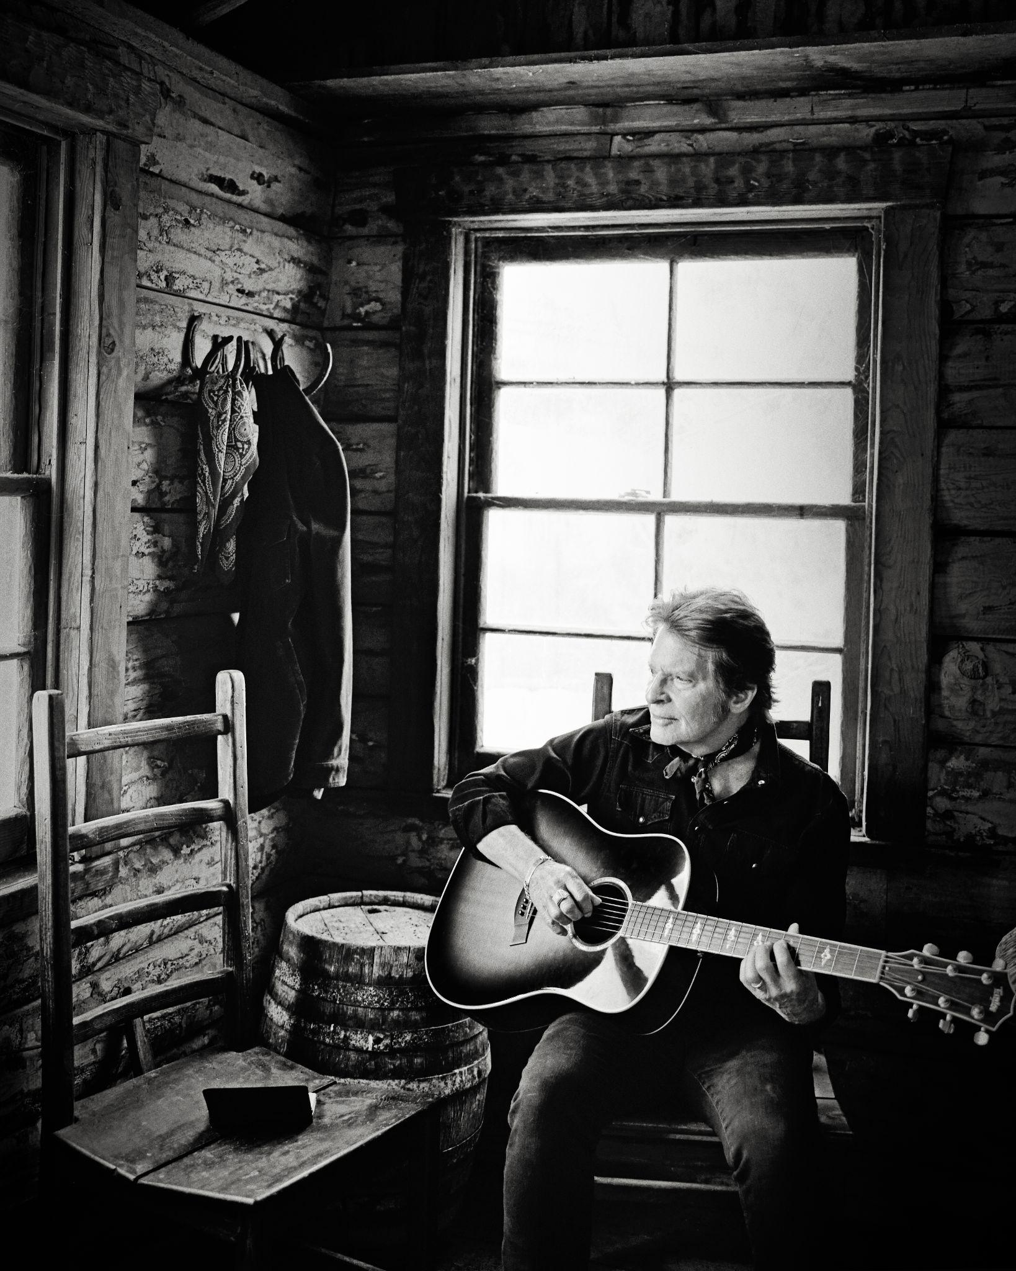
Photo credit: David McClister

