

The Celebration Continues: John Fogerty Releases Two New Singles From Upcoming Album
Legacy: the Creedence Clearwater Revival years (out August 22)

"Born On The Bayou" and "Lodi" Available Now

LISTEN HERE

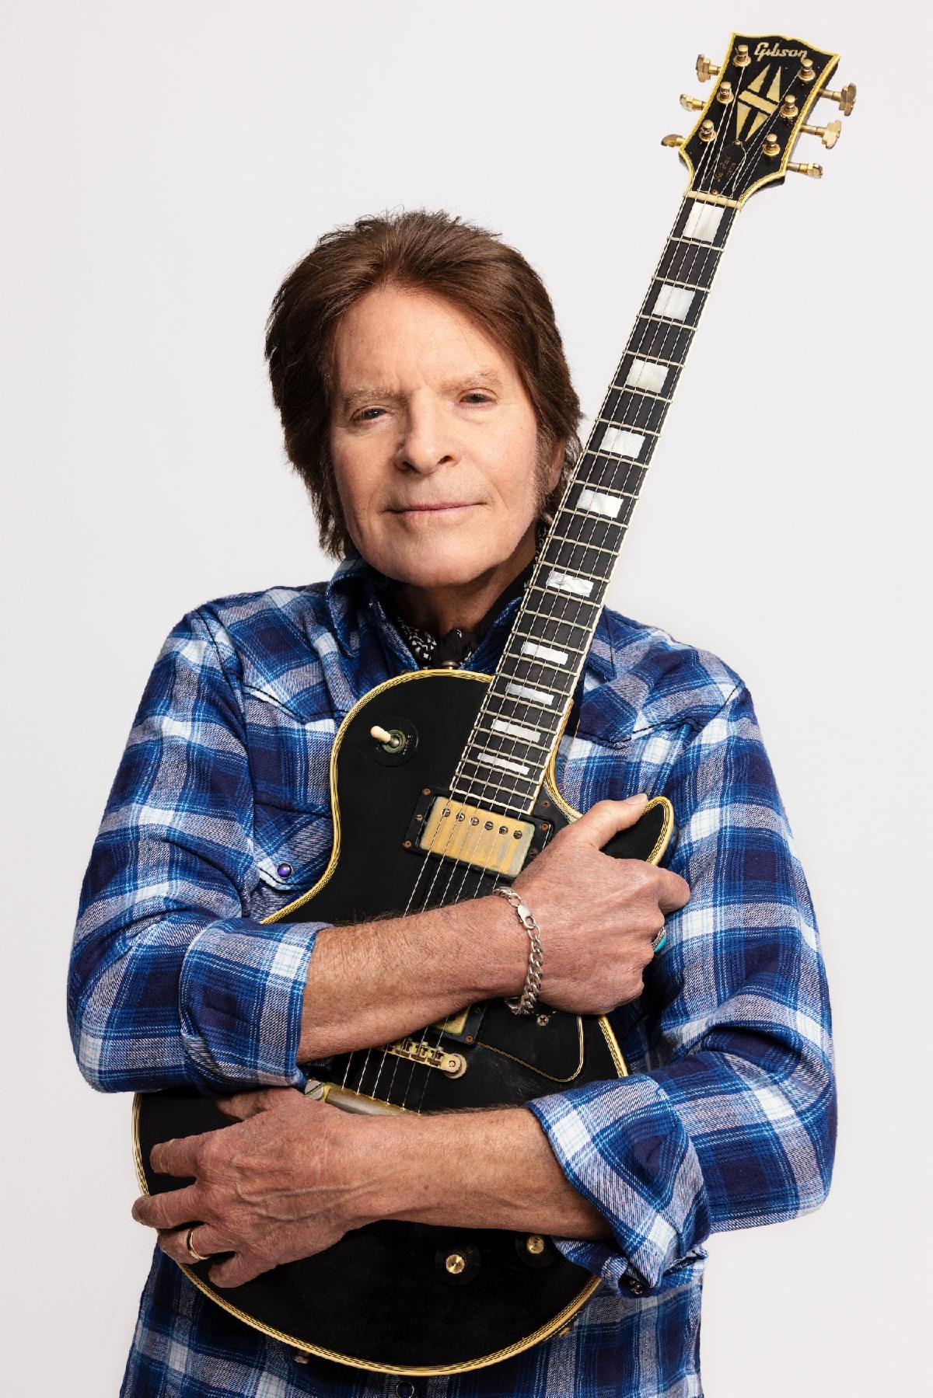
Photo Credit: David McClister

“A glorious thing is waiting for us up around the bend.”
- NYMag/Vulture on the forthcoming release of Legacy

"Fogerty somehow wrote a significant chapter
of the Great American Songbook entirely by himself."
- Rolling Stone

New York, NY — Legendary musician and Rock & Roll Hall of Famer John Fogerty continues to celebrate his unparalleled catalog with the release of two brand-new recordings, "Born On The Bayou" and "Lodi.” The tracks are the latest previews from Legacy: the Creedence Clearwater Revival years (due out August 22, 2025 via Concord), which features newly recorded versions of his most beloved songs—from "Proud Mary" and "Bad Moon Rising" to "Fortunate Son" and "Have You Ever Seen The Rain."

The new recordings of "Born On The Bayou" and “Lodi,” released 50+ years after the original versions, bring out new emotional depth in Fogerty’s iconic voice. The process of recreating these tunes, this time backed by his sons Shane and Tyler, required Fogerty to relearn his spontaneous guitar riffs and also revisit some of the darker times that inspired songs like “Lodi,” which tells the story of a musician stuck in a small town, yearning to break through.

“When it came time to sing ‘Lodi,’ I noticed that my voice seemed to have a little extra character in it from the guy who sang this same song 50+ years ago,” says Fogerty. “I realized that I had to do my darndest to get my mind into the same place that it was when I did the original vocal. I had to reflect and think about the words of the song, think about the times, make myself go back into that spiritual plane of existence and face that.”

Listen to “Born On The Bayou” and “Lodi” HERE.

For the first time in his career, Fogerty fully owns the rights to his groundbreaking Creedence Clearwater Revival catalog, and Legacy serves as both a celebration of that milestone and a personal reclamation of his artistic legacy. He announced the album during his sold-out 80th birthday show at New York’s Beacon Theatre last month. As Rolling Stone noted in its review, Fogerty "played an explosive set…that showcased a level of energy, vocal power, and swagger few of rock’s octogenarians can muster."

The powerful 20-track collection is truly a family affair, produced by Fogerty and his son Shane Fogerty, with executive production by his wife Julie Fogerty. Both Shane and his brother Tyler Fogerty perform throughout the album, recorded with Matt Chamberlain, Bob Malone, Bob Glaub, and Rob Stone. It was mixed by legendary engineer Bob Clearmountain, resulting in vibrant and electrifying versions that breathe new life into these timeless songs.

"For most of my life I did not own the songs I had written," says Fogerty. "Getting them back changes everything. Legacy is my way of celebrating that—of playing these songs on my terms, with the people I love."

The release of "Born On The Bayou" and "Lodi" follows the album’s initial trio of singles, "Up Around The Bend," "Have You Ever Seen The Rain," and "Porterville," which are available now on streaming platforms.

The album arrives during a banner year for Fogerty, who continues to experience a remarkable career resurgence. From his recent induction at the American Music Honors, introduced by Bruce Springsteen, to headlining sets at JazzFest, Glastonbury, and The Hollywood Bowl, Fogerty remains one of the most dynamic performers in rock & roll. His sold-out “Celebration Tour” and collaborations with artists like Eric Church and NASCAR on Prime further underscore his ongoing cultural impact.

Still, at the heart of it all is the music itself. As Legacy makes clear, the fire still burns.

Photo Credit: David McClister

About John Fogerty
As the leader of Creedence Clearwater Revival, Fogerty helped shape the sound of American music, blending blues, country, pop, rockabilly, R&B, and swamp boogie into a genre-defying style that continues to resonate with fans around the world. One of the greatest songwriters of all time, he has received multiple awards and honors for his undeniable impact on the culture including induction in the Songwriters Hall of Fame, the BMI Icon Award, a star on the Hollywood Walk of Fame, and a special honor for his song “Centerfield” making him the only musician ever honored by the Baseball Hall of Fame.

John Fogerty’s songwriting canon spans nearly six decades and includes foundational classics such as “Proud Mary,” “Fortunate Son,” “Born on the Bayou,” “Bad Moon Rising,” and “Have You Ever Seen the Rain.” Both “Fortunate Son” and “Bad Moon Rising” have both surpassed 1 Billion streams, while “Have You Ever Seen The Rain” continues to go viral on TikTok and has garnered over 2 Billion streams. Fogerty has sold over 100 million records worldwide, and CCR’s album Chronicle: The 20 Greatest Hits recently logged 751 weeks - or 14 years - on the Billboard 200, only the fifth album ever to reach that chart milestone.

His 1997 Blue Moon Swamp won the Grammy for Best Rock Album, and his solo work has been nominated for a total of 8 Grammys over the years. So Fogerty’s status as a legend has long been secure. What’s more remarkable, though, is how popular and influential his music remains after more than 50 years. Recently, Rolling Stone ran a story with the headline “The Biggest Band in America in 2024 is…Creedence Clearwater Revival.”

Legacy: the Creedence Clearwater Revival years Tracklist
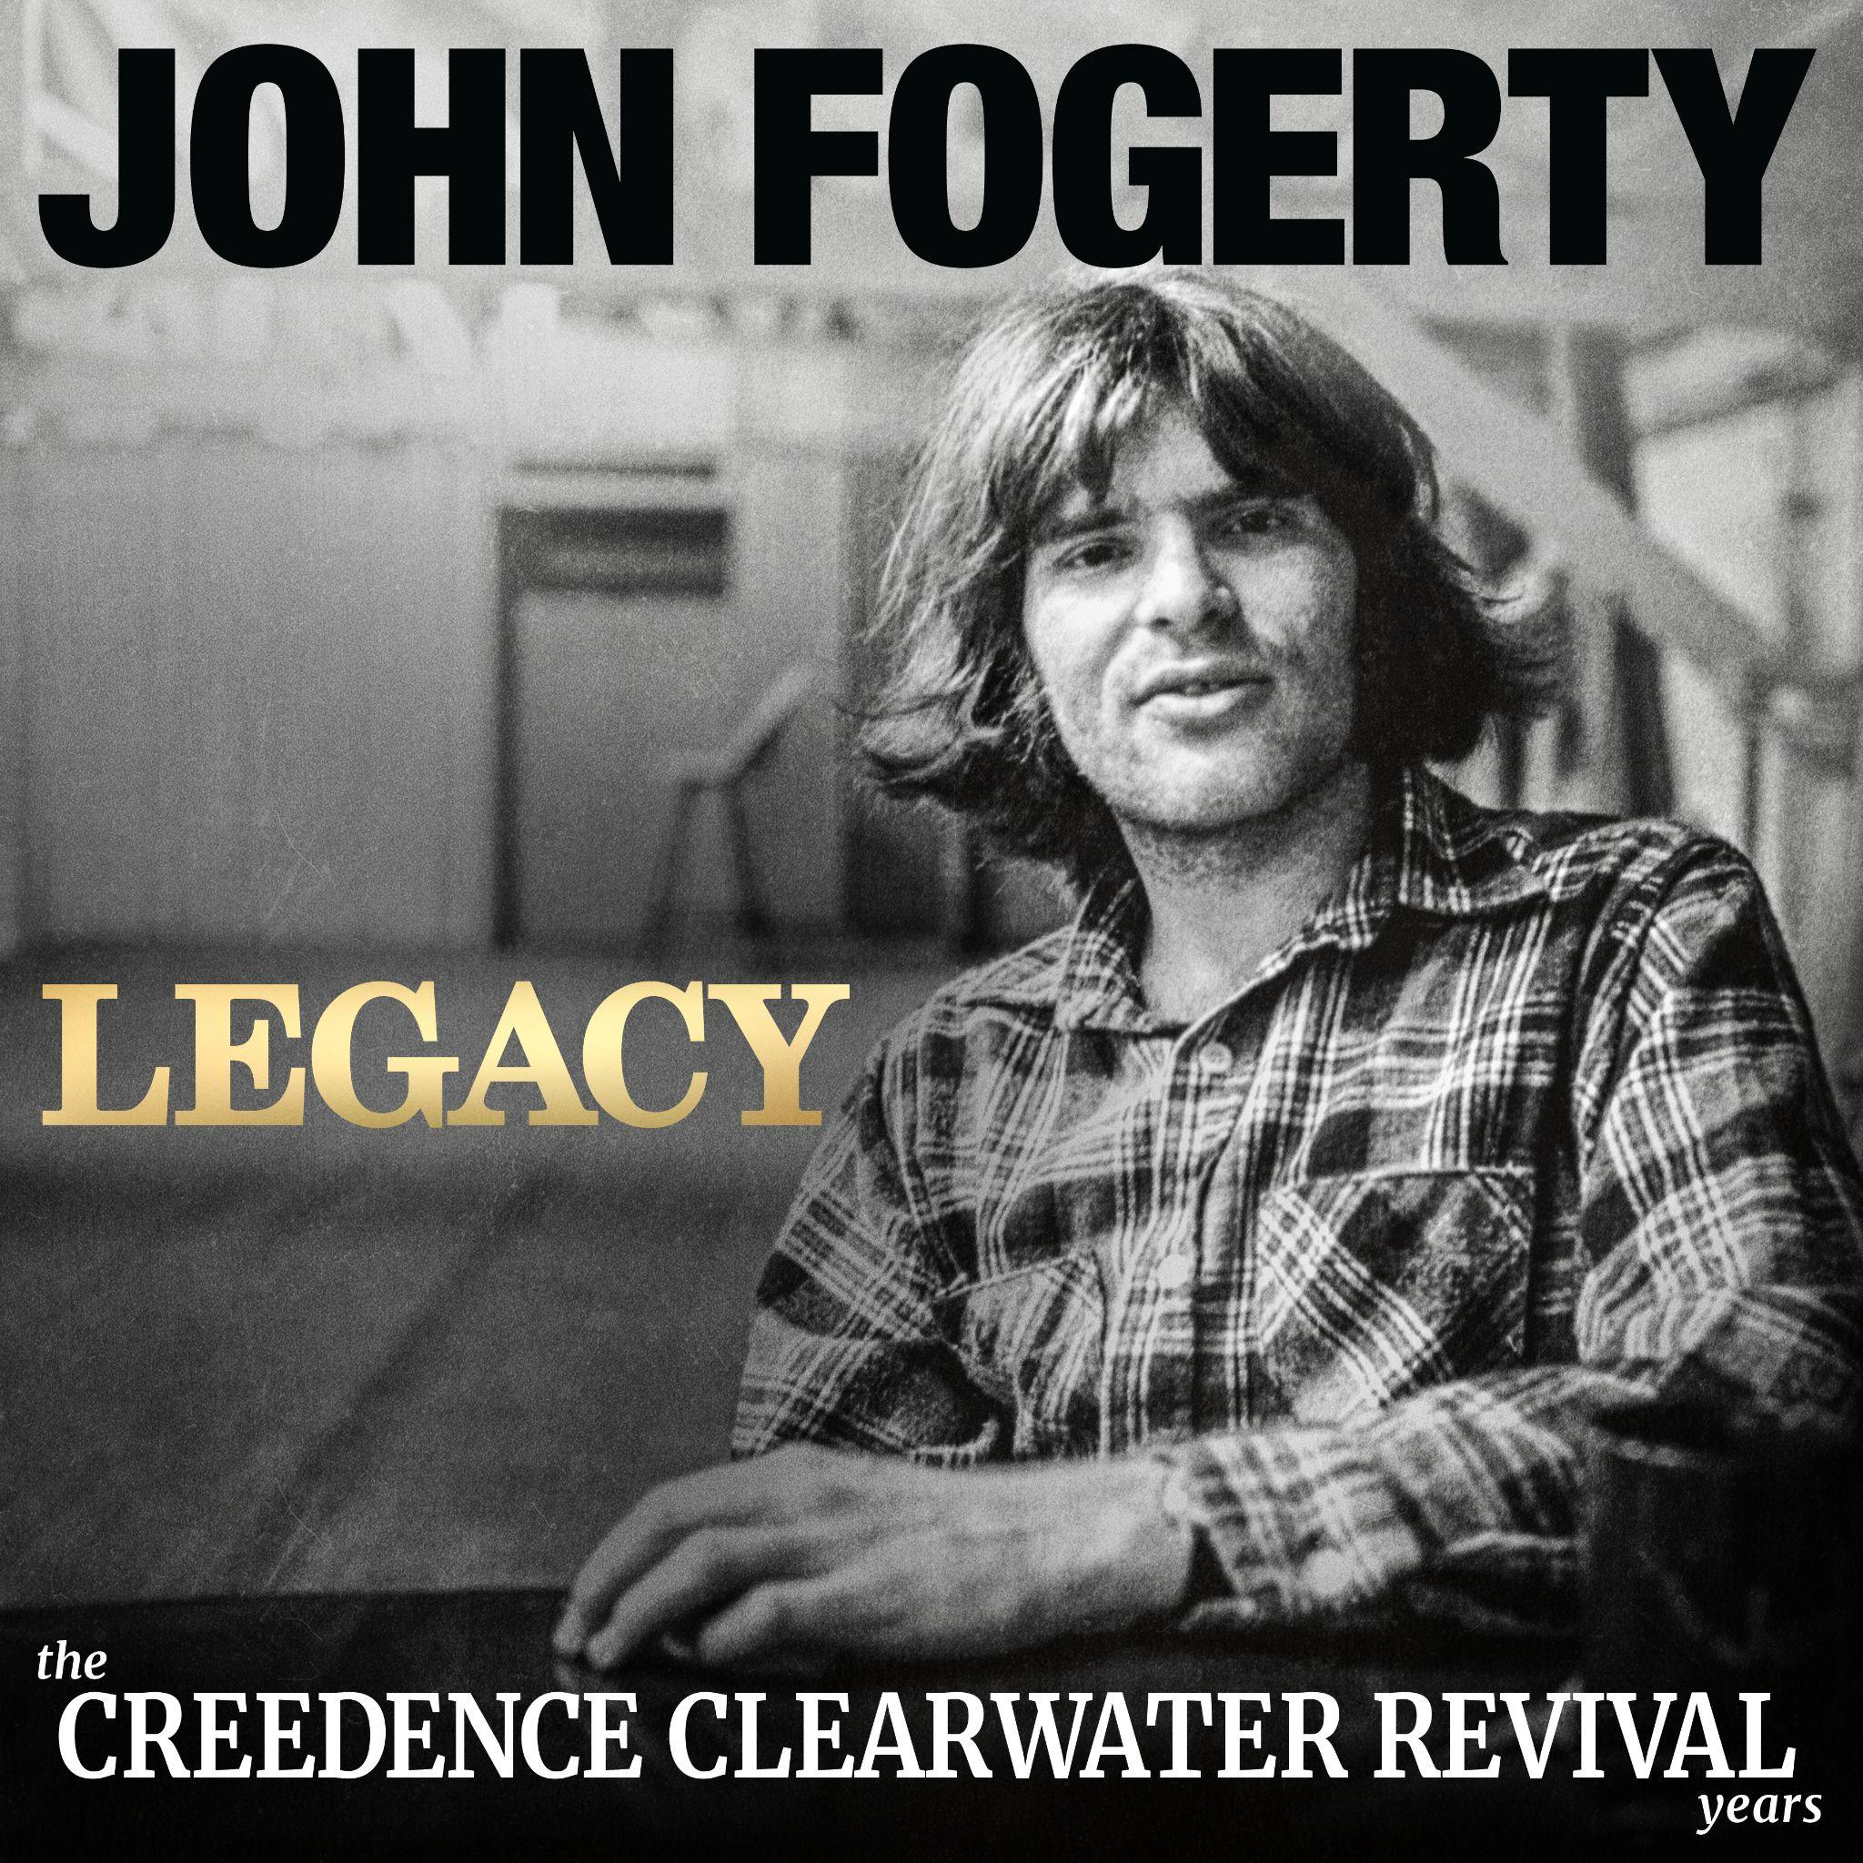
01. Up Around The Bend
﻿﻿﻿02. Who’ll Stop The Rain
03. Proud Mary
04. Have You Ever Seen The Rain
﻿﻿﻿05. Lookin’ Out My Back Door
06. Born On The Bayou
07. ﻿﻿﻿Run Through The Jungle
08. Someday Never Comes
﻿﻿﻿09. Porterville
10. Hey Tonight
11. Lodi
﻿﻿﻿﻿12. Wrote A Song For Everyone
﻿﻿﻿﻿13. Bootleg
﻿﻿﻿﻿14. Don’t Look Now
﻿﻿﻿15. Long As I Can See The Light
16. Down On The Corner
﻿﻿﻿﻿17. Bad Moon Rising
﻿﻿﻿﻿18. Travelin’ Band
﻿﻿﻿﻿19. Green River
﻿﻿﻿﻿20. Fortunate Son

For more information, please contact Allison Elbl (aelbl@shorefire.com), Matt Hanks (mhanks@shorefire.com) and Taylor Perry (tperry@shorefire.com).
###

