DAFFO

RELEASES “SIDEWAYS”
FINAL SINGLE FROM NEW ALBUM
WHERE THE EARTH BENDS
OUT THIS FRIDAY ON CONCORD RECORDS

NORTH AMERICA FALL TOUR WITH WEDNESDAY,
UK + EUROPE DATES ANNOUNCED

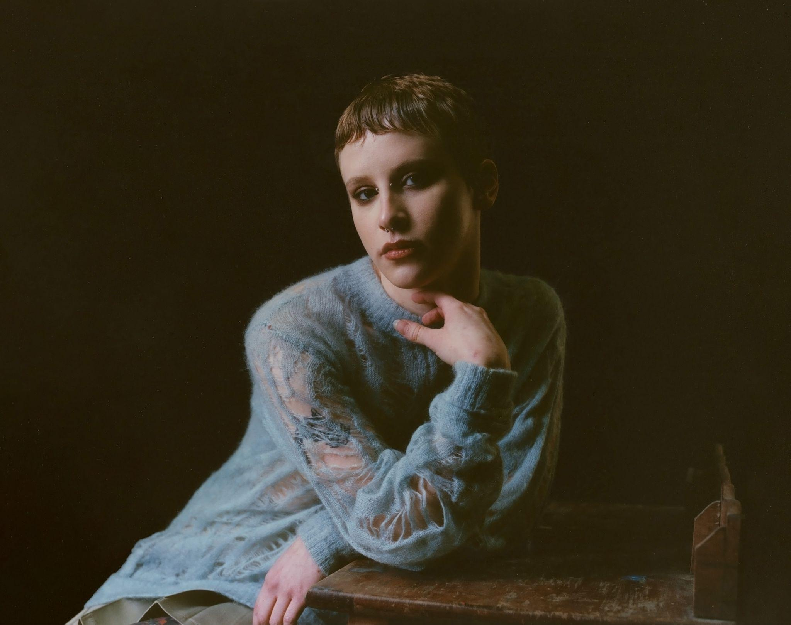
Photo Credit: Nolan Knight (download hi-res)
“Gabi Gamberg’s scratchy voice over sputtering drums and lo-fi distorted guitars seesaws between remembering the wonderment of ‘the kid in you’ and an adult realization that ‘there’s nothing I can do’ - the holiday season’s tensions laid bare.”
-The New York Times

"The gritty, slacker rock sound brings strength to their tender phrasings and acrobatic harmonies"
-Paste

"Catchy and distortion-heavy"
-Stereogum

"Uniquely confessional lyricism"
-The Needle Drop

Daffo, aka LA-based artist Gabi Gamberg, shares “Sideways,” the final single from their debut album, Where the Earth Bends, out this Friday on due Concord Records. “‘Sideways’ is tough for me to talk about, but it has to do with my habit of keeping secrets from others, or hiding certain things from people out of the belief that it’s for their own benefit,” Gamberg explains.

An essential new voice on the indie-rock scene Daffo brings an unexpected beauty to the most uncomfortable of feelings. With a poetic specificity that cuts right to the heart, they speak an unfiltered truth about all that sets them apart from the wider world, confronting everything from shame and self-loathing to misplaced affection and the chaos of living with an overactive brain. Where the Earth Bends, produced and mixed by Rob Schnapf (Elliott Smith, Beck, Cat Power), is a one-of-a-kind coming-of-age album that finds powerful catharsis in painful confession.

The album’s previously singles “Get a Life,” “Habit,” “Dagger Song,” “Quick Fix,” and “Absence Makes the Heart Grow” have collectively received praise from Alternative Press, Brooklyn Vegan, Paste Magazine, Stereogum, The Needle Drop and more, while previous songs released from the record have garnered attention from The New York Times, Pitchfork, Billboard, and more.

After spending much of the past year on tour with artists like Blondshell, illuminati hotties, and Annie DiRusso, Daffo will be touring this fall as direct support for Wednesday and playing a string a headline dates in the UK and EU next month. All dates below.

LISTEN TO “SIDEWAYS”
[Embed: https://www.youtube.com/watch?v=Ehoyz6ONMfw]

Tour Dates:
10/29 - Manchester, UK @ YES (Basement)
10/30 - Leeds, UK @ The Lending Room
10/31 - London, UK @ The Lower Third
11/01 - Amsterdam, NL @ London Calling
11/04 - Berlin, DE @ Bar Bobu
11/05 - Haldern, DE @ Haldern Pop Bar
11/06 - Brussels, BE @ Botanique (Witloof Bar)
11/07 - Paris, FR @ Pitchfork Music Festival (Supersonic Records)
11/10 – Philadelphia, PA @ Union Transfer ^
11/11 – Brooklyn, NY @ Brooklyn Steel ^
11/12 – Brooklyn, NY @ Brooklyn Steel ^
11/13 – Montreal, QC @ Club Soda ^
11/15 – Toronto, ON @ Concert Hall ^
11/16 – Detroit, MI @ Majestic Theatre ^
11/17 – Chicago, IL @ The Riviera Theater ^
11/19 – Cleveland, OH @ Globe Iron ^
11/20 – Pittsburgh, PA @ Roxian Theatre ^
11/21 – Washington, DC @ 9:30 Club ^

^ w/ Wednesday

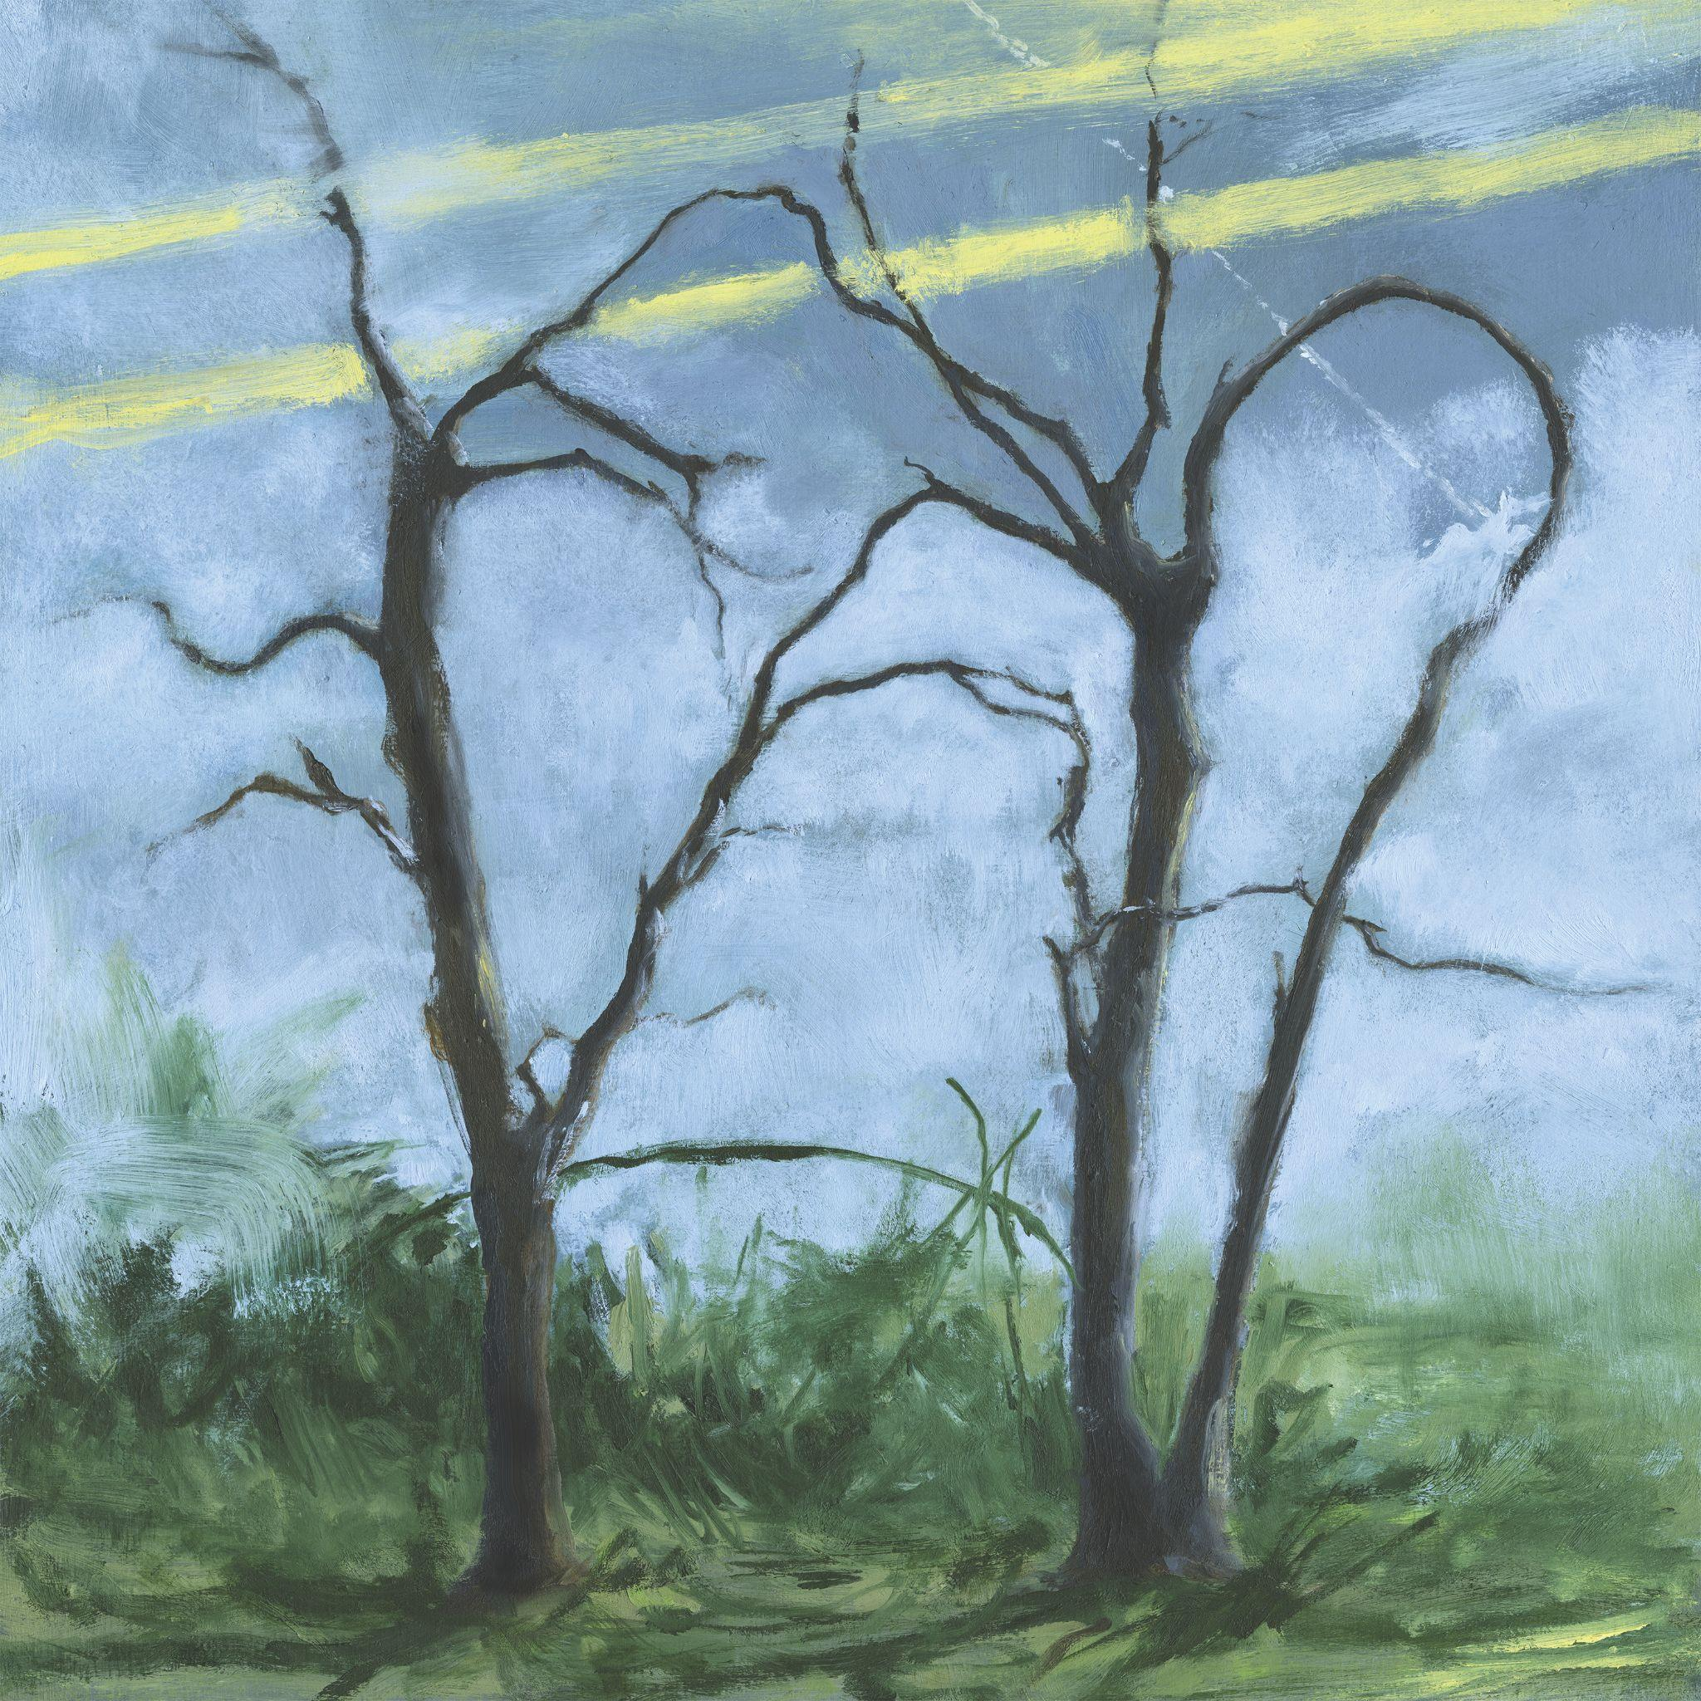
Album Art Credit: Zora Gamberg (download hi-res)
Track List:
1. Get a Life
2. Habit
3. Carrot Fingers
4. Dagger Song
5. Bad Dog
6. Quick Fix
7. Absence Makes the Heart Grow
8. Go Fetch
9. When I’m In Hell
10. Unveiling
11. Sideways
12. Where the Earth Bends

About Daffo:
The latest entry in an acclaimed catalog including their widely beloved 2021 debut EP Crisis Kit and its 2023 follow-up Pest, Where the Earth Bends begins on the oddly thrilling lament of “Get a Life”: a sing-along-ready rumination on the all-too-familiar challenge of living fully in the moment. Meanwhile, “Quick Fix” examines how attempts at self-soothing frequently lead to prolonged suffering. Detailing the empty pleasures of cigarette smoking and one-night stands, the visceral yet ineffably gentle track serves as a sonic testament to Gamberg’s inner battle to understand and forgive themselves. Imbued with equal parts rage, shame, and resolve, the sublimely grungy “Absence Makes the Heart Grow” documents the slow dissolution of a long-distance relationship.

With their artist name taken from the swath of daffodils that grew in the yard of their childhood home, Gamberg first tapped into their innate musicality by taking up violin at age six, then underwent classical training for nearly a decade before discovering their affinity for guitar. At the age of 15, they took part in a summer program at Boston’s Berklee College of Music, where they crossed paths with Hudson Pollock—a fellow student who soon introduced Gamberg to the DIY community in northern New Jersey, including all-ages spaces like Serendipity Café (a student-run nonprofit venue that’s hosted likeminded artists such as Pinegrove and Alex G). “I started going up to New Jersey almost every weekend to record or play shows, and after a while I felt like I needed to get out my town altogether,” Gamberg says. Following a failed attempt at persuading their parents to let them drop out of high school, Gamberg enrolled at Idyllwild Arts Academy (a residential arts high school in Southern California) just after Covid hit. “I spent a lot of my time secluded in the mountains, writing and recording and going to classes on Zoom,” says Gamberg, who self-released Crisis Kit during their time at Idyllwild. “At first I had a hard time with songwriting classes; I didn’t like the idea of following any kind of formula or rules. But eventually I learned a lot about what makes a song effective, and how to convey things in a way that really gets through to somebody.”

After graduating, Gamberg enrolled at the Clive Davis Institute of Recorded Music at New York University and slowly made their way into the local DIY scene. “The first time I played in New York, I didn’t know anyone and only one person showed up,” they say. “But then my first week of classes I went in and told everyone, ‘I’m playing a show on Friday and I don’t have a band, who wants to play with me?’ It’s a lot harder to tap into the DIY scene there, but pretty soon I was playing shows every weekend in New York and in Jersey.” As their community of fans began to grow, they downloaded TikTok on a whim and went viral with the second post they ever shared: a bedroom performance of a spontaneously composed song called “The Experiment,” which later appeared as a bonus track on Pest. Not long after Pest’s arrival, Daffo inked a deal with Concord Records, then left NYU to focus on their music full-time.

WEBSITE | BANDCAMP | SPOTIFY | APPLE MUSIC | TIKTOK | INSTAGRAM

