

**DAFFO**

**ANNOUNCES DEBUT ALBUM**

[***WHERE THE EARTH BENDS***](https://ffm.to/daffo-wheretheearthbends)

**OUT SEPT 26 VIA CONCORD RECORDS**

**RELEASES VIDEO FOR NEW SINGLE “**[**HABIT**](https://ffm.to/daffo-habit)**”**

**ON TOUR WITH BLONDSHELL**

**TOUR DATES ANNOUNCED WITH WEDNESDAY**

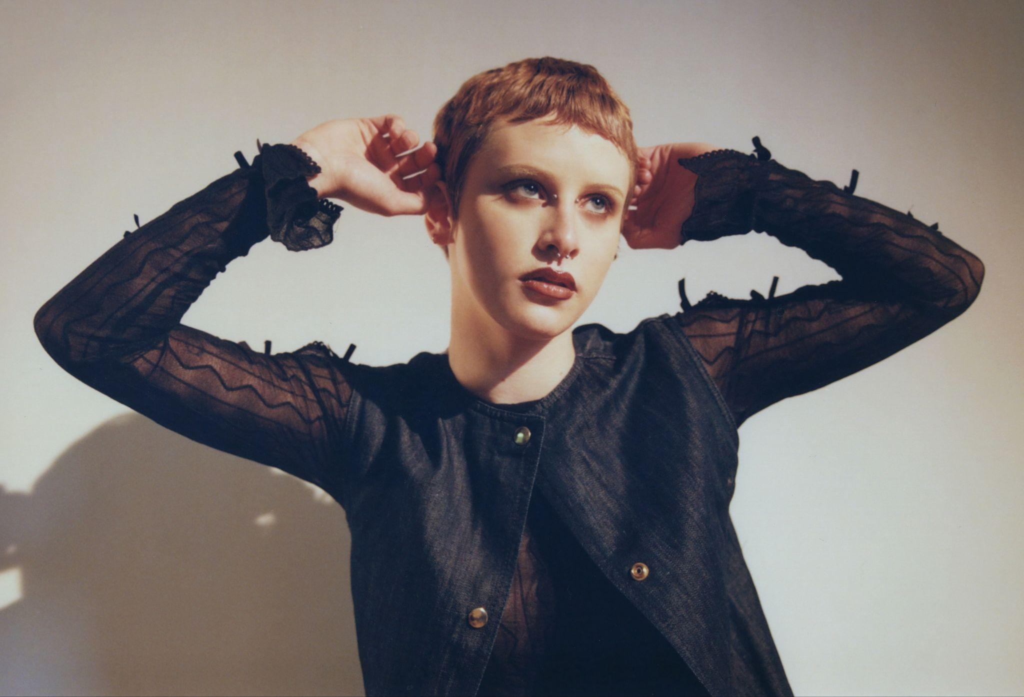

**Photo Credit: Nolan Knight (**[**download hi-res**](https://drive.google.com/file/d/1BdSRk9aFjdGA41Z-psW-oK59Nxui-hAq/view?usp=drive_link)**)**

*“Gabi Gamberg’s scratchy voice over sputtering drums and lo-fi distorted guitars seesaws between remembering the wonderment of ‘the kid in you’ and an adult realization that ‘there’s nothing I can do’ - the holiday season’s tensions laid bare.”*

***-The New York Times***

*“Thoughtful, confessional songwriting that is simply undeniable”*

***-Paste***

An essential new voice on the indie-rock scene, 21-year-old singer/songwriter **Daffo**, the moniker of **Gabi Gamberg,** brings an unexpected beauty to the most uncomfortable of feelings. With a poetic specificity that cuts right to the heart, the Los Angeles-based artist speaks an unfiltered truth about all that sets them apart from the wider world, confronting everything from shame and self-loathing to misplaced affection and the chaos of living with an overactive brain.

After spending much of the past year on tour with artists like illuminati hotties and Annie DiRusso, Daffo now makes their full-length debut with [***Where the Earth Bends***](https://ffm.to/daffo-wheretheearthbends), due **September 26th** via **Concord Records**, a one-of-a-kind coming-of-age album that finds powerful catharsis in painful confession.

Deeply rooted in Daffo’s unsparing self-reflection, *Where the Earth Bends* sheds light on their struggle with obsessive-compulsive disorder on songs like the distortion-drenched “[**Habit**](https://youtu.be/NSh7Uf83-ds),” released today alongside a video by Anastasia Duchess. “I wrote that song at a moment when I was having a hard time with my OCD and cyclical thinking,” says Gamberg. “It’s partly about how I tend to come to conclusions about certain situations before even allowing myself to experience them.”

Produced and mixed by **Rob Schnapf** (Elliott Smith, Beck, Cat Power), *Where the Earth Bends* encompasses an intimate yet frenetic sound that perfectly mirrors the album’s emotional intensity and embodies an unfettered energy that magnifies the impact of their songwriting.

Daffo is currently on tour with **Blondshell** and will be touring this fall as direct support for **Wednesday**. All dates below.

**WATCH THE “**[**HABIT**](https://youtu.be/NSh7Uf83-ds)**” VIDEO**

[Embed: https://youtu.be/NSh7Uf83-ds]

**Tour Dates:**

6/26 - Asheville, NC @ The Orange Peel *

6/27 - Atlanta, GA @ Variety Playhouse *

6/28 - Nashville, TN @ The Basement East *

11/1 – Amsterdam, NL @ London Calling

11/7 - Paris, FR @ Pitchfork Festival Paris

11/10 – Philadelphia, PA @ Union Transfer ^

11/11 – Brooklyn, NY @ Brooklyn Steel ^

11/12 – Brooklyn, NY @ Brooklyn Steel ^

11/13 – Montreal, QC @ Club Soda ^

11/15 – Toronto, ON @ Concert Hall ^

11/16 – Detroit, MI @ Majestic Theatre ^

11/17 – Chicago, IL @ The Riviera Theater ^

11/19 – Cleveland, OH @ Globe Iron ^

11/20 – Pittsburgh, PA @ Roxian Theatre ^

11/21 – Washington, DC @ 9:30 Club ^

* w/ Blondshell

^ w/ Wednesday

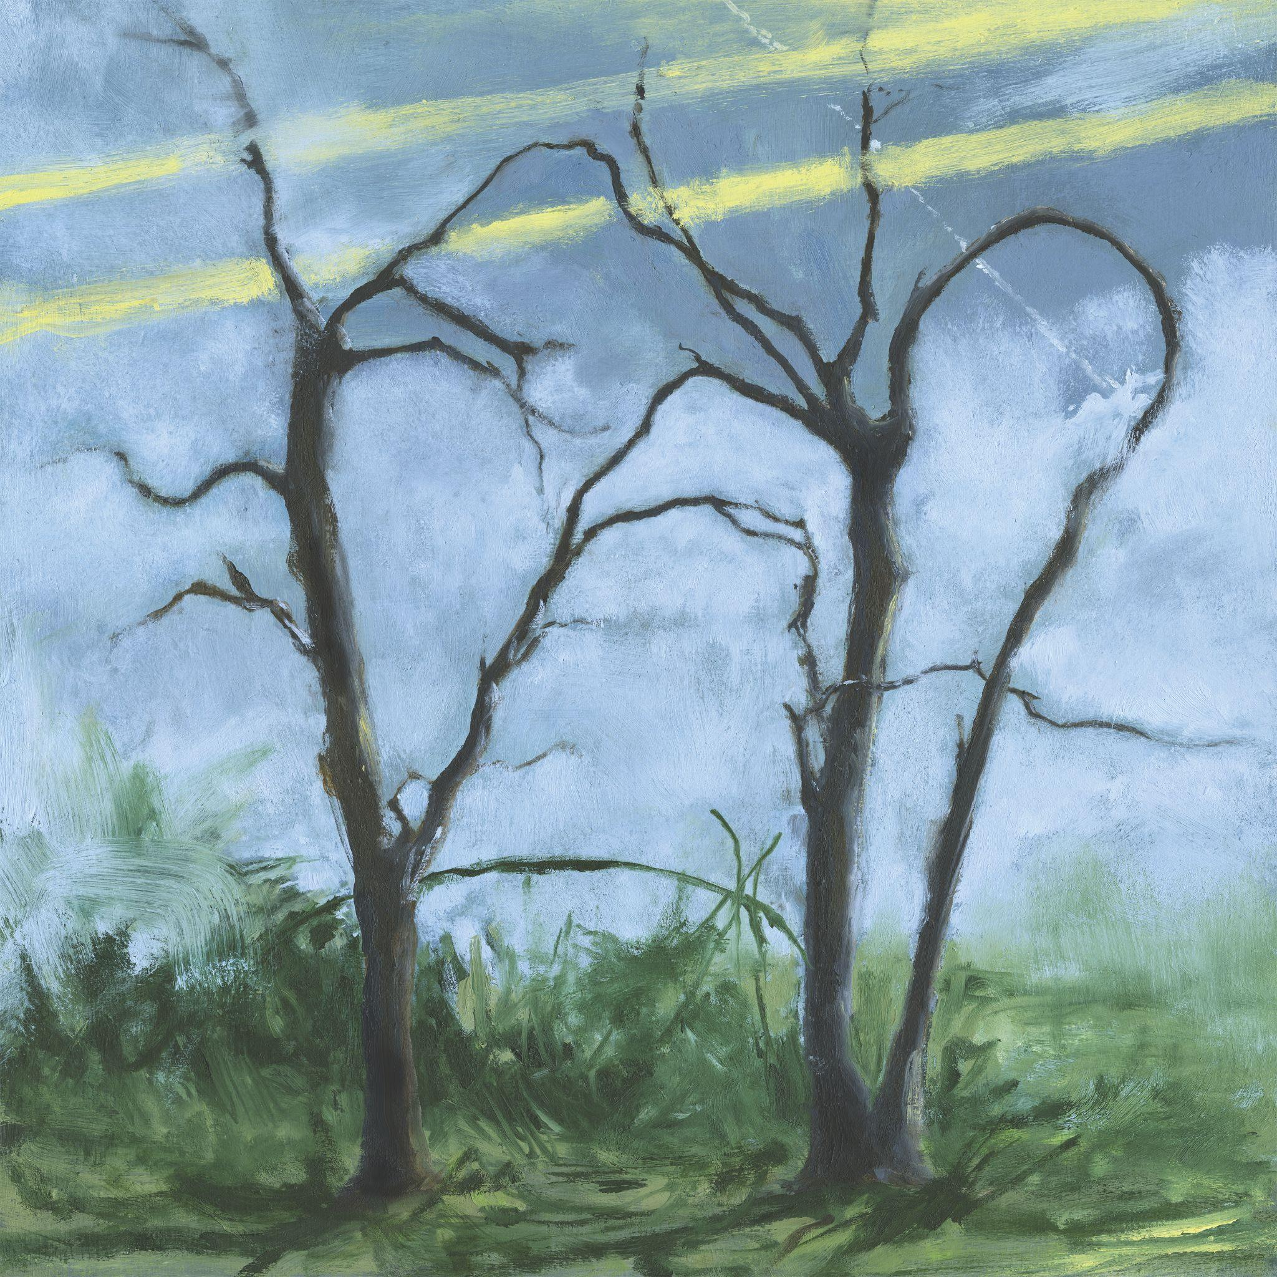

**Album Art Credit: Zora Gamberg (**[**download hi-res**](https://drive.google.com/file/d/1LjtWXWJ15gINPBjEi_6FgLtqlJLAU30U/view?usp=drive_link)**)**

**Track List:**

1. [Get a Life](https://www.youtube.com/watch?v=z_2gZmwpgpc)

2. [Habit](https://ffm.to/daffo-habit)

3. Carrot Fingers

4. Dagger Song

5. Bad Dog

6. [Quick Fix](https://youtu.be/R2VzsT_ULEQ)

7. [Absence Makes the Heart Grow](https://youtu.be/1DgdwcnD2n4)

8. Go Fetch

9. When I’m In Hell

10. Unveiling

11. Sideways

12. Where the Earth Bends

**About Daffo:**

The latest entry in an acclaimed catalog including their widely beloved 2021 debut EP *Crisis Kit* and its 2023 follow-up *Pest*, *Where the Earth Bends* begins on the oddly thrilling lament of “[Get a Life](https://www.youtube.com/watch?v=z_2gZmwpgpc)”: a sing-along-ready rumination on the all-too-familiar challenge of living fully in the moment. Meanwhile, “[Quick Fix](https://youtu.be/R2VzsT_ULEQ)” examines how attempts at self-soothing frequently lead to prolonged suffering. Detailing the empty pleasures of cigarette smoking and one-night stands, the visceral yet ineffably gentle track serves as a sonic testament to Gamberg’s inner battle to understand and forgive themselves. Imbued with equal parts rage, shame, and resolve, the sublimely grungy “[Absence Makes the Heart Grow](https://youtu.be/1DgdwcnD2n4)” documents the slow dissolution of a long-distance relationship.

With their artist name taken from the swath of daffodils that grew in the yard of their childhood home, Gamberg first tapped into their innate musicality by taking up violin at age six, then underwent classical training for nearly a decade before discovering their affinity for guitar. At the age of 15, they took part in a summer program at Boston’s Berklee College of Music, where they crossed paths with Hudson Pollock—a fellow student who soon introduced Gamberg to the DIY community in northern New Jersey, including all-ages spaces like Serendipity Café (a student-run nonprofit venue that’s hosted likeminded artists such as Pinegrove and Alex G). “I started going up to New Jersey almost every weekend to record or play shows, and after a while I felt like I needed to get out my town altogether,” Gamberg says. Following a failed attempt at persuading their parents to let them drop out of high school, Gamberg enrolled at Idyllwild Arts Academy (a residential arts high school in Southern California) just after Covid hit. “I spent a lot of my time secluded in the mountains, writing and recording and going to classes on Zoom,” says Gamberg, who self-released *Crisis Kit* during their time at Idyllwild. “At first I had a hard time with songwriting classes; I didn’t like the idea of following any kind of formula or rules. But eventually I learned a lot about what makes a song effective, and how to convey things in a way that really gets through to somebody.”

After graduating, Gamberg enrolled at the Clive Davis Institute of Recorded Music at New York University and slowly made their way into the local DIY scene. “The first time I played in New York, I didn’t know anyone and only one person showed up,” they say. “But then my first week of classes I went in and told everyone, ‘I’m playing a show on Friday and I don’t have a band, who wants to play with me?’ It’s a lot harder to tap into the DIY scene there, but pretty soon I was playing shows every weekend in New York and in Jersey.” As their community of fans began to grow, they downloaded TikTok on a whim and went viral with the second post they ever shared: a bedroom performance of a spontaneously composed song called “The Experiment,” which later appeared as a bonus track on *Pest.* Not long after *Pest’*s arrival, Daffo inked a deal with Concord Records, then left NYU to focus on their music full-time.

[**WEBSITE**](https://www.daffomusic.com/) **|** [**BANDCAMP**](https://gabigamberg.bandcamp.com/) **|** [**SPOTIFY**](https://open.spotify.com/artist/0RsNTNwQqjREcl3VG81prp) **|** [**APPLE MUSIC**](https://music.apple.com/us/artist/daffo/1576420621) **|** [**TIKTOK**](https://www.tiktok.com/@daffoband?lang=en) **|** [**INSTAGRAM**](https://www.instagram.com/daffoband/?hl=en)