
BMI TO HONOR JOHN FOGERTY WITH 2025 TROUBADOUR AWARD
Private Event Will Celebrate Fogerty's Illustrious Career with
Special Tribute Performances at BMI’s Nashville Headquarters on September 8th
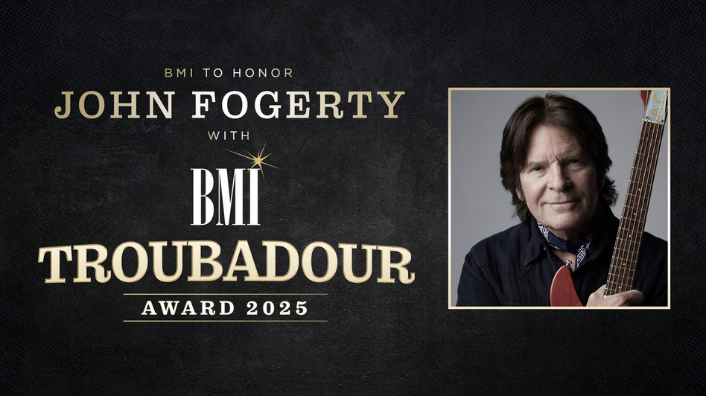

Download Images Here
NASHVILLE, TN - Aug. 4, 2025 - BMI announced today that legendary musician and Rock & Roll Hall of Famer John Fogerty will receive the 2025 Troubadour Award, honoring the tremendous influence he’s had on the American musical landscape. This prestigious accolade recognizes a songwriter who has made a profound impact on the creative community and whose work continues to set the pace for generations to follow. The private event will be held at BMI’s Nashville office on September 8th.
“John Fogerty has written and recorded some of the most distinctive and beloved rock songs of the 20th century, and his music is unequivocally the sound of America, with timeless lyrics wrapped in unforgettable melodies that continue to resonate with generations of fans around the world,” said BMI Vice President, Creative, Nashville Clay Bradley.“We’re thrilled to honor John with the BMI Troubadour Award and celebrate his creative achievements and his songs, which have become the soundtrack of so many lives.”
John Fogerty’s songwriting canon spans nearly six decades and includes foundational classics such as “Proud Mary,” “Fortunate Son,” “Born on the Bayou,” “Bad Moon Rising,” and “Have You Ever Seen the Rain.” As the leader of Creedence Clearwater Revival, Fogerty helped shape the sound of American music, blending blues, country, pop, rockabilly, R&B, and swamp boogie into a genre-defying style that continues to resonate with fans around the world. He has received multiple awards and honors for his undeniable impact on the culture including an induction into the Songwriters Hall of Fame, a star on the Hollywood Walk of Fame, and a special honor for his song “Centerfield,” making him the only musician ever honored by the Baseball Hall of Fame.
Since his affiliation with BMI in 2005, Fogerty has been named a BMI Icon in 2010 and was presented with the BMI Board of Directors Award in 2023. He’s also received 13 BMI Million-Air certificates, recognizing his songs that have surpassed over one million radio airplays, which collectively have had over 64 million broadcast performances.
Recently, Fogerty has made several high-profile appearances, including headline sets at JazzFest, Glastonbury, the Hollywood Bowl and more, plus an induction at the American Music Honors (introduced by Bruce Springsteen) and a collaboration with Eric Church for the new NASCAR on Prime anthem. On August 22nd, Fogerty will release his new album Legacy, a 20-track collection of newly recorded versions of his biggest hits. For the first time in his career, Fogerty fully owns the rights to his groundbreaking CCR catalog, and this album serves as both a celebration of that milestone and a personal reclamation of his artistic legacy on his own terms.
Dubbed “Nashville’s most glorious low-key party” (Rolling Stone), BMI’s invitation-only Troubadour Awards will include unforgettable tribute performances and commemorative speeches by special guests during a cocktail reception and dinner. In receiving this honor, Fogerty joins the ranks of Billy F Gibbons, John Hiatt, John Oates, John Prine, Robert Earl Keen and Lucinda Williams. Falling on the eve of AMERICANAFEST, this ceremony will serve as a homecoming for BMI’s Americana family of songwriters. Event sponsors include Gallagher Insurance, Gibson and WP Global.
ABOUT JOHN FOGERTY:
As the leader of Creedence Clearwater Revival, Fogerty helped shape the sound of American music, blending blues, country, pop, rockabilly, R&B, and swamp boogie into a genre-defying style that continues to resonate with fans around the world. One of the greatest songwriters of all time, he has received multiple awards and honors for his undeniable impact on the culture including induction in the Songwriters Hall of Fame, the BMI Icon Award, a star on the Hollywood Walk of Fame, and a special honor for his song “Centerfield” making him the only musician ever honored by the Baseball Hall of Fame. Fogerty’s songwriting canon spans nearly six decades and includes foundational classics such as “Proud Mary,” “Fortunate Son,” “Born on the Bayou,” “Bad Moon Rising,” and “Have You Ever Seen the Rain.” Both “Fortunate Son” and “Bad Moon Rising” have both surpassed 1 Billion streams, while “Have You Ever Seen The Rain” continues to go viral on TikTok and has garnered over 2 Billion streams. Fogerty has sold over 100 million records worldwide, and CCR’s album Chronicle: The 20 Greatest Hits recently logged 751 weeks - or 14 years - on the Billboard 200, only the fifth album ever to reach that chart milestone. His 1997 Blue Moon Swamp won the Grammy for Best Rock Album, and his solo work has been nominated for a total of 8 Grammys over the years. So Fogerty’s status as a legend has long been secure. What’s more remarkable, though, is how popular and influential his music remains after more than 50 years. Just last year, Rolling Stone ran a story with the headline “The Biggest Band in America in 2024 is…Creedence Clearwater Revival.”
ABOUT BMI:
Celebrating over 80 years of service to songwriters, composers, music publishers and businesses, BMI® is a global leader in music rights management, serving as an advocate for the value of music. BMI represents the public performance rights in over 22.4 million musical works created and owned by more than 1.4 million songwriters, composers, and music publishers. The Company negotiates music license agreements and distributes the fees it generates as royalties to its affiliated writers and publishers when their songs are performed in public. In 1939, BMI created a groundbreaking open-door policy becoming the only performing rights organization to welcome and represent the creators of blues, jazz, country, and American roots music. Today, the musical compositions in BMI’s repertoire, from chart toppers to perennial favorites, span all genres of music and are consistently among the most-performed hits of the year. For additional information and the latest BMI news, visit bmi.com, follow us on X and Instagram @BMI or stay connected through BMI‘s Facebook page. Sign up for BMI’s The Weekly™ and receive our e-newsletter every week to stay up to date on all things music.

BMI Contact:
Elice Cuff
ecuff@bmi.com
Lauren Wilkinson
lwilkinson@bmi.com

