For Immediate Release
April 15, 2025

THE REVIVALISTS TO CELEBRATE 10TH ANNIVERSARY OF
MEN AMONGST MOUNTAINS WITH VERY SPECIAL US TOUR

“ALL IN THE FAMILY: 10 YEARS OF MEN AMONGST MOUNTAINS”
GETS UNDERWAY SEPTEMBER 21 IN PORTLAND, ME

HIGHLIGHTS INCLUDE PREVIOUSLY ANNOUNCED RETURN TO
MORRISON, CO’S RED ROCKS AMPHITHEATRE ON OCTOBER 9

TICKETS ON SALE NOW

TOP-BILLED FESTIVAL DATES AND MORE
ALSO SLATED THROUGH THE SUMMER

POOLSIDE REMIX OF “WISH I KNEW YOU” OUT NOW – LISTEN

VISUALIZER STREAMING NOW – WATCH

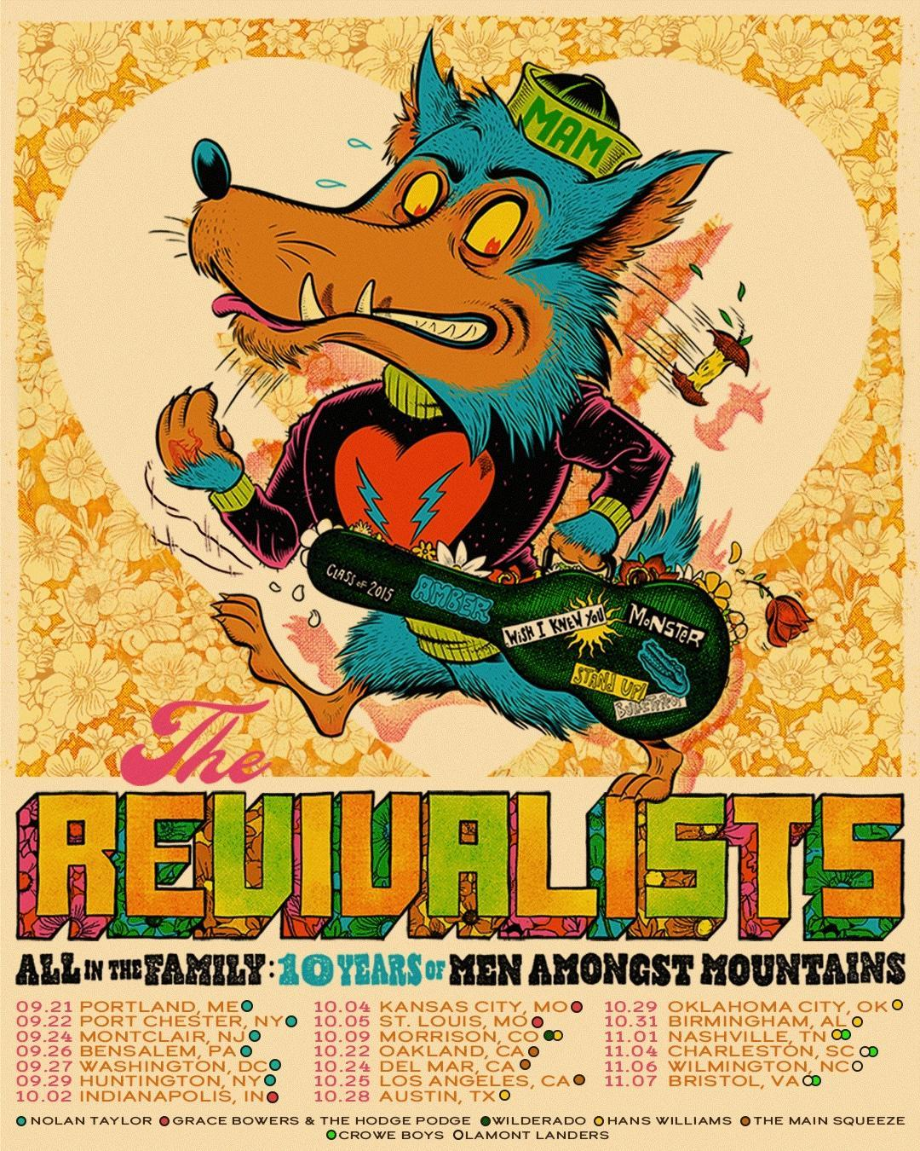

RIAA multi-Platinum certified rock band The Revivalists will celebrate the 10th anniversary of their breakthrough 2015 album, Men Amongst Mountains, with a very special US headline tour. “All in the Family: 10 Years of Men Amongst Mountains” gets underway September 21 at Portland, ME’s State Theatre and then travels through early November. Highlights include shows at such historic venues as Port Chester, NY’s Capitol Theatre (September 22), Indianapolis, IN’s Egyptian Room at Old National Centre (October 2), Oakland, CA’s Fox Theater (October 22), and Austin, TX’s Stubb's Amphitheater (October 28), as well as a previously announced return to Morrison, CO’s legendary Red Rocks Amphitheatre (October 9). The Revivalists will be joined by an impressive lineup of support acts on select dates, including Nolan Taylor, Grace Bowers & The Hodge Podge, Wilderado, Hans Williams, The Main Squeeze, Lamont Landers, and Crowe Boys. Tour goes on sale to the general public beginning today at 10:00 a.m. (local). For complete details and ticket information, please visit www.therevivalists.com/tour.

The Revivalists is also celebrating the 10th anniversary of Men Amongst Mountains by releasing a "Wish I Knew You" remix by LA-based chillwave master Poolside. The remix is accompanied by a visualizer that features throwback photos of The Revivalists from the original Men Amongst Mountains era, blended in a nostalgic mixed media style - watch HERE. The remix will be included on a 10th Anniversary Edition of the album that will be released later this year.

LISTEN TO “WISH I KNEW YOU (POOLSIDE REMIX)”
WATCH “WISH I KNEW YOU (POOLSIDE REMIX)” VISUALIZER

“We all just love love love this reimagined version of 'Wish I Knew You,'” says lead singer David Shaw. When I first heard it, I probably listened to it 20 times in a row. No joke. The reimagined groove on the chorus really smacks you. We’re all so honored that Poolside gave the greenlight for this one.”

“I basically took the original, politely asked it to leave, and invited some synthesizers and drum machines over, mixed up the arrangement ever so slightly, and BOOM. Here it is. For dancefloor use only!” says Jeffrey Paradise of Poolside. “But to be a bit more serious, remixing a song from a band this tight is kind of like trying to rearrange a finished puzzle without breaking the picture. Their chemistry is undeniable, so the challenge was to pull it apart enough to make something new, while keeping the soul intact.”

The Revivalists will precede “All in the Family: 10 Years of Men Amongst Mountains” with a wide-ranging series of additional live dates through the summer including a special double-bill with the Red Clay Strays at Orange Beach, AL’s Wharf Amphitheater (July 5) and top-billed festival appearances at Atlanta, GA’s SweetWater 420 Fest (April 20), New Orleans, LA’s New Orleans Jazz & Heritage Festival (April 27), Charlotte, NC’s Lovin’ Life Music Fest (May 2), Memphis, TN’s Smokeslam (May 16), Richardson, TX’s Wildflower Arts & Music Festival (May 17), Winnetka, IL’s Winnetka Music Festival (June 20), Marshfield, MA’s Levitate Music and Arts Festival (July 12), Ninilchik, AK’s Salmonfest 2025 (August 1-3), and Fredericton, NB’s Harvest Music Festival (September 10).

The Revivalists' third full-length studio recording, Men Amongst Mountains proved the New Orleans, LA-based band's breakthrough upon its July 2015 release, reaching #4 on "Heatseekers Albums," #18 on "Alternative Albums," and #23 on "Top Rock Albums." Produced by fellow New Orleans icon Ben Ellman of Galactic, the album's success stemmed from both the band's reputation as an electrifying live act and chart-topping hits like "Keep Going" and the 2x RIAA Platinum-certified "Wish I Knew You." The latter made history as The Revivalists' first #1 single, topping Billboard's "Adult Alternative Songs" and "Alternative Songs" charts while spending nine weeks on the Billboard "Hot 100." With over 440 million US streams alone, the heartfelt, horn-driven track earned multiple accolades, including Billboard Music Award and iHeartRadio Music Awards nominations. The Revivalists capitalized on their rising fame with standout performances at Central Park SummerStage, Austin City Limits, and Outside Lands, alongside high-profile TV appearances on NBC's TODAY, ABC's Jimmy Kimmel Live!, TBS' Conan, and ELLEN. Though their success continued—including three more #1 singles, sold-out shows at Radio City Music Hall and Red Rocks Amphitheatre, and over 800M worldwide streams—a decade later, Men Amongst Mountains remains a monumental milestone in The Revivalists' ever-evolving career.

# # #

THE REVIVALISTS - TOUR 2025

APRIL
20 – Atlanta, GA – SweetWater 420 Fest *
27 – New Orleans, LA – New Orleans Jazz & Heritage Festival *

MAY
2 – Charlotte, NC – Lovin’ Life Music Fest *
16 – Memphis, TN – Smokeslam *
17 – Richardson, TX – Wildflower Arts & Music Festival *

JUNE
18 – Grand Rapids, MI – Meijer Gardens
20 – Winnetka, IL – Winnetka Music Festival *
21 – New Lenox, IL – New Lenox Performing Arts Pavilion

JULY
5 – Orange Beach, AL – The Wharf Amphitheater ^
12 – Marshfield, MA – Levitate Music and Arts Festival *

AUGUST
1-3 – Ninilchik, AK – Salmonfest 2025 *

# # #

ALL IN THE FAMILY: 10 YEARS OF MEN AMONGST MOUNTAINS

SEPTEMBER
10 – Fredericton, NB – Harvest Music Festival *
21 – Portland, ME – State Theatre w/Nolan Taylor
22 – Port Chester, NY – The Capitol Theatre w/Nolan Taylor
24 – Montclair, NJ – Wellmont Theater w/Nolan Taylor
26 – Bensalem, PA – Parx Casino w/Nolan Taylor
27 – Washington, DC – Warner Theater w/Nolan Taylor
29 – Huntington, NY – The Paramount w/Nolan Taylor

OCTOBER
2 – Indianapolis, IN – Egyptian Room at Old National Centre
w/Grace Bowers & The Hodge Podge
4 – Kansas City, MO – Harrah’s VooDoo Lounge w/Grace Bowers & The Hodge Podge
5 – St. Louis, MO – The Pageant w/Grace Bowers & The Hodge Podge
9 – Morrison, CO – Red Rocks Amphitheatre w/Wilderado and Hans Williams
22 – Oakland, CA – Fox Theater w/The Main Squeeze
24 – Del Mar, CA – The Sound w/The Main Squeeze
25 – Los Angeles, CA – The Novo w/The Main Squeeze
28 – Austin, TX – Stubb’s Amphitheater w/Hans Williams
29 – Oklahoma, City, OK – The Jones Assembly w/Hans Williams
31 – Birmingham, AL – Avondale Brewing Company w/Hans Williams

NOVEMBER
1 – Nashville, TN – The Pinnacle w/Hans Williams and Crowe Boys
4 – Charleston, SC – The Refinery w/Lamont Landers and Crowe Boys
6 – Wilmington, NC – Greenfield Lake Amphitheatre w/Lamont Landers
7 – Bristol, VA – Hard Rock Live w/Lamont Landers and Crowe Boys

###

* FESTIVAL APPEARANCE
^ WITH RED CLAY STRAYS
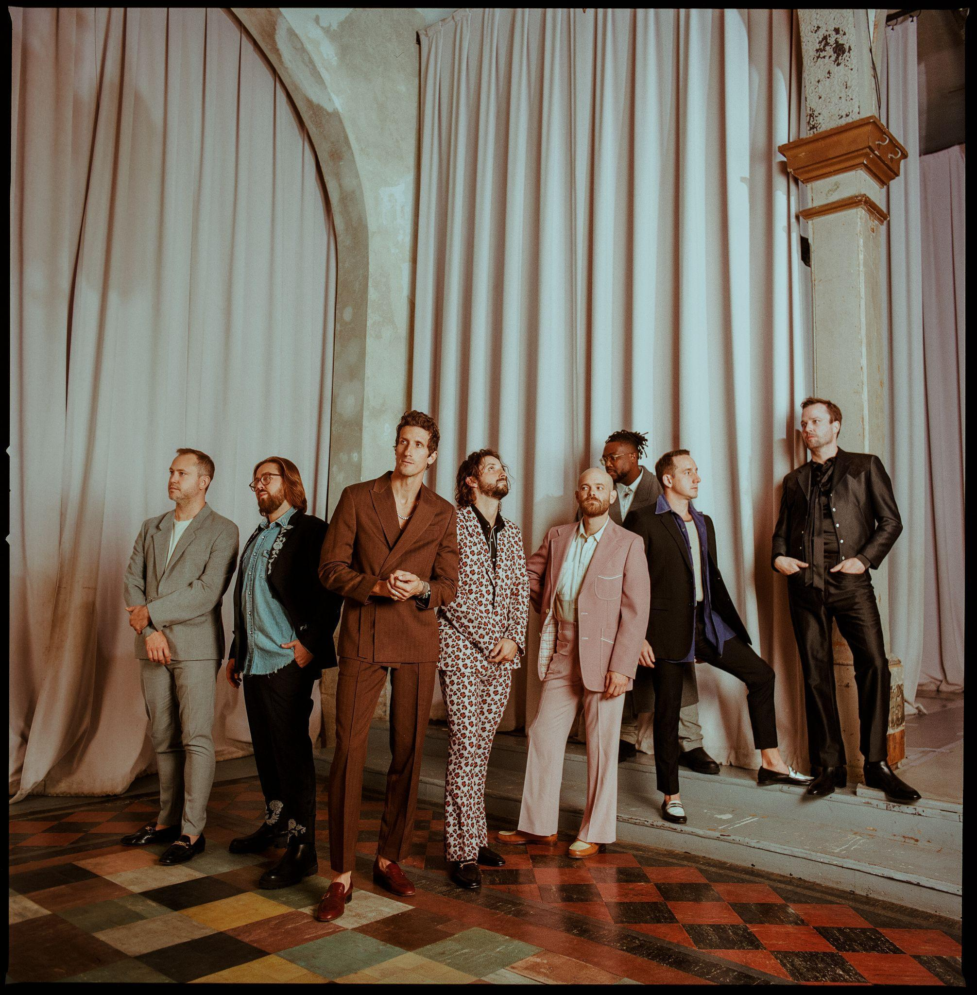
Photo credit: Alysse Gafkjen

###

CONNECT WITH THE REVIVALISTS
THEREVIVALISTS.COM | FACEBOOK | INSTAGRAM | TIKTOK | TWITTER | YOUTUBE

# # #

Press Contacts:
Ken Weinstein
weinstein@bighassle.com

Fia Kaminski
fia@bighassle.com

