**​​TAJ MAHAL AND KEB’ MO’ REUNITE FOR ‘ROOM ON THE PORCH’ (MAY 23 / CONCORD RECORDS); THEIR FIRST COLLABORATIVE TAJMO RECORD IN EIGHT YEARS, FOLLOWING GRAMMY-WINNING DEBUT**

**RUBY AMANFU JOINS TAJMO ON ALBUM’S TITLE TRACK, BRINGING THE DUO TOGETHER WITH A THIRD GENERATION OF ROOTS MUSIC TRAILBLAZER: :** [**https://found.ee/TajMo_RoomOnThePorchYT**](https://found.ee/TajMo_RoomOnThePorchYT)

**2025 TOUR DATES ANNOUNCED FROM THE GRAND OLE OPRY TO NYC’S TOWN HALL + MORE**

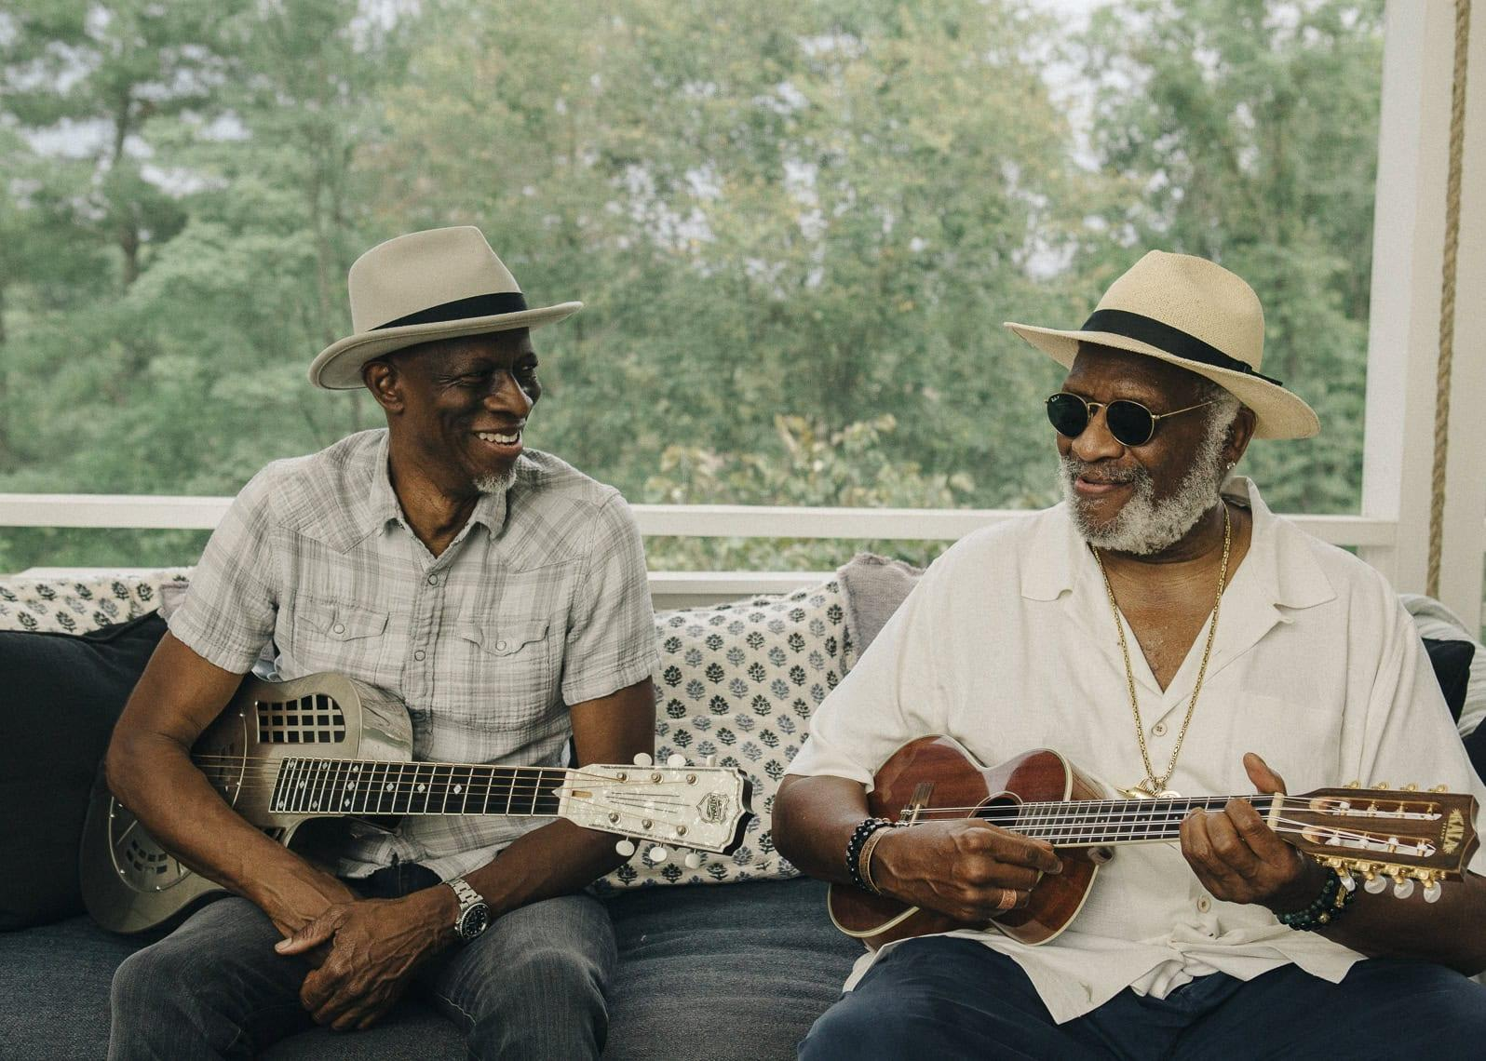

*Photo credit: David McClister*

**TajMo** - the historic collaboration between two generations of American music masters - have announced their long-awaited return with ***Room On The Porch***, a new full-length album out May 23 on Concord Records. The ten-song collection finds **Keb’ Mo’** and **Taj Mahal** reuniting for their first release together since 2017, when their debut collaboration brought them from The Late Show with Stephen Colbert ([for a stunning performance alongside Jon Batiste](https://www.facebook.com/watch/?v=10159093692439300)) to the GRAMMY stage ([where they took home Best Contemporary Blues Album](https://www.youtube.com/watch?v=BK-BFQZ3o4Q)). *“We’re just trying to keep the culture moving forward,”* said Taj Mahal during the duo’s acceptance speech that year; a joint mission statement that radiates as strong as ever with *Room On The Porch.*

*“That first album turned out so great that part of me wondered if maybe we just got lucky,”* jokes Keb’ Mo’ on reuniting with Taj Mahal. *“But when we got back into the studio together, I felt that same magic again, and I realized it wasn’t luck at all.”*

Featuring a tracklist with more original, co-written songs than ever before, *Room On The Porch* (which Taj Mahal and Keb’ Mo’ also co-produced together) brings out the best in both of these legends. The music is warm and inviting, rooted in the joy of human connection and the power of positivity. There’s no greater example than the album’s title track, which unites TajMo with **Ruby Amanfu** for a much-needed ode to friendship and community in these divisive times: “Stay as long as you like / That’s alright / Come up on / There’s room on the porch for everyone.”

**Listen to TajMo’s “Room On The Porch” (featuring Ruby Amanfu) here:** [**https://found.ee/TajMo_RoomOnThePorchYT**](https://found.ee/TajMo_RoomOnThePorchYT)

**Pre-order *Room On The Porch* here:** [**https://found.ee/TajMo-RoomOnThePorch**](https://found.ee/TajMo-RoomOnThePorch)

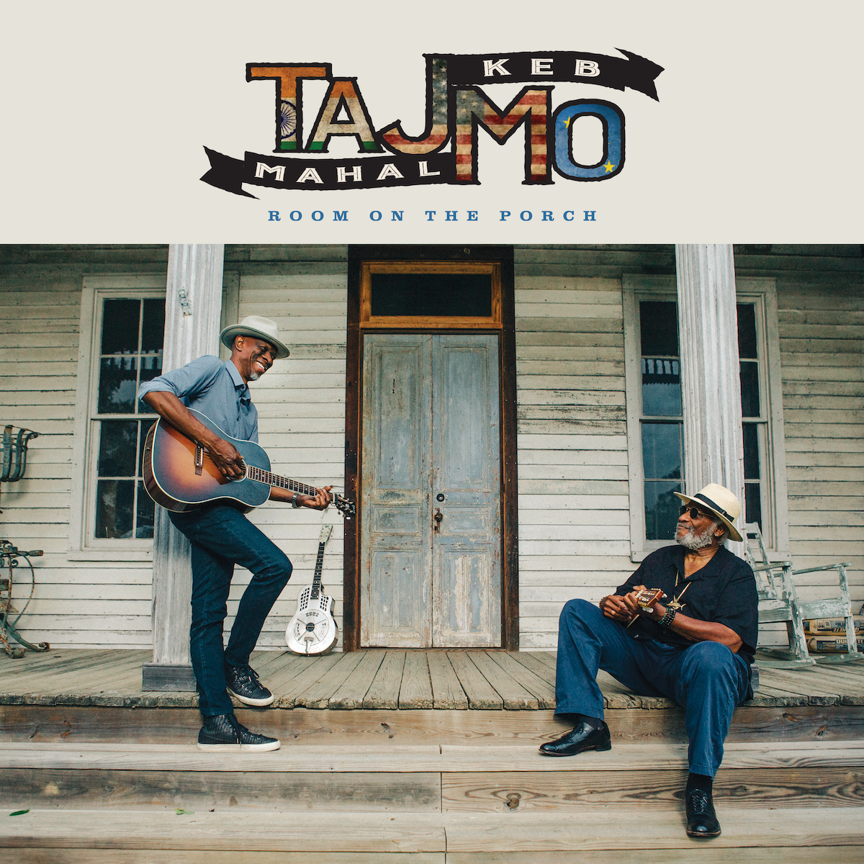

Sonically, *Room On The Porch* finds TajMo incorporating a full spectrum of sounds that prove why *“each of them is a standard-bearer in the genre-bending world of folk, blues, soul and Americana”* (Billboard). But, as Taj Mahal points out, these styles are all deeply tied together by their shared roots: *“If you take the African imprint out of Western music for the last 500 years, there’s almost nothing left,”* says Taj, who, just this month, was honored with the Recording Academy’s coveted **Lifetime Achievement Award**. *“As much as it might feel like we’re touching on all these different genres, the way I see it, we’re just connecting with the music of our ancestors and their influence on what’s happening now.”*

Taj Mahal and Keb’ Mo’ will also bring their TajMo live show back on the road in 2025, after wrapping prestigious spring dates of their own, with Taj playing JazzFest, Big Ears and Luck Reunion, while Keb’ is co-headlining the Ryman. The duo will celebrate *Room On The Porch* in over a dozen cities across the United States, beginning with a special appearance at the **Grand Ole Opry**, before their first headline show together at **New York’s Town Hall** on May 28. Pre-order *Room On The Porch* by noon ET on Sunday, February 23 to gain exclusive early access to tickets with a tour presale starting Monday, February 24. A full list of dates is below. For more information please visit <https://www.tajblues.com/tour> and <http://kebmo.com/>.

***Room On The Porch* Tracklist**

1. Room On The Porch ft. Ruby Amanfu

2. My Darling My Dear

3. Nobody Knows You When You’re Down and Out

4. She Keeps Me Movin’

5. Make Up Your Mind

6. Thicker Than Mud

7. Junkyard Dog

8. Blues’ll Give You Back Your Soul

9. Better Than Ever ft. Wendy Moten

10. Rough Time Blues

**TajMo 2025 Tour Dates:**

5/23 - Nashville, TN - The Grand Ole Opry

5/28 - New York, NY - The Town Hall

5/30 - Sidney, ME - Bowl In The Pines

5/31 - Hammondsport, NY - The Pavilion at Point of the Bluff Vineyards *

6/1 – Hyannis, MA – Cape Cod Melody Tent

6/3 – Concord, NH – Capitol Center for the Arts – Chubb Theatre

6/4 - South Deerfield, MA - Summer Stage at Tree House Brewing

6/6 - Bensalem, PA - Xcite Center at Parx Casino

6/7 - Selbyville, DE - Freeman Arts Pavilion *

6/8 - Vienna, VA - Wolf Trap, Filene Center *

6/10 - Huber Heights, OH - Rose Music Center at The Heights

6/12 - Grand Rapids, MI - Frederik Meijer Gardens & Sculpture Park *

6/13 - Interlochen, MI - Interlochen Center for the Arts *

6/14 - Highland Park, IL - Ravinia Festival *

6/15 - Detroit, MI - Masonic Cathedral Theatre

*\*Album pre-order presale not applicable*

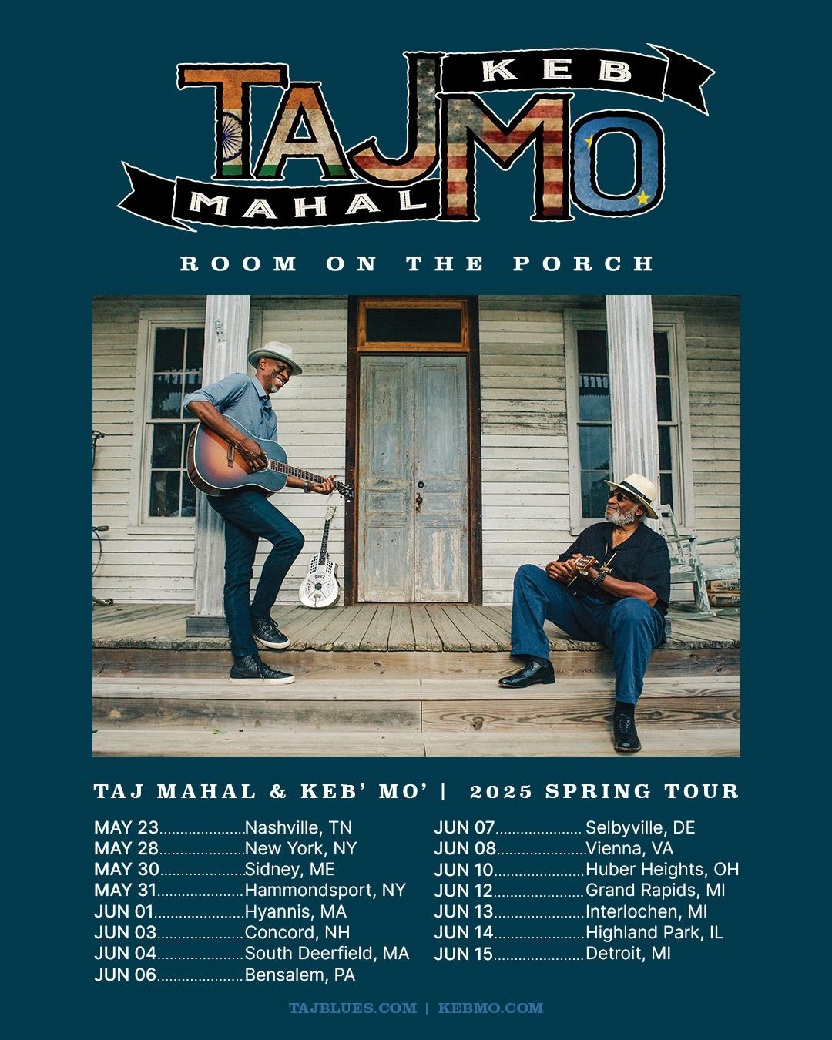

**For more information please contact:**

Matt Hanks - mhanks@shorefire.com

Max Lefkowitz - mlefkowitz@shorefire.com

Anna DeNelsky - adenelsky@shorefire.com