**​​TAJ MAHAL AND KEB’ MO’ BRING TWO GENERATIONS OF ELECTRIC BLUES EXCELLENCE TO NEW SINGLE “JUNKYARD DOG”:** [**https://found.ee/TajMo-RoomOnThePorch**](https://found.ee/TajMo-RoomOnThePorch)

**FIRST COLLABORATIVE RECORD IN EIGHT YEARS,‘ROOM ON THE PORCH’**

**OUT MAY 23 VIA CONCORD RECORDS**

**SPECIAL GRAND OLE OPRY PERFORMANCE ANNOUNCED FOR ALBUM RELEASE DAY; ALONGSIDE TWO-TIME GRAMMY ‘SONG OF THE YEAR’ NOMINEE RUBY AMANFU**

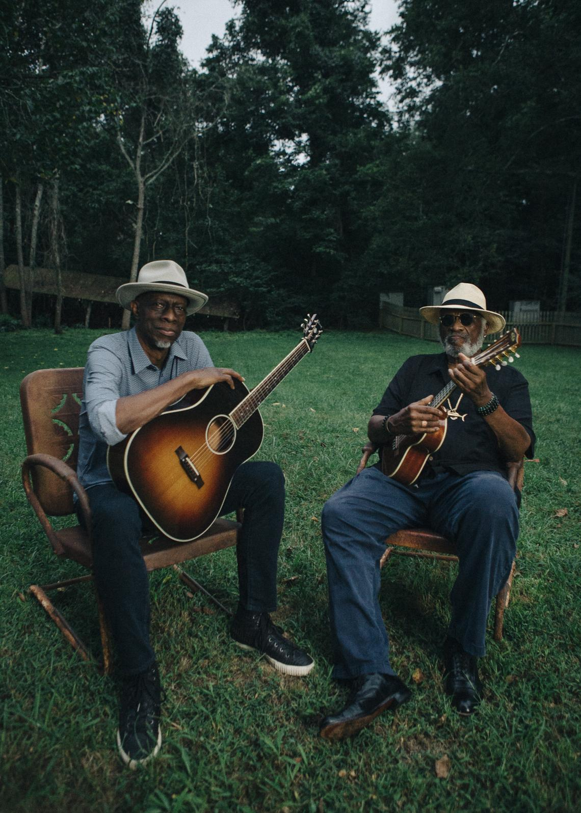

*Photo credit: David McClister*

**TajMo** - the historic collaboration between two generations of American music masters - have shared new single “**Junkyard Dog**” today, from their forthcoming full-length album *Room On The Porch* - out May 23 on Concord Records. **Keb’ Mo’** and **Taj Mahal** showcase their “strong chemistry” (Wall Street Journal) - and a blues prowess that’s earned them ten combined GRAMMY Awards - on “Junkyard Dog,” which was originally written by Nashville-based songwriter **Maia Sharp** for her album *Mercy Rising* (2021). *“This track is where this TajMo album began,”* says Keb’ Mo’. “*I heard Maia Sharp’s version of ‘Junkyard Dog’ and I knew we could put some dirt on it and make it ours. It has the bones of a blues anthem.”*

The ten-song collection finds the duo reuniting for their first release together since 2017, when their debut collaboration *TajMo* brought them from The Late Show with Stephen Colbert ([for a stunning performance alongside Jon Batiste](https://www.facebook.com/watch/?v=10159093692439300)) to [Marc Maron’s garage](https://www.wtfpod.com/podcast/episode-828-keb-mo-taj-mahal) to the GRAMMY stage ([where they took home Best Contemporary Blues Album](https://www.youtube.com/watch?v=BK-BFQZ3o4Q)). While putting their signature stamp on favorite tunes like “Junkyard Dog,” *Room On The Porch* also features more original, co-written tracks between the legendary pair than ever before - playing to each other’s strengths and discovering creative horizons more than a half-century into their storied careers.

*“The two of us collaborating has always been a very organic thing,”* Taj reflects. “*We have different skill sets that go well together, and even though it’d been a while since we’d played together, it was easy to get back to that same creative place we landed with the first album.”*

**Listen to “Junkyard Dog” here:** [**https://found.ee/TajMo-RoomOnThePorch**](https://found.ee/TajMo-RoomOnThePorch)

**Pre-order *Room On The Porch* here:** [**https://found.ee/TajMo-RoomOnThePorch**](https://found.ee/TajMo-RoomOnThePorch)

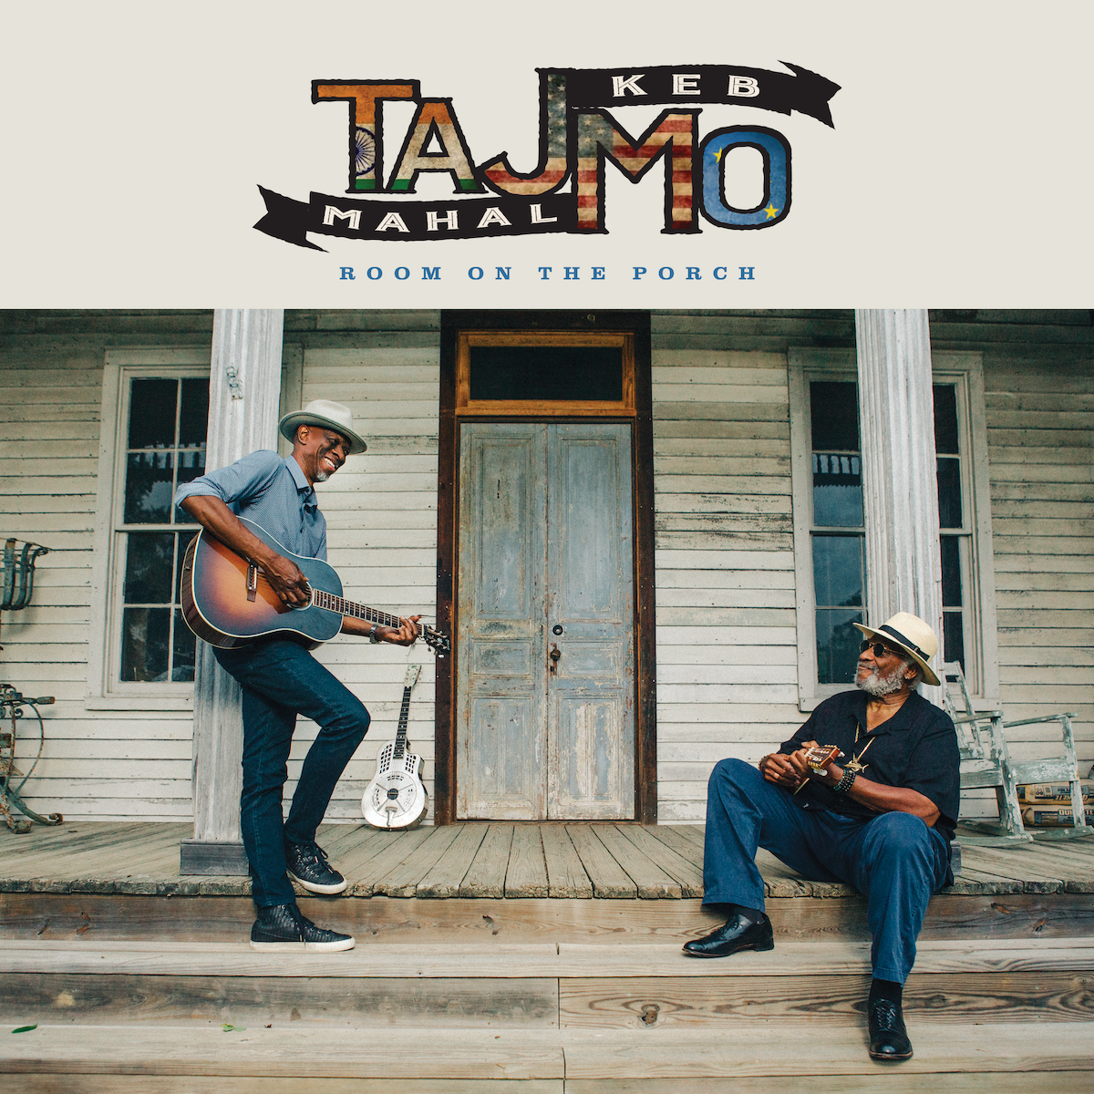

*Room On The Porch* (which Taj Mahal and Keb’ Mo’ also co-produced together)incorporates a full spectrum of sounds that showcase why *“each of them is a standard-bearer in the genre-bending world of folk, blues, soul and Americana”* (Billboard). But, as Taj Mahal points out, these styles are all deeply tied together by their shared roots: *“If you take the African imprint out of Western music for the last 500 years, there’s almost nothing left,”* says Taj (who will also play Big Ears and JazzFest this spring). *“As much as it might feel like we’re touching on all these different genres, the way I see it, we’re just connecting with the music of our ancestors and their influence on what’s happening now.”*

Taj Mahal and Keb’ Mo’ will bring their TajMo live show back on the road in 2025, celebrating *Room On The Porch* in over a dozen cities across the United States, beginning with a special appearance at the **Grand Ole Opry** (joined by Ruby Amanfu), during the Opry’s year-long 100th anniversary celebrations, before their first headline show together at **New York’s Town Hall** on May 28. A full list of dates is below. For more information please visit <https://www.tajblues.com/tour> and <http://kebmo.com/>.

***Room On The Porch* Tracklist**

1. Room On The Porch ft. Ruby Amanfu

2. My Darling My Dear

3. Nobody Knows You When You’re Down and Out

4. She Keeps Me Movin’

5. Make Up Your Mind

6. Thicker Than Mud

7. Junkyard Dog

8. Blues’ll Give You Back Your Soul

9. Better Than Ever ft. Wendy Moten

10. Rough Time Blues

**TajMo 2025 Tour Dates:**

5/23 - Nashville, TN - The Grand Ole Opry

5/28 - New York, NY - The Town Hall

5/30 - Sidney, ME - Bowl In The Pines

5/31 - Hammondsport, NY - The Pavilion at Point of the Bluff Vineyards

6/1 – Hyannis, MA – Cape Cod Melody Tent

6/3 – Concord, NH – Capitol Center for the Arts – Chubb Theatre

6/4 - South Deerfield, MA - Summer Stage at Tree House Brewing

6/6 - Bensalem, PA - Xcite Center at Parx Casino

6/7 - Selbyville, DE - Freeman Arts Pavilion

6/8 - Vienna, VA - Wolf Trap, Filene Center

6/10 - Huber Heights, OH - Rose Music Center at The Heights

6/12 - Grand Rapids, MI - Frederik Meijer Gardens & Sculpture Park

6/13 - Interlochen, MI - Interlochen Center for the Arts

6/14 - Highland Park, IL - Ravinia Festival

6/15 - Detroit, MI - Masonic Cathedral Theatre

**For more information please contact:**

Matt Hanks - mhanks@shorefire.com

Max Lefkowitz - mlefkowitz@shorefire.com

Anna DeNelsky - adenelsky@shorefire.com