May 16, 2025

**FOR IMMEDIATE RELEASE**

[judy@motormouthmedia.com](mailto:judy@motormouthmedia.com)

[humbert@motormouthmedia.com](mailto:humbert@motormouthmedia.com)

**CAUTIOUS CLAY**

**SHARES NEW ALBUM**

[***THE HOURS: MORNING***](https://found.ee/CC-TheHoursMorning)

**OUT NOW VIA CONCORD RECORDS**

**WITH FOCUS TRACK+ OFFICIAL ALBUM VISUALIZERS**

**“**[**PROMISES (9AM)**](https://youtu.be/7pEN0kCJW4w)**”**

**LISTEN/WATCH ALBUM VISUALIZERS** [**HERE**](https://www.youtube.com/playlist?list=PLdCU8agbjJppzPvC3nj8O2TSIosOG9D73)

**INTERNATIONAL TOUR KICKS OFF SEPTEMBER**

**PURCHASE TICKETS** [**HERE**](https://cautiousclay.com/#tour)



**Photo Credit: Travys Owen, Hi-Res** [**HERE**](https://www.dropbox.com/scl/fo/q5smfw5c33eweyfgnrxu2/AKIvSUwNgUA9RcIQl7L08EI?rlkey=lqxxk1m1qcu97weols30b1uok&st=prhhozbf&dl=0)

Today, singer-songwriter, producer, and multi-instrumentalist **Joshua Karpeh** aka **Cautious Clay** shares his new album, ***The Hours: Morning***, **via Concord Records**. A visualizer for the project’s focus track, “**Promises (9am)**” – a song he’s been evolving since 2017 with over 80 versions – drops alongside the album, with official visualizers for all tracks. The album follows a string of acclaimed singles including “[**Father Time (10am)**](https://www.youtube.com/watch?v=xqlFmf7GKhQ),” “[**Tokyo Lift (5am)**](https://found.ee/CC-TokyoLift),” and “[**No Champagne (6am)**](https://found.ee/CC-NoChampagne)” which have earned press praise from Hypebeast, Rolling Stone, Billboard, Vibe and more.

This Fall Cautious will embark on his international ***The Hours Tour***. The North American leg kicks off in Boston at The Sinclair on September 30th and will take him throughout the country with stops in New York, Chicago, and San Francisco before wrapping in Los Angeles on October 24th at The Regent. The tour will continue overseas with a UK and European Winter leg, making stops in five cities including London, Amsterdam, and Brussels (**full dates below**). For more information and tickets visit <https://cautiousclay.com/#tour>.

Cautious Clay ushers in a new phase with *The Hours: Morning,* a conceptual eight-track project that’s equal parts mixtape and emotive timetable, exploring the feeling, color, and emotional landscape of each morning hour. Created after relocating to Philadelphia and establishing new creative routines, the project transcends genre and blends pop precision with elements of alternative R&B, jazz, and indie rock with open-ended reflection. It marks a fresh chapter for the genre-blending artist, following the success of his jazz-infused album ***KARPEH***. From the calm of dawn to the energy of late morning, *The Hours: Morning* showcases Cautious’ versatility and evolving sound.

Beyond his own artistry, Cautious has established himself as a highly sought-after songwriter and producer, collaborating with **Billie Eilish**, **John** **Mayer**, **John** **Legend**, **Khalid**, **Kavinsky**, **Melanie** **Martinez**, **Remi** **Wolf**, and most recently, **Tycho**. Following the release of his acclaimed EPs ***Resonance*** and ***Table of Context***, he delivered his full-length 2021 debut ***Deadpan******Love***, a nuanced exploration of the complexities of human connection that earned him praise from **The New York Times**, **Rolling Stone**, **The Fader**, **PAPER**, and more. With his 2023 album ***KARPEH***, Cautious reached new artistic heights, delivering a more intentional and sonically rich project. This bold evolution offered an intimate portrayal of his journey, his past, and his family life, solidifying his place as a singular voice in modern music and one to watch. Stream the new album, catch him live this fall, and stay tuned for more news to follow.

**WATCH THE OFFICIAL VISUALIZER FOR “PROMISES (9AM)”** [**HERE**](https://youtu.be/7pEN0kCJW4w)



**WATCH THE OFFICIAL ALBUM VISUALIZERS** [**HERE**](https://www.youtube.com/playlist?list=PLdCU8agbjJppzPvC3nj8O2TSIosOG9D73)

**STREAM/PURCHASE *THE HOURS: MORNING***

[**https://found.ee/CC-TheHoursMorning**](https://found.ee/CC-TheHoursMorning)

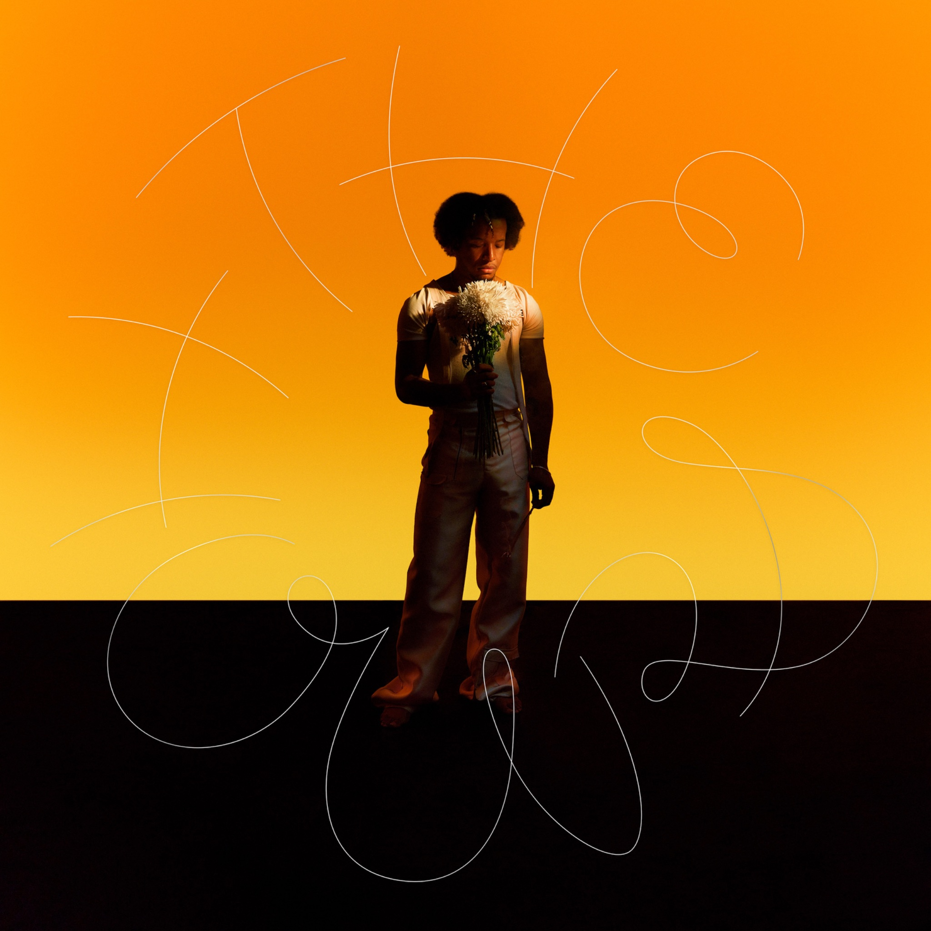

**Album Artwork; Hi-Res** [**HERE**](https://www.dropbox.com/scl/fi/k6awsrr0qrkb5o348b6r0/Album-Artwork.jpg?rlkey=c4jlzh5nat476lhy9lblblsxe&st=6lavh0hx&dl=0)

**Cautious Clay *The Hours: Morning* (Concord Records)**

**Tracklist**

1. Tokyo Lift (5am)

2. No Champagne (6am)

3. Traffic (7am)

4. The Plot (8am)

5. Promises (9am)

6. Father Time (10am)

7. Amber (11am)

8. Smoke Break (12pm)



**Upcoming Live Dates**

September 30 - Boston, MA - The Sinclair

October 2 - New York, NY - Webster Hall

October 4 - Washington, DC - Atlantis

October 7 - Toronto, ON - Axis

October 10 - Chicago, IL - Outset

October 11 - Minneapolis, MN - Fine Line

October 13 - Denver, CO - Bluebird

October 15 - Salt Lake City, UT - Soundwell

October 17 - Seattle, WA - Showbox

October 18 - Vancouver, BC - Hollywood

October 19 - Portland, OR - Roseland

October 21 - San Francisco, CA - Bimbo's

October 24 - Los Angeles, CA – Regent

December 4 - Manchester, UK - Blues Kitchen

December 5 - London, UK - Jazz Cafe

December 9 - Amsterdam, NL - Tolhuistuin (Paradiso Noord)

December 10 - Rotterdam, NL - LantarenVenster

December 11 - Brussels, BE - Botanique - The Rotonde

**CAUTIOUS CLAY ONLINE**

[**INSTAGRAM**](https://www.instagram.com/cautiousxclay) | [**TIKTOK**](https://www.tiktok.com/@cautiousxclay) | [**X**](https://twitter.com/Cautiousclayton) | [**FACEBOOK**](https://www.facebook.com/cautiousclayofficial/) | [**YOUTUBE**](https://www.youtube.com/channel/UCgr8eWYskFV6_TqrOQ2LMFw) | [**WEBSITE**](https://www.cautiousclay.com)