**MATT BERNINGER**

**SOPHOMORE SOLO ALBUM** [***GET SUNK***](https://found.ee/MB-GetSunk)

**OUT NOW ON BOOK/CONCORD RECORDS**

**WATCH OFFICIAL VIDEO FOR “**[**NO LOVE**](https://www.youtube.com/watch?v=Jijb6ppptVI)**”**

**PERFORMING ON *THE TONIGHT SHOW STARRING JIMMY FALLON* ON JUNE 2ND**

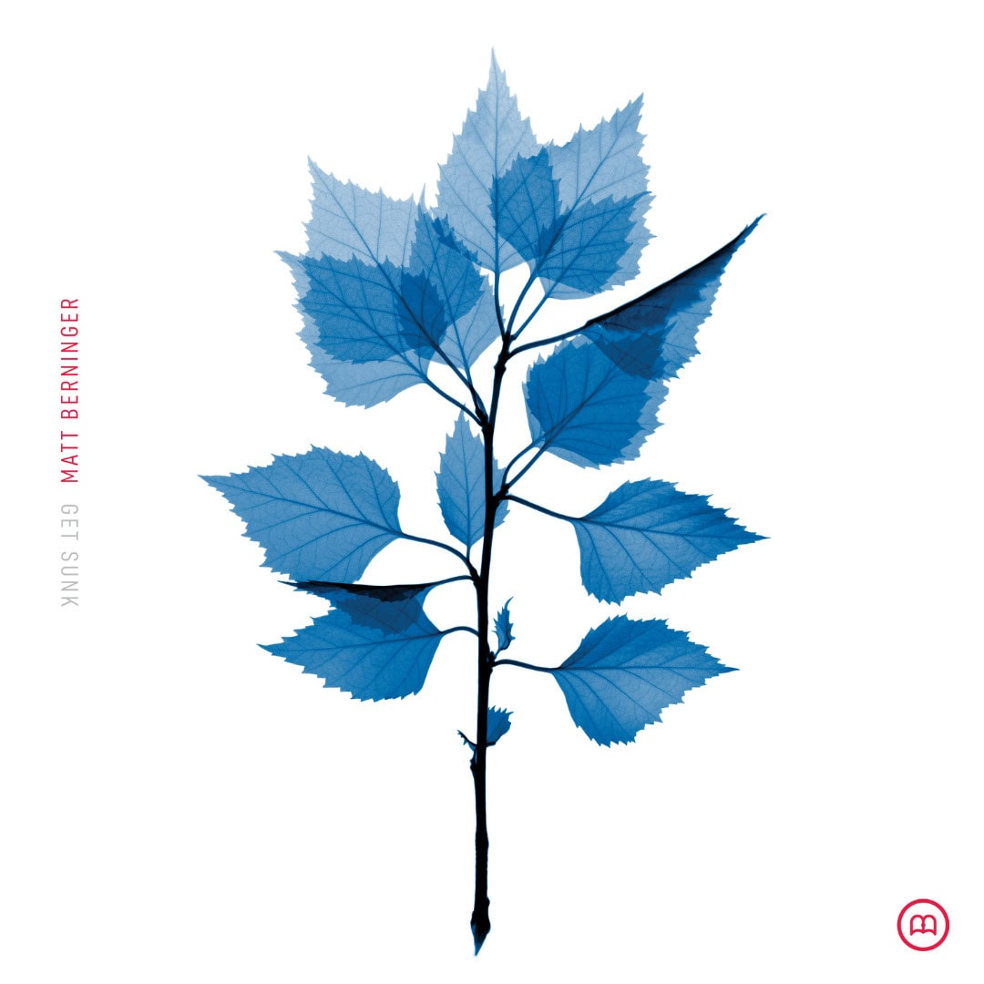

***Get Sunk* Cover Art | Hi-Res Download** [**HERE**](https://drive.google.com/file/d/1J5RJUgal4kI9fd7bnUrRq_g17qJo3p5V/view?usp=drive_link)

*"On* Get Sunk… *he’s focused on reinventing himself, not necessarily his sound, finding creative rejuvenation in a move to Connecticut after a bout of writer’s block and diffidence.*

*You can hear the juices flowing again…”*

***Vulture***

*"Berninger is at his songwriting best”*

***Associated Press***

*​​”‘Get Sunk’ retains the signature charm of The National while highlighting*

*Berninger’s strengths as a writer.”* ***Dork***

***“****An emotional deep dive”*

***MOJO***

*"Simple, charming, and just quirky enough to work"*

***Stereogum on “Breaking Into Acting”***

*"It’s muscular and satisfying, unapologetic in playing to his strengths."*

***Esquire on “Breaking Into Acting”***

*“It’s robust folk-rock with orchestral backup”*

***New York Times “Playlist” on “Bonnet of Pins”***

*"A bit of stadium-sized indie rock with driving drums and live-wire guitars that steadily build*

*with a burst of horns and choral backing vocals."*

***Rolling Stone on “Bonnet of Pins”***

*"Boasts the lived-in texture of a Neil Young song, but delivered with a rush of rock fervor that sits distinctly in The National’s sonic palette. Beaming, arena-ready guitar shines even brighter thanks to spacious synths, bringing light to the narrator’s somewhat dark vignette about encountering an old flame"*

***Paste on “Bonnet of Pins”***

*"Few indie singer/songwriters have been as consistent as The National’s Matt Berninger, who brings a unique charm to just about everything he releases."*

***Brooklyn Vegan***

**Matt Berninger’s** highly anticipated sophomore album,[***Get Sunk***](https://found.ee/MB-GetSunk), is out today on Book/Concord Records. The frontman and lyricist for The National worked on *Get Sunk* with Grammy Award-winning producer and engineer **Sean O’Brien,** who also co-wrote many of the songs. With its rich sonic landscape and poignant lyrics, *Get Sunk* is a testament to Berninger's artistry and his ability to capture the complexities of the human experience. Its sonic world blossomed with the help of numerous musicians and friends including Meg Duffy (Hand Habits), Julia Laws (Ronboy), Kyle Resnick (The National, Beirut), Garret Lang, Sterling Laws, Booker T Jones, Harrison Whitford, Mike Brewer, and The Walkmen’s Walter Martin and Paul Maroon. Most of them worked together with Berninger and O’Brien in a Silverlake, CA, basement studio.

Named one of the most anticipated albums of the summer by both ***Pitchfork*** and ***Vulture*,** *Get Sunk* features the previously released and highly praised singles “[Bonnet of Pin](https://found.ee/BonnetOfPinsYT)s,” “[Breaking Into Acting](https://youtu.be/KJalKEeTcdE),” and the most recent, “[Inland Ocean](https://found.ee/InlandOceanYT).”

Following a short run of sold-out, intimate trio shows across the UK last month, Berninger has been on the road with a full band supporting the new record, playing several sold-out shows across North America. He’ll do a special album-release show tonight at **Webster Hall in NYC**, have an in-store performance at Rough Trade in Manhattan tomorrow, and a final show in Norwalk, CT, before he heads back to Europe and the UK this August. Berninger’s shows have seen rave reviews so far, and he’s closed the set with a selection of special covers, including (so far) Radiohead’s “Kid A”, Nirvana’s “All Apologies,” and Tom Waits’ “The Heart of Saturday Night.” Find the full list of upcoming tour dates below.

Next week, Berninger will perform the album’s lead single, “Bonnet of Pins” on ***The Tonight Show Starring Jimmy Fallon*!** Tune in on June 2nd to watch the performance!

**Matt Berninger on tour:**

May 30 - New York, NY - Webster Hall **\*SOLD OUT**

June 1 - Norwalk, CT - District Music Hall

August 22 - Dublin, Ireland - Vicar Street

August 23 - Dublin, Ireland - Vicar Street **\*SOLD OUT**

August 25 - Glasgow, UK - SWG3 Galvanizers

August 26 - Manchester, UK - Albert Hall

August 27 - London, UK - Troxy

August 29 - Nr Tolland Royal, Wiltshire, UK - End Of The Road Festival

August 31 - Utrecht, Netherlands - Tivoli Vredenburg **\*SOLD OUT**

September 1 - Antwerp, Belgium - OLT Rivierenhof **\*SOLD OUT**

September 2 - Paris, France - Elysee Montmartre

September 4 - Berlin, Germany - Huxleys

September 5 - Copenhagen, Denmark - Vega

September 6 - Oslo, Norway - Rockefeller Music Hall

September 8 - Hamburg, Germany - Große Freiheit 36

September 9 - Utrecht, Netherlands - Tivoli Vredenburg

September 10 - Antwerp, Belgium - OLT Rivierenhof **\*SOLD OUT**

September 12 - Brussels, Belgium - Cirque Royal

***Get Sunk* tracklisting:**

[Inland Ocean](https://found.ee/InlandOceanYT)

No Love

[Bonnet of Pins](https://found.ee/BonnetOfPinsYT)

Frozen Oranges

[Breaking Into Acting (feat. Hand Habits)](https://found.ee/MB-GetSunk)

Nowhere Special

Little by Little

Junk

Silver Jeep (feat. Ronboy)

Times of Difficulty



Photo Credit: Chantal Anderson | [**Download Hi-Res Here**](https://drive.google.com/file/d/1KpiYRes5XRx1FpAcVRlD_pugvpMXGoiw/view?usp=drive_link)

In his work with The National, Berninger is known for contemplative narratives in which characters peer over the cliff’s edge. He has always been forthcoming about his own mental and emotional pitfalls. “Our hearts are like old wells filled with pennies and worms,” he explains. “I can’t resist going down to the bottom of mine to see what else is there. But sometimes you can get yourself stuck.”

In 2020, he went through “a long period of writer’s block and self-disgust. I just got sick of asking myself ‘Why am I like this?’” For Berninger, identity is amorphous, ever-evolving and stretches beyond individuality. This is the driving force of his second solo album. Underwater, everything moves in slow motion, and Berninger glimpsed his creative voice slipping away. But sometimes we have to drown to remember how to breathe. *Get Sunk* is the inhale, bringing blurry realizations to the surface.

Berninger’s “gorgeous” (*Rolling Stone*) solo debut, *Serpentine Prison*, came out in early 2020, produced by the legendary Booker T. Jones. While he says the follow-up is not necessarily an autobiographical album, the narrator *is* processing how he became himself. Berninger is an expert in what it feels like to lose all bravery, and *Get Sunk* points to an undulating reflection in the water. It’s about realizing that you are not yourself without a thousand others: parents, friends, siblings, spouses and exes, college roommates, childhood best friends, cousins, kids and even strangers.

Inspired by the flora and fauna of his new home in Connecticut after years living in Los Angeles, Berninger wrote lyrics and drew all over baseballs, and rearranged dust-covered items in his barn into strange and surreal works of art. It felt good to be creating and to understand why he loves what he does. “I was able to get the blurry picture as close to just right for me,” he says. That the picture ever comes into full focus isn’t the point; it’s by being happy that we can make out anything at all.

**For more information, contact:**

**Dana Erickson & Kate Jackson | Grandstand Media**