**EMBARGO 8 EST**

February 14, 2025

**FOR IMMEDIATE RELEASE**

[judy@motormouthmedia.com](mailto:judy@motormouthmedia.com)

[humbert@motormouthmedia.com](mailto:humbert@motormouthmedia.com)

**CAUTIOUS CLAY**

**RETURNS WITH NEW SINGLE AND VIDEO**

**“NO CHAMPAGNE (6AM)”**

**SIGNS TO CONCORD RECORDS**

**WATCH/LISTEN** [**HERE**](https://found.ee/CC-NoChampagne)

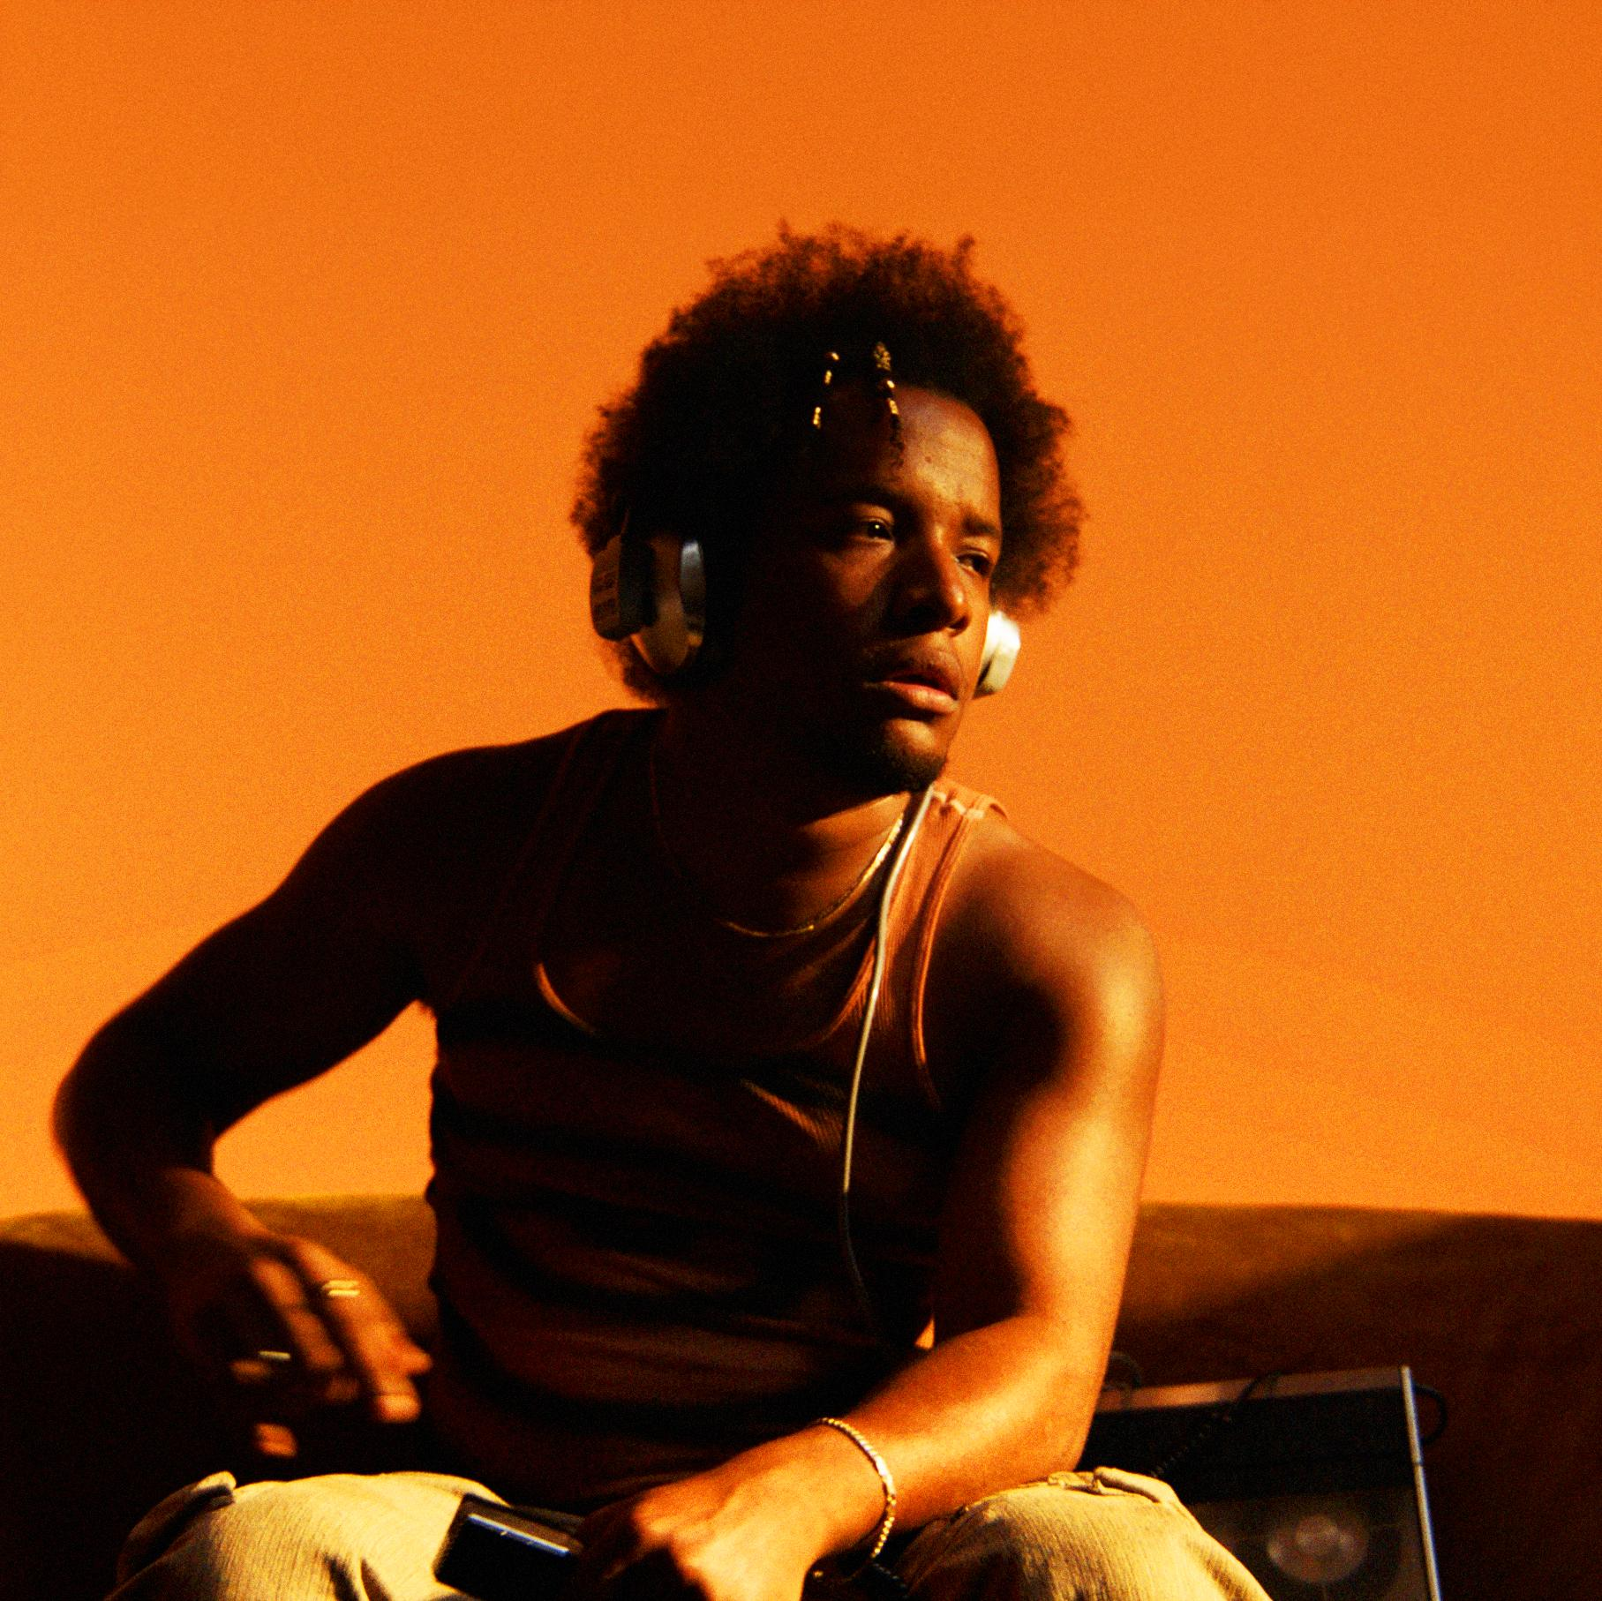

**Photo Credit: Travys Owen, Hi-Res HERE**

Today, singer-songwriter, producer, and multi-instrumentalist **Joshua Karpeh** aka **Cautious Clay**

returns with his first single this year, “**No Champagne (6am)**” via his new home on renowned indie label **Concord Records.** The track hails the beginning of a new chapter, as he is now represented by **Concord Music Publishing**, which also acquired his catalog in 2024.

Produced by Cautious and **Valley Girl** (**RAYE**, **Caroline Polachek**, **Allie X**), “No Champagne” serves as his first offering of the year and is a heartfelt meditation on love’s quiet intensity, featuring warm, ethereal production and intimate lyrics evoking the feeling of love’s push and pull. The accompanying golden-hued visual directed by **Travys Owen** helps bring to life the track’s intimate essence, reflecting his artistic evolution and personal growth.

Speaking on the song, Cautious shares, “*With ‘No Champagne’ I was really trying to set an image around defining the difference between expectation versus reality. Being in a space with someone that you care about and understanding what they want out of a relationship versus what you want out of a relationship and getting to the heart of that.*

*When we’re at our worst, how are we translating with that person in a room? When there’s no champagne, when there’s no real reason to celebrate - how are you actually connecting to me? How are we actually connecting to each other? I think that’s the heart of it thematically.*

*In terms of the setting I wanted it to feel like the morning, kind of warm and bright even though the subject matter might not be - I really like that juxtaposition.*”

“No Champagne” follows a sold-out 8-show residency at New York’s legendary **Blue Note Jazz Club** and builds on the momentum of 2023’s ***KARPEH***, which was praised by **Hypebeast**, **NME** and **NPR**, the latter calling it “*exceptional, expansive and beautifully airy*”.

Since emerging in 2017, Cautious Clay has been crafting a unique sound that defies boundaries, seamlessly blending pop, alternative R&B, jazz, and indie rock with deeply introspective songwriting. His breakthrough came with 2018’s ***Blood Type*** and the standout track “**Cold War**”*,* a raw and resonant call for emotional honesty that has since garnered **over 150M streams**. The song’s reach extended far beyond music, landing in **Issa Rae**’s **HBO** hit ***Insecure***, **Olivia Wilde**’s movie ***Booksmart***, and was reimagined by **Taylor Swift** and **Jack** **Antonoff** on ***Lover*’s** “**London Boy**”.

Beyond his own artistry, Cautious has made his mark as a sought-after songwriter and producer, collaborating with **Billie Eilish**, **John** **Mayer**, **John** **Legend**, **Khalid**, **Kavinsky**, **Melanie** **Martinez**, **Remi** **Wolf**, and most recently, **Tycho**. Following the release of his acclaimed EPs ***Resonance*** and ***Table of Context***, he delivered his full-length debut ***Deadpan******Love***, in 2021–a nuanced exploration of the complexities of human connection that earned him praise from **The New York Times**, **Rolling Stone**, **The Fader**, **PAPER**, and more. His 2023 debut ***KARPEH***, saw him reaching new heights, offering a more intentional and sonically rich work - an intimate portrayal of himself, his past and family bold evolution and one that cements his place as a singular voice in modern music as he swiftly moved amidst an intimate portrayal of himself, his past, and family life.

**Listen to “No Champagne (6am)”**

[**https://found.ee/CC-NoChampagne**](https://found.ee/CC-NoChampagne)

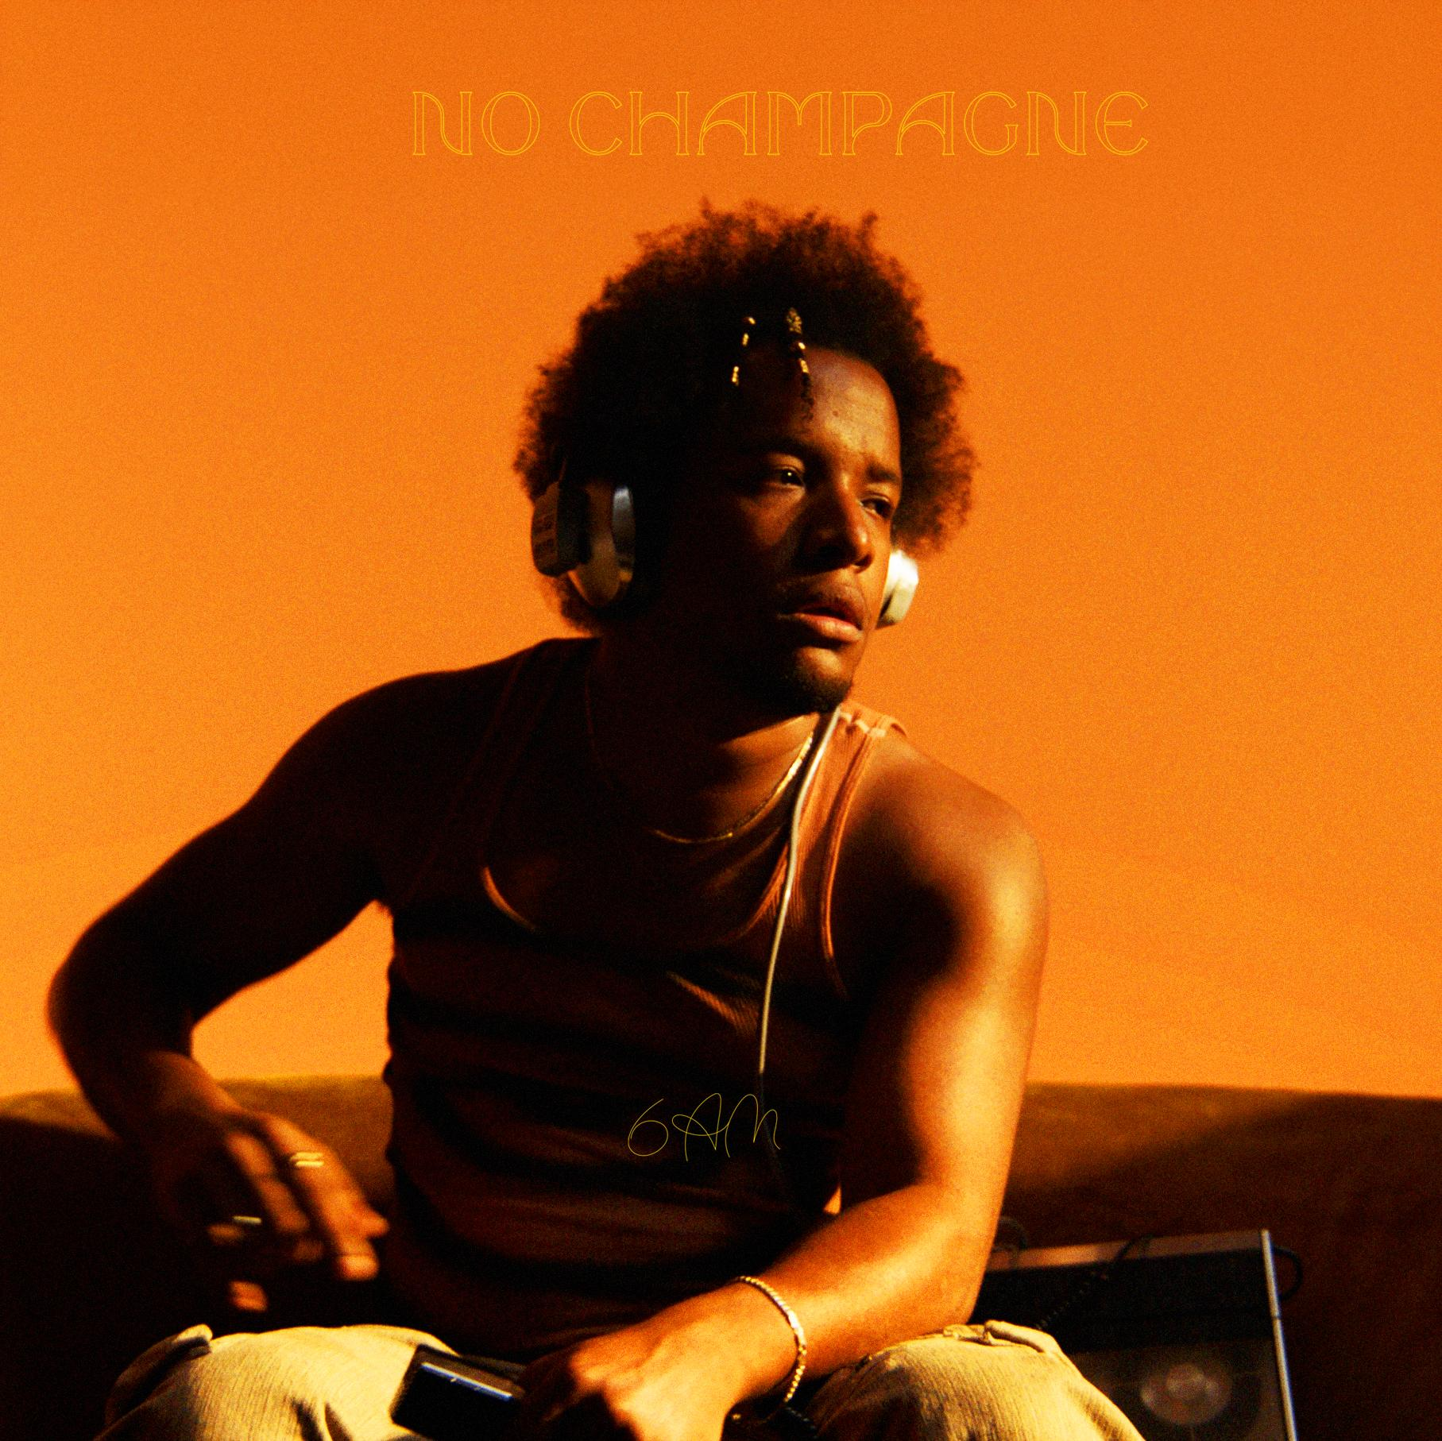

**Hi-Res cover art HERE**

**CAUTIOUS CLAY ONLINE**

[**INSTAGRAM**](https://www.instagram.com/cautiousxclay) | [**TIKTOK**](https://www.tiktok.com/@cautiousxclay) | [**X**](https://twitter.com/Cautiousclayton) | [**FACEBOOK**](https://www.facebook.com/cautiousclayofficial/) | [**YOUTUBE**](https://www.youtube.com/channel/UCgr8eWYskFV6_TqrOQ2LMFw) | [**WEBSITE**](https://www.cautiousclay.com)