February 4, 2025

For Immediate Release

**Valerie June Announces New Album,**

***Owls, Omens, and Oracles*,**

**Out April 11th Via Concord**

**Watch The Video For Lead Single, “Joy, Joy!”**



Photo Credit: Travys Owen

GRAMMY-nominated singer, songwriter, and multi-instrumentalist **Valerie June** announces her new album, ***Owls, Omens, and Oracles****,* out **April 11th** via **Concord Records**, and releases its lead single “**Joy, Joy!”** alongside an accompanying video. Rooted in the belief that what we focus on is what we manifest, June dreams a songpath forward with *Owls, Omens, and Oracles* that leaves no one behind. Halfway through a decade of immense and rapid global change, June asserts a multidimensional Blackness steeped in laughter, truth, magic, delight, and interdependence. This album is a radical statement to break skepticism, surveillance, and doom scrolling – let yourself celebrate your aliveness. Connect, weep, change, open.

June has been softening and clarifying her sound since the 2013 release of *Pushin' Against A Stone*, through *The Order of Time*, *The Moon and Stars: Prescriptions for Dreamers*, and *Under Cover*. “A willed and unblinking optimism courses through Valerie June’s songs” (*New York Times*); this newest work shows her own spiritual growth and the opening of ancestral channels into both her dynamic and distinct voice and her tender lyrics. June is not alone in crafting this sacred field for the contemplation of love and being human. Produced by **M. Ward** (Mavis Staples, She & Him) and engineered by **Pierre de Reeder** (Rilo Kiley, Jenny Lewis), *Owls, Omens, and Oracles* also features a cast of contributors, including **The Blind Boys of Alabama** and **Norah Jones**.

An instant foot-stompin' hip-shaker, lead single "Joy, Joy!" opens the album with an undeniable exuberance. June, playing acoustic guitar, sings: "And when you feel you’re not enough / Has this old been hard and rough / A golden seed beneath dark soil / To seek the sun is often rough” while backed by **Kaveh Rastegar** on bass (John Legend, Beck), **Steven Hodges** on drums (Tom Waits, David Lynch), and keys and horn arrangements by Nate Walcott (Bright Eyes, Conor Oberst and the Mystic Valley Band). In line with praise by the *New Yorker*, “[June’s] every quiver bespeaks emotional honesty.”

Reflecting on “Joy, Joy!,” June says: “Everyone has felt moments of darkness, depression, anxiety, stress, ailments, or pain. Some say it takes mud to have a lotus flower. This song reflects on the hard times we might face: to fail, to fall, to lose, to be held down, to be silenced, to be shut out yet still hold onto a purely innocent and childlike joy. I come from a heritage of ancestors who lived this truth by inventing blues music. Generations after they’ve gone, the inner joy they instilled in us radiates and lifts cultures throughout the world. From the world to home, what would a city council focused on inspiring inner joy for all of a town's citizens look like?”

**Watch the Video for “Joy, Joy!”**

*Owls, Omens, and Oracles* is expansive, growing from June’s psychedelic folk, indie rock, Appalachian, bluegrass, country soul, orchestral pop, and blues root system into an intergalactic web of wisdom. Every single note she sings is dusted with her “unorthodox, howling tin-pan of a voice” (*ELLE*), “like raw silk–intimate, elegant and strong” (*Garden & Gun*). The visceral twists and fierce raw emotion of her voice threads textures and tones through the needle of a multi-genre American quilt. Gracefulness and gentleness harmonize with edginess and precarity, evoking a tenderness within even the hardest heart as June holds the complexity of "My life is a country song," and "I am multidimensional, beyond category."

June recently announced the *Owls, Omens, and Oracles*Tour, which kicks off the week after the album release and runs through late June. All shows are full band; a full list of dates can be found below, and tickets can be purchased [here](https://www.valeriejune.com/tour).

Portions of the above text are pulled from an *Owls, Omens, and Oracles* bio by adrienne maree brown.

[**Pre-order *Owls, Omens, and Oracles***](https://found.ee/VJ-OwlsOmensOracles)

***Owls, Omens, and Oracles* Tracklist:**

1. Joy, Joy!

2. All I Really Wanna Do

3. Endless Tree

4. Inside Me

5. Trust The Path

6. Love Me Any Ole Way

7. Changed feat. The Blind Boys of Alabama

8. Superpower

9. Sweet Things Just for You

10. I Am In Love

11. Calling My Spirit

12. My Life Is A Country Song

13. Missin’ You (Yeah, Yeah)

14. Love And Let Go

**Valerie June *Owls, Omens, and Oracles* Tour Dates**

Thu, Mar. 27 - Gettysburg, PA @ Majestic Theater

Tue. Apr. 15 - Philadelphia, PA @ World Cafe Live

Wed. Apr. 16 - Alexandria, VA @ The Birchmere Music Hall

Thu. Apr. 17 - Richmond, VA @ The National

Fri. Apr. 18 - Annapolis, MD @ Ram’s Head Onstage

Sat. Apr. 19 - Annapolis, MD @ Ram’s Head Onstage

Tue. May 6 - New York, NY @ Town Hall

Wed. May 7 - Norwalk, CT @ District Music Hall

Thu. May 8 - Brownfield, ME @ The Stone Mountain Arts Center

Fri. May 9 - Albany, NY @ Swyer Theatre @ The Egg

Sat. May 10 - Northampton, MA @ Iron Horse Music Hall

Sun. May 11 - Boston, MA @ City Winery

Tue. May 27 - Ferndale, MI @ The Magic Bag

Wed. May 28 - Chicago, IL @ Park West

Thu. May 29 - Milwaukee, WI @ Vivarium

Fri. May 30 - Madison, WI @ Majestic Theatre  
Sat. May 31 - Minneapolis, MN @ State Theatre

Sun. June 1 - Iowa City, IA @ The Englert Theatre

Tue. June 3 - Indianapolis, IN @ Hi-Fi Annex

Wed. June 4 - Louisville, KY @ Headliners Music Hall

Fri. June 13 - San Diego, CA @ Music Box

Sat. June 14 - Los Angeles, CA @ The Fonda Theatre

Sun. June 15 - Santa Barbara, CA @ Lobero Theatre

Tue. June 17 - Santa Cruz, CA @ Rio Theatre

Wed. June 18 - San Francisco, CA @ Palace of Fine Arts Theatre

Fri. June 20 - Portland, OR @ Revolution Hall

Sun. June 22 - Seattle, WA @ The Showbox

[**Download hi-res images of Valerie June**](http://www.pitchperfectpr.com/valerie-june)

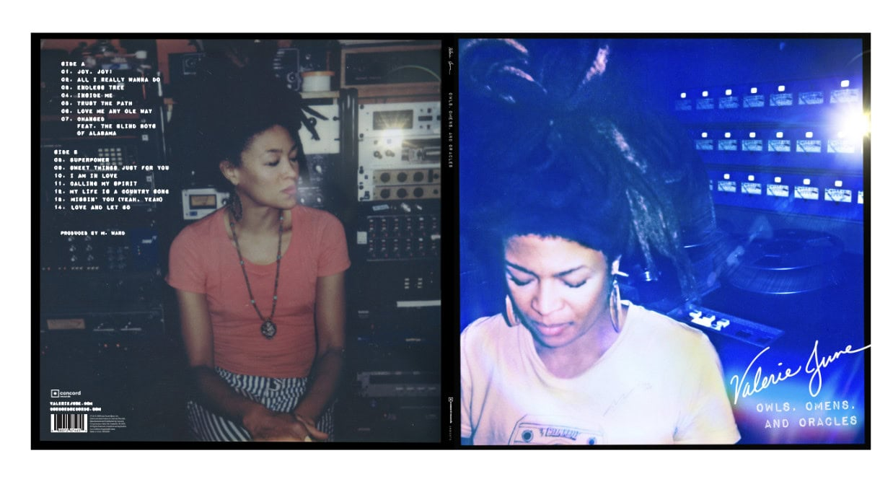

*Owls, Omens, and Oracles* Album Art, Photo Credit - Dr. Ietef Vita

**Valerie June Online**

[**Website**](https://www.valeriejune.com/) | [**Instagram**](https://www.instagram.com/thevaleriejune/?hl=en) | [**TikTok**](https://www.tiktok.com/@thevaleriejune) | [**X**](https://twitter.com/TheValerieJune) | [**Facebook**](https://www.facebook.com/valeriejunemusic)

For more information, contact:

Jessica Linker, Yuri Kwon & Chad DePasquale | Pitch Perfect PR -

[jessica@pitchperfectpr.com](mailto:jessica@pitchperfectpr.com), [yuri@pitchperfectpr.com](mailto:yuri@pitchperfectpr.com), [chad@pitchperfectpr.com](mailto:chad@pitchperfectpr.com)