Listen to “Ibiza” [HERE](https://cmg.concordrep.com/play/39986/77a114769c4d531795d76a52f932910e20f34c08/) (take note, dance/electronic heads, this is vibes)

Video preview is coming will be live at the link below tomorrow as well

9 AM ET

January 14th, 2025

**FOR IMMEDIATE RELEASE**

[judy@motormouthmedia.com](mailto:judy@motormouthmedia.com)

**BUTCHER BROWN**

**ANNOUNCE NEW ALBUM**

***LETTERS FROM THE ATLANTIC***

**OUT MARCH 28TH ON CONCORD JAZZ**

**LISTEN TO THE SINGLE / WATCH THE** [**VIDEO**](https://www.youtube.com/watch?v=2cs0CKylxPI)

**“**[**IBIZA**](https://found.ee/BB_LettersFromTheAtlantic)**”**

**NATIONAL TOUR BEGINS ON RELEASE DAY**

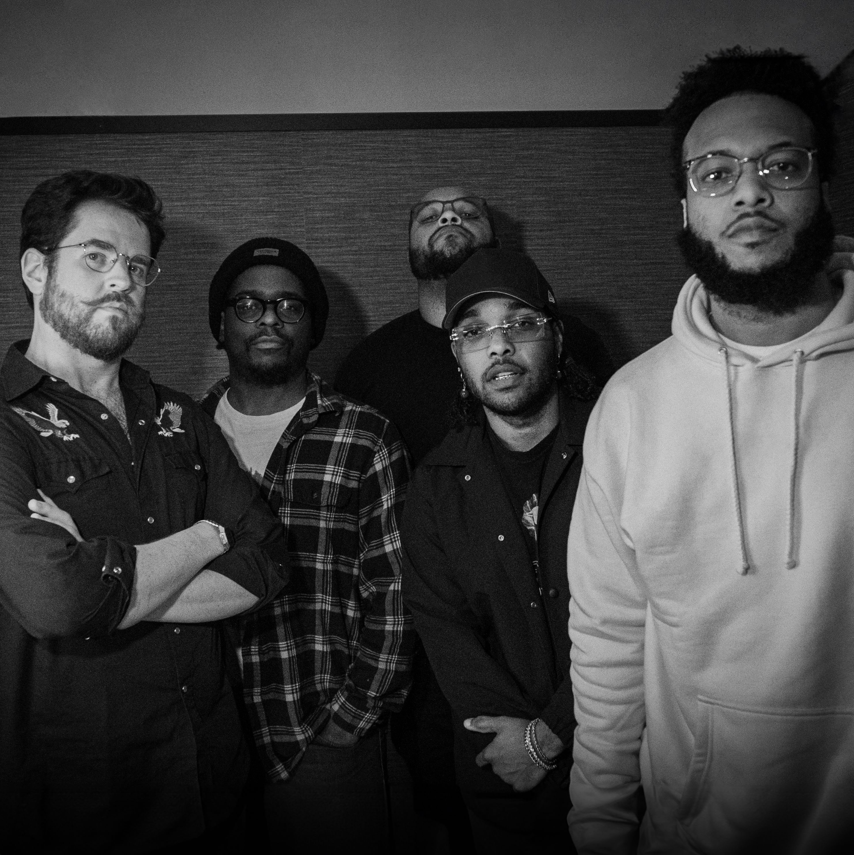

**Credit: Julian Lona Urquidi @lonajulian, Hi-Res** [**HERE**](https://www.dropbox.com/scl/fo/qbsxkocevm697ian46syt/API52M1qkRRNU96ruCqoaec?rlkey=gh1s3xoit07ow6698qmet5s61&st=6hbohdnz&dl=0)

**Praise for Butcher Brown:**

*“The ‘solar music’ Butcher Brown brought to Tiny Desk was hot and funky from the count-in.”*

**– NPR Music**

*"A spirit of generous communion runs through 'Solar Music'"*

**– The New York Times**

*“The jazz/funk/hip-hop/rock/everything-but-the-kitchen-sink quintet is respected across the genre spectrum, by musicians and fans alike."*

**– The Washington Post**

*“Solar Music is a leather-smooth guided tour through a rip in spacetime”*

**– The FADER**

*"Butcher Brown applies the harmonic and melodic sophistication of jazz to the textural and rhythmic conventions of hip-hop with impressive results."*

**– Bandcamp**

**Butcher Brown**’s limitless musical range shows no boundaries by genre and time. The Virginia-bred collective announces their new album ***Letters From The Atlantic*** will release on March 28 via Concord Jazz, offering a seamless blend of jazz, rock, funk, R&B, soul, bossa nova and more. The new record moves toward an indie groove, featuring female guest artists **Yaya Bey**, **Melanie** **Charles**, **Leanor** **Wolf**, **Mia** **Gladstone**, **Victoria** **Vict​​oria**, along with **Nicholas** **Payton** & **Neal** **Francis**. Today, Butcher Brown shares the new single and video “**Ibiza,**” which follows last month’s “**Montrose Forest.**”   
  
**Preorder/save *Letters From The Atlantic*** [**HERE**](https://found.ee/BB_LettersFromTheAtlantic)Tapping into deep house music influences, “Ibiza” is a ubiquitous earworm that weaves a slick saxophone line through instrumental songscapes.  
  
“We recorded that joint with the idea of it tapping into something you’d hear in a dance club in New York or the UK. We’re all producers, so we’re thinking of the samples a DJ would find and chop up into a groove – but do it all live, no samples, reimagining it in our own way,” says Butcher Brown of the new single. “There was something magical about the recording of this song, cosmic is the only way to describe that feeling. The excitement and joy everyone felt listening back in the control room was a clear sign we should get this out to the world. We hope ‘Ibiza’ takes you somewhere warm and offers a level of comfort.”  
  
Following the group’s critically acclaimed *Solar Music* (2023), ***Letters From The Atlantic*** takes listeners on a musical journey through destinations and influences from the Chesapeake Bay to New York, down the East Coast to Florida and overseas in Europe.   
  
“We want this full record to feel like you’re floating on a trip – it’s taking you on a journey, and you can determine what each song reminds you of. It’s a story of everything we listen to, capturing nostalgia for Virginia, the East Coast and overseas. We’re pulling sounds from across the Atlantic” says the band.   
  
“Seagulls” kicks off the record close to home, evoking peaceful vibes by the water on Virginia Beach. A song like “Unwind” feat. Melanie Charles is straight up Avenue C, Lower East Side in New York with those downtown feels. “Something New About You” with Neal Francis gets into yacht rock down in the Keys. Then “Hold You” gives a chill resonance, like you’re on a train in Europe on the other side of the ocean. Ending with “Infant Eyes” wraps up the journey with an instrumental stamp on the record that’s a homage to Wayne Shorter, giving him his flowers as a player and composer that the band looks up to.

Butcher Brown recorded ***Letters From The Atlantic*** with Alex De Jong at Spacebomb Studios in Richmond over the course of a few sessions last summer. The album draws from their collective love of disco, house music, Bossa, DnB (drum and bass), trip hop, drill and acid jazz. A strong female presence elevates a lot of the album this time around. Voices like Mia Gladstone, Victoria Victoria and Leanor Wolf bring a real harmony and chemistry to the new album.

“Our session with Yaya Bey was special because she came down to Richmond – we sat down and chopped it up for hours before recording together. You can feel that family energy on ‘I Remember,’ like laid back kicking it at a barbeque on the Fourth of July,” the band explains. “That’s the important part about being in person for sessions is you just want to vibe with the person. We’re more concerned with that than anything, and it comes across on that song.”

The nuance is turned up on ***Letters From The Atlantic***. Progressively through their studio albums, Butcher Brown is finding less potent ways to get their point across. Whereas *Solar Music* had angular edges and rougher drums, this album is more laid back, comfortable and intentional.

**2025 BUTCHER BROWN TOUR DATES**

March 29 – Chicago, IL – SPACE

April 2 – Boston, MA – Brighton

April 4 – Brooklyn, NY – Brooklyn Bowl

April 5 – Philadelphia, PA – Milkboy

April 11 – Charlottesville, VA – The Southern

April 12 – Virginia Beach, VA – Elevation 27

April 18 – Portland, OR – The Get Down

April 19 – Seattle, WA – Nectar Lounge

April 20 – Vancouver, BC – The Biltmore Cabaret

April 22 – Boise, ID – Neurolux

April 23 – Salt lake City, UT – State Room

April 26 – San Francisco, CA – The Independent

April 27 – Santa Cruz, CA – Kuumbwa

April 29 – San Diego, CA – Casbah

April 30 – Los Angeles, CA – Regent Theatre

**Preorder/save *Letters From The Atlantic*** [**HERE**](https://found.ee/BB_LettersFromTheAtlantic)

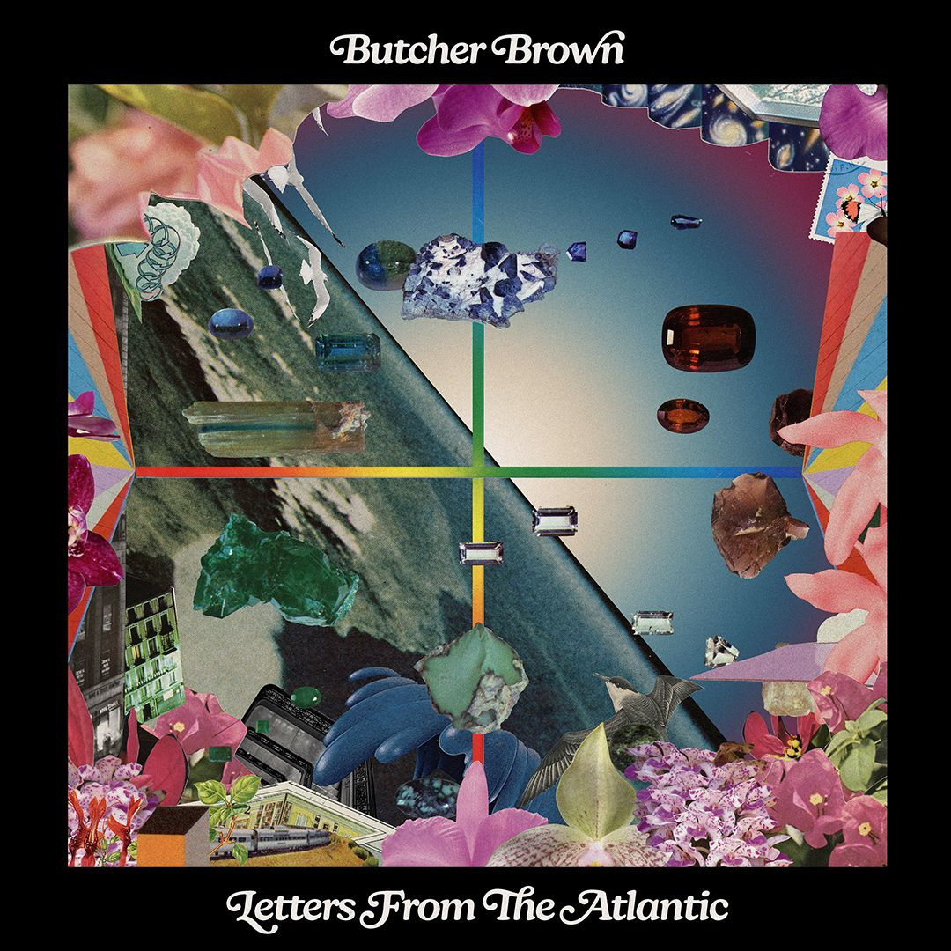

**Album art, Hi-Res** [**HERE**](https://www.dropbox.com/scl/fo/qbsxkocevm697ian46syt/API52M1qkRRNU96ruCqoaec?rlkey=gh1s3xoit07ow6698qmet5s61&st=6hbohdnz&dl=0)

**Butcher Brown *Letters From the Atlantic* (Concord Jazz)**

**Tracklist**

1. Seagulls

2. Unwind feat. Melanie Charles

3. Backline

4. Right Here feat. Leanor Wolf

5. Change in Weather feat. MIA GLADSTONE

6. Dinorah Dinorah

7. I Remember feat. Yaya Bey

8. Ibiza

9. Hold You feat. Victoria Victoria

10. Montrose Forest feat. Nicholas Payton

11. Something New About You feat. Neal Francis

12. Infant Eyes

**CONNECT WITH BUTCHER BROWN ONLINE**[**LINKTREE**](https://ffm.bio/butcherbrown)