**AUSTRALIAN INDIE ROCK BAND SPACEY JANE RETURN WITH NEW ALBUM   
*IF THAT MAKES SENSE***

**MAY 9**

**LEAD SINGLE “ALL THE NOISE” OUT NOW**

**WATCH VIDEO** [**HERE**](https://found.ee/AllTheNoiseYT)

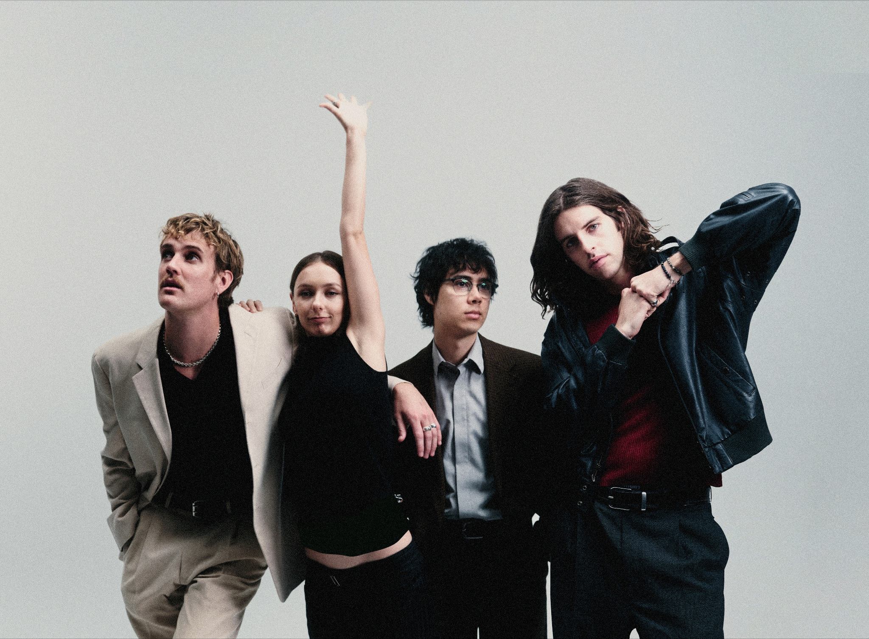

*Photo Credit: Cole Barash*

**January 16, 2025 (Los Angeles, CA) -** Today,Australian indie-rock quartet **Spacey Jane** have announced the release of their highly anticipated third studio album, ***If That Makes Sense***, which is set for release on **May 9**. In conjunction, the Perth natives are ushering in the new era with their first single “**All the Noise**,” an upbeat track fueled by dynamic guitar riffs and dreamy melodies, which premiered on **Triple J**’s **Breakfast**.

WATCH/LISTEN TO “ALL THE NOISE” [HERE](https://found.ee/AllTheNoiseYT)

*If That Makes Sense* is Spacey Jane’s most ambitious record to date, seeing the band explore new facets of their sound and dive deeper into themes of falling in and out of love, overcoming trauma and learning to pick up the pieces. Produced by **Mike Crossey** (The 1975, Arctic Monkeys, Wolf Alice), the band also collaborated with songwriters **Jackson “Day Wave” Phillips** and **Sarah Aarons** (Childish Gambino, Miley Cyrus, Lykke Li) to bring this project to life.

On creating the album, the band shares, *“This album isn’t trying to be anything in particular. Sometimes it is sure of itself and other times it whispers uncertainty. It feels like a contradiction of forgiveness and anger, love and breakdown and that's what I was trying to reconcile in the title. It's hard to give it a theme other than an overwhelming sense of confusion and a less than successful attempt to tie up emotional loose ends. We went to the U.S., we put our faith in new collaborators and finished making a self funded record without a label home for it. We stepped off the cliff everyday and loved it and we have never been happier with our work than we are now.”*

“All the Noise” invites listeners into the heart of *If That Makes Sense* as frontman **Caleb Harper** tells the complicated story of his parents’ union and collapse as he fears that he will follow in their footsteps. Expressed through **Ashton Hardman-Le Cornu**’s anthemic guitar riffs, **Peppa Lane**’s energetic bassline and a steady drum from **Kieran Lama**, the band perfectly captures the complexities and anxieties of the song.

“‘All the Noise’ was mostly written in a hotel room in Sydney having landed in Australia for the first time in 6 months,” recalls Harper. *“I suppose there was something about being down under again that made my version of the story of the beginning of my life feel so vivid. It's angry, but not at someone, and it's sad because I can't quite get to the bottom of what or who made me. It might be my favourite riff of Ashton's and the tightest Peppa and Kieran have ever locked. It's gonna be so fun live and we're beyond excited to be sharing our first new music in over a year.”*

The new album follows 2022’s ***Here Comes Everybody*** and 2020’s ***Sunlight***. The band became a hometown sensation after the release of *Sunlig*ht, topping **Triple J’s annual album poll** with breakout single “[**Booster Seat**](https://www.youtube.com/watch?v=XxKuwlnx58g)” and earning the **ARIA for Song of the Year**. Inspired by the success of their debut album, Spacey Jane got to work on their sophomore album, which debuted at **#1 on the ARIA Charts** and earned them the title of **Triple J’s most played artist** in 2022. With two critically acclaimed albums under their belt and chemistry that’s stronger than ever, Spacey Jane are swinging for the fences on their forthcoming record.

Spacey Jane are celebrating the album announcement with three intimate concerts across Australia. They kicked off the run of shows in their hometown at Perth’s Rosemount Hotel last night, and have just announced shows at The Lansdowne in Sydney tonight and Howler in Melbourne tomorrow. These shows see the band return to venues similar in size to the ones they started out in as a way to thank fans who have stuck with them. They’ll be playing a mix of fan-favorite tracks and never-before-heard songs off the forthcoming album.

Formed in Perth, Western Australia in 2016, Spacey Jane have expanded their reach far beyond their hometown. With more than half a billion streams to date and countless sold-out tours, the band has built a loyal following through their dreamy, vulnerable sound and unforgettable live performances. 2025 is shaping up to be the band’s biggest year to date - stay tuned for more.

***IF THAT MAKES SENSE* TRACKLIST**

1. Intro
2. Through My Teeth
3. Whateverrrr
4. All the Noise
5. Impossible to Say
6. How to Kill Houseplants
7. I Can’t Afford to Lose You
8. So Much Taller
9. The More That it Hurts
10. Estimated Delivery
11. Falling Apart
12. Ily the Most
13. August

**AUSTRALIAN TOUR DATES**

Thu, Jan 16 - Sydney, AUS - The Lansdowne

Fri, Jan 17 - Melbourne, AUS - Howler

  
*If That Makes Sense* Album Artwork

**KEEP UP WITH SPACEY JANE**

[Website](https://spaceyjane.com.au) | [Instagram](https://www.instagram.com/spacey_jane/?hl=en) | [YouTube](https://www.youtube.com/channel/UCZT2BAh-X6WGjokXfVJbryQ) | [TikTok](https://www.tiktok.com/@spaceyjane)

*###*

For more information, please contact:

Luke Burland | 2b Entertainment

[luke@2bentertainment.net](mailto:luke@2bentertainment.net)

Louis D’Adamio | 2b Entertainment

[louis@2bentertainment.net](mailto:louis@2bentertainment.net)

Bailey Katler | 2b Entertainment

[bailey@2bentertainment.net](mailto:bailey@2bentertainment.net)