**Grammy-Winning Pianist And Composer Hiromi Releases *OUT THERE* Today**

**(Telarc)**

**Features The Return Of Hiromi’s Sonicwonder: Hadrien Feraud On Bass, Gene Coye On Drums, Adam O’Farrill On Trumpet**

**Watch New Video for Album Highlight “**[**Yes! Ramen!!**](https://found.ee/Hiromi_YesRamenYT)**”**

**Watch Hiromi and Sonicwonder Perform** [**Live**](https://found.ee/Hiromi_BalloonBlueNote) **at Blue Note Tokyo**

**US Headlining Tour Kicks off this Evening + Special Blue Note NYC Show April 7th**

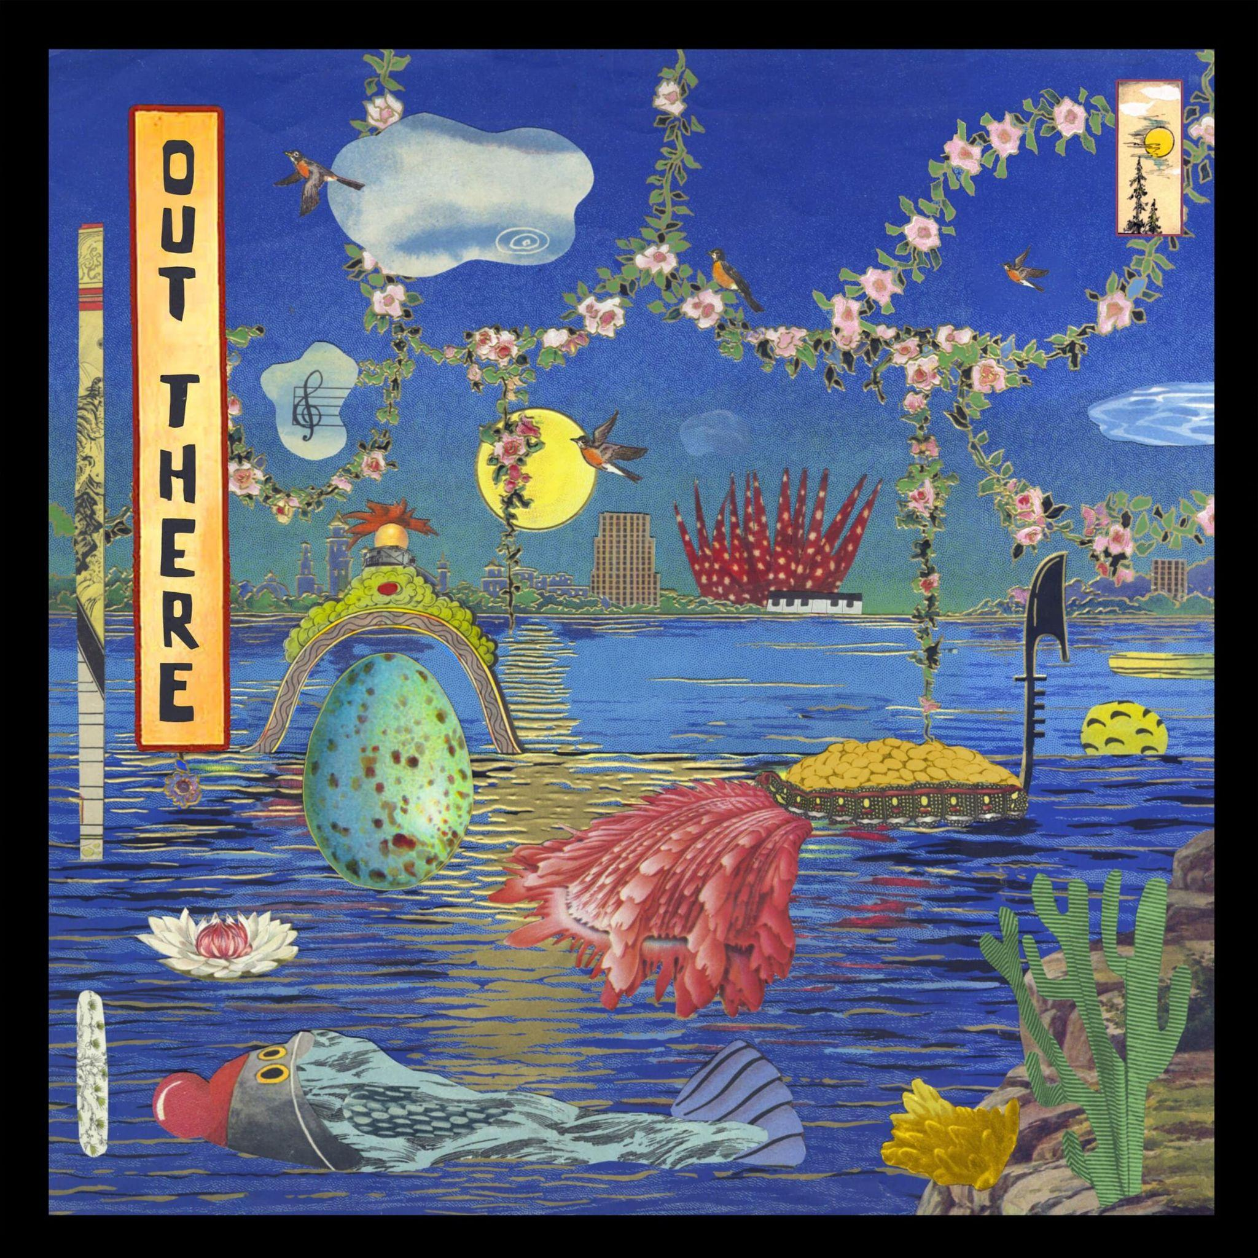

[**BUY/STREAM ‘OUT THERE’**](https://found.ee/Hiromi-OUTTHERE)

**Friday, April 4th, 2025** — Twenty years in, there is no other pianist out there that sounds quite likeHiromi. Today, Hiromi continues her shapeshifting tradition with the release of her 13th studio album ‘OUT THERE’ (Telarc), her second album with Sonicwonder, a mighty new quartet featuring Hadrien Feraud on bass, Gene Coye on drums, and Adam O’Farrill on trumpet.

‘OUT THERE’ is the follow-up to 2023’s ‘Sonicwonderland,’ the debut of one of the most expressive and versatile working bands of Hiromi’s career furthering her distinctive musical alchemy: the spirit of classic jazz-rock fusion melded with classically rooted virtuosity, entrancing funk, pop flourishes, and acoustic jazz. ‘OUT THERE’ captures their deep chemistry and fearless sense of interplay amid nearly two years of touring and playing together. Hiromi invites you to buckle up, for a fun, thoughtful, and wild musical ride.

Already, Hiromi and Sonicwonder have shared two previews from the album, the ‘80s Miles Davis channeling earworm “[Balloon Pop](https://found.ee/Hiromi-OUTTHERE)” and the ballad-to-midtempo jazz song “[Pendulum](https://found.ee/Hiromi-OUTTHERE)” kissed by sensual neo-soul. Today, album highlight “[Yes! Ramen!!](https://found.ee/Hiromi_YesRamenYT)” gets its very own video which sees Hiromi exploring Japan and enjoying some of her favorite ramen spots along the way. The track is a tribute to Hiromi’s all-time-favorite food and another wild ride boasting synth hooks, ska-tinged rhythms, revved-up disco beats, a big Black Sabbath-sounding riff, leading-edge jazz improvisation, contemporary classical and more. The band shares Hiromi’s love for ramen, especially O’Farrill and Coye, and they try to hit as many spots as possible on tour.

“For this song, it was more like putting a soundtrack to the film I had in my head,” says Hiromi on the song. “When the landscape changes, then different music comes in — different restaurant, different style. Ramen is a true source of inspiration and I respect the ramen artisans so much so I finally wrote a song about it.”

Tonight, Hiromi’s Sonicwonder kicks off a string of US tour dates with concerts at famous venues in Chicago and Toronto, a special album release show at the Blue Note next Monday, April 7th in NYC, and more. See below for the full itinerary and [revisit](https://found.ee/Hiromi_BalloonBlueNote) her performance at Blue Note Tokyo.

Says Hiromi: “On *Sonicwonderland*, I had the concept and the songs first, and I was looking for the people who could play the music in the ideal way that I had in my mind. Being with this group for well over a year,” she continues, “playing a lot of shows together and understanding each other, I started to see more of their strength and what shines in them the most. So I started to write music with them in mind.”

Hiromi’s Sonicwonder brings together world-class musicians of diverse backgrounds. French-born Feraud is a fusion virtuoso who has been compared to bass great Jaco Pastorius. Coye hails from Chicago, where he grew up playing in church and combines technical mastery with a soulful knack for groove and pocket. Brooklyn-raised O’Farrill, part of a dynasty that includes his father and grandfather, Latin-jazz titans Arturo and Chico O’Farrill, ranks among his generation's most important and progressive trumpeters. Throughout the album, O’Farrill conjures up audacious new sonic textures through electronics — part of his toolbox that Hiromi encouraged him to develop fully.

“[Bass legend and collaborator] Anthony Jackson always told me that a first-class musician can do anything,” Hiromi says. “You don’t really have to put them in one genre or one category.” Knowing that anything she composed would be met with outstanding performances, Hiromi let her fiercest ambitions run wild when crafting the music for ‘OUT THERE.’ “It all comes from curiosity,” she explains. “I think curiosity is the key to everything. How can you express yourself more? How can you write more?”

The core of ‘OUT THERE’ is its four-part suite, which Hiromi would like fans to hear as a focused front-to-back listen. It opens with the rapid-fire melody of “Takin’ Off” and traverses the sly ’70s fusion grooves of “Strollin’,” which calls to mind Herbie Hancock, George Duke and Grover Washington Jr. “Orion” follows, with bold and triumphant bookends that could score a great work of science fiction. The suite closes with “The Quest,” which unites the chopped-up rhythmic thrust of current jazz with the synth pleasures of vintage prog-rock. The album’s finale is “Balloon Pop,” which is as much of an earworm as anything currently on the Hot 100. And with O’Farrill on trumpet, its hummable theme summons up Miles Davis’ hook-filled ’80s recordings.

Hiromi’s many career triumphs include an NPR Tiny Desk Concert that has racked up 2 million views; the opportunity to represent her native Japan with a performance at the 2021 Summer Olympics in Tokyo; 2024 winner for Best Music Score for the animated feature film Blue Giant (Award of the Japanese Academy); and a GRAMMY Award for a collaboration with fusion hero Stanley Clarke. Her artistry is — to borrow a descriptor the *New Yorker* favored — “dazzling.”

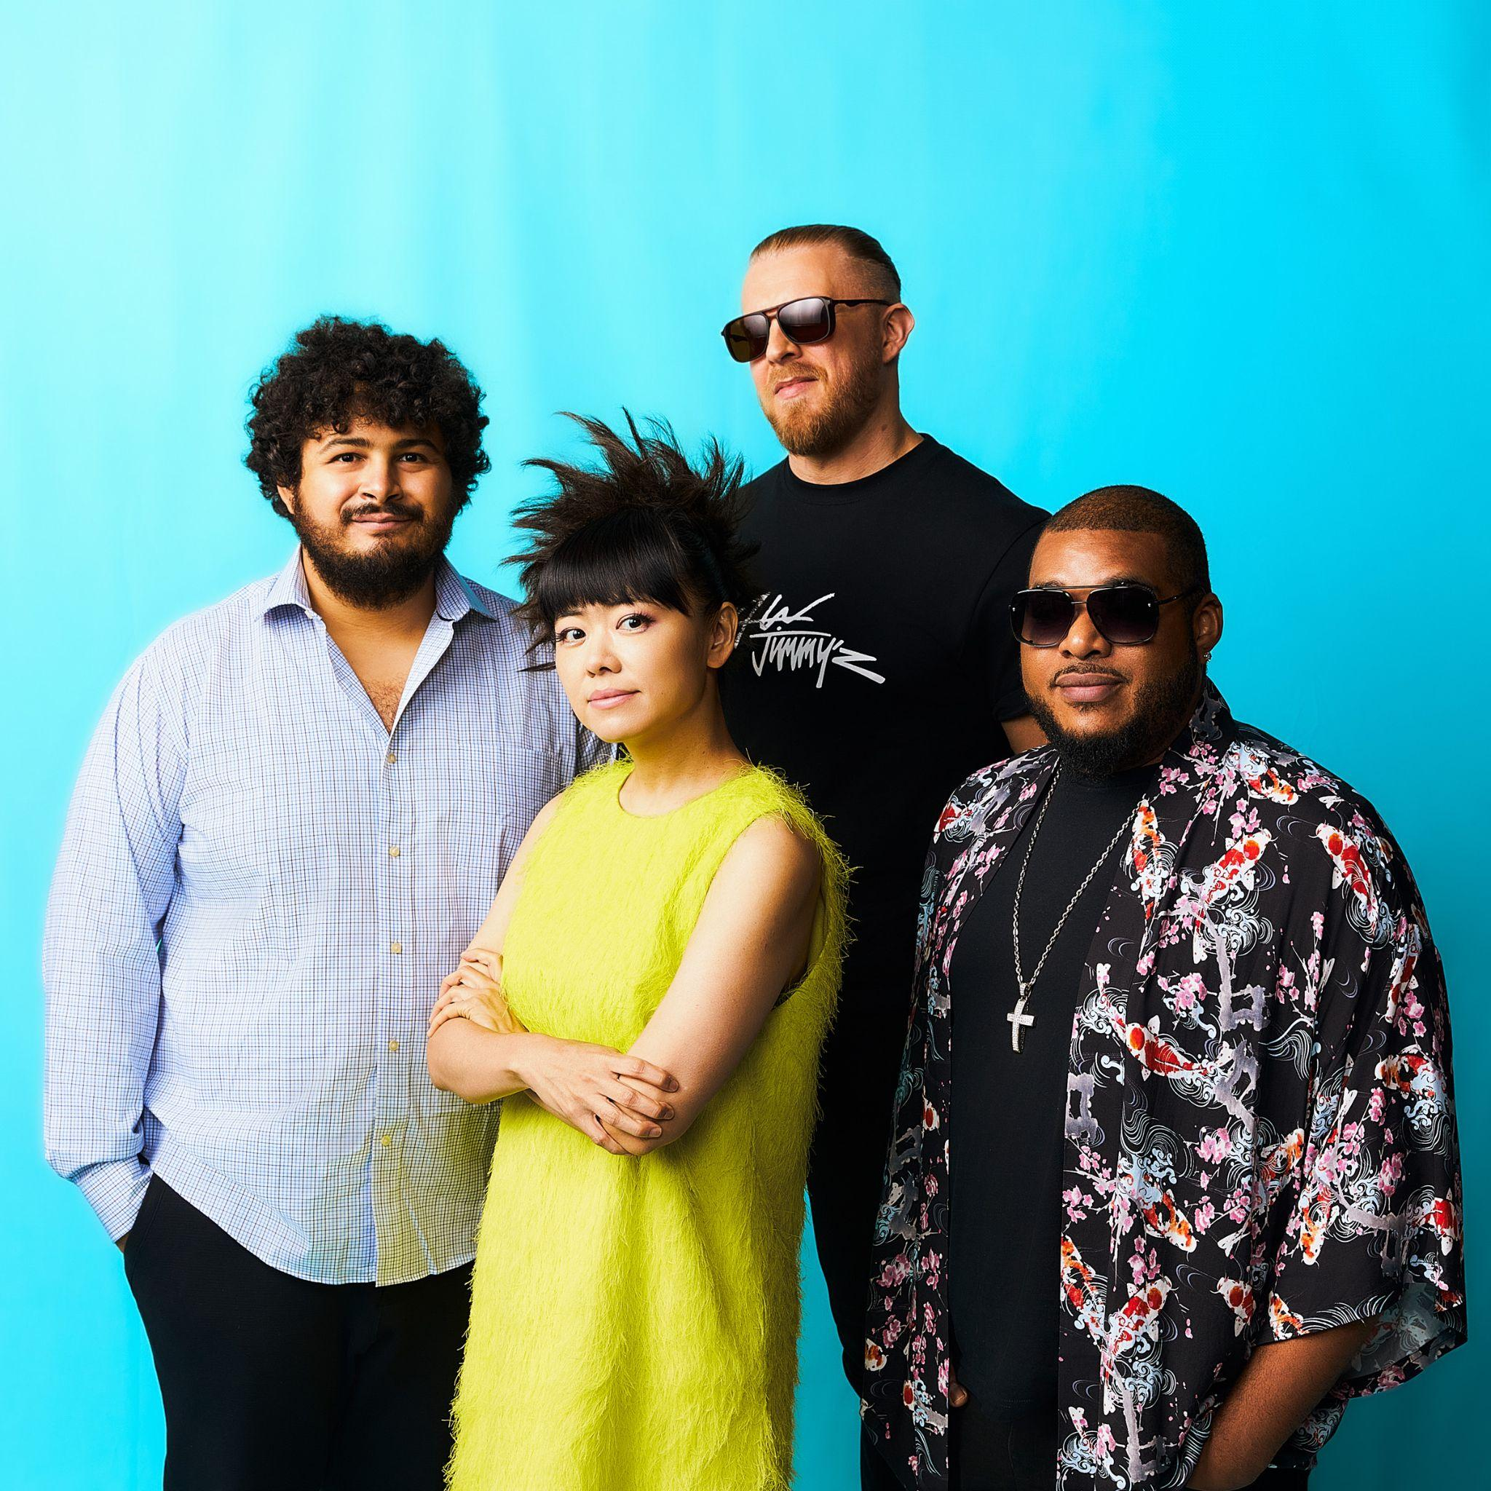

*Photo Credit: Mitsuru Nishimura*

[**BUY/STREAM ‘OUT THERE’**](https://found.ee/Hiromi-OUTTHERE)

Order Signed Vinyl & Exclusive Merch [**HERE**](https://found.ee/Hiromi_Store)

**‘OUT THERE’ TRACKLIST:**

1. XYZ
2. Yes! Ramen!!
3. Pendulum (featuring Michelle Willis)
4. OUT THERE: Takin’ Off
5. OUT THERE: Strollin’
6. OUT THERE: Orion
7. OUT THERE: The Quest
8. Pendulum
9. Balloon Pop

**HIROMI’s SONICWONDER TOUR DATES:**

Fri, APR 4 - Chicago Symphony Center - Chicago, IL

Sat, APR 5 - George Wheaton Recital Hall - Toronto, Canada

Mon, APR 7 - Blue Note - New York, NY

Tue, APR 8 - Dakota - Minneapolis, MN

Wed, APR 9 - Dakota - Minneapolis, MN

Thurs, APR 10 - Fox Tucson Theater - Tucson, AZ

Fri, APR 11 - Scottsdale Center For The Performing Arts - Tucson, AZ

Sat, APR 12 - University of Texas, Dallas - Richardson, TX

Sun, APR 13 - Moore Theatre - Seattle, WA

Tues, APR 15 - Revolution Hall - Portland OR

Thurs, APR 17 - SFJazz - San Francisco, CA

Fri, APR 18 - SFJazz - San Francisco, CA

Sat, APR 19 - SFJazz - San Francisco, CA

Sun, APR 20 - SFJazz - San Francisco, CA

Mon, APR 21 - Kuumbwa Jazz Center - Santa Cruz, CA

Thurs, APR 24 - Irvine Barclay Theater - Irvine, CA

Fri, APR 25 - Campbell Hall - Santa Barbara, CA

Thurs, MAY 15 - Sanat Concert Hall - Istanbul, Istanbul

Fri, MAY 16 - Georg Friedrich Händel - Halle, Germany

Sat, MAY 17 - Philharmonie Essen - Essen, Germany

Sun, MAY18 - Festhalle Bern - Bern, Switzerland

Mon, MAY 19 - Volkshaus Basel - Basel, Switzerland

Wed, MAY 21 - STROMWERK Kulturarena Kraftwerk Mitte - Dresden, Germany

Fri, MAY 23 - Isar Philharmonic - München, Germany

Sat, MAY 24 - Telekom Forum - Bonn, Germany

Sun, MAY 25 - Stora Teatern - Gotesborg, Sweden

Wed, MAY 28 - Jazz Sous Les Pommiers - Coutances, France

Fri, AUG 1 - Sony Hall - New York, NY

Sat, AUG 2 - Sony Hall - New York, NY

Sun, AUG 3 - Newport Jazz Festival - Newport, RI

Sat, AUG 30 - Detroit Jazz Festival - Detroit, MI

Fri, SEP 26 - Music Center At Strathmore - Bethesda, MD

Thurs, OCT 2 - Wisconsin Union Theater - Madison, WI

Fri, OCT 10 - Cahn Auditorium - Evanston, IL

Sun, OCT 12 - Curtis M. Philips Center For The Performing Arts - Gainesville, FL

Fri, NOV 7 - Muziekgebouw Frits Philips - Eindhoven, Netherlands

Sat, NOV 8 - Rockit Festival, Oosterport Main Hall - Groningen, Netherlands

Mon, NOV 10 - Amare - Den Haag, Netherlands

Tues, NOV 11 - Teatro Fernando Fernan Gomez - Madrid, Spain

Thurs, NOV 13 - Erbenhof Schallkultur Festival - Thüringen, Germany

Sat, NOV 15 - Gran Teatro Geox - Padova, Italy

Sun, NOV 16 - Etablissement public Salle de Concerts - Luxembourg City, Luxembourg

Wed, NOV 19 - Halle aux Grains - Toulouse, France

Fri, NOV 21 - Barbican Centre - London, England

**MORE INFO ON HIROMI:**

[**Website**](https://www.hiromiuehara.com/s/y01en/)

[**Press Kit**](https://shorefire.com/roster/hiromi)

[**YouTube**](https://www.youtube.com/channel/UCVUy1IfJ2R7FOM6F45lnt6A)

[**Facebook**](https://www.facebook.com/HiromiFan/)

[**Instagram**](https://www.instagram.com/hiromimusic/)

[**Twitter/X**](https://x.com/hiromispark)

[**TIKTOK**](https://www.tiktok.com/@hiromimusic)

###