**Hiromi Unveils “Pendulum” Featuring Vocalist Michelle Willis From New Album *OUT THERE* (April 4/Telarc)**

**US Headlining Tour Begins April 4, Includes Special Blue Note NYC Show**

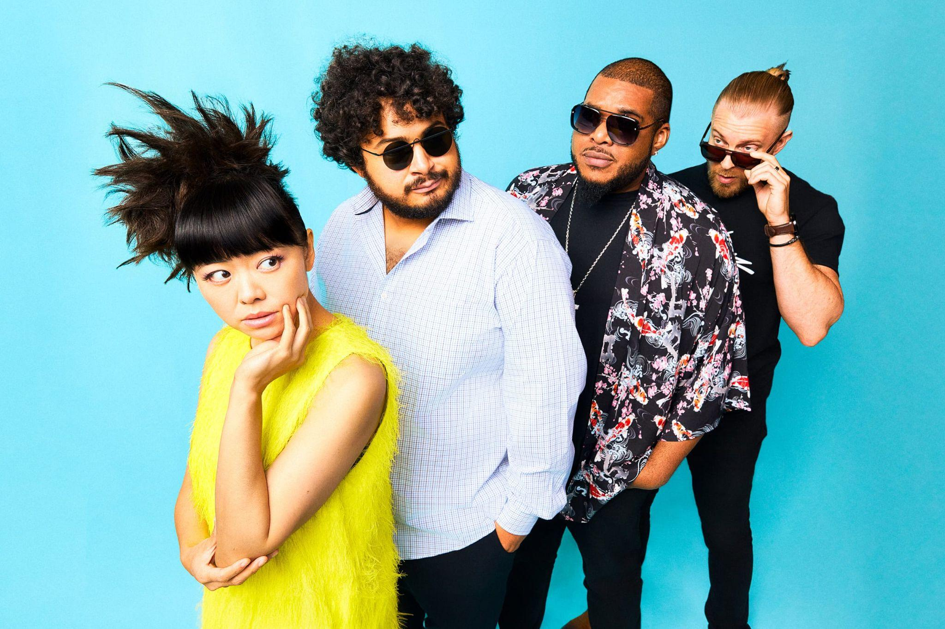

*Photo Credit: Mitsuru Nishimura*

[**PRE-ORDER/PRE-SAVE ‘OUT THERE’**](https://found.ee/Hiromi-OUTTHERE)

**February 28, 2025** — Today, pianist and composer Hiromi releases “Pendulum,” featuring her Sonicwonder band and Michelle Willis, best known for her collaborations with Becca Stevens and the late David Crosby, on vocals. Hiromi has long been a fan of Willis’ work, and calls her a “beautiful voice, and a very strong musician.” The pianist’s arrangement is ballad-to-midtempo jazz kissed by sensual neo-soul, and the original lyrics, co-written by Willis and Hiromi, are “about life,” the pianist says — “the come and go of it. Life is like a wave, or like a kind of pendulum. You have to go with the flow.”

Listen to “Pendulum” here: [LINK](https://found.ee/Hiromi-OUTTHERE)

Watch the “Pendulum” visualizer here: [LINK](https://found.ee/Hiromi_PendulumYT)

This version of “Pendulum” is one of two takes of the song on Hiromi’s 13th studio album ‘OUT THERE, the other being a solo piano rendition. ‘OUT THERE’ arrives April 4 on Telarc and features the mighty Sonicwonder quartet of Hadrien Feraud on bass, Gene Coye on drums, and Adam O’Farrill on trumpet.

‘OUT THERE’ is the follow-up to 2023’s ‘Sonicwonderland,’ the debut of one of the most expressive and versatile working bands of Hiromi’s career (watch their [NPR Tiny Desk](https://www.youtube.com/watch?v=pnISpahN2dM), which rapper Action Bronson deemed “the best Tiny Desk ever”). This new group furthered Hiromi’s distinctive musical alchemy: the spirit of classic jazz-rock fusion melded with classically rooted virtuosity, entrancing funk, pop flourishes, and acoustic jazz. ‘OUT THERE’ captures their deep chemistry and fearless sense of interplay amid nearly two years of touring and playing together. Hiromi invites you to buckle up, for a fun, thoughtful, and wild musical ride.

Hiromi and Sonicwonder unveiled “[Balloon Pop](https://found.ee/Hiromi-OUTTHERE)” in January, alongside the album announcement, which is as much of an earworm as anything currently on the Hot 100. (And with O’Farrill on trumpet, its hummable theme summons up Miles Davis’ hook-filled ’80s recordings.) Watch Hiromi’s Sonicwonder performing “Balloon Pop” Live at Blue Note Tokyo: [LINK](https://found.ee/Hiromi_BalloonBlueNote)

Hiromi’s Sonicwonder brings together world-class musicians of diverse backgrounds. French-born Feraud is a fusion virtuoso who has been compared to bass great Jaco Pastorius. Coye hails from Chicago, where he grew up playing in church and combines technical mastery with a soulful knack for groove and pocket. Brooklyn-raised O’Farrill, part of a dynasty that includes his father and grandfather, Latin-jazz titans Arturo and Chico O’Farrill, ranks among his generation's most important and progressive trumpeters. Throughout the album, O’Farrill conjures up audacious new sonic textures through electronics — part of his toolbox that Hiromi encouraged him to develop fully.

The core of ‘OUT THERE’ is its four-part suite, which Hiromi would like fans to hear as a focused front-to-back listen. It opens with the rapid-fire melody of “Takin’ Off” and traverses the sly ’70s fusion grooves of “Strollin’,” which calls to mind Herbie Hancock, George Duke and Grover Washington Jr. “Orion” follows, with bold and triumphant bookends that could score a great work of science fiction. The suite closes with “The Quest,” which unites the chopped-up rhythmic thrust of current jazz with the synth pleasures of vintage prog-rock. The album’s finale is “Balloon Pop,” which is as much of an earworm as anything currently on the Hot 100. And with O’Farrill on trumpet, its hummable theme summons up Miles Davis’ hook-filled ’80s recordings.

Tied to the album’s release, Hiromi’s Sonicwonder will perform concerts at famous venues in Chicago, Toronto, a special album release show at the Blue Note in NYC, and more. See below for the full itinerary. For the artwork, Hiromi has once again tapped the artist Lou Beach, famous for an array of album covers including Blink 182's Dude Ranch and albums by Flying Burrito Brothers, Madonna and Weird Al.

Hiromi’s many career triumphs include an NPR Tiny Desk Concert that has racked up 2 million views; the opportunity to represent her native Japan with a performance at the 2021 Summer Olympics in Tokyo; 2024 winner for Best Music Score for the animated feature film Blue Giant (Award of the Japanese Academy); and a GRAMMY Award for a collaboration with fusion hero Stanley Clarke. Her artistry is — to borrow a descriptor the *New Yorker* favored — “dazzling.”

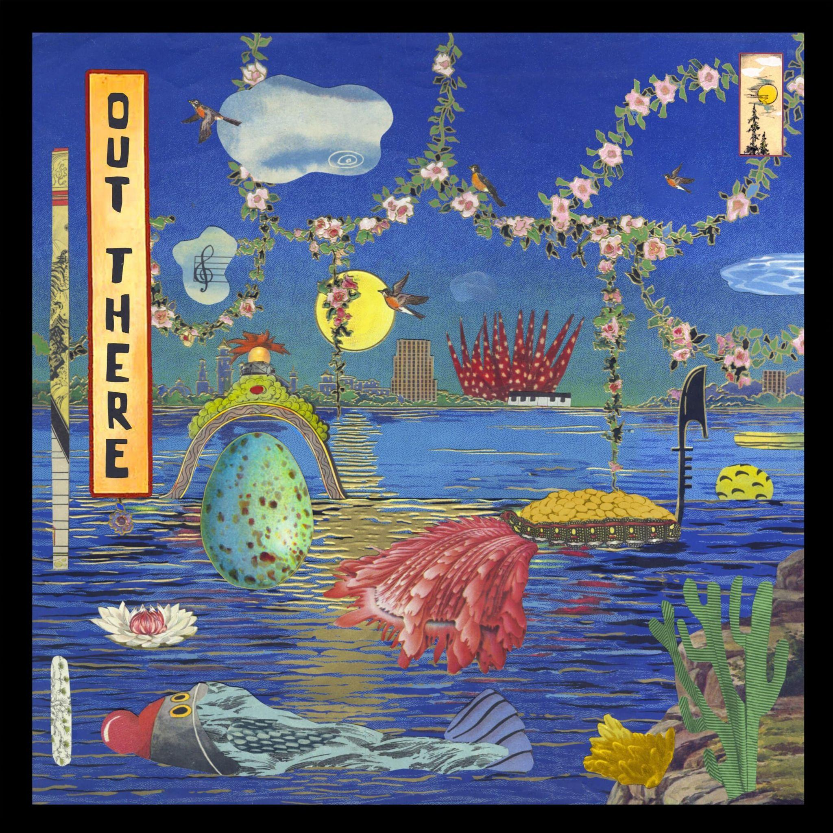

[**PRE-ORDER/PRE-SAVE ‘OUT THERE’**](https://found.ee/Hiromi-OUTTHERE)

**HIROMI’s SONICWONDER TOUR DATES:**

Fri, APR 4 - Chicago Symphony Center - Chicago, IL

Sat, APR 5 - George Wheaton Recital Hall - Toronto, Canada

Mon, APR 7 - Blue Note - New York, NY

Tue, APR 8 - Dakota - Minneapolis, MN

Wed, APR 9 - Dakota - Minneapolis, MN

Thurs, APR 10 - Fox Tucson Theater - Tucson, AZ

Fri, APR 11 - Scottsdale Center For The Performing Arts - Tucson, AZ

Sat, APR 12 - University of Texas, Dallas - Richardson, TX

Sun, APR 13 - Moore Theatre - Seattle, WA

Tues, APR 15 - Revolution Hall - Portland OR

Thurs, APR 17 - SFJazz - San Francisco, CA

Fri, APR 18 - SFJazz - San Francisco, CA

Sat, APR 19 - SFJazz - San Francisco, CA

Sun, APR 20 - SFJazz - San Francisco, CA

Mon, APR 21 - Kuumbwa Jazz Center - Santa Cruz, CA

Thurs, APR 24 - Irvine Barclay Theater - Irvine, CA

Fri, APR 25 - Campbell Hall - Santa Barbara, CA

Thurs, MAY 15 - Sanat Concert Hall - Istanbul, Istanbul

Fri, MAY 16 - Georg Friedrich Händel - Halle, Germany

Sat, MAY 17 - Philharmonie Essen - Essen, Germany

Mon, MAY 19 - Volkshaus Basel - Basel, Switzerland

Wed, MAY 21 - STROMWERK Kulturarena Kraftwerk Mitte - Dresden, Germany

Fri, MAY 23 - Isar Philharmonic - München, Germany

Sat, MAY 24 - Telekom Forum - Bonn, Germany

Sun, MAY 25 - Stora Teatern - Gotesborg, Sweden

Wed, MAY 28 - Jazz Sous Les Pommiers - Coutances, France

Fri, NOV 7 - Muziekgebouw Frits Philips - Eindhoven, Netherlands

Mon, NOV 10 - Amare - Den Haag, Netherlands

Thurs, NOV 13 - Erbenhof Schallkultur Festival - Thüringen, Germany

Sun, NOV 16- Etablissement public Salle de Concert -, Luxembourg City, Luxembourg

**MORE INFO ON HIROMI:**

[**Website**](https://www.hiromiuehara.com/s/y01en/)

[**Press Kit**](https://shorefire.com/roster/hiromi)

[**YouTube**](https://www.youtube.com/channel/UCVUy1IfJ2R7FOM6F45lnt6A)

[**Facebook**](https://www.facebook.com/HiromiFan/)

[**Instagram**](https://www.instagram.com/hiromimusic/)

[**Twitter/X**](https://x.com/hiromispark)

[**TIKTOK**](https://www.tiktok.com/@hiromimusic)

###