PREVIEW: LISTEN [HERE](https://cmg.concordrep.com/play/40596/455fcbde43a12ab413473bb2fac6fc2f47fa899e/) (NO NOT SHARE)

**EMBARGO 9 AM ET**

February 18th, 2025

**FOR IMMEDIATE RELEASE**

[judy@motormouthmedia.com](mailto:judy@motormouthmedia.com)

**BUTCHER BROWN**

**SHARES COVER SINGLE**

**“DINORAH DINORAH”**

**LISTEN TO THE** [**SINGLE**](https://found.ee/BB_LettersFromTheAtlantic) **/ WATCH THE** [**VIDEO**](https://found.ee/BB_DinorahDinorahYT)

***LETTERS FROM THE ATLANTIC***

**OUT MARCH 28TH ON CONCORD JAZZ**

**NATIONAL TOUR BEGINS ON RELEASE DAY**

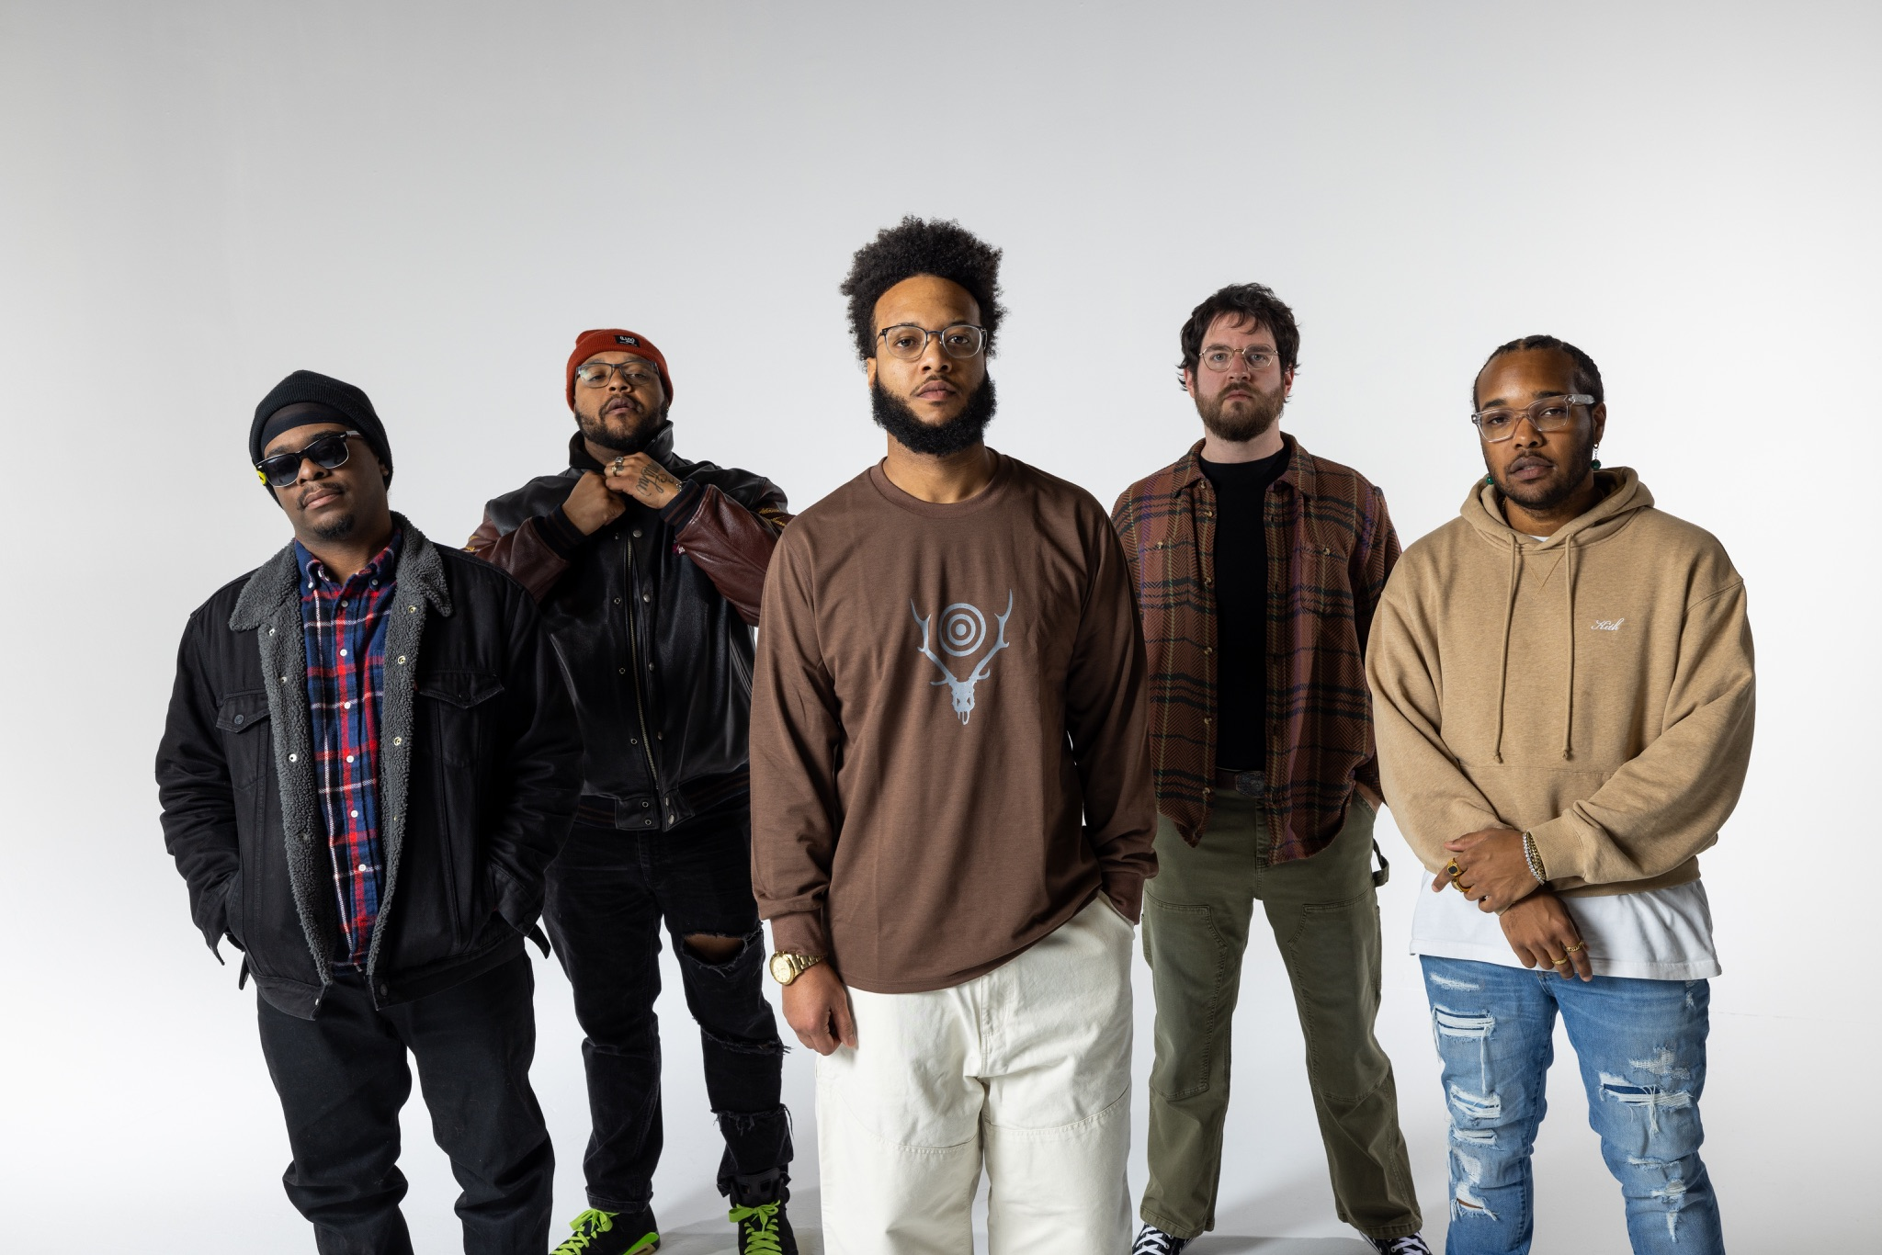

**Credit: Jacky Flav, Hi-Res** [**HERE**](https://www.dropbox.com/scl/fo/qbsxkocevm697ian46syt/API52M1qkRRNU96ruCqoaec?rlkey=gh1s3xoit07ow6698qmet5s61&st=6hbohdnz&dl=0)

**Praise for Butcher Brown:**

*“The ‘solar music’ Butcher Brown brought to Tiny Desk was hot and funky from the count-in.”*

**– NPR Music**

*"A spirit of generous communion runs through 'Solar Music'"*

**– The New York Times**

*“The jazz/funk/hip-hop/rock/everything-but-the-kitchen-sink quintet is respected across the genre spectrum, by musicians and fans alike."*

**– The Washington Post**

*“Solar Music is a leather-smooth guided tour through a rip in spacetime”*

**– The FADER**

*"Butcher Brown applies the harmonic and melodic sophistication of jazz to the textural and rhythmic conventions of hip-hop with impressive results."*

**– Bandcamp**

Today, **Butcher Brown** shares the new single and video “**Dinorah Dinorah,**” (originally by Ivan Lins) following previous tracks “**Ibiza**” and “**Montrose Forest.**” The Virginia-bred collective’s new album ***Letters From The Atlantic*** will release on March 28 via Concord Jazz, offering a seamless blend of jazz, rock, funk, R&B, soul, bossa nova and more. The new record moves toward an indie groove, featuring female guest artists **Yaya Bey**, **Melanie** **Charles**, **Leanor** **Wolf**, **Mia** **Gladstone**, **Victoria** **Vict​​oria**, along with **Nicholas** **Payton** & **Neal** **Francis**.

**Listen to “Dinorah Dinorah”** [**HERE**](https://found.ee/BB_LettersFromTheAtlantic)

**“Dinorah Dinorah”** is a cover of a cover, but **George Benson's** version is the definitive one for us,” says the band. “It feels very Brazilian, and ours definitely has a Southern Atlantic, laid-back beach party vibe. Listening to someone like George Benson is how we all learned to talk, in a way. We’re just contributing to the musical pantheon and paying homage to one of the greats. This is feel-good music.”   
  
 **Preorder/save *Letters From The Atlantic*** [**HERE**](https://found.ee/BB_LettersFromTheAtlantic)“Dinorah Dinorah” effortlessly marries a driving house beat, claps and all, with masterful arrangement of piano, saxophone, and guitar, creating a modern classic in today’s age of jazz. Meticulous solos, relentless groove, and mesmerizing vocal effects serve as the guides on this sonic journey. The first couple of minutes sound like a bright and upbeat New York morning and by the end you’ve been transported to a sunset beach in Miami, staying true to the album’s theme of a musical expedition.   
  
Following the group’s critically acclaimed *Solar Music* (2023), ***Letters From The Atlantic*** takes listeners on a musical journey through destinations and influences from the Chesapeake Bay to New York, down the East Coast to Florida and overseas in Europe.   
  
“We want this full record to feel like you’re floating on a trip – it’s taking you on a journey, and you can determine what each song reminds you of. It’s a story of everything we listen to, capturing nostalgia for Virginia, the East Coast and overseas. We’re pulling sounds from across the Atlantic” says the band.   
  
“Seagulls” kicks off the record close to home, evoking peaceful vibes by the water on Virginia Beach. A song like “Unwind” feat. Melanie Charles is straight up Avenue C, Lower East Side in New York with those downtown feels. “Something New About You” with Neal Francis gets into yacht rock down in the Keys. Then “Hold You” gives a chill resonance, like you’re on a train in Europe on the other side of the ocean. Ending with “Infant Eyes” wraps up the journey with an instrumental stamp on the record that’s a homage to Wayne Shorter, giving him his flowers as a player and composer that the band looks up to.

Butcher Brown recorded ***Letters From The Atlantic*** with Alex De Jong at Spacebomb Studios in Richmond over the course of a few sessions last summer. The album draws from their collective love of disco, house music, Bossa, DnB (drum and bass), trip hop, drill and acid jazz. A strong female presence elevates a lot of the album this time around. Voices like Mia Gladstone, Victoria Victoria and Leanor Wolf bring a real harmony and chemistry to the new album.

“Our session with Yaya Bey was special because she came down to Richmond – we sat down and chopped it up for hours before recording together. You can feel that family energy on ‘I Remember,’ like laid back kicking it at a barbeque on the Fourth of July,” the band explains. “That’s the important part about being in person for sessions is you just want to vibe with the person. We’re more concerned with that than anything, and it comes across on that song.”

The nuance is turned up on ***Letters From The Atlantic***. Progressively through their studio albums, Butcher Brown is finding less potent ways to get their point across. Whereas *Solar Music* had angular edges and rougher drums, this album is more laid back, comfortable and intentional.

**2025 BUTCHER BROWN TOUR DATES**

March 29 – Chicago, IL – SPACE

April 2 – Boston, MA – Brighton

April 4 – Brooklyn, NY – Brooklyn Bowl

April 5 – Philadelphia, PA – Milkboy

April 11 – Charlottesville, VA – The Southern

April 12 – Virginia Beach, VA – Elevation 27

April 18 – Portland, OR – The Get Down

April 19 – Seattle, WA – Nectar Lounge

April 20 – Vancouver, BC – The Biltmore Cabaret

April 22 – Boise, ID – Neurolux

April 23 – Salt lake City, UT – State Room

April 26 – San Francisco, CA – The Independent

April 27 – Santa Cruz, CA – Kuumbwa

April 29 – San Diego, CA – Casbah

April 30 – Los Angeles, CA – Regent Theatre

**Preorder/save *Letters From The Atlantic*** [**HERE**](https://found.ee/BB_LettersFromTheAtlantic)

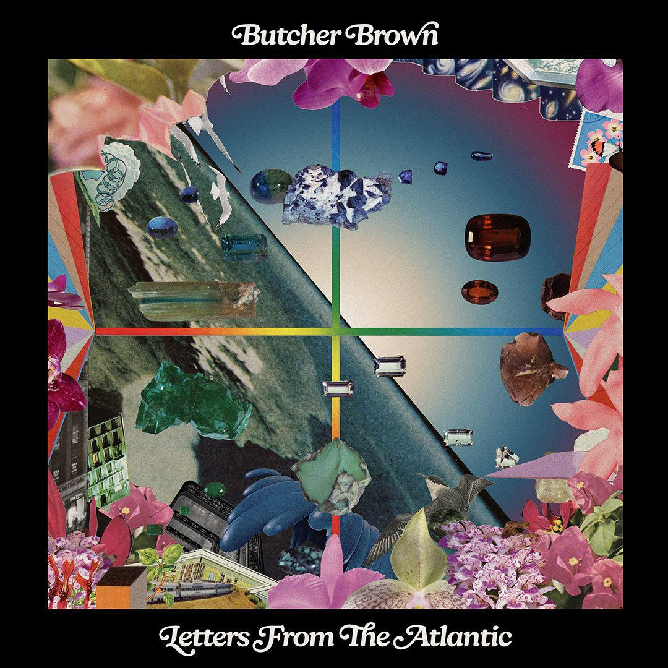

**Album art, Hi-Res** [**HERE**](https://www.dropbox.com/scl/fo/qbsxkocevm697ian46syt/API52M1qkRRNU96ruCqoaec?rlkey=gh1s3xoit07ow6698qmet5s61&st=6hbohdnz&dl=0)

**Butcher Brown *Letters From the Atlantic* (Concord Jazz)**

**Tracklist**

1. Seagulls

2. Unwind feat. Melanie Charles

3. Backline

4. Right Here feat. Leanor Wolf

5. Change in Weather feat. MIA GLADSTONE

6. Dinorah Dinorah

7. I Remember feat. Yaya Bey

8. Ibiza

9. Hold You feat. Victoria Victoria

10. Montrose Forest feat. Nicholas Payton

11. Something New About You feat. Neal Francis

12. Infant Eyes

**CONNECT WITH BUTCHER BROWN ONLINE**[**LINKTREE**](https://ffm.bio/butcherbrown)