L.S. Dunes
Shares New Single
“Fatal Deluxe”
Out Now via Fantasy Records
Watch New Music Video Here
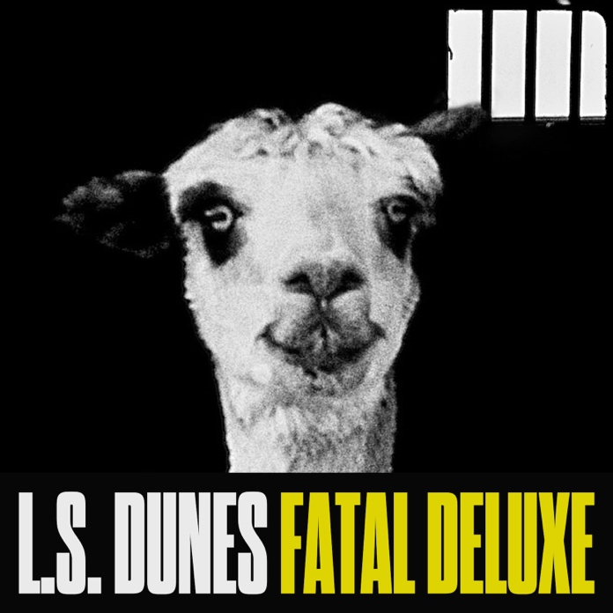

Previously Featured on Stereogum, Consequence,
Brooklyn Vegan, Revolver Mag, Alternative Press, and more

Sept 20, 2024 – Nashville, TN – L.S. Dunes is thrilled to share their new single “Fatal Deluxe”, out now via Fantasy Records. “Fatal Deluxe” offers a glimpse of what’s to come from rock’s most exciting and innovative supergroup; it swells in a cathartic crescendo that breaks just before the song’s conclusion. Listen to “Fatal Deluxe” now here: https://found.ee/FatalDeluxe and watch the new music video, directed by Pat and Nick Demarais, here: https://found.ee/FatalDeluxeYouTube.

On the new single, guitarist Frank Iero shares: “In my opinion ‘Fatal Deluxe’ marks the official opening of chapter two for L.S. Dunes. It’s a song that bridges the gap musically between where we were as a band and individually, and catches the listener up to where we are headed. It breaks quite a few conventional rules along the way and wipes clean the preconceptions of what the band is and might be capable of. It is a song I didn't want to stop listening to after we recorded it, and a song I cannot wait to play for a live audience. Those feelings are quite often the signs of something truly special.”

Fans can catch L.S. Dunes this fall. The band will be performing at Riot Fest, Louder Than Life, Furnace Fest, Aftershock, and When We Were Young Festival, in addition to a full US tour with Rise Against. For a full list of upcoming shows, please see below or visit: https://lsdunes.com.

About L.S. Dunes:

As cornerstones of some of the most captivating rock bands of the 21st Century, it's immediately apparent that L.S. Dunes is more than simply the sum of its parts. Straight-ahead, full throttle, aggressively avoiding too much polish or too many effects, this outfit turns on, turns up, and tears it all down. With their debut LP, Past Lives (2022), L.S. Dunes carved their place in the postmodern pantheon of abrasive, melodic, essential hard rock.

Vocalist Anthony Green (Circa Survive), guitarist Frank Iero (My Chemical Romance), bassist Tim Payne (Thursday), drummer Tucker Rule (Thursday), and guitarist Travis Stever (Coheed And Cambria) grind riff-heavy anthems super-charged with punk energy into a sound unlike anything that has come before it. Exploring themes of fearlessness, dependency, nonconformity, and impermanence, each of the 11 tracks on their debut album delivered confident musicality and unapologetic emotional vulnerability.

The number of “bands” and projects proposed between touring partners and like-minded hard rock troubadours over the years is incalculable. So, when those flippant suggestions actually make it over the finish line and create something really special, it’s nothing short of miraculous. Cream, Mad Season, Temple Of The Dog, A Perfect Circle, The Power Station, those bands worked. Now L.S. Dunes adds its own vibrant chapter, this one written by modern architects of the explosive, melodic post-hardcore scene, all connected through underground venues, theaters, festivals, fanzines, social media, counterculture attitude, and an unrivaled passion for the genre.
Stay tuned for more coming soon at https://lsdunes.com.

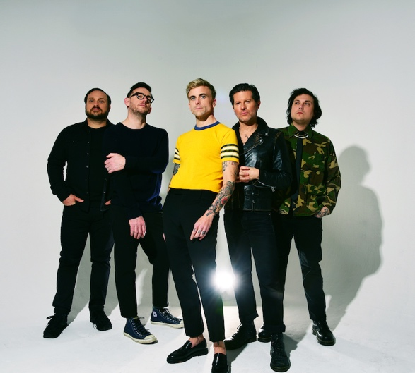
For Additional Info:
https://lsdunes.com
https://www.facebook.com/lsdunes
https://x.com/lsdunes
https://www.instagram.com/lsdunes
https://www.youtube.com/@lsdunesofficial
https://www.tiktok.com/@l.s.dunes

Upcoming Tour Dates:
9/21 - Chicago, IL @ Riot Fest
9/28 - Louisville, KY @ Louder Than Life
10/5 - Princeton, AL @ Furnace Fest
10/10 - Sacramento, CA @ Aftershock
10/11 - Sacramento, CA @ Aftershock
10/14 - Denver, CO @ Fillmore Auditorium
10/16 - St. Louis, MO @ The Pageant
10/18 - Las Vegas, NV @ Fontainebleau Theater
10/19-10/20 - Las Vegas, NV @ When We Were Young Festival
10/22 - Brooklyn, NY @ Brooklyn Paramount
10/23 - Portland, ME @ State Theatre
10/24 - Boston, MA @ Roadrunner
10/26 - Philadelphia, PA @ Franklin Music Hall
10/27 - Washington, DC @ 9:30 Club
10/28 - Washington, DC @ 9:30 Club
10/30 - Richmond, VA @ The National
11/1 - Lake Buena Vista, FL @ House of Blues Orlando
11/2 - St. Petersburg, FL @ Jannus Live
11/4 - Atlanta, GA @ The Eastern
11/5 - Nashville, TN @ Marathon Music Works
11/7 - Tulsa, OK @ Cain’s Ballroom
11/8 - Dallas, TX @ House of Blues Dallas
11/9 - Austin, TX @ Waller Creek
11/11 - Albuquerque, NM @ Revel Entertainment Center
11/13 - Garden City, ID @ Revolution Concert House
11/15 - Portland, OR @ Roseland Theater
11/16 - Vancouver, CAN @ Harbour Event Centre
11/17 - Seattle, WA @ Showbox SoDo
11/19 - Berkeley, CA @ The UC Theatre
11/22 - Del Mar, CA @ The Sound

###

Download High Res Press Photo Here (credit Shervin Laine)
Download High Res Single Art Here

US Press Contact:
Becky Kovach | Big Picture Media
becky@bigpicturemediaonline.com

