**iDKHOW’S NEW SINGLE IS AN INTOXICATING**

**’70S GROOVE TACKLING EGO, OBSESSION & THE CONSEQUENCES THAT CAN FOLLOW IF YOU INDULGE IN YOUR OWN FANTASIES TOO OFTEN**

**FINAL TASTE FROM UPCOMING SOPHOMORE LP *GLOOM DIVISION*  AHEAD OF FEB 23 RELEASE**

**LISTEN TO SOULFUL TRACK “INFATUATION” [HERE](https://found.ee/IDKHOW-INFATUATION)**

**EXTENSIVE GLOOMTOWN TOUR OF NORTH AMERICA FOR SPRING 2024, KICKS OFF MARCH 15**

**15 CITIES SOLD OUT INCLUDING NYC + LA**

**PRE-ORDER/SAVE *GLOOM DIVISION*** [**HERE**](https://found.ee/GLOOMDIVISION)

**CRITICAL PRAISE FOR iDKHOW:**  
"Spaced-out, swaggering synth-rock" - **Billboard**

"A throwback to Hot Hot Heat and early Killers — dance beat, bright neon synths, funky guitar, impassioned vocals slinging big hooks" **- Stereogum**

“Energetic” - **NME**

“Bright, vintage-pop-indebted tracks” - **DORK**“Weekes is crossing old-school glitz and glamour with contemporary futurism to create a “Channels the spirits of David Bowie and Prince” - **Alt Press**

“Captivating” **- Guitar World**

“Glam-fused soundscape” - **American Songwriter**

“Playful, retro, biting” **- FLOOD**

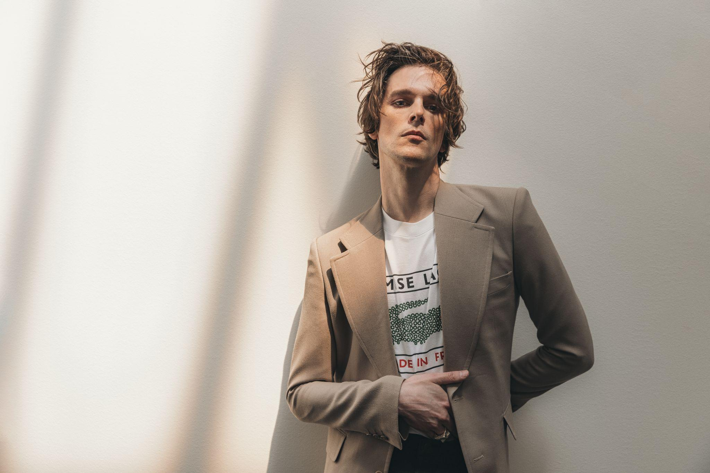

*Photo Credit: MANIC PROJECT*

Today, I DONT KNOW HOW BUT THEY FOUND ME (iDKHOW), the musical project of Salt Lake City-based singer, songwriter and multi-instrumentalist Dallon Weekes, releases “INFATUATION,” the new single off his forthcoming sophomore album, *GLOOM DIVISION* (2/23, Concord Records). “INFATUATION” is a loping cocktail of ’70s grooves about the religious guilt that comes with indulging in your own sexual fixations and fantasies.

iDKHOW recently announced the 2024 *GLOOMTOWN TOUR*, with 28 dates across North America kicking off March 15, including NYC’s Irving Plaza and Los Angeles’ Regent Theater, and support from SoCal four piece band Benches. 15 of the shows, including New York and LA have sold out. Tickets are available now at <https://idkhow.com/>.

Produced by Dave Fridmann (Tame Impala, MGMT, Weezer), *GLOOM DIVISION* showcases a boundary-pushing fusion of R&B, post-punk, and art-pop, exploring themes ranging from love and obsession to satanic panic and neurodivergence. Recorded at Fridmann's Tarbox Road Studios and Weekes' own basement studio, *GLOOM DIVISION* is a testament to the power of collaboration and fearless artistic expression.

iDKHOW has garnered nearly one billion streams worldwide to date, with two million monthly listeners on Spotify. The new album follows iDKHOW's critically acclaimed debut, *Razzmatazz*, which included the #1 Alternative radio hit "Leave Me Alone," and the previous EP *1981 Extended Play* that included RIAA certified GOLD-certified single “Choke.” They have performed on Jimmy Kimmel Live!, Ellen, and CBS This Morning: Saturday, and shared stages with Post Malone, The Killers, and more.

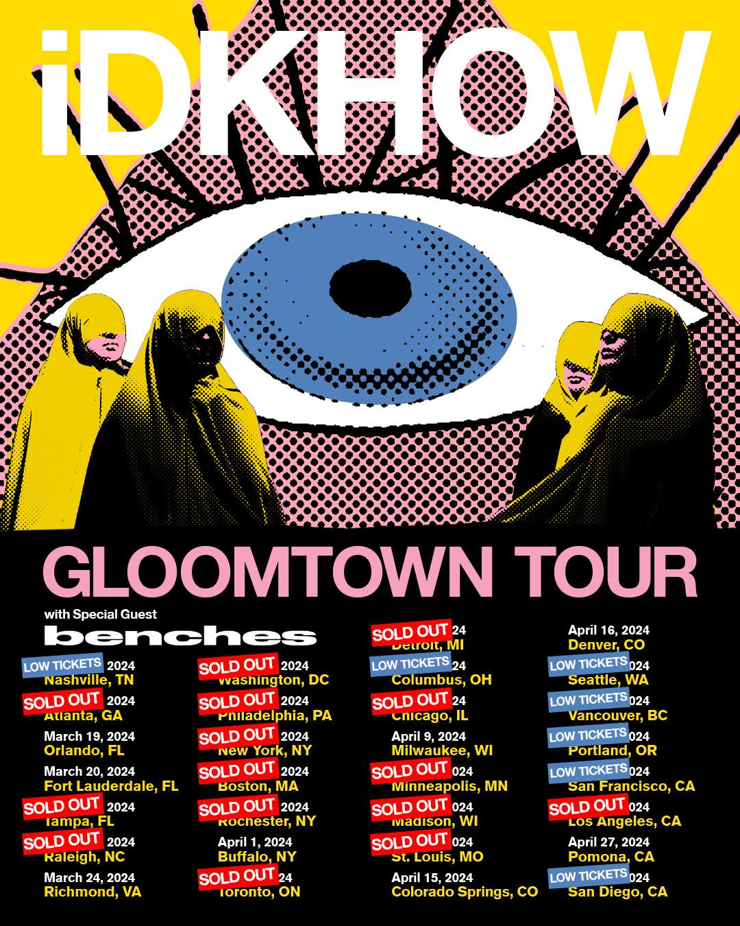

**iDKHOW tour dates:**

March 15 - Nashville, TN - Eastside Bowl *

March 17 - Atlanta, GA - Hell as Masquerade * **SOLD OUT**

March 19 - Orlando, FL - Plaza Live *

March 20 - Fort Lauderdale, FL - Culture Room *

March 21 - Tampa, FL - Crowbar * **SOLD OUT**

March 23 - Raleigh, NC - Motorco * **SOLD OUT**

March 24 - Richmond, VA - The National *

March 25 - Washington, DC - Atlantis * **SOLD OUT**

March 26 - Philadelphia, PA - Brooklyn Bowl Philly * **SOLD OUT**

March 28 - New York, NY - Irving Plaza * **SOLD OUT**

March 29 - Boston, MA - Brighton Music Hall * **SOLD OUT**

March 30 - Rochester, NY - Montage Music Hall * **SOLD OUT**

April 1 - Buffalo, NY - Buffalo Iron Works *

April 2 - Toronto, ON - The Axis Club * **SOLD OUT**

April 5 - Detroit, MI - Shelter * **SOLD OUT**

April 6 - Columbus, OH - Newport *

April 8 - Chicago, IL - Bottom Lounge * **SOLD OUT**

April 9 - Milwaukee, WI - Rave II *

April 11 - Minneapolis, MN - Fineline * **SOLD OUT**

April 12 - Madison, WI - Majestic Theatre * **SOLD OUT**

April 13 - St. Louis, MO - Delmar Hall * **SOLD OUT**

April 15 - Colorado Springs, CO - Black Sheep *

April 16 - Denver, CO - Ogden *

April 19 - Seattle, WA - Crocodile *

April 20 - Vancouver, BC - Fortune Sound Club *

April 21 - Portland, OR - Hawthorne Theatre *

April 24 - San Francisco, CA - August Hall *

April 26 - Los Angeles, CA - Regent * **SOLD OUT**

April 27 - Pomona, CA - Glass House *

April 28 - San Diego, CA - Music Box *

* w/ Benches

**iDKHOW Online**

[Instagram](https://www.instagram.com/idkhow/?hl=en) | [Facebook](https://www.facebook.com/IDKHOW/) | [Twitter](https://twitter.com/iDKHOW) | [Website](https://idkhow.com/)

For more information on iDKHOW, contact Carrie Tolles ([carrie@tcbpr.com](mailto:carrie@tcbpr.com)), Alison Smith ([alison@tcbpr.com](mailto:alison@tcbpr.com)), and Claire Marcus ([claire@tcbpr.com](mailto:claire@tcbpr.com)) at TCB PR