**iDKHOW ANNOUNCES EXTENSIVE GLOOMTOWN TOUR OF NORTH AMERICA FOR SPRING 2024**

**HEAR AN APOCALYPSE OF VANITIES ON EMPHATIC, BRET EASTON ELLIS-ESQUE SINGLE “GLOOMTOWN BRATS” HERE**

**PRE-ORDER/SAVE SOPHOMORE LP *GLOOM DIVISION* (OUT FEB 23)** [**HERE**](https://found.ee/GLOOMDIVISION)

**TICKETS FOR *GLOOMTOWN TOUR* ON PRE-SALE TODAY; GENERAL ON-SALE TOMORROW, 12/8**

**CRITICAL PRAISE FOR iDKHOW:**  
"Spaced-out, swaggering synth-rock" - **Billboard**

"A throwback to Hot Hot Heat and early Killers — dance beat, bright neon synths, funky guitar, impassioned vocals slinging big hooks" **- Stereogum**

“Energetic” - **NME**

“Bright, vintage-pop-indebted tracks” - **DORK**“Weekes is crossing old-school glitz and glamour with contemporary futurism to create a “Channels the spirits of David Bowie and Prince” - **Alt Press**

“Captivating” **- Guitar World**

“Glam-fused soundscape” - **American Songwriter**

“Playful, retro, biting” **- FLOOD**

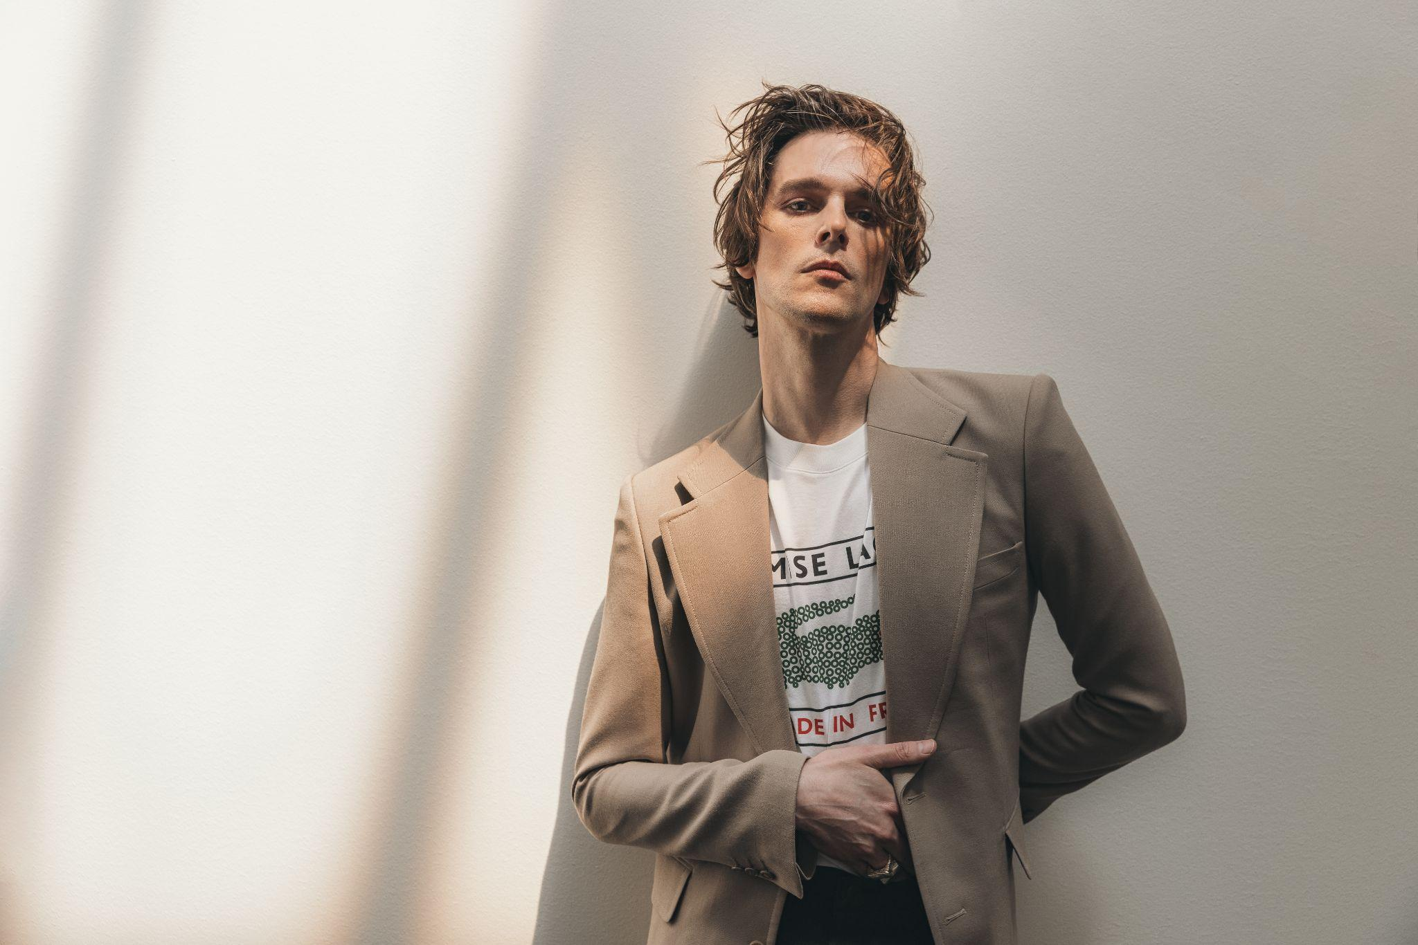

*Photo Credit: MANIC PROJECT*

Today, I DONT KNOW HOW BUT THEY FOUND ME (iDKHOW), the musical project of Salt Lake City-based singer, songwriter and multi-instrumentalist Dallon Weekes, releases “GLOOMTOWN BRATS,” the second single off his forthcoming sophomore album, *GLOOM DIVISION* (2/23, Concord Records). For Weekes, the Joe DiMaggio quote "rich boys don't make it to the majors” became his guiding light growing up poor while trying to find his footing as a musician. The mantra shines through in the theatrical, bass-heavy new anthemic single that centers an apocalypse of vanities - the nepotistic lifestyles that are rarely earned and always flaunted.

The track is accompanied by the announcement of the 2024 *GLOOMTOWN TOUR*, with 27 dates across North America kicking off March 15, including NYC’s Irving Plaza and Los Angeles’ Regent Theater. Tickets are available for pre-sale today at 11am ET with code GLOOMTOWN and general on-sale is tomorrow, 12/8 at 10am local time.

Additionally, iDKHOW has confirmed a hometown New Year’s celebration that will take place on December 30 at The Depot in Salt Lake City. Tickets are on sale now.

Produced by Dave Fridmann (Tame Impala, MGMT, Weezer), *GLOOM DIVISION* showcases a boundary-pushing fusion of R&B, post-punk and art-pop, exploring themes ranging from love and obsession to satanic panic and neurodivergence. Recorded at Fridmann's Tarbox Road Studios and Weekes' own basement studio, *GLOOM DIVISION* is a testament to the power of collaboration and fearless artistic expression.

iDKHOW has garnered nearly one billion streams worldwide to date, with two million monthly listeners on Spotify. The new album follows iDKHOW's critically acclaimed debut, *Razzmatazz*, which included the #1 Alternative radio hit "Leave Me Alone," and the previous EP *1981 Extended Play* that included RIAA certified GOLD-certified single “Choke.” They have performed on Jimmy Kimmel Live!, Ellen and CBS This Morning: Saturday, and shared stages with Post Malone, The Killers and more.

**iDKHOW tour dates:**

December 30 - Salt Lake City, UT - The Depot

March 15 - Nashville, TN - Eastside Bowl

March 17 - Atlanta, GA - Hell as Masquerade

March 19 - Orlando, FL - Plaza Live

March 20 - Fort Lauderdale, FL - Culture Room

March 21 - Tampa, FL - Crowbar

March 23 - Raleigh, NC - Motorco

March 24 - Richmond, VA - The National

March 25 - Washington, DC - Atlantis

March 26 - Philadelphia, PA - Brooklyn Bowl Philly

March 28 - New York, NY - Irving Plaza

March 29 - Boston, MA - Brighton Music Hall

March 30 - Rochester, NY - Montage Music Hall

April 1 - Buffalo, NY - Buffalo Iron Works

April 2 - Toronto, ON - The Axis Club

April 5 - Detroit, MI - Shelter

April 6 - Columbus, OH - Newport

April 8 - Chicago, IL - Bottom Lounge

April 9 - Milwaukee, WI - Rave II

April 11 - Minneapolis, MN - Fineline

April 12 - Madison, WI - Majestic Theatre

April 13 - St. Louis, MO - Delmar Hall

April 15 - Colorado Springs, CO - Black Sheep

April 16 - Denver, CO - Ogden

April 19 - Seattle, WA - Crocodile

April 20 - Vancouver, BC - Fortune Sound Club

April 21 - Portland, OR - Hawthorne Theatre

April 24 - San Francisco, CA - August Hall

April 26 - Los Angeles, CA - Regent

April 28 - San Diego, CA - Music Box

**iDKHOW Online**

[Instagram](https://www.instagram.com/idkhow/?hl=en) | [Facebook](https://www.facebook.com/IDKHOW/) | [Twitter](https://twitter.com/iDKHOW) | [Website](https://idkhow.com/)

For more information on iDKHOW, contact Carrie Tolles ([carrie@tcbpr.com](mailto:carrie@tcbpr.com)), Alison Smith ([alison@tcbpr.com](mailto:alison@tcbpr.com)), and Claire Marcus ([claire@tcbpr.com](mailto:claire@tcbpr.com)) at TCB PR